MC900353918[1]Name: _________________________________ Date: _________

**Gen Bio 1 Lab #1: Microscopes and Measurements**

**Prelab Reading Assignment:** Pages 94-97 in Campbell 10th edition.

Appendix C and D at the back of your text.

Please look at the following websites for more information to help you with this lab:

[**http://www.microscope-microscope.org/basic/microscope-parts.htm**](http://www.microscope-microscope.org/basic/microscope-parts.htm)

[**https://b51ab7d9e5e1e7063dcb70cee5c33cf7f4b7bad8.googledrive.com/host/0Bx6hk6AUBHxDc2d4TDJZTFIyMGs/files/Bio%20101/Bio%20101%20Laboratory/Metric%20System/Metric_System.htm**](https://b51ab7d9e5e1e7063dcb70cee5c33cf7f4b7bad8.googledrive.com/host/0Bx6hk6AUBHxDc2d4TDJZTFIyMGs/files/Bio%20101/Bio%20101%20Laboratory/Metric%20System/Metric_System.htm)

**Prelab vocabulary (complete before turning in beginning of Lab 2)**

1. Stage –
2. Objectives –
3. Light diaphragm –
4. Course & Fine focus adjustment knobs –
5. Illuminator (lamp) –
6. Field of view –
7. Working distance –
8. Meniscus –
9. Volume –
10. Surface tension –
11. Solution –
12. Solvent –
13. Solute –
14. Molarity –

**PROCEDURE 1 (together as a class)**

1. Label the following parts of the microscope:

1

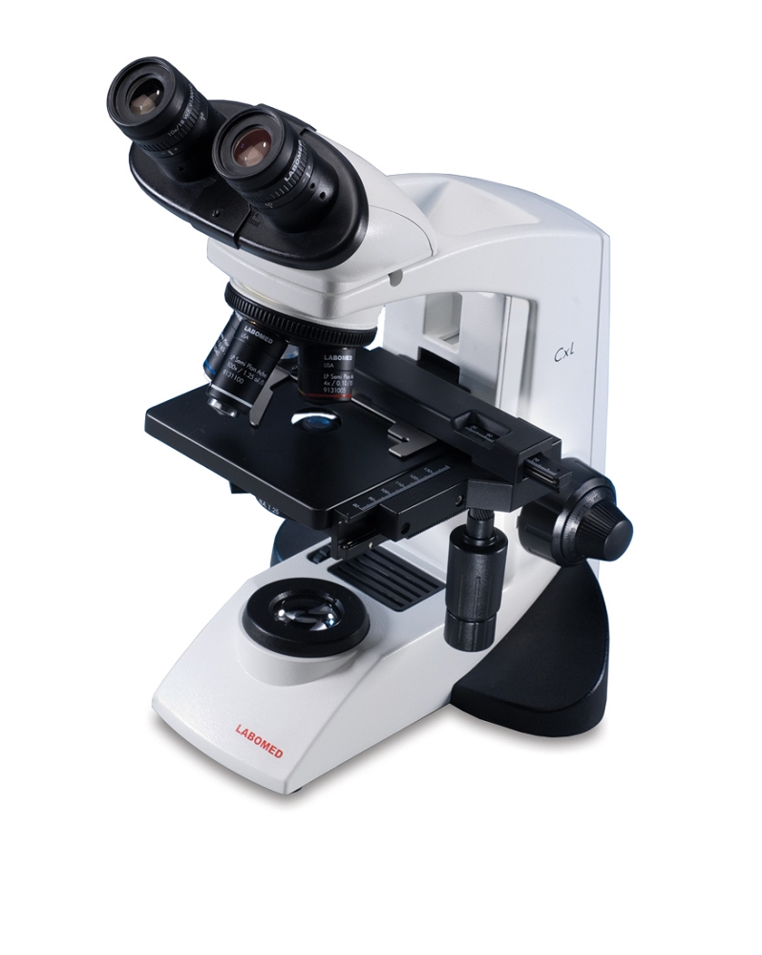

11

2

3

10

4

5

9

6

8

7

**Procedure 1 Materials:**

Compound light microscopes

Stereomicroscopes (2)

Prepared Microscope slides: Letter ‘e’

Wet Mount: Pond or creek water samples

Honeybee head in plastic

Pennies (2-3)

Wood sample

1. Examine the letter ‘e’ slide. **Draw** what you observe in the following spaces:

Letter ‘e’

4X 10X 40X

1. **Prepare a wet mount slide.** Take a clean microscope slide and a cover slip. Place one drop of your sample onto the clean microscope slide. Next, holding the coverslip perpendicular to the drop of sample, slowly lower the coverslip unto the sample until it is flat onto the slide. Make sure there are no air bubbles between the coverslip and slide. Your instructor will give a demonstration on how to perform this procedure. Draw what you observe in the following spaces:

*Water Sample*

4X 10X 40X

**Questions:**

**I.** **Based on your observations from the microscope specimens:**

1. At what magnification can you see the largest area on the slide?
2. At what magnification is the field of view the smallest?
3. Does the working distance increase or decrease as the magnification increases?
4. Does the light intensity increase or decrease as the magnification increases?
5. What happens to the image of the object as you observe it through the eyepiece?

**II. Calculate the following**

Power Magnification of Magnification of Total

Ocular Objective Magnification

Low X =

Medium X =

High X =

1. Using the **stereomicroscope (dissecting scope)**, look at the various available items: honeybee head, penny, and piece of wood.

**Choose at least two items for viewing on the stereomicroscope and draw each in the boxes below. Try “zooming” in and out on the objects to observe the changes and the level of detail you can see.**

**Procedure 2 Materials:**

Pen/Pencil

Textbook (be sure to bring this to lab)

Ruler (large)

Beakers: 150 ml, (2) 250 ml, 600ml

Graduated cylinder: 100ml

Erlenmeyer flasks: 100ml

Water

Methanol

Salt

Hot plate

**Intro:**

Scientific measurements are always in the **metric** system units. The advantage of this system is that conversions can be made from one unit to another by multiplying or dividing by multiples of 10. The standard for length is the meter and for volume it is the liter (**L**). The standard unit of mass is the gram (**g**). However, this unit is so small that the kilogram (**kg**) is often used.

**Procedures:**

1. Using a ruler, measure the width of your textbook using metric units. What is the width of your book in:

**Millimeters (mm): ______**

**Centimeters (cm): ______**

**Meters: ______**

2. Using the same ruler, measure the length of your pen or pencil: What is the length of your pen/pencil in:

**Millimeters (mm): ______**

**Centimeters (cm): ______**

**Meters: ______**

3. Take the 100 mL beaker. Fill the beaker to the 50 mL line with tap water. Then transfer the water to a graduated cylinder.

**Is the volume exactly 50 mL? ____ If not, what is the volume? __________**

4. Fill an Erlenmeyer flask to the 50 mL line with tap water. Next, transfer the water to a graduated cylinder.

**Is the volume exactly 50 mL? _____ If not, what is the volume? __________**

5. Place a weigh boat on the scale and then zero out the scale. Then weigh out **5 g** of NaCl onto the weigh boat. Add this NaCl to a beaker that contains **500 mL of water**. Gently mix the solution, while observing, until the NaCl has completely dissolved, then answer these questions:

**What is the solute? _____________**

**What is the solvent? _____________**

**What is the concentration of the solution in parts per thousand (ppt) (hint: g/L = ppt)?**

**What is the concentration of the solution in parts per million (ppm) (hint: mg/L = ppm)?**

1. Obtain two 250-mL beakers. Fill one beaker with **100 mL of water** and the other with **100 mL of methanol**. Place each beaker on a hot plate and record the temperature (**in Celsius**) at which each liquid **begins to boil**.

(**CAUTION:** do not let the beakers boil until completely empty)

**What was the boiling temperature for methanol? __________**

**What was the boiling temperature for water? ___________**

**Before your lab group can leave, your instructor must check off these 2 boxes:**

Your lab group table is wiped clean (**using spray Fabuloso cleanser**), all supplies or equipment are organized and back in place, and all glassware is clean and set upside down on paper towels to dry (**do this for ALL future labs**)

Your lab group microscopes are back in the “storage position”

* Stage is lowered all the way down using Coarse focus knob
* 4X objective is clicked into place
* Power cord is wrapped around the base
* Cover is on
* After check-off, microscopes are placed back into under-table cabinets

These same clean-up activities must happen at the end of ALL future labs before your Instructor will allow your lab group to leave.

MC900221937[1] **Questions to e x p a n d your mind**. MC900221937[1]

1. What are the benefits of a scanning electron microscope, transmitting electron microscope, and a light microscope? How are these scopes different from each other?
2. The United States does not use the metric system (we use the American Standard System). However, metric measurements are fairly common in the here. List three (3) places where you would encounter metric measurements of length, volume, or mass and examples of what would be labeled using these measurement units.
3. Americans are taught to measure in US Customary Units (Ex. Inches), while the rest of the world is taught the Metric system (or SI units). If you were to never leave the U.S. in your lifetime, could you get away with not learning anything about the metric system? Does career choice matter? Why or why not?