MCj03970480000[1]Name: ______________________________ Date: __________

**Gen Bio 1 Lab #2: Acids & Bases**

**Pre-lab reading assignment**  Pages 51-53 in Campbell 10th edition.

Watch the following for more information…

<https://www.youtube.com/watch?v=DupXDD87oHc>

<https://www.youtube.com/watch?v=C-8ubzn4BoM>

**Pre-lab vocabulary (must be complete before lab begins)**

1. acid-
2. base-
3. pH
4. neutral-
5. neutralize-
6. electrolytes-
7. buffer-
8. salt-

Solutions preview video: <https://www.youtube.com/watch?v=F2BRpFihX3M>

**Solutions review: group activity**

The concentration of a solute in a solution is generally expressed as percent (%) or molarity. **Molarity** defines the number of moles of a substance in a solution. A **mole** is a defined number of molecules of any substance (6.022 X 1023). Since we cannot measure molecules, we use the molecular weight of a substance instead. **Molecular weight** is the sum of the **atomic masses** of all of the atoms in a substance expressed in **grams**.

Example:

Molecular wt. of water H2O = the atomic mass of 2 Hydrogen atoms + 1 Oxygen atom.

The atomic mass of H is 1g and the atomic mass of O is 16g.

The molecular wt. of H2O then = 2 (1) + 16 = 18g

Molarity of solutions is always based on the amount you would put in 1 liter (1000 ml) of solvent. i.e.

A 1 molar (M) solution = 1 mole of a substance in 1 liter of water.

A 0.5 M solution = 0.5 mole of a substance in 1 liter of water.

**Problem 1: What is the molecular weight of 1 mole of NaCl where the atomic mass of Na = 23 and Cl = 35.4?**

­­­­­­­­­­­­­­­­­­­­­­­­­­­

**Problem 2:**

**a. How many grams of NaCl do you need to make 1 liter of a 1M NaCl solution?**

**b. How many grams of NaCl do you need to make 1 liter of a 0.5 M NaCl solution?**

**c. How may grams of NaCl do you need to make 500 ml of a 1 M NaCl solution?**

**d. Convert 10 mM to Molar ________ and scientific notation _______.**

NOTE: 1 millimolar (mM) solution has 1 mMole of a substance in 1 liter of solution.

Thus, 1 mM = 0.001M or 10-3M (scientific notation)

***Objectives***

1. Compare pH of common solutions using pH papers and pH meters.

2. Define neutralization and demonstrate using common solutions.

3. Define buffer and show how buffers stabilize the pH of a liquid.

4. Measure the ability of commercial antacids to buffer the pH of a liquid.

**Acids & Bases**

One important application of molarity is measuring the concentration of hydrogen ions (H+) in a solution. pH (or whether the solution is acid, basic or neutral) is a convenient way of expressing the H+ concentration ([H+]). The pH of pure water is the standard by which all other solutions are compared, because it is neutral. Although very stable some water molecules dissociate into 2 ions:

H2O **↔** H+ + OH-

The concentration of H+ in pure water is 10-7 M.

How do we calculate pH?

pH = - log of [H+]

pH of water = - log of 10-7 M

= - (-7)

= 7

7.0 is considered a neutral pH. If the pH is lower than 7 the solution is an acid and if the solution has a pH higher than 7 it is a base. An **acid** can also be defined as a substance that donates H+ when dissolved in water. A **base** then is a substance that absorbs H+ or donates (OH-) when dissolved in water. The pH scale ranges from 1 (100 M) to 14 (10-14 M).

Here are the pH’s of some common substances:

**Measuring pH**

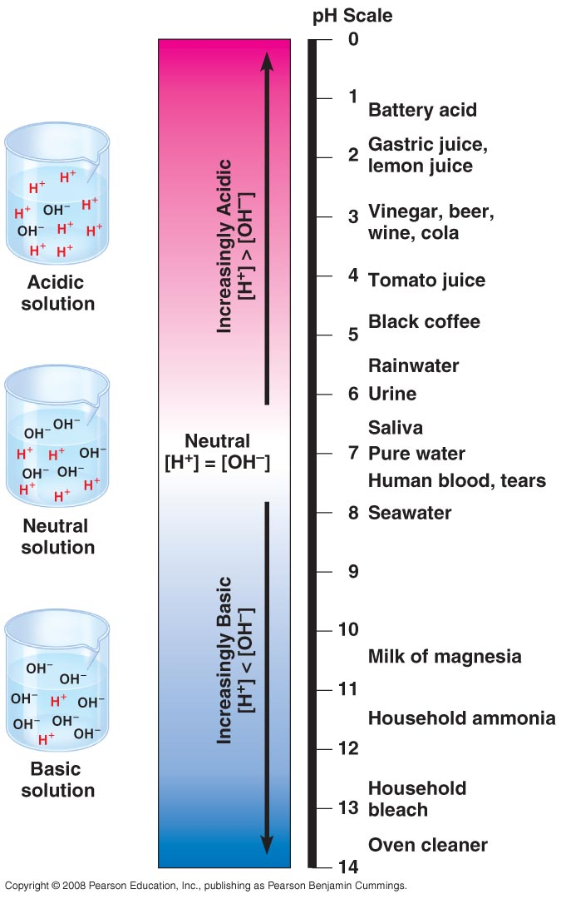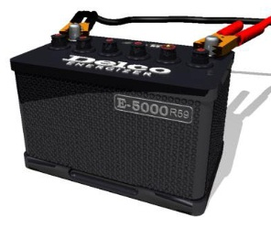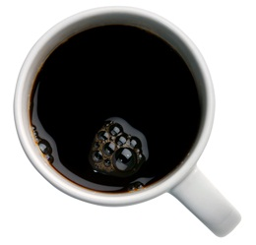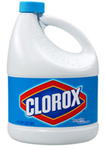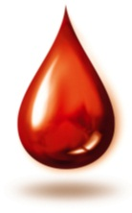

There are several methods used to measure pH, using indicator solutions, pH papers which are impregnated with indicators and pH electrodes. The pH electrodes are the most accurate but pH paper and indicators are a good estimate.

**Materials**

pH paper 10 ml of Coke + Windex

10 ml of distilled water 10 ml of NaOH

10 ml of tap water 10 ml of milk

10 ml of Coke Forceps

10 ml of Windex

**Procedure 1**

1. For each of the following solutions, predict the pH – weak acid, strong acid, weak base, strong base, neutral.
2. Measure the pH of each solution using a **small** strip of pH paper. Using forceps, dip one end of the paper into the solution quickly and compare the color to the chart on the container.

**Table 1**

|  |  |  |
| --- | --- | --- |
| Solution | Predicted pH | pH measured with pH paper |
| Distilled water |  |  |
| Tap water |  |  |
| Milk |  |  |
| NaOH |  |  |
| Coke |  |  |
| Windex |  |  |
| Coke + Windex |  |  |

**Questions:**

**Why would you need to know the exact pH of a solution?**

**Neutralization:** If you combine equal quantities of equal concentrations of an acid and a base the pH will be neutral or 7.0. Why? Because the H+ from the acidic solution combines with the OH- from the basic solution to form HOH or H2O which is neutral.

**When you combined the Windex and Coke what happened to the pH?**

**Was it 7.0? Why or why not?**

**Procedure 2**

**Making Acid dilutions**

**Materials:**

4 medium test tubes—labeled 1M, 100mM, 10mM, 1mM

Distilled H2O

1M HCl

pH paper

**Procedure 2**

1. Measure the pH of 2 ml of 1M HCl in tube 1, & record it in the table below.
2. Make a 100mM solution of HCl by putting exactly 9 ml of H2O in test tube 2 and pipetting exactly 1 ml of 1 M HCl from test tube 1. Cover with parafilm, vortex, measure & record pH.
3. Make a 10 mM solution of HCl by putting exactly 9 ml of H2O in test tube 3 and pipetting exactly 1 ml of your 100mM HCl from test tube 2. Cover with parafilm, vortex, measure & record pH.
4. Make a 1 mM solution of HCl by putting exactly 9 ml of H2O in test tube 4 and pipetting exactly 1ml of 10 mM HCl from test tube 3. Cover with parafilm, vortex, measure & record pH.

**Visual Procedure 2**

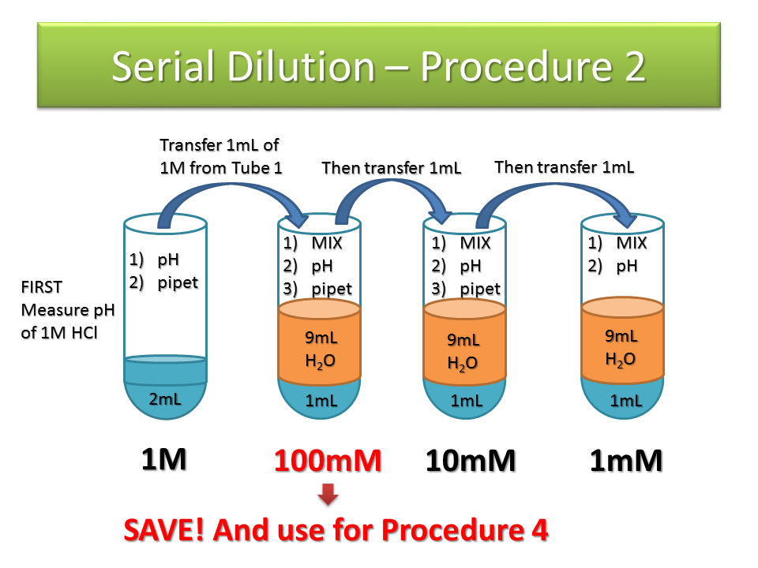

**Table 2**

|  |  |  |
| --- | --- | --- |
| **Solution** | **Predicted pH** | **pH measured with pH paper** |
| 1M HCl |  |  |
| 100mM HCl |  |  |
| 10mM HCl |  |  |
| 1 mM HCl |  |  |

**Question:**

**What would this technique be useful for in medical science? (Hint: toddlers)**

**Procedure 3**

**Buffers**

It is very important in living organisms that the pH of their solutions is kept within certain limits. For instance, in humans the pH of the blood must be within the range of 7.3 – 7.5. A blood pH outside this range may be fatal. Most biological solutions have buffers to maintain the pH within certain limits. Buffers can donate H+ when the pH is too high (basic) and absorb H+ when the pH is too low (acid) – within certain limits.

**Materials:**

4 medium test tubes

5 ml Distilled H2O

5 ml Milk

5 ml 0.1M (PO­4) Buffer

5 ml 0.1 M HCl

5 ml 0.1M NaCl

pH paper

**Procedure 3**

**Test the ability of buffers to stabilize pH.**

1. Label 4 medium sized test tubes as follows: water, NaCl, 2% milk, PO­­­­4.

2. Add 5 ml of each solution to the appropriate tube.

3. Measure the pH of each solution using the pH paper and record results on Table 3.

4. Add 5 drops of 0.1M HCl to each tube, mix, measure pH again and record in Table 3.

**Table 3**

|  |  |  |
| --- | --- | --- |
| **Solution** | **pH Before** | **pH After** |
| Distilled H2O |  |  |
| 0.1M NaCl |  |  |
| 2% Milk |  |  |
| 0.1M (PO­4) buffer |  |  |

**Questions:**

**Which solution showed the largest pH change?**

**Which solutions showed the smallest pH change?**

**Which solution is the best buffer? Why?**

**Procedure 4**

**Test the effectiveness of commercial antacids.**

Commercial antacids claim to neutralize stomach acid by absorbing excess H+ (from HCl produced by the stomach). Let’s investigate 4 antacids to see whether they are capable or not.

**Materials:**

4 Tall test tubes

5 ml of Alka-Seltzer

5 ml of Maalox

5 ml of Tums

5 ml of Rolaids

Bromcresol purple

**100 mM HCl made in Procedure 2**

**Procedure 4**

1. Label 4 tall test tubes as follows: Alka-Seltzer, Maalox, Tums, and Rolaids.
2. Pipet **5 ml** of each antacid solution - **STIR WELL BEFORE PIPETTING – into the appropriate tube.
3. Add **4 drops** of bromcresol purple into each tube and mix.
4. Add 100mM HCl 1 drop at a time into the tubes, and mix well. Do this until the solution turns from purple to yellow (this indicates it has transitioned to an acid). If single drops become tedious, increase to 5 or 10 drops at a time.
5. Record the number of drops you added to each tube to obtain a yellow solution in Table 4.

**Table 4**

|  |  |
| --- | --- |
| **Solution** | **Drops added** |
| Alka-SeltzerTM |  |
| MaaloxTM |  |
| TumsTM |  |
| RolaidsTM |  |

**Questions:**

**Which antacid is the most effective? Why?**

**Which is the least effective?**

**Read the labels for each antacid and record the active ingredients.**

**Alka Seltzer_____________________________________________________________________**

**Maalox_________________________________________________________________________**

**Tums___________________________________________________________________________**

**Rolaids_________________________________________________________________________**

MC900221937[1] **Questions to e x p a n d your mind.** MC900221937[1]

1. What are some “everyday applications” of pH and acidity?

2. Your stomach secretes hydrochloric acid (HCl) as a normal part of digestion. How would antacids “settle an upset stomach”? (look up online as well)

3. Of all the solutions you tested which pH surprised you the most and which the least? Why?

4. **INTERNET QUESTION** How does **Prilosec** **or** **Zantec** work? (Choose **1 medication**; Hint: They work differently from the other antacids used in our lab)