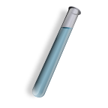Name: _____________________________ Date: _________

**Gen Bio 1 Lab #3: Biologically Important Molecules**

**Pre-lab reading assignment:** Pages 66-85 Campbell 10th edition.

**It is very helpful to print this lab in COLOR!**

**Pre-Lab Vocabulary:**

1. Monomer-
2. Polymer-
3. Negative control-
4. Positive Control-
5. Carbohydrate-
6. Lipid-
7. Protein-
8. Reducing sugar-
9. Benedict’s reagent-

**CARBOHYDRATES**

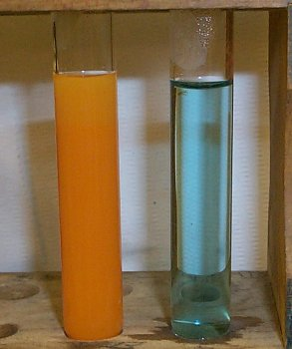**Procedure 1** Reducing Sugars:

**Benedict’s reagent** can be used to identify the presence of reducing sugars and is a good indicator for the presence of some carbohydrates. At a basic/alkaline pH (8-14) the copper ions (Cu2+) in Benedict’s reagent are *reduced* by the monosaccharide functional groups (i.e. -CHO or –C=O) to form cuprous oxide. In the Benedict’s test for reducing sugars, the Benedict’s reagent is reduced while the reducing sugar is oxidized. This redox reaction results in a tractable color change going from a **light blue** solution to a **green** or **reddish orange solution** with precipitation. The **intensity** of the color change is indicative of the **amount** of reducing sugar present. This is called a semi-quantitative test.

_________________________________________________________________________________________

**Benedict’s Solution Scale**

**Blue Green Orange Red Reddish-Brown**

**-- + ++ +++ ++++**

**_________________________________________________________________________________________**

**Materials**

•7 test tubes •1-250ml Beaker

•Pipette •Benedict’s Reagent  
•Hot Plate  
•*Water (what type of control is this?)*

•*Potato juice*

•*Sucrose*

•*Glucose*

•*Starch Solution*

•*Reducing Sugar (what type of control is this?)*

**Procedure 1** Examine Reducing Sugars:

1. Obtain six test tubes and label them 1 through 6 with wax pencil.
2. Add the test materials listed in **Table 1** to each of your tubes.
3. Half fill a 250mL beaker with water. Place it on the hot plate at your station and allow it to come to a gentle boil, designating 1 lab-group member as the “watcher”.
4. In the meantime, predict the color changes you expect to occur in each tube according to what you now know about carbohydrates from lecture and record them in **Table 1** in the “Benedict’s Test Results Expected (color)” column. Also, as indicated in the Materials list, mark which tube you think is the ***positive control*** and which is the ***negative control***.
5. Add **2mL** of Benedict’s reagent to each tube.
6. Place all 6 tubes in the gently boiling water bath for **3 minutes**, with the “watcher” doing their job of observing the tubes for any change in color, and for even but controlled boiling, during this time.
7. After **3 minutes**, remove the tubes with your test tube holder and allow them to cool to room temperature in the tube rack. Record the color of each tube in Table 1 in the “Benedict’s Test Results Observed (color)”column.

**Table 1:**

|  |  |  |  |
| --- | --- | --- | --- |
| **Tube #** | **Solution** | **Benedict’s Test Results** | |
| **Expected (color)** | **Observed (color)** |
| **1** | 10 drops potato juice |  |  |
| **2** | 10 drops sucrose |  |  |
| **3** | 10 drops glucose |  |  |
| **4** | 10 drops distilled water |  |  |
| **5** | 10 drops reducing sugar |  |  |
| **6** | 10 drops starch |  |  |

**Questions:**

1. **How do mono-, di- and polysaccharides differ?**
2. **Which of the solutions in Table 1 were your positive and negative controls? Explain.**
3. **How does the Benedict’s test work? What chemical reactions does it test for, and what does this have to do with carbohydrates?**

**Procedure 2 Starch:**

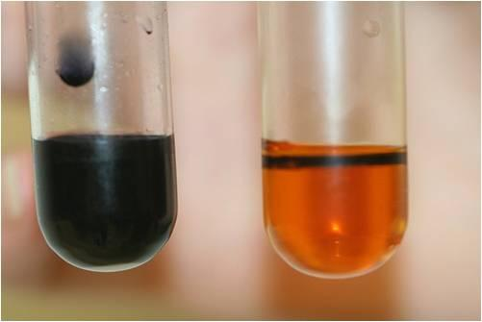Starch is a polysaccharide often used by organisms for storage of metabolic energy: glucose. Unlike the simpler mono- and disaccharides, starch is a structurally complex polymer. Iodine (iodine-potassium iodide, I2KI) reacts with the three-dimensional (3D) structure of this molecule, resulting in a color change (going from **yellow** to purple to **blue-black**) in a semi-quantitative manner.Using the substances previously examined for the presence of reducing sugars, we will test in this exercise for starch.

**Materials**

7 test tubes

Pipette

Water  **-- ++++**

Potato juice brown blue-black

Sucrose

Glucose

Reducing Sugar

Starch Solution

Iodine

**Procedure:**

1. Obtain six test tubes and label them 1 through 6.
2. Add the materials listed in **Table 2** to each of your tubes.
3. Predict the color changes you expect to occur in each tube and record them in **Table 2** in the “Iodine Test Results Expected (color)” column. Also mark which tube you think is the ***positive control*** and which is the ***negative control***.
4. Add **8 drops of iodine** to each tube.
5. Record the color of each tube in **Table 2** in the “Iodine Test Results Observed (color)” column.

**Table 2:**

|  |  |  |  |
| --- | --- | --- | --- |
| **Tube #** | **Solution** | **Iodine Test Results** | |
| **Expected (color)** | **Observed (color)** |
| **1** | 10 drops potato juice |  |  |
| **2** | 10 drops sucrose |  |  |
| **3** | 10 drops glucose |  |  |
| **4** | 10 drops distilled water |  |  |
| **5** | 10 drops reducing sugar |  |  |
| **6** | 10 drops starch |  |  |

**Questions**:

1. **What type of carbohydrate are you testing for when you use the Iodine test? Is this type of carbohydrate a mono-, di- or polysaccharide?**
2. **Which of the solutions in Table 2 were your positive and negative controls for starch detection? Explain.**

**PROTEIN**

Proteins are composed of amino acids covalently linked by peptide bonds. All amino acids contain an amino group (-NH2), a carboxyl group (-COOH), and a unique side chain (R-group) by which they are categorized. Peptide bonds (O=C-N-H) form when the amino group of one amino acid reacts with the carboxyl group of another. The Biuret reagent, regularly colored **blue**, is used to identify proteins. When the copper ions (Cu2+) in the reagent interact with peptide bonds, a **violet** color is produced. In order for the interaction between Cu2+ and the peptide bonds to result in a color change, a **minimum of 4-6 peptide bonds is required**. The *longer* the protein polypeptide chain, the ***greater*** the intensity of the reaction, thus this test is also semi-quantitative.

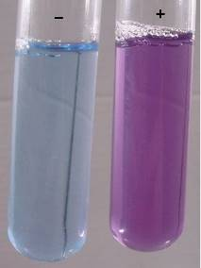

**Materials**

5 test tubes

Pipette

Water blue pink/purple violet   
Honey (polypeptide) (protein)

Amino Acid solution  **-- + ++++**

Egg Albumen

Protein Solution

**Procedure 3: Biuret test for protein**

1. Obtain 4 test tubes and label them 1-4.
2. Add the substances listed in **Table 3** to each test tube.
3. Predict the color changes you expect to occur in each tube and record them in Table 2 in the “Expected Results (color)” column. Also mark which tube you think is the ***positive control*** and which is the ***negative control***.
4. Add 2mL of 2.5% sodium hydroxide, followed by 3 drops of Biuret reagent, and mix.
5. Record the color of each tube in **Table 3** in the “Observed Results (color)” column.

**Table 3:**

|  |  |  |  |
| --- | --- | --- | --- |
| **Tube #** | **Solution** | **Expected Results (color)** | **Observed Results (color)** |
| **1** | 2mL egg albumen |  |  |
| **2** | 2mL amino acid solution |  |  |
| **3** | 2mL distilled water |  |  |
| **4** | 2mL protein solution |  |  |

**Questions**:

1. **What monomers comprise a polypeptide? What molecular structures indicate that a molecule is a protein?**
2. **Using the Biuret test, what would a positive and a negative result indicate? What makes this a semi-quantitative test?**

**LIPIDS**

Lipids, which include triglycerides (fats), steroids, waxes, and oils, vary in function. Similar to carbohydrates, fatty acids bond to glycerol with the input of energy and the formation of water. While triglycerides and oils serve as energy-storage molecules, phospholipids aggregate to form cellular membranes which are an important source of cholesterol, a necessary component of steroid hormones. All lipids share one characteristic; they are insoluble in water (i.e. **hydrophobic**) because they have a high proportion of non-polar carbon-hydrogen bonds and can only dissolve in non-polar solvents such as ether, ethanol and acetone. This property can be used to test unknown solutions for the presence of lipids.

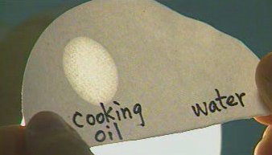

**Materials**

2 test tubes

Pipette

Water

Acetone

Vegetable oil

**Procedure 4: Lipids test #1**

1. Obtain two test tubes and label them 1 and 2.
2. In this exercise, you will assess the solubility of lipids in polar and non-polar solvents. Predict what you expect to occur in each tube and record your predictions in **Table 4** in the “Expected Results” column.
3. Add 1mL of vegetable oil to each tube followed by the solutions listed in **Table 4**.
4. Record your observations in **Table 4** in the “Observed Results” column.

**Table 4:**

|  |  |  |  |
| --- | --- | --- | --- |
| **Tube #** | **Solution** | **Expected Results** | **Observed Results** |
| **1** | 5mL water |  |  |
| **2** | 5mL acetone |  |  |

**Questions**:

* 1. **Can a lipid dissolve in water? Why or why not?**
  2. **How did this test incorporate what you know about a lipid’s structure and its solubility properties?**

**Materials**

Salad oil: both EVO and Olive oil

Fat-free and regular mayonnaise

Peanut butter

Honey

Known Lipid

Pipette

Brown paper squares

**Procedure 5: Lipids test #2**

1. Obtain squares of brown paper.
2. In this exercise, you will test whether each solution is a lipid. Predict what you expect to occur and record your predictions in **Table 5** in the “Expected Results” column.
3. Add 1 drop of each solution listed in **Table 5** to the brown paper. Then, label each spot with a pen or pencil so that you can keep track.
4. Hold the brown paper up to the light, and if the solution is a lipid, the area where the drop soaks in will be translucent (see-thru). If the solution is not a lipid, it will just look like wet brown paper.
5. Record your observations in **Table 5** in the “Observed Results” column.

**Table 5:**

|  |  |  |
| --- | --- | --- |
| **Brown paper spots** | **Expected Results** | **Observed Results** |
| **1 = Extra Virgin Olive oil** |  |  |
| **2 = Olive oil** |  |  |
| **3 = Honey** |  |  |
| **4 = Mayonnaise** |  |  |
| **5 = Fat free mayonnaise** |  |  |
| **6 = Peanut butter** |  |  |
| **4 = Known lipid** |  |  |

**Questions**:

1. **What observation indicates a positive test for lipids?**
2. **Lipids contain twice as many calories per gram compared to carbohydrates. Based on your test results, which has more calories, the salad oil or the honey?**
3. **Define emulsion and give an example.**

Description: MC900221937[1] **Questions to e x p a n d your mind.** Description: MC900221937[1]

1. What is the difference between the lipid content of the 2 mayonnaises. Why does this difference exist?
2. Why is the 3D structure for starch biologically important? What is it about this type of structure that we rely on for energy generation?
3. Would the Biuret reagent detect DNA or RNA? Why or why not?