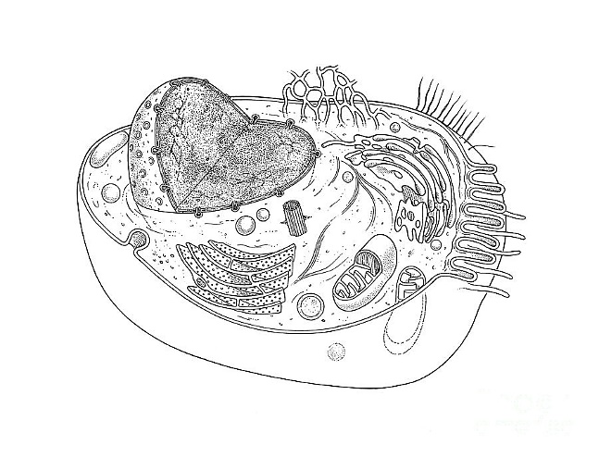**ame: _________________________________ Date: ___________**

**General Biology 1 Lab #4: Cells**

**Pre-lab Reading Assignment:** ALL of CHAPTER 6 in Campbell 10th ed.

Bring paper for taking notes; you will have a **lecture on Cells**.

Reading the Chapter will make this lab go so much faster.

Visit the following websites for help:

<http://www.biologyjunction.com/cell_functions.htm> <http://cellsalive.com/cells/3dcell.htm>

**Pre-lab Vocabulary:**

1. Prokaryote-
2. Eukaryote-
3. Endomembrane system-
4. Cytoplasmic streaming-
5. Plastids –
   1. Chromoplasts-
   2. Chloroplasts-
   3. Amyloplasts-
6. Pseudopods-

**Pre-lab exercise:** On the next page is a picture of a typical animal cell and a typical plant cell you need to **label** the cytoplasm, nucleus and ***all*** of the organelles found in each type of cell. Use **Figure 6.8** in your textbook as reference.

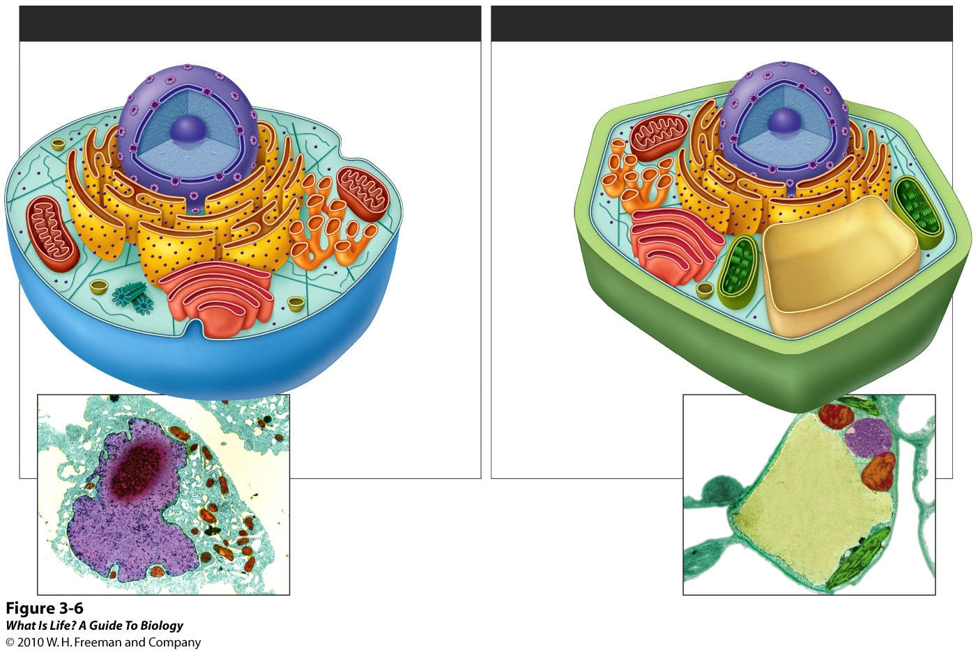

**Procedure: Plant Cells   
Materials**

|  |  |
| --- | --- |
| Microscope 2 microscope slides with coverslips razor blade  thinly sliced potato tip of water plant leaf | water methylene blue pipette |

**Procedure: Wet Mount of water plant**

1. Cut the tip off a water plant leaf.
2. Place a drop of water on a microscope slide.
3. Place the tip of water plant leaf in the water.
4. Place the coverslip on the leaf.
5. Observe the specimen under the microscope. **Remember**: **First** find water plant cells using 4X objective, **then change to 10X and focus and draw, then turn to 40X and draw**.
6. Draw a few water plant cells below, labeling the nucleus, cytoplasm, cell wall, and the chloroplasts.
7. Leave under the microscope for 20 minutes then check to see if you can observe cytoplasmic streaming. Label your drawing if you see this.

**Plant Cell _____magnification Plant Cell _____magnification**

**Procedure: Wet Mount of Potato**

1. Slice a very thin, super-duper thin, piece of potato, if you think it’s thin, slice again.
2. Place a drop of water on a microscope slide.
3. Place the wafer-thin piece of potato on the drop of water.
4. Place the coverslip on the potato—if it wobbles your slice is too thick–slice again. This is one time it is an example of “YOU CAN’T BE TOO THIN”
5. You need to stain the potato using iodine:
   1. Reason for iodine: it stains starch.
   2. Hint: add a drop of stain to the right side of the coverslip after you have placed it on the potato and let the color be drawn under the coverslip slowly.
6. Observe the specimen under the microscope. **Remember**: **First** find plant cells using 4X objective, **then change to 10X and focus, then turn to 40X and draw**. Draw a few potato cells below, label the nucleus, cytoplasm, cell wall, and amyloplasts.

**Procedure: Animal Cells**

**Materials**MicroscopeMicroscope slide and coverslip  
toothpick  
water  
methylene blue  
  
**Procedure: Wet Mount Human Cheek Cells**

1. Obtain a microscope slide and place a drop of water on the slide.
2. Gently scrape the toothpick on the inside of your cheek.
3. Swirl the end of the toothpick with cheek cells in the water, the more you swirl the more distributed the cells will be in the water.
4. Place the coverslip over your specimen.
5. You may want to stain the cheek cells with methylene blue (CAREFULL IT WILL STAIN DARK AND IT WILL STAIN EVERYTHING-biology students, book bags, lab instructors-who will get grouchy)
   1. Hint: add a drop of stain to the right side of the coverslip after you have placed it on the specimen and let the color be drawn under the coverslip slowly.
6. Observe the specimen under the microscope. **Remember**: **First** find water plant cells using 4X objective, **then change to 10X and focus, then turn to 40X and draw**. Draw a few cheek cells below, label the nucleus, cytoplasm, and plasma membrane.

**Procedure: Single Cell Eukaryotes   
Materials**Microscope  
Microscope slide and coverslip Prepared slide of Amoeba  
Pond water  
Protoslo®  
pipette

**Procedure: Prepared Amoeba Slide-look at atlas for pictures**

1. Obtain a prepared Amoeba slide.
2. **Remember**: **First** find water plant cells using 4X objective, **then change to 10X and focus, then turn to 40X and draw**.
3. Draw several Amoebas below labeling, nucleus, cytoplasm, and pseudopods.

**Procedure: Wet mount Paramecium from pond water—look at atlas for pictures**

1. Obtain a microscope slide, and place a drop of Protoslo® onto the center of your slide.
2. Using pipette, obtain a sample of pond water to look for paramecium, carefully from the sample jar.
3. Place the sample on the drop of Protoslo® and cover with a coverslip.
4. Observe under microscope: these are tiny unicellular organisms that even with Protoslo® will move around pretty fast.
5. **Note—If another lab group finds a paramecium and your lab group does not, ask to observe their sample.**
6. Draw a picture of a paramecium below and *observe (make notes) on their movements*.

**Procedure: Prokaryotes (Cyanobacteria)**

**Materials**Microscope  
Microscope slide and coverslip Prepared slide of *Gleocapsa* or *Anabaena*  
Prepared slide of *Oscillatoria*

**Procedure: Prepared *Gleocapsa* or *Anabaena* Slide-look at atlas for pictures**

1. Obtain a prepared *Gleocapsa* or *Anabaena* slide.
2. **Remember**: **First** find water plant cells using 4X objective, **then change to 10X and focus, then turn to 40X and draw**. Draw several *Gleocapsa* or *Anabaena* below labeling cytoplasm, and plasma membrane.

**Procedure: Prepared *Oscillatoria* Slide-look at atlas for pictures**

1. Obtain a prepared *Oscillatoria* slide. (These are tiny organisms that look like small blades of green grass)
2. **Remember**: **First** find water plant cells using 4X objective, **then change to 10X and focus, then turn to 40X and draw**. Draw several *Oscillatoria* below labeling cytoplasm, and plasma membrane.

MC900221937[1] **Questions to e x p a n d your mind.** MC900221937[1]

1. Why is methylene blue necessary to observe some of your samples?
2. The light microscope used in the lab is not powerful enough to view most organelles in the cheek cell. What parts of the cell were visible? If we had a transmission electron microscope, what organelles might we be able to see?
3. Our mouths are the first site of chemical digestion in humans. Digestive enzymes, like amylase, in saliva begin the process of breaking down the food you eat. Keeping this in mind, what organelle do you think would be most numerous inside the cells of your mouth? (**HINT: What organelle makes and secretes enzymes in our cells?**)
4. Compare and contrast plant and animal cells, mentioning at least 3 primary differences.