**Name: ____________________________________ Date: _______________**

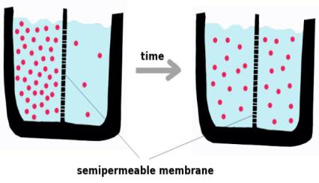 **Gen Bio 1 Lab #5: Diffusion and Osmosis**

**Pre-lab Reading Assignment: Pages 124-133 Campbell Biology 10th Edition. Watch the following videos before coming to lab.**

[**https://www.khanacademy.org/science/biology/cell-division/v/diffusion-and-osmosis**](https://www.khanacademy.org/science/biology/cell-division/v/diffusion-and-osmosis)

[**https://www.youtube.com/watch?v=GwYCr0VubNM**](https://www.youtube.com/watch?v=GwYCr0VubNM)

**Pre-lab Vocabulary:**

1. Diffusion-
2. Selective permeability-
3. Osmosis-
4. Hypotonic-
5. Hypertonic-
6. Isotonic-
7. Plasmolysis-
8. Crenated-

**Procedure: Simple Diffusion**

**Materials**

2-100 mL beakers

1-250 mL beaker  
tap water  
methylene blue  
hot plate  
ice

**Procedure: Simple Diffusion**

**Hot Setup**

1. Set your hotplate to **80°C**.
2. Fill both 100 ml beakers with 80 mL of **tap water**.
3. Place one 100ml beaker on the hot plate and warm to **80°C** (**be careful to avoid boiling**).

**Cold Setup**

1. Fill your 250ml beaker with **ice**, to about the 100ml mark.
2. Place the other 100ml beaker (with 80ml of water) into the 250ml beaker with ice. Pack ice around the 100ml beaker for even cooling.

**Let both the Hot and Cold setups sit for 5 min for temp adjustment**

1. Add ***1 drop of methylene blue*** into each 100 ml beaker of water.
2. Check on amount of blue diffusion **every 5 min** (for a total of 20 minutes) and estimate the **% of diffusion through the beaker (Ex: 0%, 50%, 100%)** in **Table 1 below**.

**Table 1 % Diffusion**

|  |  |  |  |  |
| --- | --- | --- | --- | --- |
| **Time** | **After 5 min** | **After 10 min** | **After 15 min** | **After 20 min** |
| Hot |  |  |  |  |
| Cold |  |  |  |  |

**The results of this experiment tell you what about temperature & diffusion?**

**Procedure: Osmosis-Dialysis tubing as “cell”**

**Materials needed per group**

Dialysis tubing (2 pieces about 10 cm in length)

String (4 pieces about 10 cm in length)

2- 100 mL beakers

tap water

syrup

starch solution

iodine

**Your lab group will only do Version A or Version B. Your lab instructor will tell you which version to do. You then need to find a group that did the other version, and record results from that group.**

**Procedure: Osmosis: Syrup and water-Version A**

1. Take a piece of dialysis tubing (it looks like plastic tape). Hold it under running water several minutes to soften it and roll it between your fingers until it opens in the shape of a tube.
2. Twist one end tightly. Fold the twisted part over and tie it tightly with string.
3. 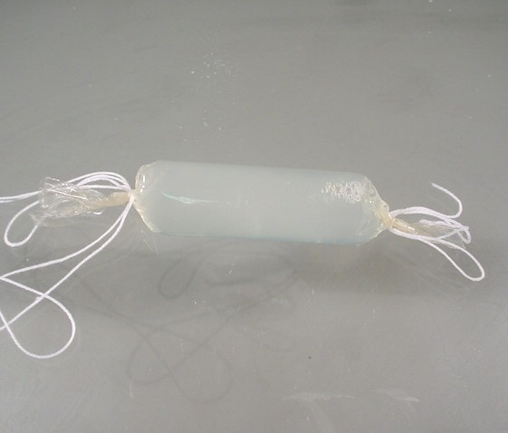Add about 4 cm of **tap water** to the “cell” you just made with dialysis tubing.
4. Twist the remaining end, fold it over, and tie it tightly with string.
5. The resulting “cell” should be **short, fat, and plump**… not long and skinny.
6. Let everyone in your group observe this “cell.”
7. Put 50 mL of syrup in 100-mL beaker. **\*\*recycle - keep for next lab\*\***
8. Drop the “cell” in the syrup.
9. **Wait 30 minutes** and observe your “cell”.

**Questions**

1. **What happened to the “cell”?**
2. **Why did this happen?**

**Procedure: Osmosis: Syrup and water-Version B**

1. Take a piece of dialysis tubing (it looks like plastic tape). Hold it under running water several minutes to soften it and roll it between your fingers until it opens in the shape of a tube.
2. Twist one end tightly. Fold the twisted part over and tie it tightly with string.
3. Add about 4 cm of **syrup** to the “cell” you just made with dialysis tubing.
4. Twist the remaining end, fold it over, and tie it tightly with string.
5. The resulting “cell” should be **long and skinny**… not short, fat and plump.
6. 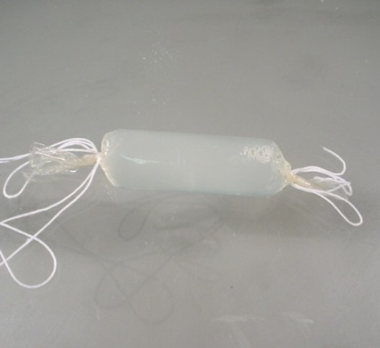Let everyone in your group observe this “cell.”
7. Put 50 mL of tap water in 100-mL beaker.
8. Drop the “cell” in the water.
9. **Wait 30 minutes** and observe your “cell”.

**Questions**

1. **What happened to the “cell”?**
2. **Why did this happen?**

**Procedure: Osmosis: Starch and Iodine All Groups do this.**

1. Take a piece of dialysis tubing (it looks like plastic tape). Hold it under running water several minutes to soften it and roll it between your fingers until it opens in the shape of a tube.
2. Twist one end tightly. Fold the twisted part over and tie it tightly with string.
3. Add about 4 cm of **starch solution** to the “cell” you just made with dialysis tubing.
4. Twist the remaining end, fold it over, and tie it tightly with string.
5. The resulting “cell” should be short, fat, and plump… not long and skinny.
6. Let everyone in your group observe this “cell.”
7. Put 50 ml of tap water in 100ml beaker.
8. Put **15-30 drops of iodine** in the tap water. **It should look like tea**. If it doesn’t then add more iodine, **stir to distribute**.
9. Put your “cell” full of starch solution in the iodine/water combination.
10. **Wait 30 minutes** and observe your cell.

**Questions**

1. **What happened to the “cell”?**
2. **Why did this happen?**

**Procedure: Osmosis: Sheep blood**

C:\Users\owner\Documents\Brazosport College\Spring 2013\Gen Bio 1 1406\Spring 2013 Lab documents\Spring 2013 Labs\Diffusion-Osmosis Blood Figure.tif**Materials**

Microscopes (2 per table)

3 slides and 3 coverslips

10% NaCl solution

0.9% NaCl solution

0% NaCl solution (pure water)

sheep’s blood

pipette

wax pencil

**Please refer to Figure 7.12 page 132 in your textbook for background reading.**

**Procedure: Osmosis: Sheep blood**

1. Label **3 microscope slides** (**10%, 0.9%, and 0%**) **with a wax pencil** to represent the three NaCl solutions.
2. For each slide, add NaCl solution drops and blood drops **as shown in the Figure above, placing the coverslip directly over the area of mixing**.
3. On the **10% slide**, place a very small drop of sheep’s blood.
   1. Right next to the blood place a large drop of 10% NaCl solution. Refer to the picture above
   2. Cover with a coverslip
4. On the **0.9% slide**, place a very small drop of sheep’s blood.
   1. Right next to the blood place a large drop of 0.9% NaCl solution. Refer to the picture above
   2. Cover with a coverslip
5. On the **0% slide**, place a very small drop of sheep’s blood.
   1. Right next to the blood place a large drop of 0% NaCl solution. Refer to the picture above
   2. Cover with a coverslip
6. Observe the shape of the red blood cells under the microscopes.
7. Fill in Table 2 below using the following terms:

**crenate**, **lysis**, **normal**, **hypertonic**, **hypotonic**, **isotonic**

**Table 2.**

|  |  |  |
| --- | --- | --- |
| Concentration of NaCl | What do the cells look like? | What is their tonicity? |
| 10% NaCl |  |  |
| 0.9% NaCl |  |  |
| 0% NaCl |  |  |

**Procedure: Osmosis: Plant plasmolysis**

**Materials**

microscope  
slide and coverslip  
*Anacharis* water plant in a beaker of tap water (***change tap water at the end of each day***)

DI water

30% NaCl solution

pipette  
scissors

**Procedure: Osmosis: Plant plasmolysis**

1. Cut the tip off an *Anacharis* leaf.
2. Place a drop of water on a microscope slide.
3. Place the tip of *Anacharis* leaf in the water.
4. Place the coverslip on the leaf.
5. Observe the specimen under the microscope, remember to find under the lowest power 1st and then change powers.
6. Draw a few *Anacharis* cells below.
7. After you have drawn the cells, place 1 large drop of 30% NaCl on your specimen.
8. Wait 5 minutes and observe the specimen under the microscope, remember to find under the lowest power 1st and then change powers.
9. Draw a few *Anacharis* cells after high NaCl treatment.

**Draw a picture of the *Anacharis* cells *BEFORE* you put 30% NaCl on them.**

**Draw a picture of the *Anacharis* cells AFTER you add 30% NaCl.**

**Questions**

1. **Why did the *Anacharis* cells plasmolyze when immersed in the hypertonic solution?**
2. **What do the results of this experiment tell you about the permeability of these plants’ cell membrane and cell wall?**

MC900221937[1] **Questions to e x p a n d your mind.** MC900221937[1]

1. What variables affect the rate of diffusion in biological systems?
2. Explain ***why*** a sailor lost at sea cannot drink saltwater.
3. If a medical technologist notes that many red blood cells are crenated, what could have caused this phenomenon?

1. **\*\*Online Search Opportunity\*\*** What is the difference between an osmoregulator and an osmoconformer? Give several examples of each.