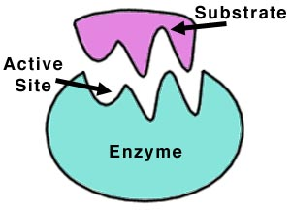Name: _________________________________ Date:_______________

**General Biology 1 Lab #6: Enzymes**

**Pre-Lab Reading assignment:** Chapter 8 Pages 151-161 Campbell Biology 10th Edition.

**Pre-Lab Online assignments:**

**Watch these 3 online videos before you go to lab:**

<https://www.youtube.com/watch?v=ok9esggzN18>

<https://www.youtube.com/watch?v=E-_r3omrnxw>

<https://www.youtube.com/watch?v=j00Ep0Byu0Y>

**Pre-lab Vocabulary:**

1. Enzyme:
2. Catalyze:
3. Catalase:
4. Energy of activation (EA):
5. Denature:
6. Substrate:
7. Active site:
8. Co-factor:
9. Rennin:

**Background:** Most chemical reactions are not spontaneous but require an input of energy to initiate the interaction of the molecules (reactants). This energy is called the **activation energy (EA)**. One example of activation energy is heating a reaction mixture to increase the rate at which the molecules collide with each other and then interact. The heat energy in this case is an example of activation energy. Enzymes are biological catalysts that function to speed up chemical reactions in living organisms. Enzymes work by decreasing the amount of activation energy needed to get a chemical reaction started. **Figure 1** demonstrates the activation energy required for a chemical reaction with and without an enzyme.

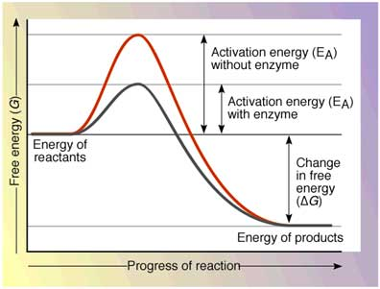**Figure 1: Progress of a reaction with and without activation energy**

Most enzymes are proteins that have a specific **tertiary structure** due to folding of the amino acid chain. This structure provides a region where the molecules (reactants) can bind and easily interact with each other. The binding region is called the **active site**. The shape of the active site allows only certain reactants to bind, i.e. the enzyme is **specific** for certain reactants and certain chemical reactions.

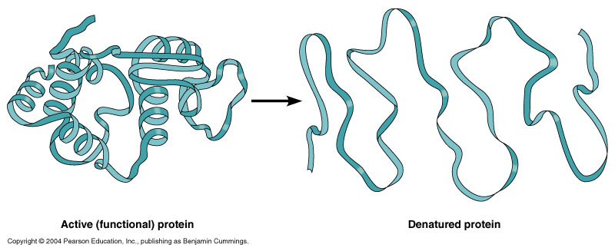Enzymes are complex proteins that act in a living organism’s closely controlled internal environment, where the temperature and pH remain within a rather narrow range. Extreme changes in the temperature or pH at which the enzyme is designed to act will cause a decrease or inhibition of enzyme activity. Changes in temperature and pH cause a change in the shape of the protein, or **denaturation** of the protein. When the structure of the protein in altered, the active site is altered and enzyme activity declines.

**Figure 2: Extreme conditions result in protein unfolding, or denaturation**

**Procedure 1: Effect of Temperature on Enzyme Activity**

In general, cold temperatures slow chemical reactions while warm temperatures speed up chemical reactions. Boiling, however, causes an enzyme to denature, meaning that it can no longer function.

In the experimental procedure that follows, you will be working with the enzyme rennin. **Rennin** is an enzyme found in the stomach lining of cows and newborn babies. Its main function is to solidify (or curdle) milk so that it remains in the stomach long enough to be digested by other protein-digesting enzymes. Commercially, rennin is used to make cheese and cottage cheese from animal milk, as well as tofu from soy milk.

**Materials**

3 test tubes

Pipettes

Cold Rennin

Rennin

Boiled Rennin

2% Milk

Ice Bath

Water bath set at 37°C

**Procedure 1: Effect of Temperature**

1. Predict what you will see in each of the 3 test tubes you will prepare (i.e. will/will not solidify).

2. Using your wax pencil label 3 test tubes with the numbers: 1, 2, and 3.

3. Add the following to each tube:

Tube #1: Add 3 ml of **cold** 2% milk and 3 drops of **cold** rennin (***both found on ice***).

Place this tube in the **ice bath tube rack**.

Tube #2: Add 3 ml of 2% milk and 3 drops of Rennin.

Place this tube in the **37o C water bath tube rack**.

Tube #3: Add 3 ml of 2% milk and 3 drops of **BOILED** rennin.

Place this tube in the **37o C water bath tube rack**.

*(NOTE: Your instructor has already boiled the rennin for you.)*

After 30 minutes, examine the tubes, and record and explain your results below.

**TABLE 1.**

|  |  |  |  |
| --- | --- | --- | --- |
| **Tube** | **Prediction** | **Results** | **Explanation** |
| #1 – **Cold** Rennin |  |  |  |
| #2 – Rennin |  |  |  |
| #3 – **Boiled** Rennin |  |  |  |

P**rocedure 2: Effect of Enzyme Concentration on Activity**

Enzyme activity is also affected by the concentration of the enzyme, the reactants, and the products. As the concentration of **reactants** or **enzyme** is increased, the ***rate*** of the reaction increases, up to a threshold. Conversely, if the concentration of products increases, the ***rate*** of the reaction generally *decreases*.

For this experiment, you will be testing the activity of catalase. Catalase is an enzyme found in all living organisms which speeds up the breakdown of hydrogen peroxide (H2O2), a toxic chemical, to non-toxic water and oxygen. Perhaps you have used hydrogen peroxide to clean a wound. What happens when you pour it on an open wound where skin cells have released their store of the enzyme catalase? The catalase reaction is as follows:

Catalase

H2O2 2 H2O + O2 (gas)

**Materials:**

3 Test tubes

Hydrogen peroxide (H2O2)

Sand

2 Potato cubes

Razor blade

**Procedure 2: Effect of enzyme concentration**

For this experiment you will use potato as a source of catalase. When the potato catalase reacts with hydrogen peroxide, oxygen is released and bubbling should occur. Use the following key to record catalase activity:

**Catalase Activity Key**

|  |  |
| --- | --- |
| **Result** | **Record** |
| No bubbling | 0 |
| Moderate bubbling | + |
| Good bubbling | ++ |
| Very good bubbling | +++ |

1. Predict what will happen in each test tube in the “Predicted” column.

2. Label 3 test tubes with the numbers 1, 2, and 3.

3. Add 4.5 ml of hydrogen peroxide to each tube.

4. Then add the following to each tube and observe the degree of bubbling.

Tube #1: Add a pinch of sand

Tube #2: Add a whole potato cube

Tube #3: Add a cube of potato that you have **diced** into small pieces.

5. Record your results (observations) below and explain these results based on the above Background.

**TABLE 2.**

|  |  |  |  |
| --- | --- | --- | --- |
| **Tube** | **Predicted Bubbling** | **Bubbling Observed** | **Explanation** |
| #1 – Sand |  |  |  |
| #2 – **Whole** Potato cube |  |  |  |
| #3 – **Diced** potato cube |  |  |  |

**Procedure 3: Effect of pH on Enzyme Activity**

Each enzyme has a pH at which the ***rate*** of the reaction is optimal. Higher or lower pH affects the hydrogen bonding and structure of the enzyme, directly altering the active site where substrate binds, and thus reduces or inhibits the enzyme’s activity or rate.

**CAUTION:** You will be using sulfuric acid (a strong acid) and sodium hydroxide (a strong base) for this experiment. Exercise care using these chemicals. If you spill these solutions on your skin, rinse immediately with water. If you spill these chemicals on the floor or table top, inform your instructor for clean-up.

**Materials:**

3 Test tubes

3 potato cubes

Sulfuric acid (H2SO4)

Sodium hydroxide (NaOH)

Hydrogen peroxide (H2O2)

Distilled water

Razor blade

**Procedure 3: Effect of pH**

You will again be using potato as a source of catalase. Predict the degree of bubbling for each tube below in Table 3.

1. Label 3 tubes with the number: 1, 2, and 3.

2. Add the following to the appropriate tube:

Tube # 1: Add 3 ml of distilled water and 1 **diced** potato cube.

Tube # 2: Add 3 ml of sulfuric acid (H2SO4) and 1 **diced** potato cube.

Tube #3: Add 3 ml of sodium hydroxide (NaOH) and 1 **diced** potato cube.

3. Wait 3 minutes and measure the pH of each tube with a small piece of pH paper.

4. Add 5 ml of hydrogen peroxide (H2O2) and observe the degree of bubbling.

5. Record your results in Table 3 using the Catalase Activity Key on the previous page, and explain your results based on the Background.

**Table 3**

|  |  |  |  |  |
| --- | --- | --- | --- | --- |
| **Tube** | **Predicted**  **Bubbling** | **Bubbling**  **Observed** | **Observed pH** | **Explanation** |
| #1-distilled water |  |  |  |  |
| #2-sulfuric acid |  |  |  |  |
| #3-sodium hydroxide |  |  |  |  |

**Online search opportunity: Explain why the potato changed color in only 1 of these tubes** *(Hint: sodium hydroxide is also called lye or caustic soda)*.

MC900221937[1] **Questions to e x p a n d your mind**. MC900221937[1]

1. Explain the Induced-Fit model of enzyme action, and how this differs from the ‘Lock-&-Key” model.
2. Distinguish between catabolic and anabolic enzyme reactions.
3. Define and describe 3 variables that may affect enzyme activity.
4. **\*\*Online Search Opportunity\*\*** What are the steps involved in commercial cheese making? Is this different from how organic farm cheese is made?