**Name: ______________________________ Date: ___________**

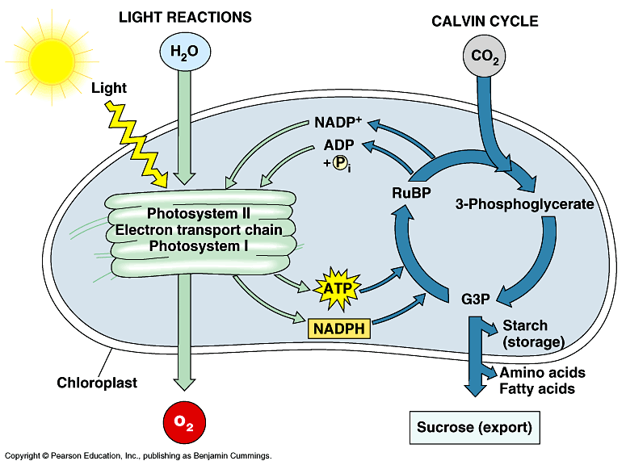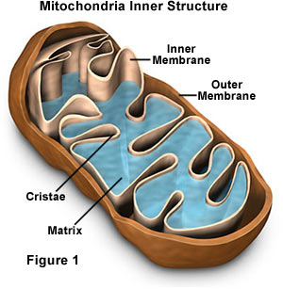**Gen Bio 1 Lab #7:**

**Cell Respiration & Photosynthesis**

**PRE-LAB**: Do all of the **Pre-lab Vocabulary**, **Pre-Lab Reading**, and **Pre-lab Activities** on **pages 1-2 and pages 6-7** before coming to lab.

**PRELAB VOCABULARY:**

1. Chemical reduction-
2. Chemical oxidation-
3. Glycolysis-
4. Formation of Acetyl CoA-
5. Krebs cycle (Citric Acid cycle)-
6. Electron Transport Chain-
7. Chemiosmosis-
8. Aerobic respiration-
9. Alcohol fermentation-

**PRE-LAB READING**

Cellular respiration is the process by which cells harvest the energy stored in the chemical bonds of complex molecules like glucose. They then convert this energy into **ATP**, **adenosine triphosphate**, the only source of energy that can be used to produce new compounds, transport materials into and out of the cell, etc.

Cellular respiration includes 3 series of chemical reactions: **Glycolysis**, **oxidation of pyruvate and the Kreb’s cycle**, and the reactions of the **electron transport chain**.

All cells use glycolysis, the oxidation of glucose into pyruvate. This series of reactions produces 2 new ATP molecules and 2 **NADH** (reducing power) for each glucose molecule oxidized.

In aerobes, organisms that require oxygen to survive, pyruvate is oxidized to an acetyl group and fed into the Krebs cycle where the remainder of the glucose molecule is broken down. These reactions produce 2 more ATP molecules, 10 **NADH** and 2 **FADH2**. The NADH and FADH2 then release the electron and H+ into the electron transport chain where their energy is harvested and used to produce a large amount of ATP. The by-products include **CO2 and H2O**.

Some organisms are anaerobes, cannot survive in and oxygen rich environment, and are only capable of glycolysis. In order to continue to produce ATP, they must remove the electrons and H+ from NADH and convert pyruvate to another molecule. The process used is called **fermentation**. In yeast and some bacteria, fermentation of pyruvate produces **ethanol and CO2**. This process is used to make bread rise and to produce alcoholic beverages, etc. In other bacteria and in animal cells, the pyruvate is converted to **lactic acid**. Both pathways regenerate NAD+ so that glycolysis can continue.

**PRE-LAB ACTIVITY**

**Write the sequence of reactions for glycolysis beginning with glucose and ending with pyruvate (see pp 168-169), enzyme names not required.**

***Section B:* Photosynthesis**

**PRE-LAB:** Do all Pre-lab vocabulary, reading, and activities (on next page) before you come to lab.

**PRE-LAB VOCABULARY**

1. Photosynthesis:
2. Chloroplast:
3. Pigment:
4. Chlorophyll:
5. Light-Dependent Reactions:
6. Light-Independent Reactions (Calvin Cycle):
7. Spectrophotometer:

**PRE-LAB READING: Figures 10-8, 10-12, 10-13, 10-14, and 10-19 in text.**

Photosynthesis is the process used by plants to convert our waste product, CO2, and water into sugars. To do this they capture light energy from the sun and convert it into **ATP and “reducing power”** – energized electrons and their H+ carried by **NADP**. This step also produces O2 as a waste product. The reactions are collectively called the “light-dependent reactions”. The ATP and NADPH are then used to reduce CO2 to form **glyceraldehyde 3-phosphate (G3P)** which is ultimately used to produce glucose. The series of reactions that produce G3P are collectively called the light independent reactions or the Calvin Cycle.

**Identification of photosynthetic pigments.** Chlorophyll *a* and *b* plus other pigments, the xanthophylls and carotenes, capture light energy from the sun and convert it to ATP. Each pigment absorbs certain wavelengths of light and reflects the rest. What we see is the reflected light which will have a certain color. In this lab you are going to determine the wavelengths of light that spinach leaf pigments absorb and in the process identify the different pigments in spinach leaves. An extract of pigments will be made by blending spinach leaves with acetone.

**PRE-LAB ASSIGNMENT**

**Label** the two following figures from your textbook:

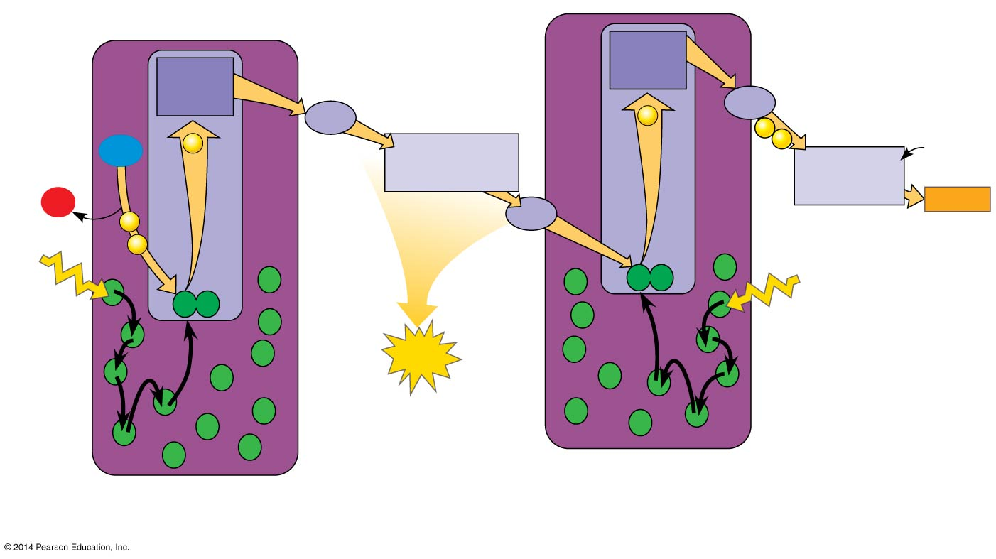

Light Dependent reactions

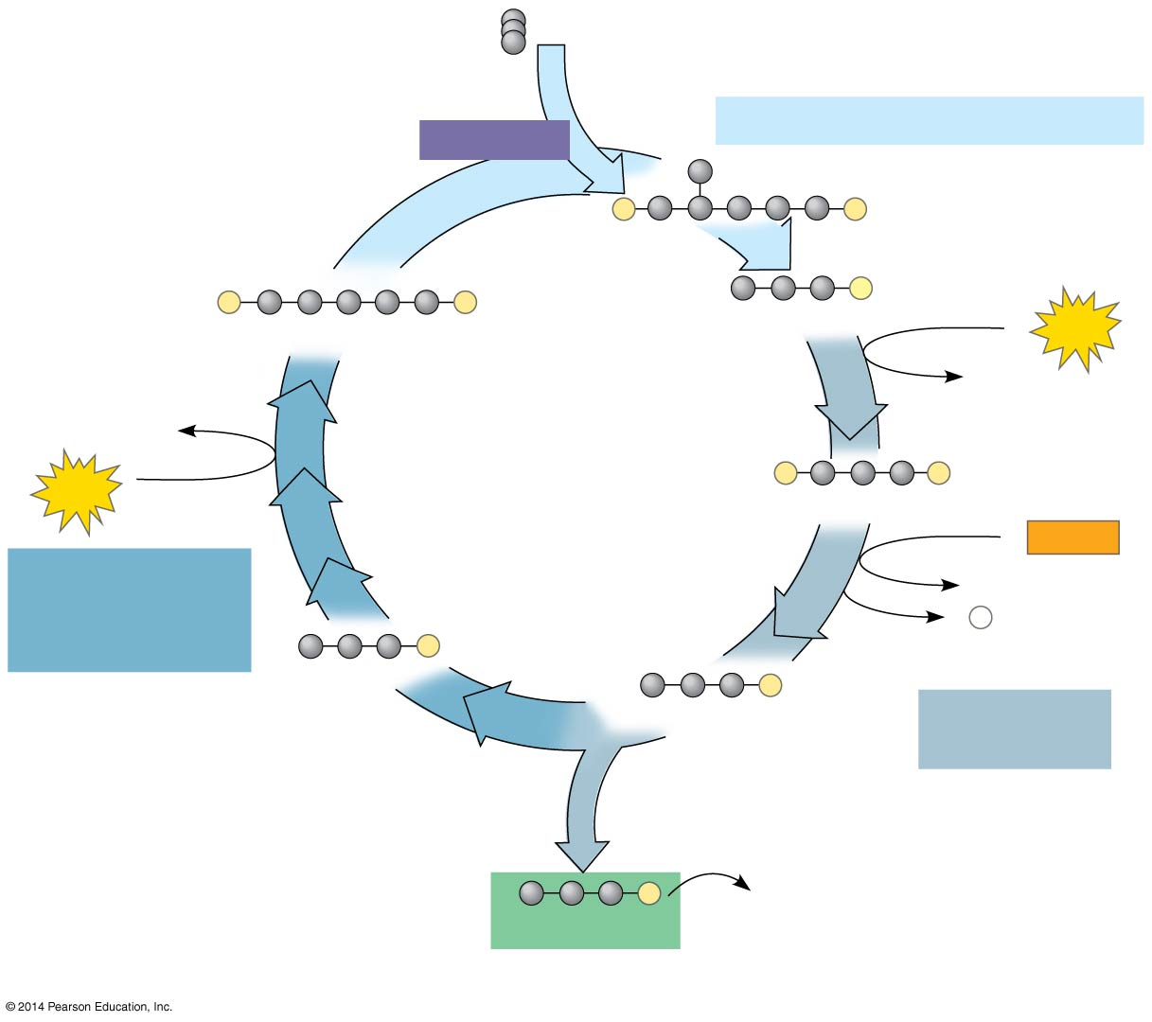

Light Independent Reactions (Calvin Cycle)

**Cell Respiration Procedure 1: Effect of CO2 on the pH indicator, phenol red.**

1. Obtain a cup with phenol red solution and a straw.

2. Blow through the straw until you see a color change in the phenol red.

***Note phenol red is a pH indicator that turns from red to yellow as the solution becomes acid.

**Questions:**

**What color did it change to?**

**What gases do you exhale?**

So why did this happen? Well….

When CO2 combines with water the following reaction takes place:

**CO2 + H2O ↔ H2CO3 (carbonic acid) ↔ H+ + HCO3-** (H+ makes the solution acidic)

Blood buffer system

**Cell Respiration Procedure 2: Fermentation grape juice.**

Examine the Erlenmeyer flask with grape juice and yeast suspension.

**Questions:**

**Why are there bubbles in only 1 of the flasks?**

**How do the bubbles help us explain what has happened to the phenol red solution?**

**Cell Respiration Procedure 3: Using Tetrazolium Chloride to see Evidence of Electron Transport Chain**

* The chemical Tetrazolium chloride has long been used to determine if a seed embryo is alive and therefore respiring.
* The oxidation-reduction reactions occurring in the electron transport system in the mitochondria can be detected using dyes that change color when reduced. One such dye is tetrazolium (2,3,5-triphenyl tetrazolium chloride). Cytochromes will transfer electrons to tetrazolium in the electron transport system as well as to oxygen.
* Oxidized tetrazolium is colorless. Reduced tetrazolium is bright pink to red in color. If the electron transport system is functioning in viable mitochondria, a tetrazolium solution will turn pink or red.
* You will test viability in corn by checking to see if the electron transport systems in their mitochondria are doing cell respiration.
* You will be using two different types of seeds, corn seeds and beans. One group of each type has been boiled to kill the seeds. The other group has been soaked for 24 hours to initiate the germination process.

**Materials**

Plastic petri plate

Razor blade

1 boiled bean

1 normal bean

4 drops of Tetrazolium chloride (Your instructor will have 0.1% tetrazolium chloride prepared in PBS pH7.4)

**Cell Respiration 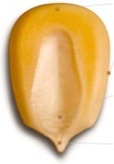Procedure 3: Electron Transport Chain**

1. On your plastic petri plate draw a line down the center.
2. On one side of the line mark normal.
3. On the other side mark boiled.
4. Get one kernel of corn from each bag
5. Cut the kernel of corn using the razor blade. Make sure to cut it in half into right and left halves, use the cutting image on the right as a guide.
6. Place several drops of Tetrazolium chloride on each side of the petri plate.
7. Using forceps, place the corn cut side down into the drops.
8. 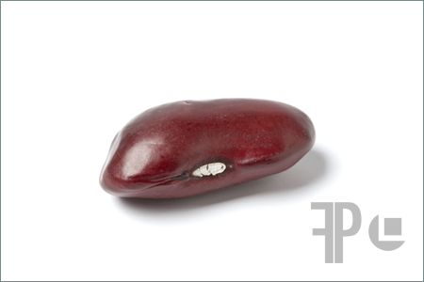Repeat steps 1-7 for your beans. (note-the cutting image on the right for bean is different)
9. Let sit for 15 minutes.
10. Pick up the petri plate and observe the underside of the

kernel and bean to see the staining results.

**CAUTION: DO NOT ALLOW** Tetrazolium chloride to splash on your skin.

**Questions:**

**How does Tetrazolium chloride staining work?**

**Which seeds have a pink-stained embryo?**

**What does the pink stain indicate is happening in the embryo?**

**Germinating seeds have a higher rate of respiration than adult plants. Why?**

**Photosynthesis Procedure 1: Using a spectrophotometer to measure absorbance of light by spinach leaf pigments (*See Fig. 10.9 in your textbook*)**

1. Obtain 2 test tubes and add 10 ml of acetone to each tube.

2. To **one** of these tubes add 10 drops of the pigment extract, cover with parafilm and invert to mix. This is your spinach pigment extract dilution.

3. Obtain 2 of the special tubes that are used in the spectrophotometer (called cuvettes) and pour the plain acetone into one – this is your “blank” you will use to ‘zero’ the machine. Pour your pigment extract dilution into the other tube.

4. Wipe all liquid, fingerprints, dust particles, etc. from the cuvettes with **lens paper** and when it is your turn read the absorbance of your extract using the spectrophotometer.

5. Check with your instructor to make sure that the spectrophotometer has been on for 15 minutes before use. Set the read out to **Transmittance (100%T)** using the following labeled diagram.

6. Set the first wavelength (**380nm**) and set the filter control lever to 340-599nm reading (left). Adjust the Transmittance reading to 0 using the Power/Zero control Knob (front left). Switch the read out to **Absorbance (OA)**.

7. Insert your Blank cuvette (acetone) and align the vertical line with the mark on the sample compartment.



8. Adjust the reading to 0 using the Transmittance/Absorbance knob (front right).

9. Remove the blank and insert your spinach pigment dilution.

10. Record your results in **Table 1**.

11. We are dividing up the absorbance readings by group. Each group will be reading at 2-4 wavelengths, depending on the total lab size. Your instructor will write a table up on the board, or just tell you, which wavelengths are assigned to your group. We will combine our data together to create a lab Table 1, which all of you will use for graphing.

12. **Repeat steps 7-10 for each wavelength assigned to your group.**

**\*\*\*When you measure absorbance at 600 nm and above flip the filter lever to the right\*\***

12. Graph your results using the graph paper provided and compare to the graph of common plant pigments to determine which ones are present in spinach. Label the x-axis Wavelength (nm) and the y-axis Absorbance. Make the long side of the paper the X-axis and spread out your results. Or to make it nice and snazzy use Excel and create a graph. Lab Instructors like nice and snazzy.

**TABLE 1 Absorbance vs. Wavelength**

|  |  |
| --- | --- |
| **Wavelength (nm)** | **Absorbance** |
| 380 |  |
| 400 |  |
| 420 |  |
| 440 |  |
| 460 |  |
| 480 |  |
| 500 |  |
| 520 |  |
| 540 |  |
| 560 |  |
| 580 |  |
| **CHANGE FILTER!!!** | **FLIP LEVER TO RIGHT!!!** |
| 600 |  |
| 620 |  |
| 640 |  |
| 660 |  |
| 680 |  |
| 700 |  |

**You need to graph your results** – **Refer to the chart at your table to figure out which pigments you have**. If you have a “hump” where chlorophyll *a* is supposed to be, then you have chlorophyll a.

**Questions:**

**Which pigments did you find in your extract?**

**Why do spinach leaves appear green?**

**Photosynthesis Procedure 2: Determining amount of starch storage in variegated coleus plant leaves using iodine staining**

When leafy plants are making a large amount of glucose, they store this glucose as starch in their chloroplasts. Other plants, like potatoes, store glucose as starch in specialized tuber structures, in amyloplasts. The production of sugars requires photosynthesis and photosynthesis only occurs in the presence of light. Additionally, photosynthesis requires chlorophyll a. If this is not present in the leaf or parts of the leaf, there will be no starch storage. You will test several leaves and determine starch storage using iodine.

**\* What happens when you add iodine to starch?**

1. Obtain a leaf from the following:

a. Variegated coleus with purple and green leaves grown in the light.

b. Variegated coleus with purple and green leaves grown in the dark.

2. Boil each leaf in water for 2 minutes. This removes water-soluble pigments.

3. Boil each leaf in methanol for 5 minutes or until the color fades. This removes the lipid soluble pigments.

**\*\* BE CAREFUL WITH THE METHANOL – BOIL AT LOWER TEMPERATURE AND DO NOT ALLOW THE BEAKER TO BOIL DRY. Save your used methanol. \*\***

4. Transfer the leaves to a petri dish and cover each leaf with iodine.

5. Draw the leaves showing the intensity of the iodine staining.

6. Explain your results.

**TABLE 2 Starch determination in leaves**

|  |  |  |
| --- | --- | --- |
| **Leaf** | **Intensity and location of staining** | **Explanation** |
| Purple/green coleus in light |  |  |
| Purple/green coleus in dark |  |  |

**Leaf drawings:**

**Photosynthesis Procedure 3:** Using your leftover methanol in its beaker (with the lab lights out – wait for instructor to indicate when this occurs) use a powerful flashlight to shine into the base of the beaker. **Can you see colored areas or flashes? What colors do you see?** This is due to fluorescence which occurs when an energized electron falls back into it original electron shell. The energy released is in the form of heat and light (fluorescence).

MC900221937[1]**Questions to e x p a n d your mind.** MC900221937[1]

1. **Compare and contrast** anaerobic and aerobic respiration. Include an account of the number of ATP molecules produced in each reaction.

2. **Describe** the light-dependent and light-independent reactions of photosynthesis.

3. **Discuss** the role of pigments in photosynthesis. And what are **several products** of photosynthesis that are important to humans.

**\*\*\*Online search opportunity\*\*\*** What is Diabetes Mellitus Type 2, how does it develop in humans, and what role does diet play in its development?