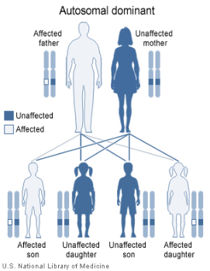**Gen Bio 1 Lab #8: Mendelian Genetics**

**Pre-Lab Reading:** Pages 270-285 in the 10th edition of Campbell Biology

**Pre-Lab Vocabulary:**

1. Gene -
2. [Allele](http://www2.estrellamountain.edu/faculty/farabee/biobk/BioBookglossA.html#alleles) -
3. [Homozygous](http://www2.estrellamountain.edu/faculty/farabee/biobk/BioBookglossH.html#homozygous) -
4. [Heterozygous](http://www2.estrellamountain.edu/faculty/farabee/biobk/BioBookglossH.html#heterozygous) -
5. [Dominant](http://www2.estrellamountain.edu/faculty/farabee/biobk/BioBookglossD.html#dominant) -
6. [Recessive](http://www2.estrellamountain.edu/faculty/farabee/biobk/BioBookglossR.html#recessive) -
7. [Phenotype](http://www2.estrellamountain.edu/faculty/farabee/biobk/BioBookglossPQ.html#phenotype) –
8. [Genotype](http://www2.estrellamountain.edu/faculty/farabee/biobk/BioBookglossG.html#genotype) -
9. [Punnett squares](http://www2.estrellamountain.edu/faculty/farabee/biobk/BioBookgenintro.html#Punnett squares) –
10. Monohybrid cross
11. Dihybrid cross-
12. Gametes -

**Procedure 1: Modeling Genetic Inheritance Probability by Coin Toss**

In heredity, we are concerned with the occurrence, every time an egg is fertilized, of the probability that a particular gene or chromosome will be passed on through the egg or the sperm gametes, to the offspring. Recall that genes on maternal and paternal chromosomes are present in pairs in each individual, and that maternal and paternal chromosomes segregate as gametes (egg and sperm) are produced by Meiosis. Therefore, it is equally likely that our secondary eggs or sperm will receive either the maternal or paternal chromosomes we inherited with modification from our parents. If the probability of getting either one is equal, this probability can be expressed as ½, like the probability of getting heads or tails when you flip a penny. While we can examine the genes in a sperm or egg through genomic sequencing to determine our genotype, phenotype characteristics and traits can only be observed once fertilization has occurred and a new individual has been produced and allowed to develop according to their unique gene expression patterns. So in reality, we are faced with 2 distinct probabilities: ½ probability that a modified maternal or paternal gene will be given to each gamete, and ¼ probability that 1 of the 4 gametes produced by each germ cell will be the gamete fusing at fertilization of the zygote.

**Materials**

2 pennies

**Procedure 1:**

1. Use 2 pennies. One penny represents a pair of genes in one parent (ex. Maternal). The other penny represents the same pair of genes on the other parent (ex. Paternal).

P= head = dominant gene (purple)

p = tail = recessive gene (white)

2. Both parents are heterozygous (Pp)

a. Pp= the pair of genes in one parent

b. Pp= the other pair of genes in other parent.

3. Complete the Punnett Square below for the resulting offspring of Pp X Pp. Record the results as a percentage in the **Expected Probability** column on **Table 1**.

**P** p

|  |  |
| --- | --- |
|  |  |
|  |  |

**P**

p

4. For our coin-toss experiment, heads will represent P the allele and tails will represent the p allele. Toss the coins together a total of 50 times, recording the toss results in the Coin Toss Tally column.

5. Determine the percentage for each genotype (Ex. # of PP tosses/50) and record under **Actual Probability** on **Table 1**.

**TABLE 1**

|  |  |  |
| --- | --- | --- |
| **Coin Toss Tally** | **Expected Probability** | **Actual Probability** |
| (Heads Heads) **PP** |  |  |
| (Heads Tails) **Pp** |  |  |
| (Tails Tails) **pp** |  |  |

**QUESTIONS:**

1. **How close did your actual results come to your expected results? What caused the difference?**
2. **Do the percentage of actual PP, Pp, and pp probabilities you recorded match the ratio Mendel predicted? Why do you think this is?**

**Procedure 2: Genetic Traits in Humans**

This is an activity to observe actual genetic traits in humans. Each phenotype will be represented by a genotype letter. We will look first at ourselves, and then our lab class as a whole, to see if dominant traits are indeed always seen at a higher percentage in a population.

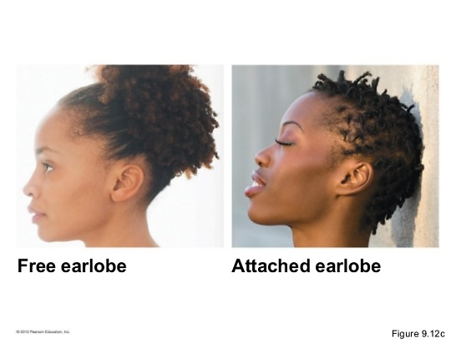**Earlobes:** Free ear lobes (**dominant trait**) vs. Attached ear lobes (**recessive trait**).   
Free earlobes are those that hang below the point of attachment to the head.  Attached ear lobes are attached directly to the side of the head.

|  |  |  |
| --- | --- | --- |
| **Earlobes** | **Phenotype** | **Possible Genotypes** |
| You |  |  |
| Class |  |  |

|  |  |  |
| --- | --- | --- |
| **Widow’s Peak** | **Phenotype** | **Possible Genotypes** |
| You |  |  |
| Class |  |  |

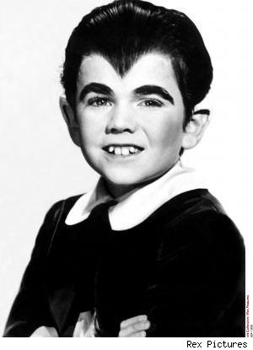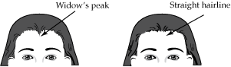A **widow's peak** hairline is dominant over a no widow's peak hairline.

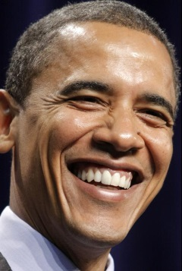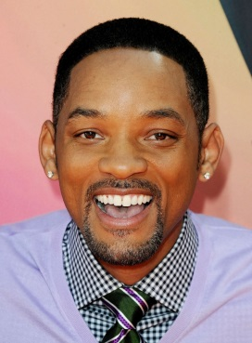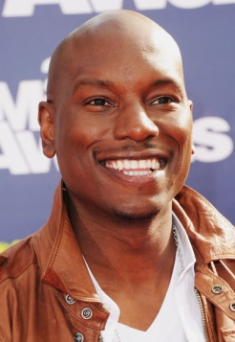**Dimples and Cleft Chin:** Dimples (**dominant trait**) vs. no dimples (**recessive trait**)   
Dimples are natural dents in the face to the right or left of the mouth.  If a person has **only one dimple**, they should be counted as having dimples. Cleft chin is **dominant** over no cleft.

|  |  |  |
| --- | --- | --- |
| **Dimples** | **Phenotype** | **Possible Genotypes** |
| You |  |  |
| Class |  |  |

|  |  |  |
| --- | --- | --- |
| **Cleft Chin** | **Phenotype** | **Possible Genotypes** |
| You |  |  |
| Class |  |  |

|  |  |  |
| --- | --- | --- |
| **Hitchhikers Thumb** | **Phenotype** | **Possible Genotypes** |
| You |  |  |
| Class |  |  |

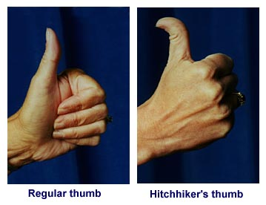**Hitchhiker Thumbs:** Straight thumb (**dominant trait**) vs. curved thumb (**recessive trait**) When viewed from the side as in the illustration below, curved thumbs can be seen as part of a circle.

**Pinky:** Straight pinky (**recessive trait**) vs. bent pinky (**dominant trait**)

|  |  |  |
| --- | --- | --- |
| **Pinky** | **Phenotype** | **Possible Genotypes** |
| You |  |  |
| Class |  |  |

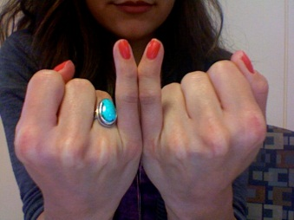

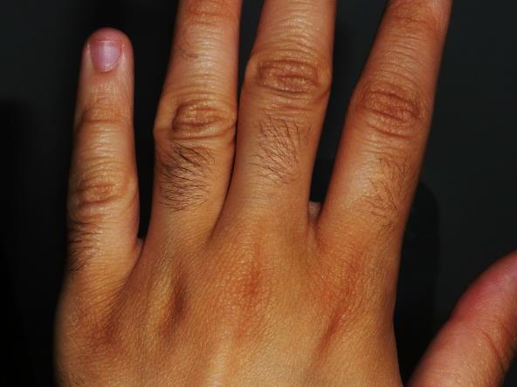**Mid-digit hair:** Mid-digit hair (**dominant trait**) vs. No mid-digit hair (**recessive trait**)

|  |  |  |
| --- | --- | --- |
| **Mid-digital hair** | **Phenotype** | **Possible Genotypes** |
| You |  |  |
| Class |  |  |

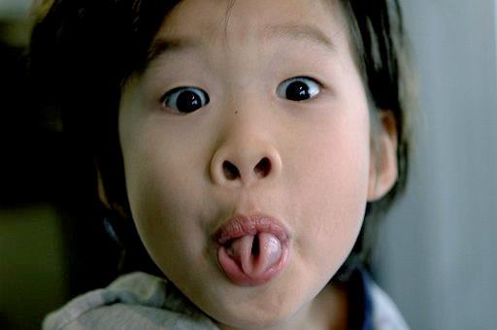Tongue-Rolling: Rolling up edges (**dominant trait**) vs. not rolling (**recessive**)

|  |  |  |
| --- | --- | --- |
| **Tongue-Rolling** | **Phenotype** | **Possible Genotypes** |
| You |  |  |
| Class |  |  |

**Procedure 3: Corn problem - Monohybrid cross**

A monohybrid cross begins with experimental breeding between two parental plants that “breed true” for different forms of a single trait. The trait you will investigate in this problem is kernel color. The two forms of kernel color are yellow (pp) and purple (PP). The offspring that result from this cross are called hybrids and are the F1generation.

**Question**:

**What is/are the genotype(s) and phenotype(s) of all the F1 individuals?**

The second phase of a monohybrid cross is when a cross between the F1 individuals (Pp

x Pp) is performed and results in the F2 generation. **Complete the Punnett square below** to help you calculate the genotypes of the F2 individuals resulting from this cross.

|  |  |
| --- | --- |
|  |  |
|  |  |

**Questions**:

**What is the expected genotypic ratio in the F2 generation?**

**What is the expected phenotypic ratio in the F2 generation?**

**Procedure 4: Monohybrid cross using Corn**

**Material**Monohybrid Corn Cob

1. Obtain an ear of corn labeled Monohybrid Cross.   
2. Mark and count the number of purple and yellow kernels in a row and record in the table.  
3. Repeat in 4 more **random** rows.   
4. Record your results in **Table 2**.

**TABLE 2**

|  |  |  |
| --- | --- | --- |
|  | Yellow | Purple |
| Row 1 |  |  |
| Row 2 |  |  |
| Row 3 |  |  |
| Row 4 |  |  |
| Row 5 |  |  |
| Total of all rows |  |  |

**What is your observed phenotypic ratio for your group?**

**From the above information what are the genotypes of the parental corn?**

**Procedure 5: Dihybrid Cross in corn**

In this problem, you will investigate the inheritance of two kernel traits; color (purple or yellow) and shape (smooth or wrinkled). Your goal is to determine the phenotypic ratio in the F2 generation. Assuming P = purple, p = yellow, S = smooth and s = wrinkled, write out the cross between a homozygous purple smooth parent and a homozygous yellow wrinkled parent: **_________ X ________**

**The genotype of all F1 individuals resulting from the above cross is ________.**

**What is the phenotype of all F1 individuals?**

**Material**

Dihybrid Corn

**Dihybrid Cross in corn**

1. Obtain an ear of corn from the box labeled Dihybrid Cross.

2. Count the number of purple-smooth, purple-wrinkled, yellow-smooth, and yellow-wrinkled kernels in a row and record in the table 3.

3. Count and record the number of kernels of each phenotype in the 4 more **random** rows and record in the **Table 3**.

**TABLE 3**

|  |  |  |  |  |
| --- | --- | --- | --- | --- |
| Rows | Purple-smooth | Purple-wrinkled | Yellow-smooth | Yellow-wrinkled |
| Row 1 |  |  |  |  |
| Row 2 |  |  |  |  |
| Row 3 |  |  |  |  |
| Row 4 |  |  |  |  |
| Row 5 |  |  |  |  |
| Total |  |  |  |  |

**Questions:**

**Complete the dihybrid cross Punnett square below:**

|  |  |  |  |
| --- | --- | --- | --- |
|  |  |  |  |
|  |  |  |  |
|  |  |  |  |
|  |  |  |  |

**What is your observed phenotypic ratio?**

**Procedure 5: Blood Grouping and Typing**

Blood group and type is determined by the presence or absence of specific antigens on the surface of red blood cells (erythrocytes).  There are two different classes of antigens: the A and B antigens, and the Rh antigens.  A person's blood type is determined by mixing blood with specific antisera which contain antibodies for the A, B, or Rh antigens.  If the blood agglutinates (clumps together) with a particular antiserum, then the blood contains that antigen.

Blood type is inherited through several different gene loci: the locus for the A or B antigens and the loci for the Rh antigens, of which there are several.  There are three different possible alleles for the A and B locus.  They are designated by the symbols IA, IB, and i.  A person with the IA allele will produce the A antigen, a person with the IB allele will produce the B antigen, and the i allele produces no antigen.  The presence of any Rh allele will produce one of the Rh antigens.  These alleles combine to produce the different possible blood types: A+, A-, B+, B-, AB+, AB-, O+, or O-.

Procedure

1. Wipe off finger with alcohol swab and let dry completely.
2. Stick your finger using the sterile lancet until bleeding. Best finger: Stick the **side** of the middle finger on your off-hand.
3. Squeeze your finger gently, allowing a drop of blood to fall on the card marked A and a second drop on the circle marked B and a third drop on the circle marked Rh.
4. Press a cotton ball on the stick until you coagulate, then put a band-aid on the spot.
5. Drop a little serum containing anti A, anti B and anti Rh antibodies onto the blood in the corresponding circles.
6. Mix the serum and blood with a different plastic stick for each antigen and look for clotting clumps.
7. Record whether your blood agglutinates (clumps) or not in **Table 4**.
8. Dispose of your hazardous waste in an appropriate manner according to your instructor.

**Table 4: Reactivity of your blood**

|  |  |  |  |
| --- | --- | --- | --- |
| **Antiserum** | **Agglutination (clumping)?** | **Antiserum D** |  |
| **A** |  | Rh+ |  |
| **B** |  | Rh- |  |

**Based on results from Table 4, what is your blood type?**

MC900221937[1] **Questions to e x p a n d your mind** MC900221937[1]

1. In cattle, the hornless condition (H) is dominant and the horned condition (h) is recessive. A bull without horns is crossed with a cow without horns. Of the four offspring, one (1) is horned and three (3) are hornless. Using Punnett squares, determine the genotype of the parental bull and the cow.

2. In humans, widow's peak (W) is dominant over a continuous hairline (w), and short fingers (F) are dominant over long fingers (f). Two parents, both with a widow's peak and short fingers, have a child with continuous hairline and long fingers. Using Punnett squares, determine the genotype of the parents.

3. In Minx cats, the alleles **TT** yield a cat with a normal tail, the heterozygous alleles **Tt** yield a cat with a short tail or no tail at all, and the recessive alleles **tt** are lethal to the embryo. Using Punnett squares, determine the genotypes and phenotypes of all offspring from parent Minx cats that both have short-tails.