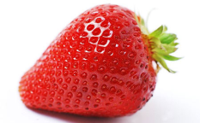**Gen Bio 1 Lab #9: CSI and Strawberry DNA Analysis**

**Pre-Lab Reading:** Page 412-416 in the 10th edition of Campbell Biology

**Pre-Lab Vocabulary:**

1. Agarose DNA gel –
2. Gel Electrophoresis –
3. Endonuclease restriction enzymes –
4. DNA endonuclease recognition sites –
5. Recombinant DNA –
6. Cloning vector –
7. Expression vector –

**Who Done It?**

DNA fingerprinting allows for the identification of the source of a DNA sample, which is important in many forensic cases. DNA fingerprinting can provide positive identification with great accuracy by matching DNA obtained from a crime scene to individual suspects.

Several steps are involved in DNA fingerprinting. First, a suitable sample must be obtained. DNA is then isolated from the evidence, such as blood or hair samples. Once the DNA is isolated, it is either digested with special enzymes called restriction endonucleases (restriction enzymes), or checked for specific genomic markers (particular repeats of sequence in the DNA of humans) using the polymerase chain reaction.

Restriction endonucleases are enzymes that cleave the sugar-phosphate backbone of DNA according to specific base-pairings. In most practical settings, a given enzyme cuts both strands of duplex DNA within a stretch of 4-10 base pairs. The site at which a restriction enzyme will cleave the DNA is called a **recognition site**. Most recognition sites are palindromes, they read the same forward (5' to 3' on the top strand) and backward (5' to 3' on the bottom strand).

**Materials**

Edvotek gel casting tray with dams and a comb

Electrophoresis chamber

Running buffer (1X concentration)

0.8-1% agarose

DNA samples from the crime scene and 2 suspects, each cut with 2 different restriction enzymes.

**Procedure 1:**

1. Your **instructor** will melt 1% agarose in the microwave.
   1. 200 ml needed for whole lab
   2. Microwave in a large Erlenmeyer flask to avoid boil-over, for enough time to dissolve all agarose and form a clear liquid after swirling
   3. Cool by holding base of flask under running cold water until evaporation ceases and glass is just warm to the bare-skin touch)
   4. *Hot agarose irreversibly warps plastic casting trays.*
2. Students: assemble your **casting tray**. (See image on next page)
3. Carefully pour **30 ml** of melted agarose gel into each casting tray. Allow to loosely solidify on cool **countertop**, solidify until opaque in the **fridge**.
4. Carefully remove the comb from the casting tray and then carefully remove the dams.
5. Before placing the gel trays into the chamber, be sure your **instructor** has placed the plastic tray dividers into the slots in the base of the gel chamber. The notches should align with the notches in the gel chamber.
   1. All **6 groups** are sharing the **same** gel chamber (See image on next page)
   2. **1000 ml** of 1X TBE running buffer are required to fill it.
6. Students: when placing your gel tray into the chamber, make sure to align the tab on the side of the gel tray with the notch in the gel chamber (and not one of the side vents).
7. Place the tray with the gel into the electrophoresis chamber with the wells closest to the **negative electrode** (**see image on next page**).
8. Add **35** **microliters** of each **sample** to a separate well (hole) produced when you removed the comb. **NOTE: record the order in which your group adds your samples.**

**NOTE: DNA 1 = cut with endonuclease #1, DNA 2 = cut with endonuclease #2**

**Foil Label Sample Lane order on your gel**

A Crime scene DNA 1

B Crime scene DNA 2

C Suspect 1 DNA 1

D Suspect 1 DNA 2

E Suspect 2 DNA 1

F Suspect 2 DNA 2

1. Place lid on the **shared** gel chamber plug cord into the power supply, adjust the voltage to **110V (maximum)** and turn the power supply ON.
2. Allow samples to run until the “fastest” piece (dye) has moved along about 2/3 of the gel, which should take about **20-25 min**.
3. Compare the bands in the crime scene samples to the bands from the 2 suspects and determine which suspect is the perp.

**Questions:**

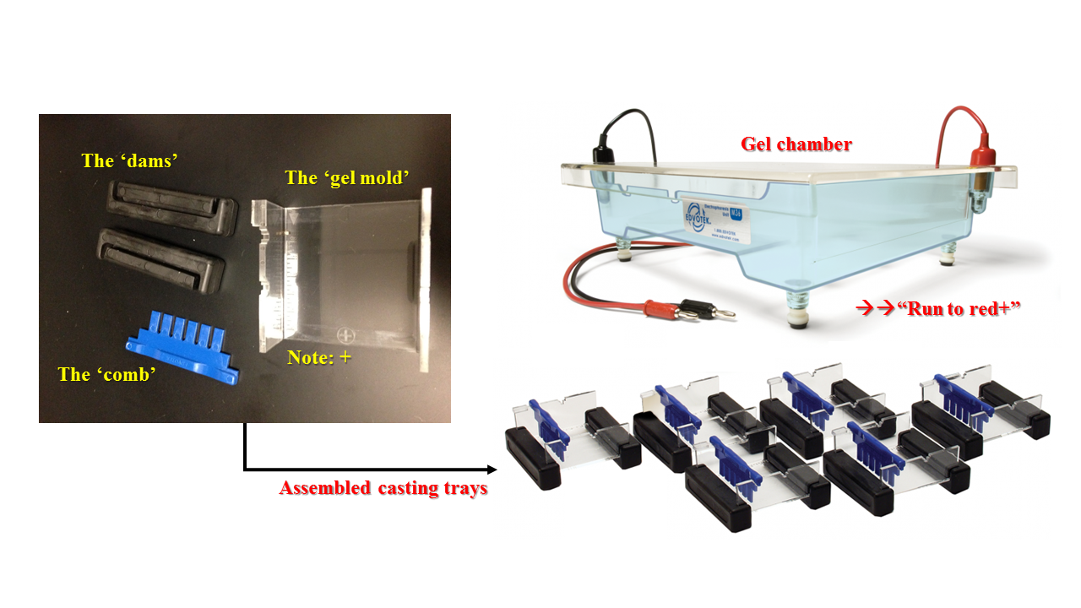

1. **Which suspect is the perpetrator of the crime? Explain how you know.**
2. **What is the central variable in this experiment?**
3. **What kind of evidence would you look for at a crime scene to obtain DNA?**
4. **Why was the suspects’ DNA cut with 2 different restriction endonucleases?**
5. **Why did you place the wells near the negative electrode of the gel chamber?**
6. **Why does each person have a unique pattern in their DNA?**

**Strawberry DNA Extraction Lab**

Every cell in a strawberry contains eight copies of each of its chromosomes. As a result, strawberries contain large amounts of DNA. Strawberry DNA is easy to extract because strawberries are easy to mash, and ripe strawberries produce enzymes that contribute to the breakdown of cell walls.



**Materials**

Strawberries

Detergent + salt solution

Ice-cold ethanol

Zip-lock baggie

Graduated cylinder (10-mL)

Funnel

Cheese cloth

Test tube

Wire loop

**Procedure 1:**

1. Obtain one strawberry and place it inside a sealable plastic bag. Press the air out of the bag and seal it carefully. **Mash the bagged strawberry with your fist for two minutes.**
2. Add **10 mL** of detergent + salt solution to the bag. Press the air out carefully and reseal the bag. **Mash the bagged strawberry + detergent + salt for one minute**.
3. Set up the filtration apparatus as shown in front of the class and in the Figure above, using the test tube rack.
4. Pour the liquid extract into the filtration apparatus, and let it drip directly into the test tube.
5. When the **test tube is approximately 1/8 full**, remove the funnel. Discard any extra mashed strawberry pulp with the cheesecloth.
6. Slowly drizzle cold ethanol (your instructor will get this for you when you are ready for this step) **along the side of the test tube**, until you’ve **added about 1 inch of ethanol**. The ethanol should form a separate layer on top of the filtered extract.
7. Dip the loop into the test tube to where the ethanol and extract layers meet as shown in the Figure above. Gently twirl the loop. Keep the tube at eye level so that you can see what is happening. Observe the characteristics of the DNA as it precipitates (clumps together) out of the solution.

**Questions:**

1. **Match the following lab steps with the effects on the strawberry cells:**

**________________________________________________________________________**

1. **Mash the fruit to slush. _____ breaks open the cells**
2. **Filter the strawberry extract. _____ dissolves plasma membrane**
3. **Add detergent solution. _____ clumps DNA together**
4. **Layer cold ethanol over _____ separates organelles and cell debris, filtered extract. such as fragments of cell walls and membranes, from DNA**

**and small dissolved molecules such as proteins and sugars.**

1. **A person cannot see a single strand of cotton from 30 meters away, but if thousands of threads are wound together into a rope, the rope can be seen at some distance. How is this statement an analogy to the DNA extraction you just completed? Describe the DNA you extracted. Was it what you expected to observe?**
2. **DNA dissolves in water, but not in ethanol. Explain what happened when the ethanol came in contact with the strawberry extract during the DNA extraction.**
3. **If DNA is invisible under a light microscope, how will you be able to see the strawberry DNA you extract?**
4. **Why do you think clumps of precipitated DNA molecules have a ropelike shape?**

MC900221937[1] **Questions to e x p a n d your mind.** MC900221937[1]

1. Can you think of a case when 2 people may have identical genomic DNA sequence? How about identical mitochondrial DNA sequence? Identical Y chromosome DNA sequence?
2. List 3 things that can affect how material (DNA, dyes, etc.) moves through an agarose gel, and why.
3. In order to study human genes, scientists must first extract the DNA from human tissues. Would you expect the method of purification for human DNA to be the same as the method you used to purify DNA from strawberries? Why or why not? (Look it up online)
4. If you were a strawberry farmer, what questions/suggestions would you pose to a plant DNA geneticist about modifying strawberry genes to possibly increase your strawberry harvest and farming profits?