**Name: __________________________________ Date:___________ Grade: _______________**

**Gen Bio 1 Quiz 10: PCR & Transcription/Translation Lab**

**Directions: Choose the best answer (2 points each)**

1. The two GMO genestested for in this lab are:
   1. Round-Up Ready and Luminescence
   2. Bt and Luminescence
   3. Round-Up Ready and Bt
   4. Herbicide and insecticide
   5. Bt and
2. Polymer Chain Reaction (PCR) involves cycles of a three main steps. The three steps in order are:
   1. Denaturation, Extension, Annealing
   2. Annealing, Denaturation, Extension
   3. Extension, Denaturation, Annealing
   4. Extension, Annealing, Denaturation
   5. Denaturation, Annealing, Extension
   6. Annealing, Extension, Denaturation
3. What would happen if we left primers out of the PCR reaction?
   1. With no primers there would be no primers annealing to the denatured DNA strands so Taq polymerase cannot add additional nucleotides during extension.
   2. The PCR reaction would stop because Taq polymerase is not thermostable and thus cannot withstand the high temperatures.
   3. Primers are not needed for the PCR reaction so nothing would happen.
   4. Without primers the PCR reaction would replicate faster and thus more DNA would be the end result.
   5. The DNA strands would not separate during the denaturation step.
4. How many different kinds of bases can be found on DNA:
5. Two
6. Three
7. Four
8. Five
9. Six
10. What base is found on RNA but not on DNA?
11. Thymine (T)
12. Uracil (U)
13. Guanine (G)
14. Adenine (A)
15. Cytosine (C)

**Directions: Use the genetic code chart and your knowledge about transcription and translation to solve the following problems.**

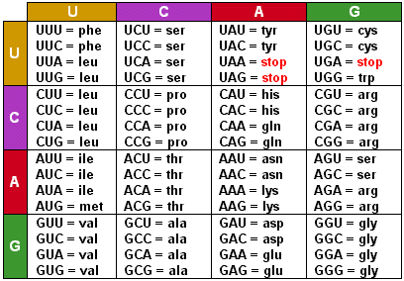

1. What is the amino acid sequence based on the following mRNA sequence? (2 points)

5’-AUG GCU UUA CUC CCU UGA -3’

1. What are all the possible mRNA codon sequences for the amino acid Valine (**val**)? (2 points)
2. What is the mRNA sequence of its complementary the tRNA **UAC**? (1 point)