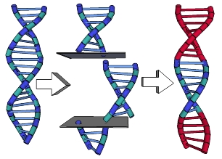**Name: \_\_\_\_\_\_\_\_\_\_\_\_\_\_\_\_\_\_\_\_\_\_\_\_\_\_ Date:\_\_\_\_\_\_\_\_\_\_\_**

**Gen Bio 1 Lab #11: PCR Gel & GATACCA**

**Pre-Lab Reading:** Pages **286 & 831-833** in the 10th edition of Campbell Biology

**Pre-Lab Vocabulary:**

1. Genetic Information Non-discrimination Act –
2. Transgenic –
3. Golden rice –
4. Transgenic cassava –
5. *Bt* maize –
6. The problem of the **“superweed”** –

**Procedure 1: Analyzing our PCR results using Agarose Gel Electrophoresis**

Today we will run out our PCR samples from last week, hopefully observing strong detection bands of our amplified DNA. Each group will be pouring a gel, and running their samples independently. Note that we all need to wear gloves today, because the chemical we use to stain our agarose gels is toxic.

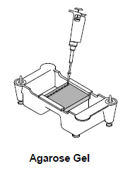

**Materials**

Gel casting tray with dams and a comb

Electrophoresis chamber

**-** (black)

Running buffer (TAE 1X concentration)

**+** (red)

2.0% agarose (premixed)

Eppendorf Micropipette

Pipet tips (100 or 200)

**From Bio-Rad freezer kit:** PCR molecular weight ruler, 200 µl & Orange G loading dye, 1ml

**Remember: “run to red”**

Plastic 1ml pipettes

PCR tubes from last week (stored in the freezer)

Warm or room temp QUIKView DNA Stain (100mL per group)

Staining trays

100 or 200mL Graduated cylinder

Camera phone (student-provided; photo documentation)

**Procedure A: Preparing and loading the gel**

1. Your **instructor** will melt 1% agarose in the microwave.
   1. 200 ml needed for whole lab
   2. Microwave in a large Erlenmeyer flask to avoid boil-over, for enough time to dissolve all agarose and form a clear liquid after swirling
   3. Cool by holding base of flask under running cold water until evaporation ceases and glass is just warm to the bare-skin touch)
   4. *Hot agarose irreversibly warps plastic casting trays.*
2. Students: assemble your **casting tray**. (See image on next page)
3. Carefully pour **30 ml** of melted agarose gel into each casting tray. Allow to loosely solidify on cool **countertop**, solidify until opaque in the **fridge**.
4. Carefully remove the comb from the casting tray and then carefully remove the dams.
5. Before placing the gel trays into the chamber, be sure your **instructor** has placed the plastic tray dividers into the slots in the base of the gel chamber. The notches should align with the notches in the gel chamber.
   1. All **6 groups** are sharing the **same** gel chamber (See image on next page)
   2. **1000 ml** of 1X TBE running buffer are required to fill it.
6. Students: when placing your gel tray into the chamber, make sure to align the tab on the side of the gel tray with the notch in the gel chamber (and not one of the side vents).
7. Place the tray with the gel into the electrophoresis chamber with the wells closest to the **negative electrode** (**see image on next page**).
8. Obtain your PCR tubes from instructor and pulse-spin the tube for ~3 seconds in microcetrifuge.
9. Using a fresh tip each time, add **10 microliters (μl)** of Orange G 10X loading dye to each sample, and mix.
10. Using a fresh tip each time, add **20 microliters** of your samples to separate wells (hole) produced on your gel when you removed the comb in this order:

|  |  |  |
| --- | --- | --- |
| **Sample** | **Lane on gel:** | **Pipette into well:** |
| PCR tube 1: Non-GMO food control with plant primers | 1 | 20 μl |
| PCR tube 2: Non-GMO food control with GMO primers | 2 | 20 μl |
| PCR tube 3: Test food with plant primers | 3 | 20 μl |
| PCR tube 4: Test food with GMO primers | 4 | 20 μl |
| PCR tube 5: GMO positive DNA with plant primers | 5 | 20 μl |
| PCR tube 6: GMO positive DNA with GMO primers | 6 | 20 μl |

**Procedure B: Running the gel**

1. Place lid on the **shared gel chamber** plug cord into the power supply, adjust the voltage to **110V (maximum)** and turn the power supply ON.
2. Allow samples to run until the “fastest” piece (dye) has moved along about 2/3 of the gel, which should take about **20-25 min**.

**Procedure C: Using QUIKView DNA Stain**

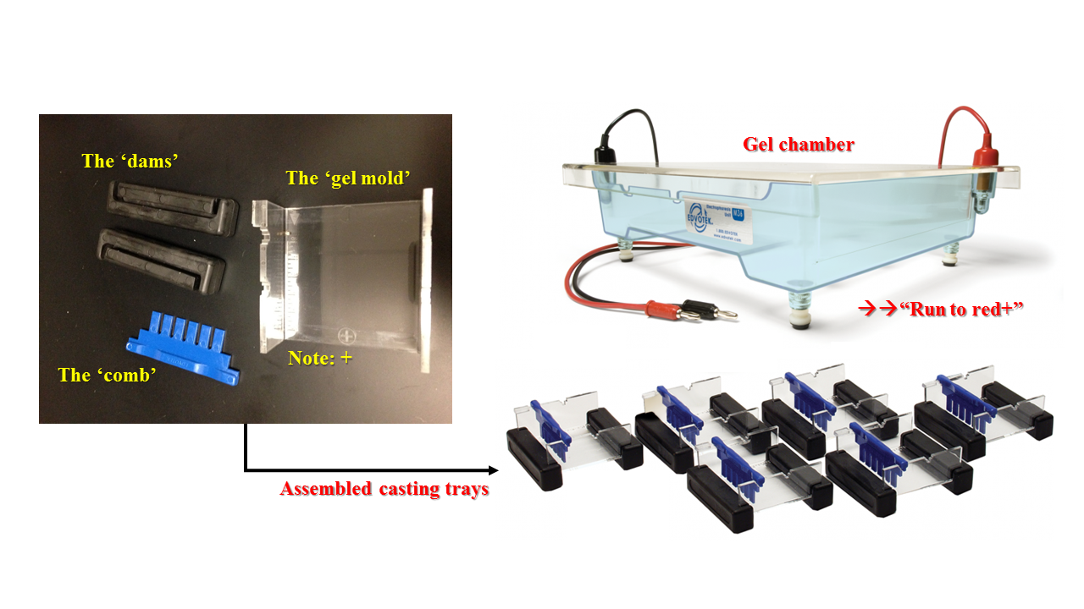

1. Gently slide the gel from the casting tray into the **staining tray** and pour approximately about **100 mL of warm dilute stain** into the staining tray so that it just covers the gel.
2. Place the staining tray with your gel on the gel rocker for **10 minutes**.
3. When finished staining, decant it (pour carefully, while holding the gel gently with your gloved fingers) into a sealable container. **Reduce, reuse, recycle!**
4. Flush the gel under a **gentle stream of tap water**, not directly on gel**, instead on the plastic tray beside the gel**. Do this until the water runs clear.
5. Add distilled water to the staining tray (grey tap at back lab sink or squeeze bottle at your bench) and set on the gel rocker for **15 minutes**.
6. **View your gel on the light box**.
   1. If your bands are not clear enough, add fresh distilled water (grey tap) and set on gel rocker for an additional **5 min**.
7. Take an **image of your gel with your phone’s camera**.
8. Accurately sketch the bands you see on the blank gel in **Question 1**. Be as exact as possible in sketching the bands in their actual positions. If you choose to take an image, send it to your email, copy it into Word and then print it out.

**Questions to be answered by your lab group:**

1. C:\Users\Isaiah\AppData\Local\Microsoft\Windows\INetCache\Content.Word\NewLab11_Gel-Diagram.tif**Label your gel picture. Include what sample was loaded into each lane. (You can also attach a printed image of your gel if your group uses a camera phone to capture an image.)**
2. **Which lanes were our “Controls”? What do these controls mean?**
3. **Did your test food contain GMO genes? How do you know?**
4. **Summarize your thoughts on buying foods from the grocery store that contain GMO genes, now that you understand what ‘genetically modified’ means.**

**Procedure 2: GATTACA**

**Instructors: Start movie after all groups have started Procedure 1B**

As you watch the movie GATTACA answer the questions below.

1. What does Jerome (Vincent) place on the comb at his workstation?
2. “They used to say that a child conceived in love has a greater chance of….” What?
3. What is Jerome’s (Vincent’s) life expectancy?
4. After Marie’s fertilized embryos are screened, how many healthy ones are left?
5. According to the geneticist, we have enough of this built in already. What is it?
6. What is the name given to discriminating against people because of their genetic profile?
7. “After all there is no gene for …” what?
8. What is a “borrowed ladder” or “de-generate”?
9. What does Jerome (Vincent) leave behind at the murder scene?
10. The director claims that Gattaca is occasionally forced to accept candidates with “minor shortcomings”, but nothing that would prevent them from working in \_\_\_\_\_\_\_\_\_\_\_\_?
11. When Jerome (Vincent) and Irene go to a concert, what is unusual about the piano player?
12. Who do we eventually find out killed the mission director?
13. Who does the lead detective of the murder investigation turn out to be?

MC900221937[1] **Questions to e x p a n d your mind.** MC900221937[1]

1. As a scientist, you perform the PCR process routinely in your lab. You don’t give the process much thought and take it for granted that it works. Recently, a friend without a science background has asked you about the process. Create an analogy to explain an aspect of the PCR process to a nonscientist. (You can sketch a picture too)
2. What does the movie GATTACA say about DNA determining a person’s potential? What are the positive and negative aspects of the world showed in the movie? Provide examples from the movie to support your answer.
3. Examine the two gel results below and determine which baby might have been fathered by Mr. X. Explain your reasoning.

