Yeast Fluctuation Essay

DEADLINES

Essay draft due @@@
Final essay due @@@

DOCUMENT FORMAT, NAMING AND SUBMISSION

@@@@.

QUOTATION AND ATTRIBUTION RULES

The quotation rules are easy to summarize: quotations aren’t allowed, whether attributed or not. You’re free to use diagrams, tables and other illustrative materials from the handouts; they should be attributed to “Handouts for @@@.” Other illustrative material, if any, should be attributed to the appropriate source.

POINT VALUES

Draft @@ points
Essay @@ points.

THIS IS NOT A TEST!!

Below you will be provided wih a list of “subtopics” to be addressed. But your job is not to convince your prof that you understand those subtopics. It’s to write an essay that conveys your understanding to your “intended reader”: a student with roughly your general biology background, but with no specific knowledge of the fluctuation test. If you write your essay as if it were an answer to an exam question, you will surely do an inadequate job of meeting that goal. As you introduce each new term or concept, you need to “put yourself in your reader’s shoes,” meaning you need to imagine how your reader will understand what you’ve written. This is not just an exercise in “getting it right” (perfect score on an exam question), it’s learning how to explain your understanding to other people. If you find “shoes” next to some highlighted text in your draft or essay, you’ll know that means you’ve failed to put yourself in your reader’s shoes.

SUBTOPICS TO BE ADDRESSED

Below are listed major subtopics to be covered. You don’t need to cover them in the order below, nor do you have to organize the essay according to the subtopics list. But you should make sure that the subtopics are addressed within your narrative.

1. Darwin versus Lamarck as applied to microbial mutations

You can assume your intended readers have already encountered Darwin’s and Lamarck’s contrasting views as applied to animals and plants, though it would be a really good idea to remind them. There’s that famous example of the evolution of the giraffe’s long neck, for instance. And of course by the beginning of the 20th century biologists had rejected the Lamarckian view in favor of the Darwininan view in the case of plant and animal evolution. But some microbiologists questioned whether Darwinian mechanisms would suffice to explain the extraordinarily rapid evolution of microbial resistance to lethal agents such as viruses and antibiotics. That’s the issue that Luria and Delbrück sought to address in their 1943 microbial fluctuation test. You need to explain in easy-to-understand terms the evolutionary question Luria and Delbrück sought to answer. Your explanation will include many terms and concepts that you can’t assume your intended readers have encountered before or remember, such as:

- Growth of single-cell microbes such as bacteria and yeast in liquid medium suspension; formation of colonies by those microbes on agar medium in petri dishes
- Mutations that confer microbial resistance to a lethal agent (e.g., the antibiotic canavanine in the case of your yeast experiment); selective versus non-selective media
- Do resistance mutations arise before exposure to the lethal agent, as Darwin would envision (the “pre-exposure” hypothesis); or only after exposure, as Lamarck would maintain (the “post-exposure” hypothesis)?

2. Logic of a generic fluctuation test: contrasting expectations of Darwin and Lamarck

The fluctuation test has a generic logic that transcends the details of any particular test. That logic can be explained before you launch into the details of our particular yeast fluctuation test. Key elements of the generic fluctuation test include:

- Growth of many tiny individual cultures and a single large “bulk” culture in non-selective medium
  - Darwin predicts resistance mutations occur at random times, giving rise to resistant clones of widely differing sizes
  - Lamarck predicts no resistance mutations occur at all because the microbes have not yet encountered the lethal agent
- Spreading the individual cultures and many samples of the bulk culture on petri dishes with selective medium
- Counting surviving colonies
- Lamarck predicts the same distribution of colony counts on both individual culture and bulk culture sample dishes. In both cases, colony counts should cluster about their mean
- Darwin predicts dramatically different distributions of colony counts on individual culture dishes versus bulk culture sample dishes:
  - On the bulk culture sample dishes, Darwin predicts that colony counts will cluster about their mean, as predicted for random sampling error (for slightly different reasons, Lamarck predicts the same thing for both bulk culture sample dishes and individual culture dishes).
  - On the individual culture dishes, colony counts will be extremely variable, and won’t cluster about their mean
- You need to explain the reason for these contrasting expectations of Darwin versus Lamarck

3. Design of the yeast fluctuation test

You should briefly describe the yeast fluctuation test, including only those details that are essential for understanding the logic of the experiment. It may help to include the diagram in YeastFluctuation3.pptx and refer to it specifically during your description.

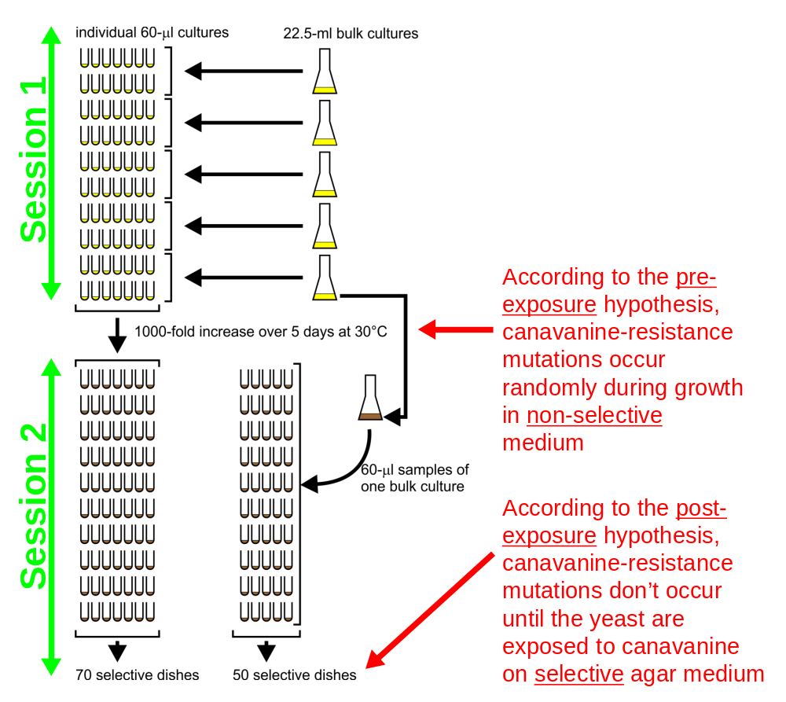

4. Interpretation of colony count results

What did you observe on the petri dishes? What do the colony count results say about the Darwinian versus the Lamarckian theories of microbial mutations? No doubt you’ll want to include the scattergram in YeastFluctuationSession4Discussion.pptx.

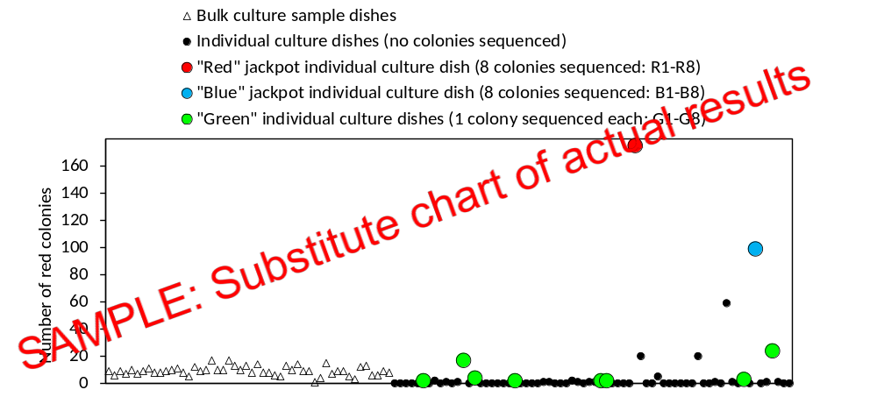

5. Colony sequencing and analysis of sequencing results

You need to outline the colony sequencing part of the fluctuation test. Focus only on what your reader will need to understand the logic of the sequence analysis. There’s no need to explain the details of the process—how genomic DNA was extracted from small samples of individual colonies, the logic of PCR or how the PCR reactions were carried out, purification of the PCR product, and submission of samples (PCR products plus primer) for sequence analysis. But it is vital to explain what the sequence results mean (you can use the summary figure from YeastFluctuationSession5.pptx). Are they consistent with Darwin’s view? With Lamarck’s view?

