**Bootstrap Project: UI Design Report**

Kryspin Turczynski, December 2020

This report will explain the features, layout and navigation flow of my Bootstrap project, which is a static website for a hypothetical restaurant named BT Bistro.

INTRODUCTION

The BT Bistro website will consist of three pages: Home, Menu, and About. The goals of the project are to establish the restaurant’s brand identity, build trust among potential customers, and provide a visually compelling and hassle-free user experience, resulting in increased revenue via both dine-in and take-out/delivery orders.

USER INTERFACE DESIGN AND PROTOTYPE

A wireframe diagram of the website’s three pages was created using wireframe.cc and may be viewed here:

<https://wireframe.cc/pro/pp/5947d74d2404540>

* In keeping with a mobile-first design philosophy, the wireframe was created for XS/S viewports, and will be adjusted accordingly for larger viewports
* Each page will have the same header, sticky-top navbar, and a footer with critical info regarding operations, location, contact, etc.
* Sticky-top navbar will include a small restaurant logo (stylized “BT”) on the left as a link to the Home page, and an “Order” button on the right for online ordering
* Emphasis on visual aspects, including an earthy color scheme and plenty of high-res images
* Additional buttons amidst each page’s content help navigate to other pages
* Page content written in narrative format to help facilitate flow towards actions (looking at menu and ordering)

NAVIGATION STRUCTURE

The effectiveness of the website will depend more on visual appeal, rather than amount of information, so the navigation has been designed to be relatively simple.

The main logo in the header of each page will serve as a link to the homepage, as will the mini-logo on the left end of the sticky-top navbar.

The navbar has only 4 elements (the mini-logo, Menu, About, and an “Order” button), so it will remain horizontal and sticky-top for all pages and viewports.

There are additional links to Menu and About interspersed throughout each page’s narrative, plus additional “Order” buttons including in each page’s footer.

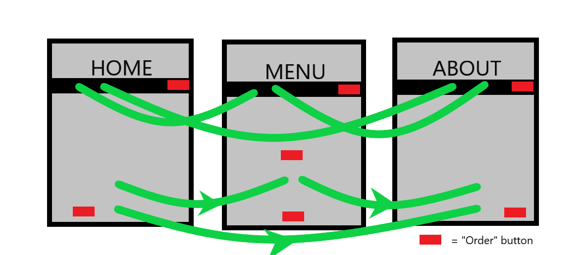

REFERENCES

How To Wireframe an App on Wireframe.CC:

<https://www.youtube.com/watch?v=Yfp9Jy3Yc3E>