黑马程序员
www.itheima.com

传智播客旗下
高端IT 教育品牌

改变中国IT 教育，我们正在行动



应用篇
效率

1.使用多线程充分利用CPU
1)环境搭建
●基准测试工具选择，使用了比较靠谱的JMH, 它会执行程序预热，执行多次测试并平均
· cpu 核数限制，有两种思路
1.使用虚拟机，分配合适的核
2.使用msconfig, 分配合适的核，需要重启比较麻烦
●并行计算方式的选择
1.最初想直接使用parallel stream,后来发现它有自己的问题
2.改为了自己手动控制thread, 实现简单的并行计算
●测试代码如下
mvn archetype:generate -DinteractiveMode= false DarchetypeGroupId= org.openjdk. jmh -
DarchetypeArtifactId= jmh-java- benchmark-archetype -DgroupId =org.sample -DartifactId =test - Dversion =1. 0
package org. sample;

import java. util. Arrays;
import java. util. concurrent. FutureTask;

import org.openjdk.jmh.annotations.Benchmark;
import org.openjdk. jmh.annotations.BenchmarkMode;
import org.openjdk.jmh.annotations. Fork;
import org.openjdk.jmh.annotations.Measurement;
import org.openjdk.jmh.annotations.Mode;
import org.openjdk.jmh.annotations. Warmup;

@Fork(1)
@BenchmarkMode(Mode.AverageTime)
@Warmup(iterations=3)
@Measurement(iterations =5) public class MyBenchmark {
static int[]ARRAY =new int[1000_000_00];
static {
Arrays.fill(ARRAY, 1); }
@Benchmark
public int c() throws Exception{
int []array = ARRAY;

北京市昌平区建材城西路金燕龙办公楼一层 电话：400-618-9090

FutureTask< Integer >t1 = new FutureTask<>(()->{ int sum = 0;
for( int i=0;i< 250_000_00; i++){
sum += array[ 0+ i];

return sum; });
FutureTask< Integer >t2= new FutureTask<>(()->{ int sum = 0;
for(int i=0;i< 250_000_00; i++){
sum += array [250_000_00+i];

return sum; });
FutureTask< Integer >t3 = new FutureTask<>(()->{ int sum = 0;
for( int i=0;i< 250_000_00; i++){
sum += array [500 _000_00+i];

return sum; });
FutureTask< Integer >t4= new FutureTask<>(()->{ int sum = 0;
for( int i=0;i< 250_000_00;i ++){
sum += array [750_000_0 0 +i];

return sum; });
new Thread(t1).start();
new Thread(t2).start();
new Thread(t3).start();
new Thread(t4).start();
return t1.get()+ t2.get() +t3. get()+t4.get(); }
@Benchmark
public int d() throws Exception {
int []array = ARRAY;
FutureTask< Integer >t1 = new FutureTask<>(()->{ int sum = 0;
for( int i=0;i< 1000_000_00; i++){
sum += array[0+i];

return sum;
});
new Thread(t1).start();
return t1.get();

2)双核CPU(4 个逻辑CPU)

C:\Users\lenovo\eclipse-workspace\test>java -jar target/benchmarks.jar
#VM invoker:C:\P rogram Files\Java\jdk-11\bin\java.exe
#VM options:<none>
#Warmup:3 iterations, 1 s each
#Measurement:5 iterations,1 s each
#T hreads :1 thread,will synchronize iterations #Benchmark mode:Average time,time/op
#Benchmark:org. sample.MyBenchmark.c

#R un progress:0.00%complete, ETA 00:00:16
#Fork: 1 of 1
 | #Warmup  #Warmup #Warmup  Iteration  Iteration  Iteration  Iteration | Iteration  Iteration  Iteration  1: 0. 020  2:0. 020  3:0. 020  4:0. 020  5:0. 020 | 1:0.022 2:0.019  3:0.020  s/op  s/op  s/op  s/op  s/op | s/op  s/op  s/op
Result: 0. 020±(99.9%)0.001 s/op [Average]
Statistics: (min,avg,max )=(0.020,0.020,0.020),stdev =0.000
Confidence interval(99.9%):[0.019,0.021]

#VM invoker: C:\Program Files\Java\jdk-11\bin\java.exe
#VM options:<none>
#Warmup:3 iterations,1 s each
#Measurement:5 iterations ,1 s each
# Threads:1 thread,will synchronize iterations #Benchmark mode:Average time,time/op
#Benchmark:org. sample.MyBenchmark.d

#Run progress:50.00%complete ,ETA 00:00:10 #Fork:1 of 1
#Warmup Iteration 1:0.042 s/op
#Warmup Iteration 2:0.042 s/op
#Warmup Iteration 3:0.041 s/op
Iteration 1: 0. 043 s/op
Iteration 2:0. 042 s/op
Iteration 3:0. 042 s/op
Iteration 4: 0. 044 s/op
Iteration 5:0. 042 s/op

Result: 0. 043±(99.9%) 0.003 s/op [Average]
Statistics: (min,avg,max )=(0.042,0.043,0 .044), stdev =0.001
Confidence interval(99.9%):[0.040,0.045]

# Run complete. Total time:00:00:20


改变中国IT 教育，我们正在行动
传智播客旗下
高端IT 教育品牌
黑马程序员
www.itheima.com


Benchmark  0.s.MyBenchmark.c  0.s.MyBenchmark. d | avgt  avgt | 50.020 | Score | error  0. 001  0. 003 | s/op  s/op

可以看到多核下，效率提升还是很明显的，快了一倍左右

3)单核 CPU

C:\Users\lenovo\eclipse-workspace\test>java -jar target/benchmarks.jar
#VM invoker: C:\Program Files\Java\jdk-11\bin\java.exe
#VM options:<none>
# Warmup: 3 iterations,1 s each
# Measurement:5 iterations,1 s each
#Threads:1 thread, will synchronize iterations
#Benchmark mode: Average time, time/op
#Benchmark: org.sample. MyBenchmark.c

#Run progress:0.00%complete,ETA 00:00:16
#Fork:1  #Warmup # Warmup #Warmup  Iteration  Iteration  Iteration Iteration | of 1  Iteration  Iteration  Iteration  1: 0.053  2:0. 052  3:0. 053 4:0.057  5:0.088 | 1:0.064 2:0.052 3:1.127  s/op s/op s/op s/op s/op | s/op s/op  s/op
Result: 0. 061±(99.9%)0.060 s/op [Average]
Statistics: (min,avg,max )=(0.052,0.061,0.088),stdev =0.016
Confidence interval(99.9%):[0.001,0.121]

#VM invoker: C:\Program Files\Java\jdk-11\bin\java.exe
#VM options: <none>
# Warmup: 3 iterations ,1 s each
#Measurement:5 iterations,1 s each
#Threads:1 thread, will synchronize iterations
#Benchmark mode: Average time, time/op
#Benchmark: org.sample.MyBenchmark.d

# Run progress:50.00%complete,ETA 00:00:11 #Fork: 1 of 1
# Warmup Iteration 1:0.054 s/op
#Warmup Iteration 2:0.053 s/op
#Warmup Iteration 3:0.051 s/op
Iteration 2:0. 054 s/op
Iteration 3:0. 065 s/op
Iteration 4: 0. 050 s/op

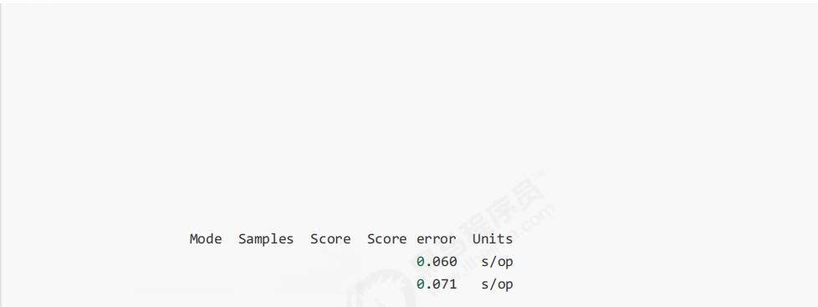
Iteration 5:0.055 s/op

Result :0. 064±(99.9%)0.071 s/op [Average]
Statistics:(min,avg,max )=(0.050 ,0.064,0.096),stdev =0.018
Confidence interval(99.9%):[-0.007,0.135]

#R un complete. Total time: 00:00:22

Benchmark
o.s.MyBenchmark.c avgt 5 0.061
0.s.MyBenchmark. d avgt 5 0.064

性能几乎是一样的

限 制

1.限制对CPU的使用
sleep 实现
在没有利用cpu来计算时，不要让while(true)空转浪费cpu, 这时可以使用yield或sleep 来让出cpu 的使用权 给其他程序
while( true ){ try {
Thread.sleep (50 );
} catch (InterruptedException e){ e.printStackTrace();
●可以用wait或条件变量达到类似的效果
·不同的是，后两种都需要加锁，并且需要相应的唤醒操作，一般适用于要进行同步的场景
· sleep 适用于无需锁同步的场景

wait 实现

synchronized (锁对象) { while (条件不满足){
try {
锁对象.wait() ;
} catch (InterruptedException e){ e.printStackTrace();


条件变量实现
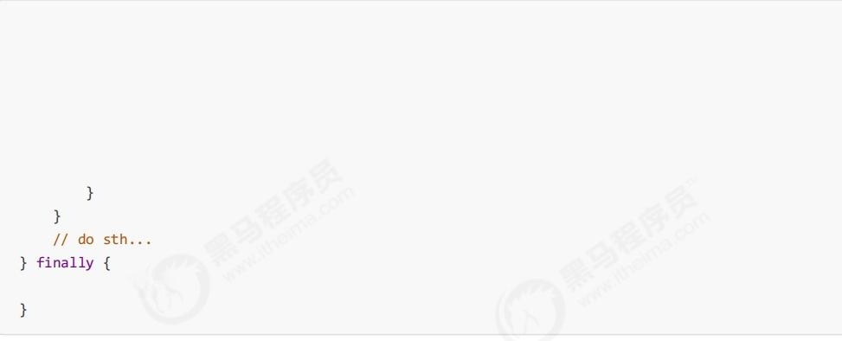
lock.lock(); try {
while (条件不满足){
try {
条件变量.await();
} catch (InterruptedException e){ e.printStackTrace();

lock.unlock();

2. 限制对共享资源的使用
semaphore实现
●使用Semaphore限流，在访问高峰期时，让请求线程阻塞，高峰期过去再释放许可，当然它只适合限制单机 线程数量，并且仅是限制线程数，而不是限制资源数(例如连接数，请对比 Tomcat LimitLatch的实现)
· 用 Semaphore 实现简单连接池，对比『享元模式』下的实现(用wait notify),性能和可读性显然更好， 注意下面的实现中线程数和数据库连接数是相等的
@Slf4j(topic ="c.Pool") class Pool {
//1 . 连接池大小
private final int poolsize;

//2. 连接对象数组
private Connection[]connections;

//3. 连接状态数组0表示空闲，1 表示繁忙
private AtomicIntegerArray states;

private Semaphore semaphore;

//4. 构造方法初始化
public Pool (int poolSize){
thi s. poolSize = poolSize;
// 让许可数与资源数一致
this. semaphore =new Semaphore(poolsize);
this. connections =new Connection[poolsize];
this. states =new AtomicIntegerArray(new int[poolsiz e]);
for (int i=0;i<poolSize;i++){
connections[i] =new MockConnection( "连接"+ (i+1));

//5. 借连接
public Connection borrow() {//t1,t2,t3
// 获取许可
try {
semaphore.acquire(); // 没有许可的线程，在此等待
} catch (InterruptedException e){
e.printStackTrace(); }
for (int i=0;i<poolsize ;i++){
// 获取空闲连接
if( states.get(i) == 0){
if (states. compareAndset(i, θ,1)){
log. debug( "borrow {}", connections [i]);
return connections[i];

1/ 不会执行到这里

//6. 归还连接
public void free(Connection conn){
for (int i =0;i<poolSize;i ++){
if (connections[i] == conn){
states. set(i, θ);
log. debug( "free {}", conn);
semaphore.release ();
break ;
3. 单位时间内限流 guava 实现

@RestController
public class TestController{

private RateLimiter limiter = RateLimiter.create( 50);

@GetMapping("/ test")
public String test(){
// limiter. acquire( );
return "ok" ;
没有限流之前
ab -c 10 -t 10 http: //localhost:8080/test
结果

This is ApacheBench,Version 2.3<$Revision:1843412 $>
Copyright 1996 Adam Twiss,Zeus Technology Ltd,http://www.zeustech.net/ Licensed to The Apache Software Foundation,http://www.apache.org/

Benchmarking localhost(be patient) Completed 5000 requests
Completed 10000 requests
Completed 15000 requests
Completed 20000 requests Finished 24706 requests

Server Software:
Server Hostname: localhost
Server Port: 8080

Document Path: | /test
Document Length: | 2 bytes
Concurrency Level: | 10
Time taken for tests: | 10.005 seconds
Complete requests: | 24706
Failed requests:
Total transferred: | 3311006 bytes
HTML transferred: | 49418 bytes
Requests per second: | 2469.42 [#/sec](mean)
Time per request: | 4.050 [ms](mean)
Time per request: | 0.405 [ms] (mean, across | all concurrent | requests)
Transfer rate: | 323.19[Kbytes/sec]received
Connection Times (ms)
min mean[+/-sd]median max
Connect: 1 6

传智播客旗下
黑马程序员
www.itheima.com
高端IT 教育品牌 改变中国IT 教育，我们正在行动

Processing: 0 4 7.6 0 323
Waiting: 0 3 6.9 0 323
Total: 0 4 7.6 0 323
Percentage of the requests served within a certain time(ms)
50% 0
66% 2
75% 8
80% 8
90% 10
95% 16
98% 16
99% 16
100% 323(longest request)
限流之后

This is ApacheBench,Version 2.3<$Revision:1843412 $>
Copyright 1996 Adam Twiss,Zeus Technology Ltd,http://www.zeustech.net/ Licensed to The Apache Software Foundation,http://www.apache.org/

Benchmarking localhost(be patient) Finished 545 requests

Server Software:
Server Hostname: localhost
Server Port: 8080

Document Path: /test
Document Length: 2 bytes

Concurrency Level: 10
Time taken for tests: 10.007 seconds
Complete requests: 545
Failed requests: 0
Total transferred: 73030 bytes
HTML transferred: 1090 bytes
Requests per second: 54.46[#/sec] (mean)
Time per request: 183.621 [ms](mean)
Time per request: 18.362 [ms] (mean, across all concurrent requests)
Transfer rate: 7.13 [Kbytes/sec]received

Connection | Times(ms)
 | min mean[+/-sd]median | max
Connect: | 0 0 1.1 0 | 16
Processing: | 0 179 57.0 199 | 211
Waiting: | 0 178 57.6 198 | 211
Total: | 0 179 56.9 199 | 211

Percentage of the requests served within a certain time(ms) 50% 199

66% | 200
75% | 200
80% | 200
90% | 201
95% | 201
98% | 202
99% | 203
100% | 211(longest | request)

互斥

1. 悲观互斥
互斥实际是悲观锁的思想 例如，有下面取款的需求
interface Account {
// 获取余额
I nteger getBalance();

// 取款
void withdraw( Integer amount);

/ **
* 方法内会启动1000 个线程，每个线程做-10元的操作
* 如果初始余额为10000那么正确的结果应当是0
static void demo(Account account){
List<Thread>ts = new ArrayList<>();
for (int i=0;i< 1000; i++ ){
ts.add( new Thread(()- >{
account. withdraw (10);
}) );
}
long start = System. nanoTime();
ts.forEach(Thread::start);
ts.forEach(t -> {
try {
t.join();
} catch (InterruptedException e){
e. printstackTrace();

});
long end =System.nanoTime();
System. out. println(account.getBalance()
+"cost:"+ (end-start)/ 1000_ 000 +"ms");

用互斥来保护
class AccountSync implements Account { private Integer balance;
public AccountUnsafe( Integer balance){
this. balance = balance;

@Override
public Integer getBalance(){
synchronized ( this ){
return this.balance;

@Override
public void withdraw( Integer amount){ synchronized(this ){
this. balance -= amount;

2.乐观重试
另外一种是乐观锁思想，它其实不是互斥
class AccountCas implements Account {
private AtomicInteger balance;

public AccountCas(int balance){
this. balance =new AtomicInteger(balance);

@Override
public Integer getBalance(){
return balance.get();

@Override
public void withdraw(Integer amount){ while( true ){
// 获取余额的最新值
int prev = balance.get();
// 要修改的余额
int next = prev - amount;
// 真正修改
if( balance.compareAndSet(prev,next)){

break ;

北京市昌平区建材城西路金燕龙办公楼一层 电话：400-618-9090


同步和异步

1.需要等待结果
这时既可以使用同步处理，也可以使用异步来处理

1.join 实现(同步)

static int result = 0;

private static void test1 ()throws InterruptedException {
log. debug("开始");
Thread t1 = new Thread(() ->{
log. debug("开始");
sleep (1);
log. debug("结束");
result = 10 ;
}, "t1") ;
t1.start();
t1.join();
log. debug(" 结果为：{}", result);
输出
20:30:40.453 [main] c.TestJoi n - 开 始
20:30:40.541 [Thread- 0]c. TestJoin - 开始
20:30:41.543 [Thread-0]c. TestJoin - 结束
20:30:41.551 [main ]c.TestJoin - 结果为：10
评价
·需要外部共享变量，不符合面向对象封装的思想
●必须等待线程结束，不能配合线程池使用

2.Future 实现(同步)

北京市昌平区建材城西路金燕龙办公楼一层 电话：400-618-9090

private static void test2() throws InterruptedException,ExecutionException{
log. debug("开始");
FutureTask< Integer >result =new FutureTask<>(()->{
log. debug("开始");
sleep (1) ;
log. debug("结束");
return 10 ; });
new Thread(result, "t1"). start();
log. debug(" 结果为：{}", result. get());
输出

10:11:57.880
10:11:57.942
10:11:58.943
10:11:58.943

c.TestSyn c [main ]- 开 始
c.TestSync [t1]- 开始
c.TestSync [t1]- 结束
c.TestSync [main]- 结果为：10


评价
●规避了使用join 之前的缺点
●可以方便配合线程池使用

private static void test3() throws InterruptedException,ExecutionException{
ExecutorService service =Executors.newFixedThreadPool(1);
log. debug("开始");
Future< Integer >result =service.submit(()->{
log. debug("开始");
sleep (1);
log. debug("结束");
return 10 ; });
log .debug(" 结果为：{}, result 的类型：{}",result.get(),result.getClass());
service.shutdown(); }
输出
10:17:40.090 c.TestSyn c [main ]- 开 始
10:17:40.150 c.TestSync [pool- 1-thread-1 ]- 开 始
10:17:41.151 c.TestSync [pool-1 -thread- 1]- 结束
10:17:41.151 c.TestSync [main]- 结果为：10,result 的类型：class java.util. concurrent.FutureTask
评价
●仍然是main 线程接收结果
· get 方法是让调用线程同步等待

北京市昌平区建材城西路金燕龙办公楼一层 电话：400-618-9090

3.自定义实现(同步)
见模式篇：保护性暂停模式

4.CompletableFuture 实现(异步)
private static void test4 (){
// 进行计算的线程池
ExecutorService computeService =Executors.newFixedThreadPool(1);
// 接收结果的线程池
ExecutorService resultService =Executors.newFixedThreadPool(1);
log. debug( "开始");
CompletableFuture. supplyAsync(()->{
log. debug("开始");
sleep (1);
log. debug("结束");
return 10 ;
}, computeService).thenAcceptAsync((result) ->{
log. debug( "结果为：{}", result);
},resultService);
输出

10:36:28.114 | c.TestSync | [main ]- 开始
10:36:28.164 | c.TestSync | [pool-1-thread- 1]- 开始
10:36:29.165 | c.TestSync | [pool-1-thread-1]- 结束
10:36:29.165 | c.TestSync | [pool-2-thread- 1]- 结果为：10

评价
●可以让调用线程异步处理结果，实际是其他线程去同步等待
●可以方便地分离不同职责的线程池
● 以任务为中心，而不是以线程为中心

5.BlockingQueue 实现(异步)
private static void test6 (){
ExecutorService consumer =Executors.newFixedThreadPool(1);
ExecutorService producer =Executors.newFixedThreadPool(1); BlockingQueue< Integer >queue = new SynchronousQueue<>();
log. debug( "开始");
producer.submit(()->{
log. debug("开始");
sleep (1);
log. debug("结束");
try {
queue.put (10);

北京市昌平区建材城西路金燕龙办公楼一层 电话：400-618-9090

} catch (InterruptedException e){ e.printStackTrace();

});
consumer.submit(()->{ try {
Integer result = queue. take(); log. debug("结果为：{}", result); } catch (InterruptedException e){
e.printStackTrace();

2. 不需等待结果
这时最好是使用异步来处理

1.普通线程实现
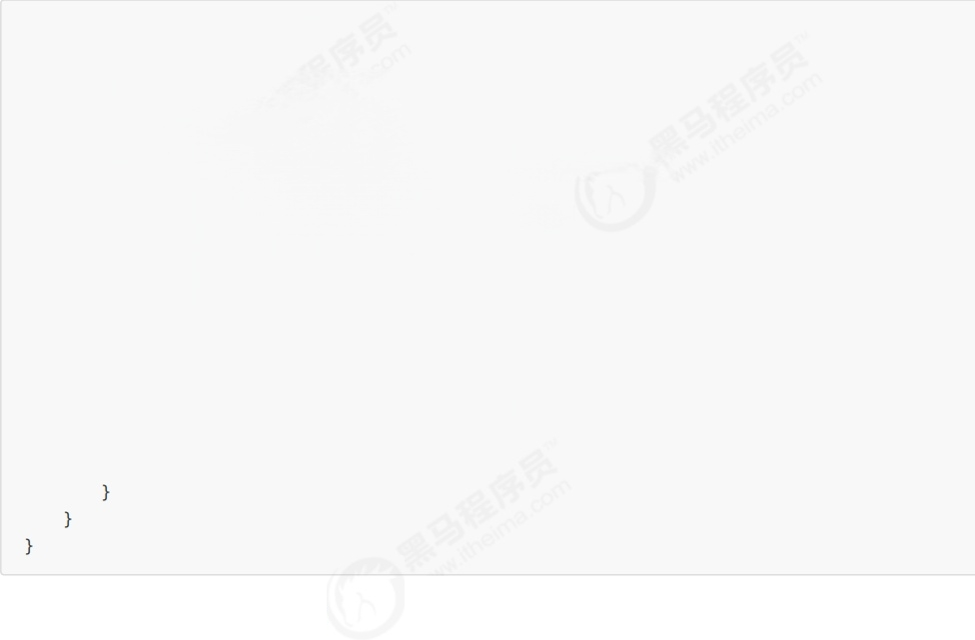
@S1f4j(topic ="c.FileReader")
public class FileReader {
public static void read( String filename){
int idx =filename.lastIndexOf(File.separator);
String shortName = filename.substring(idx +1);
try (FileInputStream in =new FileInputStream(filename)){
long start = System.currentTimeM illis();
log.debug( "read [{}]start ...",shortName);
byte []buf = new byte[1024 ];
int n =- 1;
do {
n = in.read(buf);
} while (n !=- 1);
long end = System. currentTimeMillis ();
log .debug( "read [{}]end..cost:{}ms", shortName,end -start);
} catch (IOException e){
e.printStackTrace();

没有用线程时，方法的调用是同步的：

北京市昌平区建材城西路金燕龙办公楼一层 电话：400-618-9090

@S1f4j(topic ="c.Sync") public class Sync {
public static void main( String []args){
String fullPath ="E:\\1.mp4";
FileReader.read(fullPath);
log.debug ("do other things ...");
输出
18:39:15 [main]c.FileReader -read [1.mp4] start ...
18:39:19 [main]c.FileReader -read [1.mp4]end ...cost:4090 ms
18:39:19 [main]c.Sync - do other things ...
使用了线程后，方法的调用时异步的：

private static void test1 (){
new Thread(()-> FileReader.read(Constants.MP4_FULL_PATH)).start();
log. debug( "do other things ...");

输出

18:41:53 [main]c.Async -do other things ..
18:41:53[Thread-0]c.FileReader -read [1.mp4]start ..
18:41:57 [Thread-0]c.FileReader -read [1.mp4]end ...cost:4197 ms

2. 线程池实现
private static void test2 (){
ExecutorService service =Executors.newFixedThreadPool(1);
service.execute (()-> FileReader. read(Constants. MP4_FULL_PATH));
log. debug("do other things ...");
service.shutdown(); }
输出

11:03:31.245 | c.TestAsyc [main]-do other things | .
11:03:31.245 | c.FileReader [pool-1-thread-1] -read | [1.mp4]start ...
11:03:33.479 | c.FileReader [pool-1-thread-1]-read | [1.mp4]end ...cost:2235 | ms

北京市昌平区建材城西路金燕龙办公楼一层 电话：400-618-9090

3.CompletableFuture 实现
private static void test3()throws IOException {
CompletableFuture.runAsync (()-> FileReader.read(Constants.MP4_FULL_PATH));
log. debug("do other things ..");
System.in.read();

输出

11:09:38.145 c.TestAsyc [main]-do other things ..
11:09:38.145 c.FileReader [ForkJoinPool.commonPool-worker-1]-read | [1.mp4]start … ..
11:09:40.514 c.FileReader [ForkJoinPool.commonPool-worker-1]-read | [1.mp4]end ...cost:2369 | ms

缓存
1.缓存更新策略
更新时，是先清缓存还是先更新数据库 先清缓存
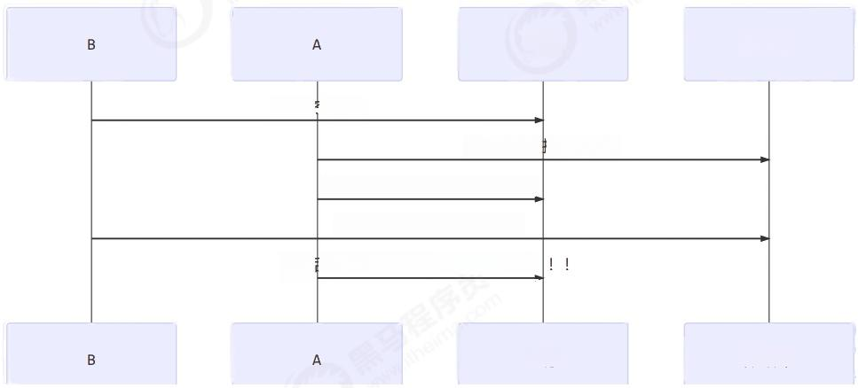  缓存  1)清空缓存  2)查询数据库( x=1)  3)将查询结果放入缓存( x=1)  4)将新数据存入库( x=2)  5)后续查询将一直是旧值( x=1)!  缓存 | 数据库  数据库
先更新数据库

北京市昌平区建材城西路金燕龙办公楼一层 电话：400-618-9090

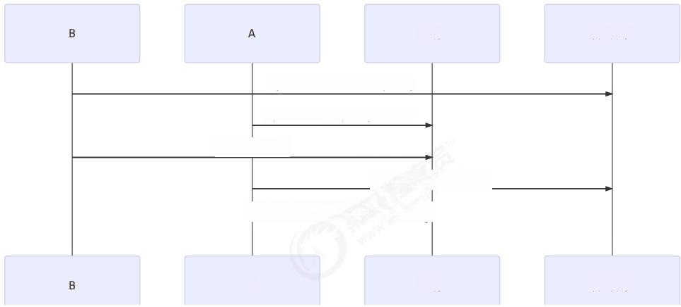
缓存
数据库

1)将新数据存入库(x=2)
2)查询缓存(x=1)!!!
3)清空缓存
4)查询数据库(x=2)
5)后续查询可以得到新值(x=2)

A 缓存 数据库

补充一种情况，假设查询线程A 查询数据时恰好缓存数据由于时间到期失效，或是第一次查询

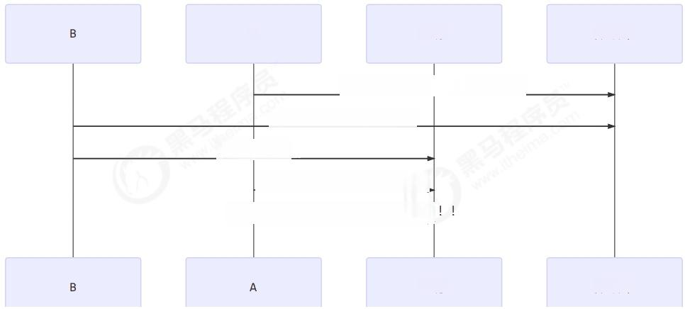
A 缓存
数据库

1)缓存没有，查询数据库(x=1)
2)将新数据存入库(x=2)
3)清空缓存
4) 将查询结果放入缓存( x=1)
5) 后续查询将一直是旧值(x=1)!

缓存 数据库

这种情况的出现几率非常小，见facebook论 文

2. 读写锁实现一致性缓存
使用读写锁实现一个简单的按需加载缓存
class GenericCachedDao<T>{
//HashMap 作为缓存非线程安全，需要保护
HashMap<SqlPair,T>map =new HashMap<>();

ReentrantReadwriteLock lock =new ReentrantReadwriteLock(); GenericDao genericDao =new GenericDao();
public int update(String sql,Objec t... params){
SqlPair key =new SqlPair(sql,params);
//加写锁，防止其它线程对缓存读取和更改

北京市昌平区建材城西路金燕龙办公楼一层 电话：400-618-9090

lock.writeLock().lock();
try {
int rows =genericDao.update(sql,params);
map.clear( );
return rows;
}finally {
lock.writeLock().unlock();

public T queryOne(Class<T>beanClass, String sql, Object ...params){ SqlPair key =new SqlPair(sql,params);
// 加读锁，防止其它线程对缓存更改
lock. readLock().lock();
try {
T value = map.get (key);
if (value != null ){
return value;
}
}finally {
lock.readLock().unlock(); }
// 加写锁，防止其它线程对缓存读取和更改
lock. writeLock (). lock ();
try {
// get 方法上面部分是可能多个线程进来的，可能已经向缓存填充了数据 // 为防止重复查询数据库，再次验证
T value = map.get(key);
if (value == null ){
// 如果没有，查询数据库
value =genericDao.queryOne(beanClass, sql, params);
map.put(key,value);
}
return value;
}finally {
lock.writeLock().unlock();

//作为 key 保证其是不可变的
class SqlPair {
private String sql;
private Object[] params;
public SqlPair(String sql, Object [] params){
this. sql = sql;
this. params = params; }

@Override
public boolean equals (Object o){
if ( this == o){

return true;
if(0== null |l getClass()!= 0.getClass()){ return false ;
SqlPair sqlPair =(SqlPair)o;
return sql.equals(sqlPair.sql) &&
Arrays. equals(param s, sq1Pair. params);

@Override
public int hashCode(){
int result = Objects.hash(sql);
result =31* result +Arrays.hashCode(params); return result;
注意
· 以上实现体现的是读写锁的应用，保证缓存和数据库的一致性，但有下面的问题没有考虑
o 适合读多写少，如果写操作比较频繁，以上实现性能低
o 没有考虑缓存容量
o 没有考虑缓存过期
o 只适合单机
o 并发性还是低，目前只会用一把锁
o 更新方法太过简单粗暴，清空了所有 key( 考虑按类型分区或重新设计 key)
· 乐观锁实现：用CAS去更新
分治

1. 案例-单词计数
private static <V> void demo(Supplier<Map<S tring ,V>> supplier,BiConsumer<Map <String ,V>,
List< String >> consumer){
Map<String, V> counterMap =supplier.get();
List<Thread >ts = new ArrayList<>();
for (int i=1;i<= 26; i++){
int idx = i;
Thread thread =new Thread(() ->{
List <String> words =readFromFile(idx);
consumer.accept(counterMap, words);
});
ts.add(thread);

->t.start()); ->{
ts.forEach(t
ts.forEach(t

t.join ( );
} catch (InterruptedException e){
e.printStackTrace();

});

System.out.println(counterMap);

public static List<String> readFromFile (int i){
ArrayList <String> words =new ArrayList<>();
try (BufferedReade r in =new BufferedReader(new InputStreamReader(new FileInputstream( "tmp/" + i +".txt" )))){
while ( true ) {
String word = in.readLine();
if (word == null ){
break ;
words.add(word);

return words;
} catch (IOException e){
throw new RuntimeException(e);
解法1:

() -> new ConcurrentHashMap<String ,LongAdder>(), (map,words)->{
for(String word :words){
map.computeIfAbsent(word,(key )->new LongAdder()).increment();
解法2:
Map<String, Integer >collect =IntStream.range(1,27). parallel()
.mapToObj(idx -> readFromFile(idx))
.flatMap(list -> list.stream())
.collect(Collectors. groupingBy(Function.identity(),Collectors. summingInt(w -> 1)));

2. 案例-求和
class AddTask3 extends RecursiveTask<Integer>{
int begin;
int end;

public AddTask3(int begin, int end){ this. begin = begin;
this. end = end; }
@Override
public String toString(){
return "{"+ begin +","+end +'}'; }
@Override
protected Integer compute(){
//5,5
if (begin == end){
log. debug( "join (){ }", begin);
return begin;

//4, 5
if (end - begin == 1){
log. debug("join(){}+{}={}", begin, end,end +begin); return end + begin;

// 15
int mid = (end + begin) /2; 113

AddTask3 t1 = new AddTask3(begin, mid); //1,3
t1.fork ();
AddTask3 t2 =new AddTask3(mid+1,end); //4,5
t2.fork();
log. debug("fork(){}+{}=? ",t1,t2);

int resu lt =t1.join()+ t2.j oin();
log.debug( "join (){}+{}={}", t1,t2,result);
return result;

然后提交给ForkJoinPool来执行
public static void main(String []args){
ForkJoinPool pool =new ForkJoinPool(4);
System.out.println(pool. invoke(new AddTask3(1,10)));
结果

[ForkJoinPool-1-worker-0]-join()1+2=3
[ForkJoinPool-1- worker-3]-join()4+5=9
[ForkJoinPool-1- worker- 0]- join ()3
[ForkJoinPool-1-worker- 1]-fork(){1,3}+{4,5}=?
[ForkJoinPool-1-worker- 2]-fork(){1,2}+{3,3}=?
[ForkJoinPool-1-worker- 2]-join(){1,2}+{3,3}=6
[ForkJoinPool-1-worker- 1]-join(){1,3}+{4,5}=15 15
统筹
案例-烧水泡茶 解法1:join
Thread t1 = new Thread(() ->{
log. debug("洗水壶");
sleep (1) ;
log. debug(" 烧开水");
sleep (15); }, "老王");
Thread t2 = new Thread(() ->{
log. debug("洗茶壶");
sleep (1);
log. debug("洗茶杯");
sleep (2);
log. debug("拿茶叶");
sleep (1);
try {
t1.join () ;
} catch (InterruptedException e){ e.printStackTrace();
}
log. debug( "泡茶"); }, "小王");
t1.start ();
t2.start();
输出
19:19:37.547 [小王] c .TestMakeTea - 洗茶壶
19:19:37.547 [老王] c.TestMakeTe a - 洗水壶
19:19:38.552 [小王] c.TestMakeTea - 洗茶杯
19:19:38.552 [老王] c.TestMakeTea - 烧开水
19:19:40.553 [小王] c .TestMakeTea - 拿茶叶
19:19:53.553 [小王] c .TestMakeTea - 泡茶
解法1的缺陷：

·上面模拟的是小王等老王的水烧开了，小王泡茶，如果反过来要实现老王等小王的茶叶拿来了，老王泡茶 呢?代码最好能适应两种情况
·上面的两个线程其实是各执行各的，如果要模拟老王把水壶交给小王泡茶，或模拟小王把茶叶交给老王泡茶 呢

解法2:wait/notify

class S2 {
static String kettle ="冷水";
static String tea = null;
static final Object lock = new Object ();
static boolean maked = false;
public static void makeTea(){
new Thread(() ->{
log. debug(" 洗水壶");
sleep (1);
log. debug("烧开水");
sleep (5) ;
synchronized (lock){
kettle =" 开水";
lock. notifyAl1( );
while (tea == null ){ try {
lock.wait();
} catch (InterruptedException e){ e.printStackTrace();

if ( !maked){
log. debug("拿({})泡({})",kettle,tea);
maked = true;

}, "老王"). start ();

new Thread(() ->{
log. debug( "洗茶壶");
sleep (1) ;
log. debug("洗茶杯");
sleep (2) ;
log . debug( "拿茶叶");
sleep (1);
synchronized (lock){
tea = "花茶";
lock. notifyAl1 ();
while (kettle. equals ("冷水")){ try {
lock.wait();
} catch (InterruptedException e){ e.printStackTrace();

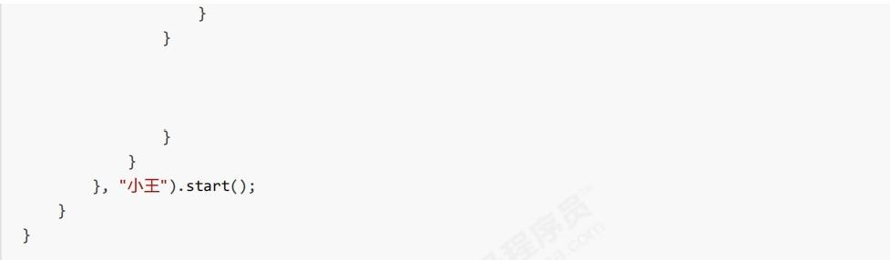

if ( !maked){
log. debug("拿({})泡({})",kettle,tea);
maked = true;

输出

20:04:48.179 | c.S2 [ 小王]-洗茶壶
20:04:48.179 | c.S2 [ 老王]-洗水壶
20:04:49.185 | c.S2 [ 老 王 ]- 烧 开 水
20:04:49.185 | c.S2 [ 小 王 ]- 洗 茶 杯
20:04:51.185 | c.S2 [ 小 王 ]- 拿 茶 叶
20:04:54.185 | c.S2 [ 老王]-拿(开水)泡(花茶)

解法2解决了解法1的问题，不过老王和小王需要相互等待，不如他们只负责各自的任务，泡茶交给第三人来做
解法3:第三者协调
class S3 {
static String kettle ="冷水";
static String tea = null;
static final Object lock = new Object ();

public static void makeTea(){
new Thread(() ->{
log. debug("洗水壶");
sleep (1) ;
log. debug(" 烧开水");
sleep (5);
synchronized (lock){ kettle ="开水";
lock. notifyA l1( ); }, "老王"). start ();
new Thread(() ->{
log . debug(" 洗茶壶");
sleep (1);
log. debug("洗茶杯");
sleep (2) ;
log. debug( "拿茶叶");
sleep (1);
synchronized (lock){ tea = "花茶";
lock. notifyAl1( );

},"小王"). start();

new Thread(() ->{
synchronized (lock){
while (kettle. equals( "冷水") || tea == null){ try {
lock.wait();
} catch (InterruptedException e){ e.printStackTrace();

log. debug("拿({})泡({})",kettle, tea);
输出

20:13:18.202 | c.S3 [ 小 王 ]- 洗 茶 壶
20:13:18.202 | c.S3 [ 老王]-洗水壶
20:13:19.206 | c.S3 [ 小王]-洗茶杯
20:13:19.206 | c.S3 [ 老 王 ]- 烧 开 水
20:13:21.206 | c.S3 [ 小王]-拿茶叶
20:13:24.207 | c.S3 [ 王夫人]-拿(开水)泡(花茶)

定时

1. 定期执行
如何让每周四18:00:00定时执行任务?

// 获得当前时间
LocalDateTime now =LocalDateTime.now(); //获取本周四18:00:00.000
LocalDateTime thursday =
now.with(DayofWeek.THURSDAY).withHour(18). withMinute(0).withSecond(θ).withNano(θ); //如果当前时间已经超过本周四18:00:00.000,那么找下周四18:00:00.000
if (now.compareTo(thursday)>=0){
thursday =thursday.plusWeeks(1);

//计算时间差，即延时执行时间
long initialDelay =Duration. between(now,thursday). toMillis();
//计算间隔时间，即1 周的毫秒值
long oneWeek =7*24*3600*1000;

ScheduledExecutorService executor =Executors.newScheduledThreadPool(2);

System.out.println( "开始时间："+ new Date()); executor.scheduleAtFixedRate (()->{
System.out.println( "执行时间："+ new Date());
}, initialDelay, oneWeek,TimeUnit. MILLISECONDS);

