# Protocol - Tourplaner

## Wireframe

The planning started with a wireframe diagram.

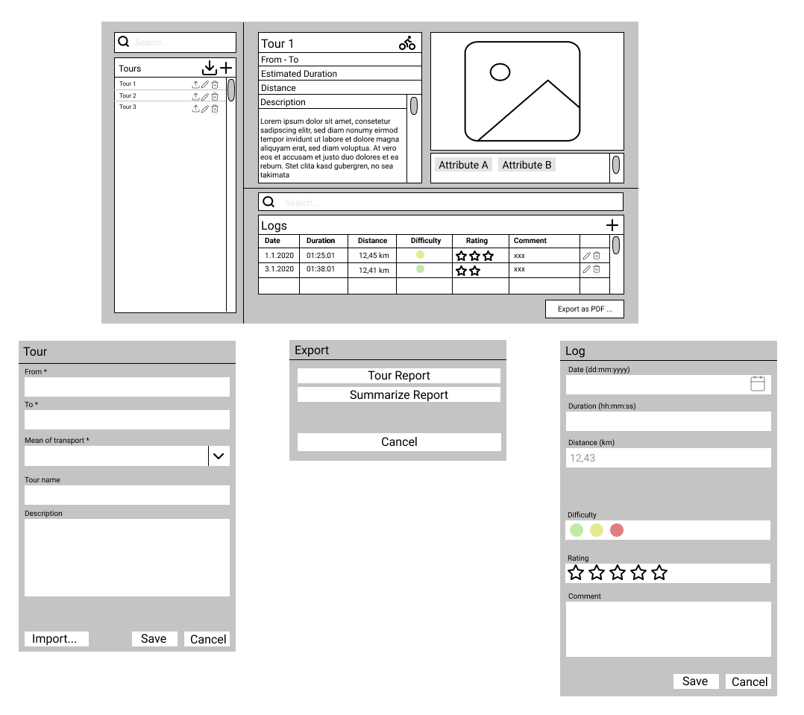

## Decisions

The project is structured in REST-Server and Application. The Application has a 3 Layer Architecture, including the MVVM Pattern to separate UI from logic.

We chose ASP.NET Core to set up a simple REST-Server. While we chose DynamicPDF for our reporting framework.

## Application architecture

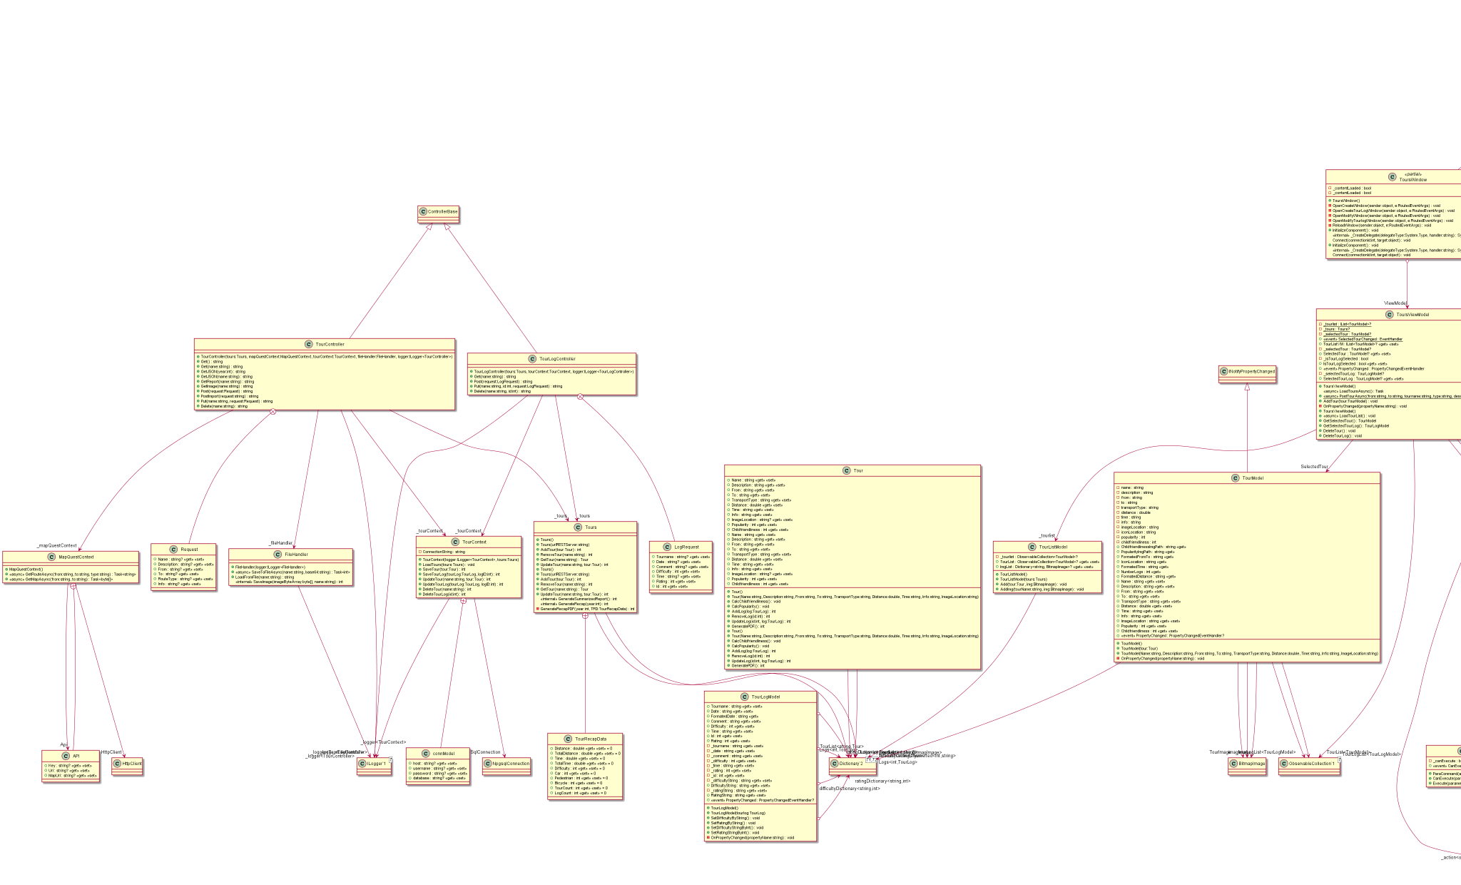

## 

## 

## Unit Tests

The chosen Unit Test mainly covers the CRUD functions of the REST-Server for the Tours and Tour Logs which are the quintessential part of our application. Therefore it is critical to test these features thoroughly.

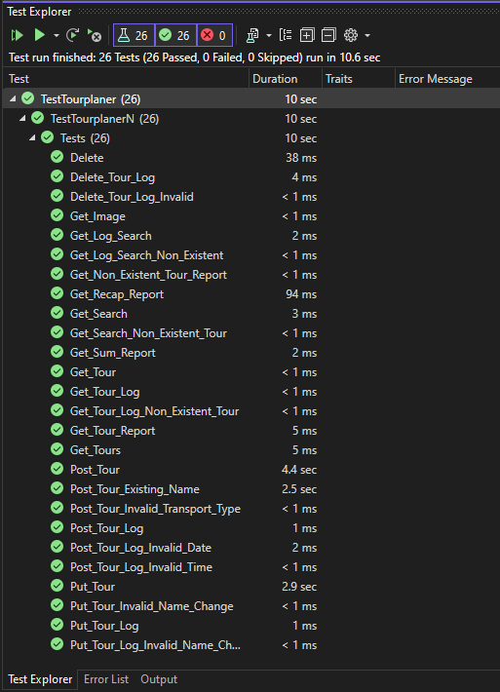

## Use Case Diagram

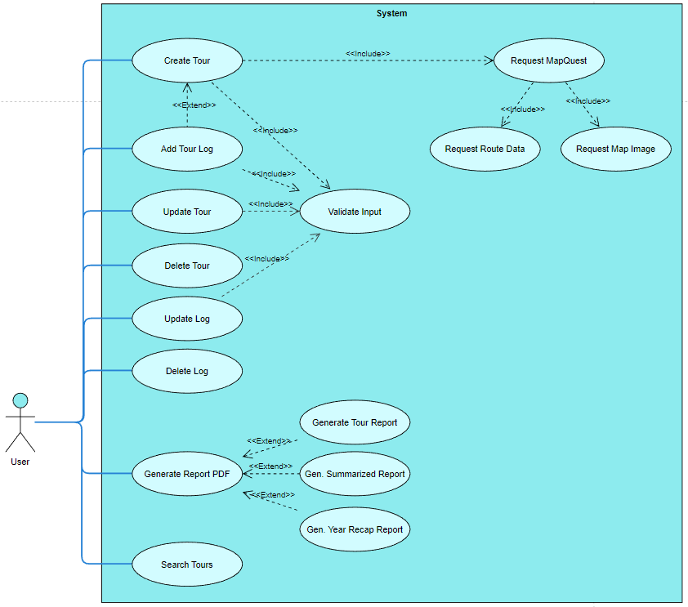

## Time spent

180 +/- 10 Stunden

## Git Link

https://github.com/kjubie/SWE-Routenplaner