
PROJECT REPORT
Hybrid DenseNet-121 and Quantum Circuit Classification of Medical Images
Diabetic retinopathy, LIDC lung and Y-Net Capsule experiments
Submitted by: Khushboo Talaviya,Karunya Agarwal,Kunal Jhindal
PRN / Roll No.: 24070126080,24070126090,24070126098
Course: DEEP LEARNING
Guide: Dr. Ananya Bhattacharjee
Date:25/10/26

DEPARTMENT OF ARTIFICIAL INTELLIGENCE & MACHINE LEARNING
SYMBIOSIS INSTITUTE OF TECHNOLOGY, PUNE
AY 2026-27

Contents
1. Abstract
2. Objectives
3. Project overview
4. Shared methodology
5. Experiment 1: diabetic retinopathy grading (DDR)
6. Experiment 2: LIDC lung images
7. Experiment 3: Y-Net Capsule images
8. Cross-experiment comparison
9. Limitations
10. Reproducibility

1. Abstract
This project applies one hybrid pipeline to three medical image datasets: a pretrained DenseNet-121 classifier, a 4-qubit variational quantum circuit (VQC) trained on features taken from that network, a rule-based uncertainty layer that recommends manual review, and Grad-CAM++ heatmaps. The three experiments are diabetic retinopathy (DR) grading on the DDR data (five ordered grades, 512 x 512), three-class classification of LIDC lung images (benign, malignant, normal, 224 x 224), and the same three-class task on a second archive called Y-Net Capsule.
On the held-out test sets, DenseNet-121 C for DR reaches 80.91% accuracy, 0.6579 macro F1 and 0.8129 quadratic weighted kappa (QWK) on 3,725 images. On LIDC, DenseNet-121 and the VQC both reach 85.42% accuracy on 48 images, with macro F1 of 0.8494 and 0.8521. On Y-Net Capsule, DenseNet-121 reaches 98.92% accuracy and 0.9778 macro F1 on 93 images, and the VQC reaches 97.85% and 0.9628. Probability-level fusion of the two models gave the same test predictions as one of them in both three-class experiments, so it added nothing measurable. The VQC has 39 trainable parameters in the three-class setting and matches or trails the DenseNet in every experiment.
All results come from one training seed per experiment. The two three-class test sets are small, and the Capsule archive shows an image-size difference between its classes, so the very high Capsule scores need careful reading. Neither Y-Net archive contains segmentation masks, so no Y-Net segmentation model was trained or evaluated.

2. Objectives
• Fine-tune DenseNet-121 on three medical image datasets and select every checkpoint by validation macro F1, never by test performance.
• Train and evaluate a 4-qubit VQC on DenseNet features and compare it with the DenseNet it depends on.
• Test probability-level fusion of the DenseNet and VQC outputs, with the fusion weight chosen on validation data only.
• Report accuracy, macro and weighted F1, per-class precision, recall and F1, and confusion matrices for every model, plus QWK where the classes are ordered.
• Add a transparent uncertainty layer and Grad-CAM++ explanations to each experiment.
• Build the LIDC and Capsule experiments with leakage-aware splits, so that transformed copies of one source image never appear in more than one split.

3. Project overview
The project consists of three Google Colab notebooks. The DR notebook is the final version of the retinal study. The LIDC and Capsule notebooks adapt it to nominal three-class tasks. They load no checkpoints, features or tables from any other notebook, and every model in them is trained or evaluated afresh.
Table 1. The three experiments
Experiment | Data | Classes | Network input | Split (train / val / test) | GPU
1. DR | DDR retinal images, cached 512 x 512 with CLAHE | 5 ordered grades | 512 x 512 | 6,210 / 2,487 / 3,725 | Tesla T4
2. LIDC | LIDC_Y-Net archive, 1,924 files, 319 source images | benign, malignant, normal | 224 x 224 | 223 / 48 / 48 | Tesla T4
3. Capsule | Y-Net_Capsule archive, 1,608 files, 615 source images | benign, malignant, normal | 224 x 224 (after a 256 x 256 pre-resize) | 430 / 92 / 93 | A100 40 GB

The LIDC and Capsule archives are named after Y-Net, a segmentation architecture, but both contain class folders only. The notebooks state that no segmentation masks are present, so this project reports image classification results and no segmentation results. The notebooks also do not state the imaging modality or clinical source of either archive.

4. Shared methodology

4.1 DenseNet-121
All three experiments use the timm densenet121 model. The DR experiment loads saved checkpoints (variants B and C) and fine-tunes C. The LIDC and Capsule experiments start from ImageNet weights, replace the classifier with three outputs and use dropout 0.2. Class weights are the inverse square root of the training class counts, scaled to a mean of one. Checkpoints are chosen by validation macro F1 with a minimum improvement of 0.001. The settings are listed below.
Table 2. Training configuration of the three DenseNet-121 runs
Setting | DR (fine-tuning C) | LIDC | Capsule
Starting weights | dn121_512_c_best.pt | ImageNet | ImageNet
Optimizer | AdamW, lr 1e-5, wd 1e-4 | AdamW, lr 1e-4, wd 1e-4 | AdamW, lr 1e-4, wd 1e-4
Batch size | 16 (32 for evaluation) | 16 | 16
Epochs / patience | 100 / 99 | 100 / 98 | 100 / 98
Augmentation | Horizontal flip | Horizontal flip, rotation up to 7 degrees | Horizontal flip, rotation up to 7 degrees
Dropout | 0.3 | 0.2 | 0.2
Precision | Mixed (autocast) | Mixed (autocast) | Mixed (autocast)
Seed | 42 | 42 | 42
Software | PyTorch 2.11.0 (CUDA 13.0 build) | PyTorch 2.11.0, timm 1.0.30, PennyLane 0.45.1 | PyTorch 2.11.0, timm 1.0.30, PennyLane 0.45.1

4.2 Variational quantum circuit
In the LIDC and Capsule notebooks the 1,024-dimensional DenseNet embedding of each image is standardized, reduced to four principal components and rescaled to the range 0 to pi. All three transforms are fitted on training images only and then applied to validation and test images. The four values enter a PennyLane default.qubit circuit with Y-rotation angle embedding and two StronglyEntanglingLayers on four qubits. Pauli-Z expectation values feed a linear layer from four values to three classes. The circuit has 24 weights and the linear layer has 15 parameters, so the model has 39 trainable parameters. It trains on the CPU with Adam (learning rate 0.02, weight decay 1e-4, batch size 16, 100 epochs, patience 98).
Four components keep only a small part of the embedding variance: 35.28% for LIDC (components 0.1538, 0.1147, 0.0429, 0.0414) and 36.18% for Capsule (0.2208, 0.0652, 0.0406, 0.0353). The DR notebook evaluates a saved VQC checkpoint on four saved features per image. Its layer count is read from the checkpoint and is not printed.

4.3 Probability-level fusion
The LIDC and Capsule notebooks combine the two models as w x P(DenseNet) + (1 - w) x P(VQC). The DenseNet weight w is searched from 0.10 to 0.90 in steps of 0.05, which keeps both weights above zero. The best w is the one with the highest validation macro F1, with validation accuracy as the tie-breaker. The test set plays no part in the search.

4.4 Neuro-symbolic uncertainty layer
The layer recommends manual review and does not retrain anything. The DR version reads the DenseNet C probabilities and uses three rules that rely on the grade order. The two three-class versions read the fused probabilities, and because the classes are nominal they use only two rules, shown below. All thresholds are illustrative values and are not clinically validated.
Table 3. Uncertainty rules
Experiment | Rule | Quantity | Fires when
DR | LOW_CONFIDENCE | Top-class probability | Below 0.55
DR | GRADE_INCONSISTENCY | Probability on the predicted grade and its two neighbours | Below 0.70
DR | HIGH_UNCERTAINTY | Shannon entropy | Above 1.25 (maximum ln 5 = 1.609)
LIDC, Capsule | LOW_CONFIDENCE | Top-class probability | Below 0.60
LIDC, Capsule | HIGH_UNCERTAINTY | Entropy divided by ln 3 | Above 0.75

4.5 Grad-CAM++
Heatmaps come from DenseNet-121 only, using the last dense block (features.denseblock4) as the target layer. A forward hook stores the activations and gradients for the predicted class. Channel weights follow the Grad-CAM++ formula with squared and cubed gradients. The map is clipped at zero, scaled to the range 0 to 1, resized to the input size and overlaid with the jet colour map at 42% opacity. Each notebook explains the first test image of every true class. A heatmap does not segment anything and is not clinical evidence.

4.6 Metrics
Every model is scored on its test set with accuracy, macro precision, macro recall, macro F1, weighted F1, a per-class report and a confusion matrix. QWK is reported for DR only, because the lung and Capsule classes have no order. The LIDC and Capsule notebooks print precision, recall and support for each class but draw confusion matrices as colour images without counts. Because those test sets have only three classes, the printed values fix the counts exactly, and this report shows the matrices as counts reconstructed from them.

5. Experiment 1: diabetic retinopathy grading (DDR)

5.1 Data and models
This experiment grades DR into five classes: No DR, Mild, Moderate, Severe and Proliferative. The notebook reads cached 512 x 512 images prepared with CLAHE contrast enhancement. The training, validation and test splits hold 6,210, 2,487 and 3,725 images, which is about 50%, 20% and 30% of the 12,422 images. The notebook prints class counts for the test split only. Images use ImageNet normalization, and the notebook warns that this must match the original training setup before a rerun counts as definitive.
Table 4. DR test split class distribution (3,725 images)
Grade | No DR | Mild | Moderate | Severe | Proliferative | Total
Images | 1,846 | 189 | 1,344 | 71 | 275 | 3,725
Share | 49.56% | 5.07% | 36.08% | 1.91% | 7.38% | 100%

Three models are compared. DenseNet-121 B is the baseline and DenseNet-121 C is the primary model, and the notebook does not state how they differ beyond their checkpoints. The VQC is a saved 4-qubit checkpoint evaluated on four saved features per image, and an assertion confirms that its labels match the test CSV order. The test set is never used for training or checkpoint selection. Moderate DR makes up more than a third of the test set, and Severe DR has only 71 images, so one Severe image moves its recall by 1.4 percentage points.

5.2 Fine-tuning DenseNet-121 C
Fine-tuning starts from dn121_512_c_best and writes the best result to a separate file. Each epoch took about 163 seconds on the T4, so the 100 epochs ran for about 4.5 hours (16,328 seconds). The patience of 99 exceeded the epochs remaining after the last improvement, so early stopping never triggered.
Table 5. Selected epochs from the DR fine-tuning log
Epoch | Train loss | Val accuracy | Val macro F1 | Note
1 | 0.2747 | 0.8476 | 0.6798 | First checkpoint saved
4 | 0.2153 | 0.8625 | 0.6912 | Checkpoint saved
8 | 0.1485 | 0.8649 | 0.6942 | Checkpoint saved
87 | 0.0034 | 0.8749 | 0.6985 | Final checkpoint
89 | 0.0017 | 0.8782 | 0.6994 | Gain below 0.001
93 | 0.0018 | 0.8778 | 0.6994 | Gain below 0.001
100 | 0.0020 | 0.8641 | 0.6706 | Last epoch

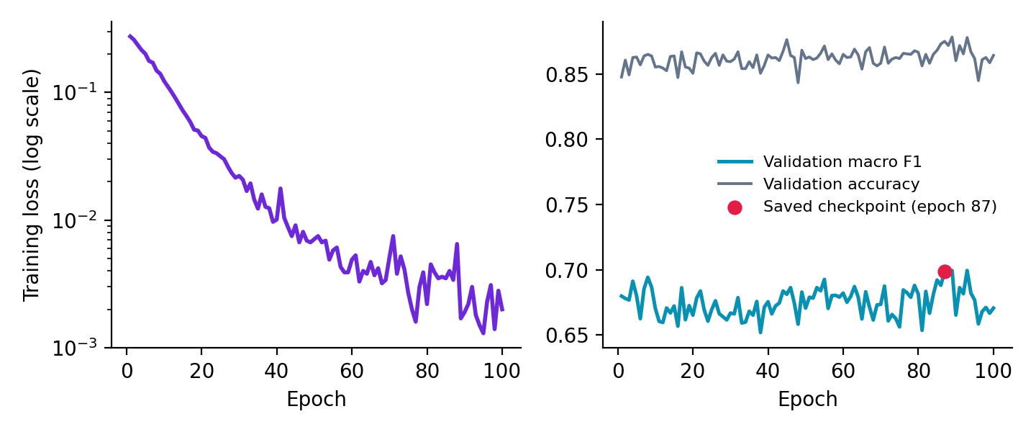
Figure 1. DR fine-tuning history of DenseNet-121 C
Training loss fell from 0.2747 to 0.0020, yet validation macro F1 stayed between 0.6519 and 0.6994 and validation accuracy between 0.8432 and 0.8782. The best validation macro F1 moved from 0.6798 after one epoch to 0.6985 at epoch 87, a gain of 0.0187. Epochs 89 and 93 reached 0.6994, which is 0.0009 above the saved value and under the 0.001 margin, so they did not replace the epoch 87 checkpoint. The scores of the original checkpoint before fine-tuning are not printed.

5.3 Test results
Table 6. DR test metrics recomputed from the saved checkpoints (3,725 images)
Model | Accuracy | Macro precision | Macro recall | Macro F1 | Weighted F1 | QWK
DenseNet B | 0.8013 | 0.7079 | 0.5872 | 0.6146 | 0.7808 | 0.8002
DenseNet C | 0.8091 | 0.7058 | 0.6271 | 0.6579 | 0.8003 | 0.8129
VQC | 0.6948 | 0.5649 | 0.6632 | 0.5711 | 0.7091 | 0.7692

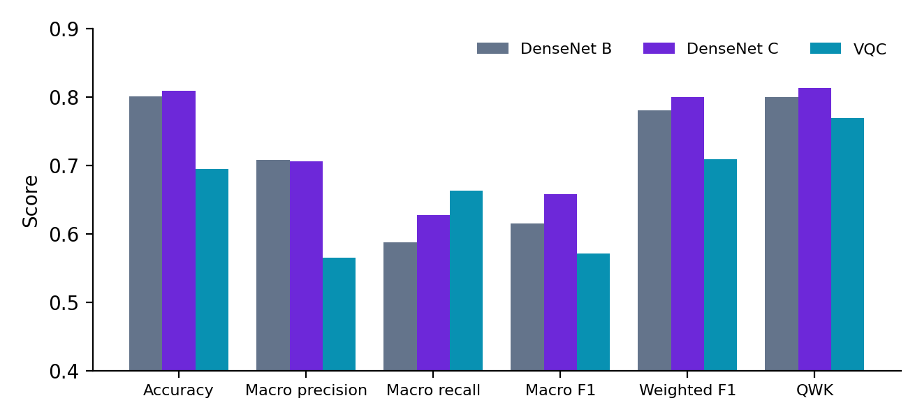
Figure 2. DR test metrics for the three models
DenseNet C leads on accuracy, macro F1, weighted F1 and QWK. Against DenseNet B it adds 0.78 points of accuracy, 4.33 points of macro F1 and 0.0127 of QWK. The VQC has the highest macro recall (0.6632) and the lowest accuracy (0.6948): it finds more rare-grade images and pays with many false alarms.
The notebook header lists an earlier evaluation. DenseNet B and the VQC match the recomputed values. DenseNet C does not, because the recomputed run uses the fine-tuned checkpoint.
Table 7. DenseNet C before and after fine-tuning
Source | Accuracy | Macro F1 | Weighted F1 | QWK
Earlier saved result (notebook header) | 0.7874 | 0.6460 | 0.7830 | 0.8249
Recomputed, fine-tuned checkpoint | 0.8091 | 0.6579 | 0.8003 | 0.8129
Change | +0.0217 | +0.0119 | +0.0173 | -0.0120

Fine-tuning improved accuracy, macro F1 and weighted F1 and lowered QWK by 0.0120. DenseNet C still has the highest QWK of the three models. The notebook calls DenseNet B the accuracy baseline, which no longer holds because the fine-tuned C has higher accuracy.
Table 8. DR per-class precision, recall and F1 on the test set
Grade | Support | DenseNet B (P / R / F1) | DenseNet C (P / R / F1) | VQC (P / R / F1)
No DR | 1,846 | 0.7964 / 0.9854 / 0.8809 | 0.8176 / 0.9762 / 0.8899 | 0.8349 / 0.8629 / 0.8487
Mild | 189 | 0.4545 / 0.0794 / 0.1351 | 0.3590 / 0.2963 / 0.3246 | 0.2073 / 0.6032 / 0.3085
Moderate | 1,344 | 0.8118 / 0.6868 / 0.7441 | 0.8455 / 0.6801 / 0.7538 | 0.7703 / 0.4665 / 0.5811
Severe | 71 | 0.5484 / 0.4789 / 0.5113 | 0.6042 / 0.4085 / 0.4874 | 0.2458 / 0.6197 / 0.3520
Proliferative | 275 | 0.9282 / 0.7055 / 0.8017 | 0.9025 / 0.7745 / 0.8337 | 0.7664 / 0.7636 / 0.7650
Macro average | 3,725 | 0.7079 / 0.5872 / 0.6146 | 0.7058 / 0.6271 / 0.6579 | 0.5649 / 0.6632 / 0.5711
Weighted average | 3,725 | 0.7896 / 0.8013 / 0.7808 | 0.8066 / 0.8091 / 0.8003 | 0.7635 / 0.6948 / 0.7091

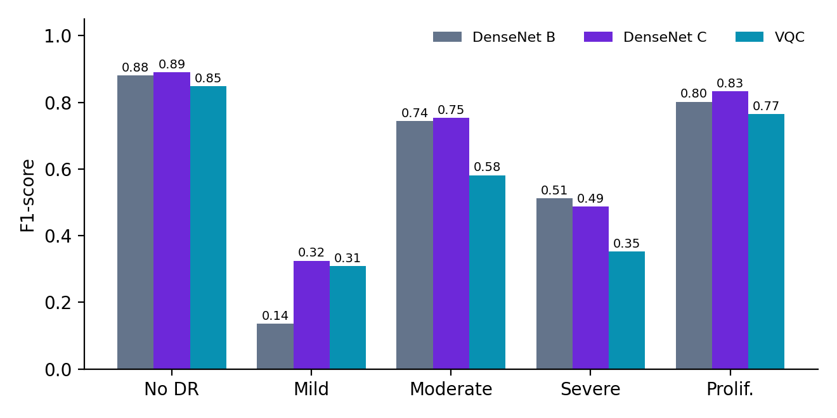
Figure 3. DR per-class F1 on the test set
• No DR and Proliferative are handled well by both DenseNets, with F1 between 0.80 and 0.89.
• Mild is the weakest grade. DenseNet C raises Mild F1 from 0.1351 to 0.3246 and Mild recall from 7.94% to 29.63%, which is 56 of 189 images against 15 for DenseNet B.
• DenseNet B scores slightly higher on Severe (F1 0.5113 against 0.4874), and DenseNet C finds 29 of 71 Severe images against 34.
• The VQC finds 114 Mild and 44 Severe images, the most of any model, but its precision on those grades is only 0.2073 and 0.2458. Its Moderate recall of 46.65% is the lowest of the three.
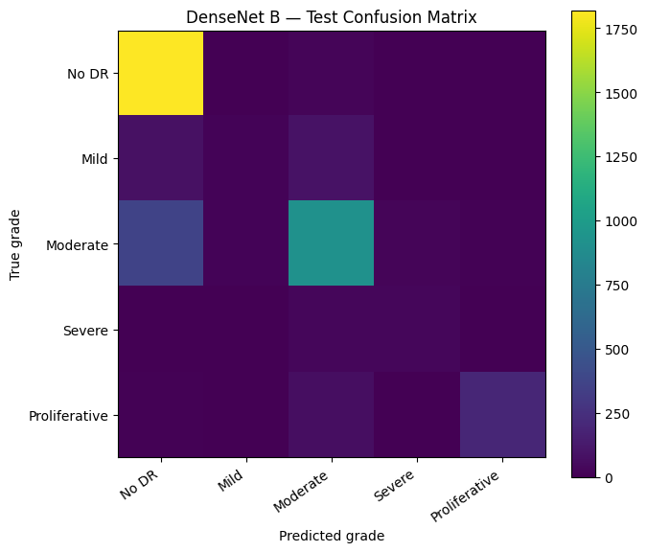 | 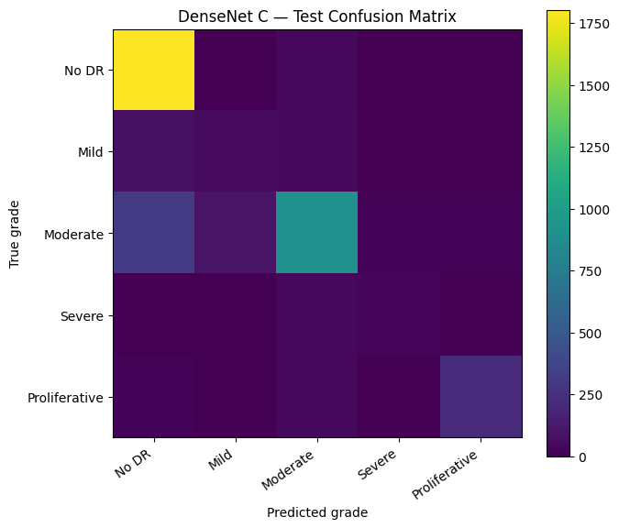
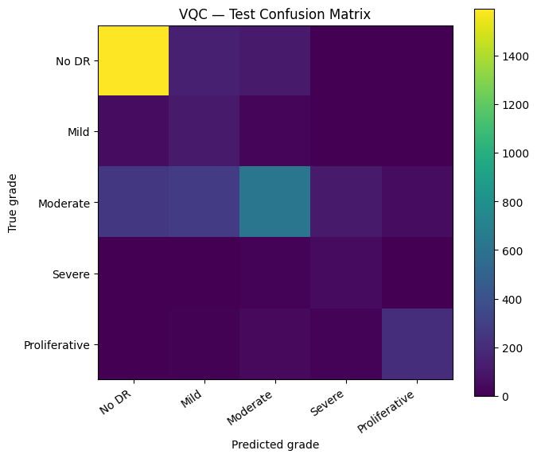

Figure 4. DR test confusion matrices for DenseNet B (top left), DenseNet C (top right) and the VQC (bottom left). Rows are true grades, columns are predictions.
The DR matrices are the notebook images, which show colour intensity without counts, and five classes do not fix the counts from the printed metrics. For both DenseNets the largest off-diagonal block is Moderate images predicted as No DR. The VQC also spreads Moderate images across Mild, Severe and Proliferative, which matches its lower Moderate recall.

5.4 Uncertainty layer
Across the 3,725 test predictions the layer flagged 97 for manual review (2.60%) and left 3,628 (97.40%) unflagged. Per-image results are saved to neuro_symbolic_test_predictions.csv.
Table 9. First ten DR test rows as printed in the notebook
Index | True grade | Predicted | Confidence | Entropy | Neighbour mass | Flagged for review
0 | No DR | No DR | 0.9997 | 0.0031 | 0.9997 | No
1 | No DR | No DR | 1.0000 | 0.0004 | 1.0000 | No
2 | Proliferative | Proliferative | 1.0000 | 0.0000 | 1.0000 | No
3 | Moderate | Mild | 0.5959 | 0.7721 | 1.0000 | No
4 | Moderate | Moderate | 0.6124 | 0.7709 | 0.9735 | No
5 | No DR | No DR | 0.9989 | 0.0092 | 0.9994 | No
6 | Mild | Moderate | 0.9568 | 0.1792 | 0.9569 | No
7 | No DR | No DR | 0.9984 | 0.0133 | 0.9989 | No
8 | No DR | No DR | 0.9999 | 0.0011 | 1.0000 | No
9 | Moderate | Moderate | 0.9999 | 0.0011 | 0.9999 | No

Two of these ten predictions are wrong (rows 3 and 6) and neither is flagged. Row 3 has a confidence of 0.5959, just above the 0.55 limit, and row 6 is a confident error. The rules respond to uncertainty in the probability vector, so a confident wrong answer passes. The saved CSV is not part of the notebook output, so the accuracy of flagged versus unflagged predictions cannot be computed.

5.5 Grad-CAM++ examples
Table 10. DR Grad-CAM++ examples (first test image of each grade)
True grade | DenseNet C prediction | Confidence | Outcome
No DR | No DR | 100.0% | Correct
Mild | Moderate | 95.7% | Wrong
Moderate | Mild | 59.6% | Wrong
Severe | Severe | 98.4% | Correct
Proliferative | Proliferative | 100.0% | Correct

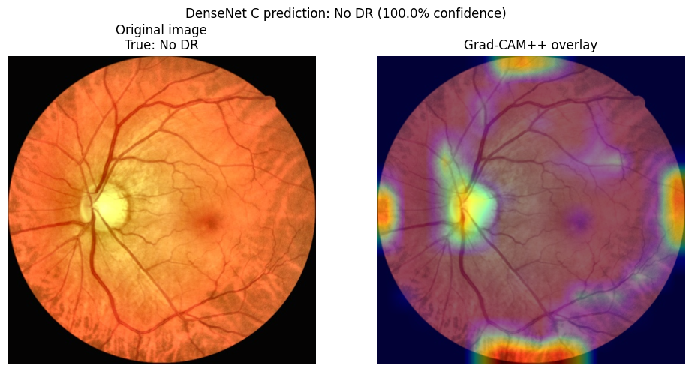 | 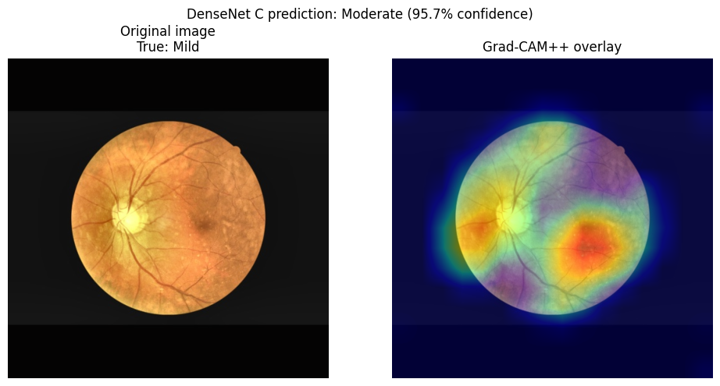
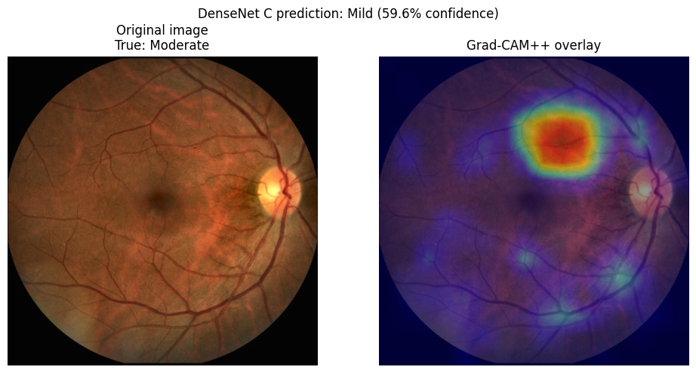 | 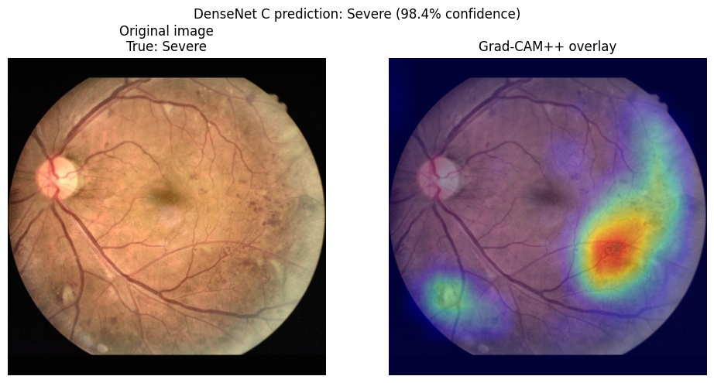
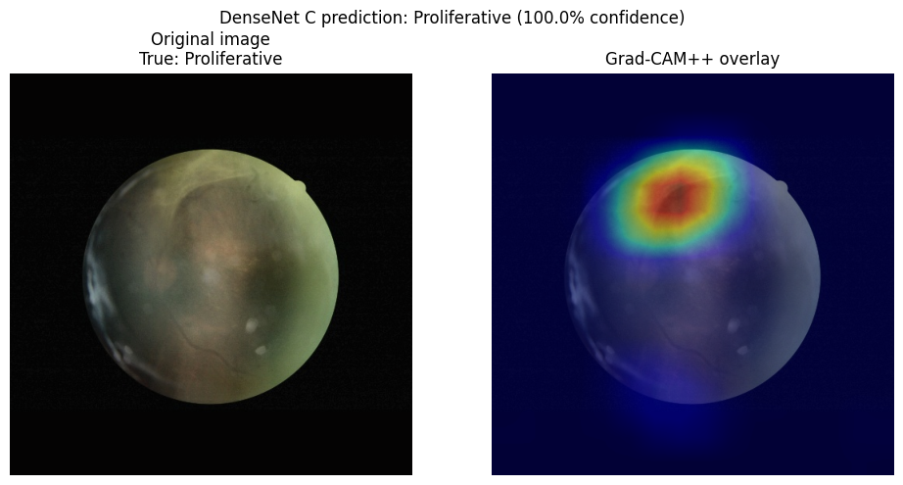

Figure 5. DR Grad-CAM++ overlays, ordered No DR, Mild, Moderate, Severe, Proliferative
• The No DR example highlights the optic disc and the edges of the image, and the Proliferative example highlights a region at the top of the retina.
• The Severe example concentrates on a lower right region of the retina, and each of the two misclassified examples shows one main hot region.
• Heat along the image border in the No DR panel suggests the model may react to acquisition artifacts, which a larger sample would have to confirm.

6. Experiment 2: LIDC lung images

6.1 Dataset audit and split
The LIDC_Y-Net archive holds 1,924 image files in three class folders. Many files are derived copies of one source image, with names ending in cropped, hflip, vflip or rotateflip. Counting those copies as independent samples would let near-duplicates fall in different splits. The notebook therefore keeps one canonical file per source ID (the filename prefix before Resized) and uses augmentation only on the fly during training. The source ID 11_29 appears under more than one class and was excluded, which leaves 319 source images. These were split 70/15/15 by class at the source-image level, before any training.
Table 11. LIDC files, source images and split
Class | Image files | Source images | Train | Validation | Test
benign | 592 | 99 | 69 | 15 | 15
malignant | 666 | 110 | 77 | 16 | 17
normal | 666 | 110 | 77 | 17 | 16
Total | 1,924 | 319 | 223 | 48 | 48

The test set holds 48 images, so each image moves accuracy by 2.1 percentage points.

6.2 DenseNet-121 training
DenseNet-121 learned the task quickly. Validation macro F1 rose from 0.3394 at epoch 1 to 0.7521 at epoch 2 and reached 1.0 at epoch 15, where the final checkpoint was saved. Validation macro F1 then equalled 1.0 in 40 of the 100 epochs, so the 48-image validation set stopped separating epochs. The checkpoint was saved eight times in total (epochs 1, 2, 4, 5, 6, 8, 9 and 15). Training loss fell from 1.0500 to 0.0016.

6.3 VQC training
The VQC reads four principal components that keep 35.28% of the embedding variance. It reached a validation macro F1 of 0.9106 at epoch 2 and its best value of 0.9784 (accuracy 0.9792) at epoch 18, where its checkpoint was saved. Validation macro F1 stayed at 0.9784 for the second half of training while the loss fell from 1.0816 to 0.0117.
Table 12. LIDC training outcomes
Model | Checkpoint epoch | Val macro F1 at checkpoint | Final train loss | Val macro F1 range | Run time
DenseNet-121 | 15 | 1.0000 | 0.0016 | 0.3394 to 1.0000 | 259 s
VQC | 18 | 0.9784 | 0.0117 | 0.3028 to 0.9784 | 31 s

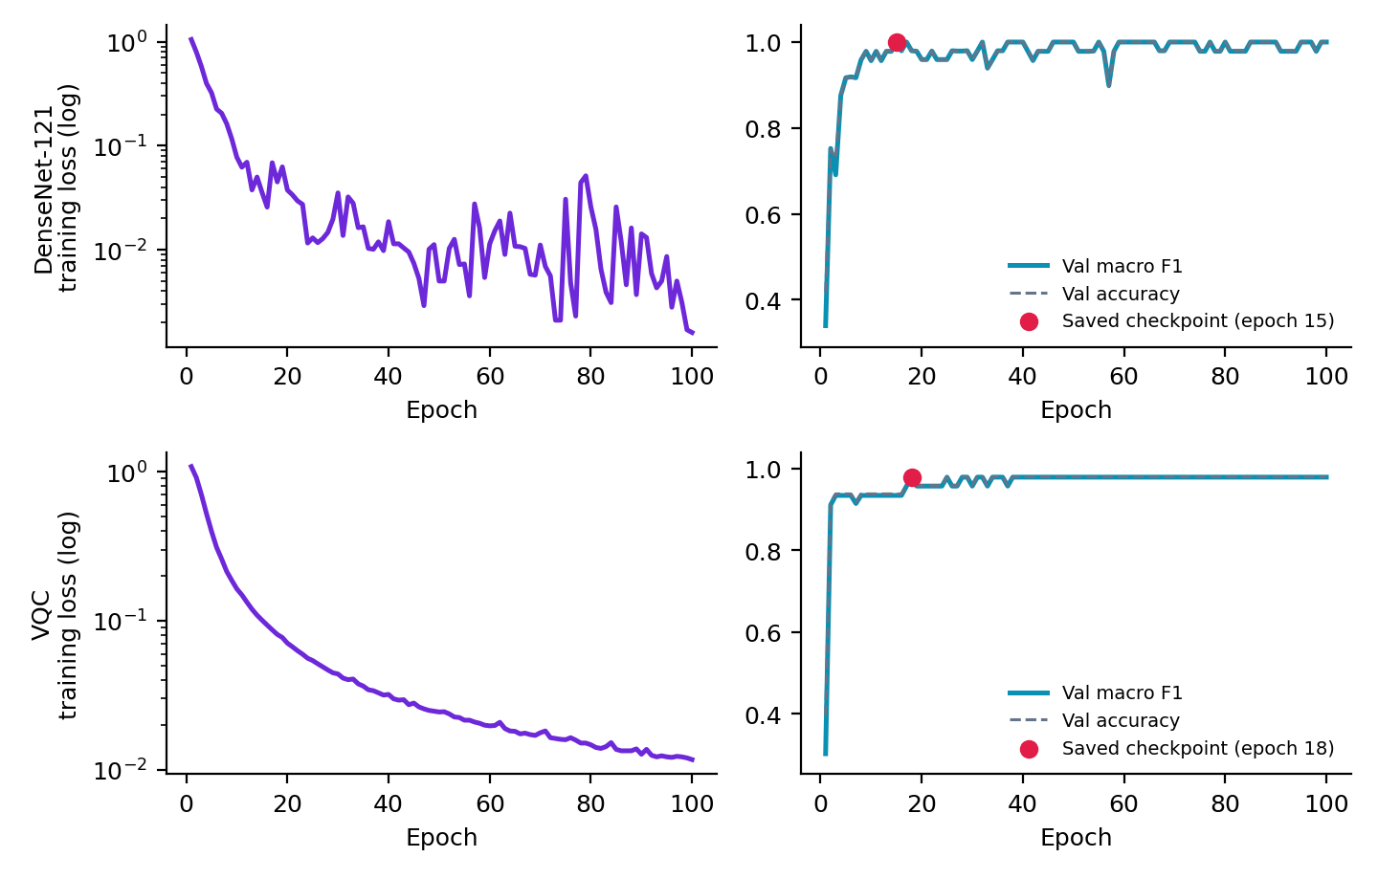
Figure 6. LIDC training histories. Top row: DenseNet-121. Bottom row: VQC. The red dot marks the saved checkpoint.

6.4 Fusion
The validation search selected a DenseNet weight of 0.90 and a VQC weight of 0.10. The search table is saved to fusion_weight_validation_search.csv and is not part of the notebook output.

6.5 Test results
Table 13. LIDC test metrics (48 images)
Model | Accuracy | Macro precision | Macro recall | Macro F1 | Weighted F1
DenseNet-121 | 0.8542 | 0.8611 | 0.8601 | 0.8494 | 0.8476
VQC | 0.8542 | 0.8543 | 0.8575 | 0.8521 | 0.8513
DenseNet + VQC | 0.8542 | 0.8611 | 0.8601 | 0.8494 | 0.8476

Table 14. LIDC per-class precision, recall and F1 on the test set
Class | Support | DenseNet-121 (P / R / F1) | VQC (P / R / F1) | DenseNet + VQC (P / R / F1)
benign | 15 | 0.7778 / 0.9333 / 0.8485 | 0.7647 / 0.8667 / 0.8125 | 0.7778 / 0.9333 / 0.8485
malignant | 17 | 0.9167 / 0.6471 / 0.7586 | 0.8571 / 0.7059 / 0.7742 | 0.9167 / 0.6471 / 0.7586
normal | 16 | 0.8889 / 1.0000 / 0.9412 | 0.9412 / 1.0000 / 0.9697 | 0.8889 / 1.0000 / 0.9412

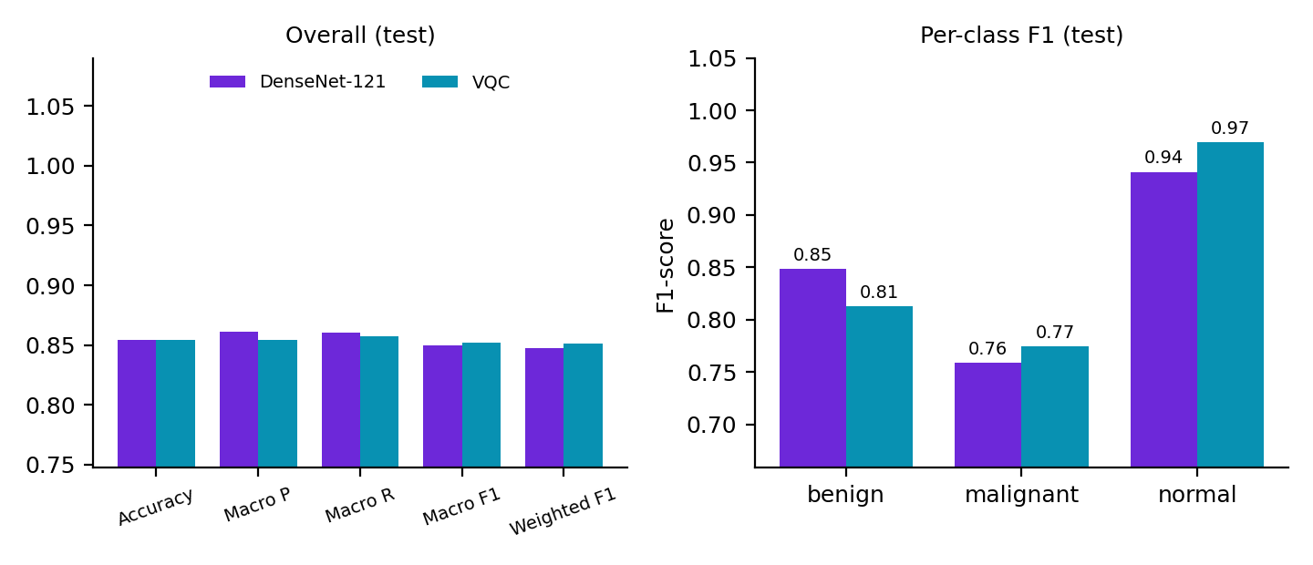
Figure 7. LIDC test metrics. The fused model matches DenseNet-121 exactly and is not drawn separately.
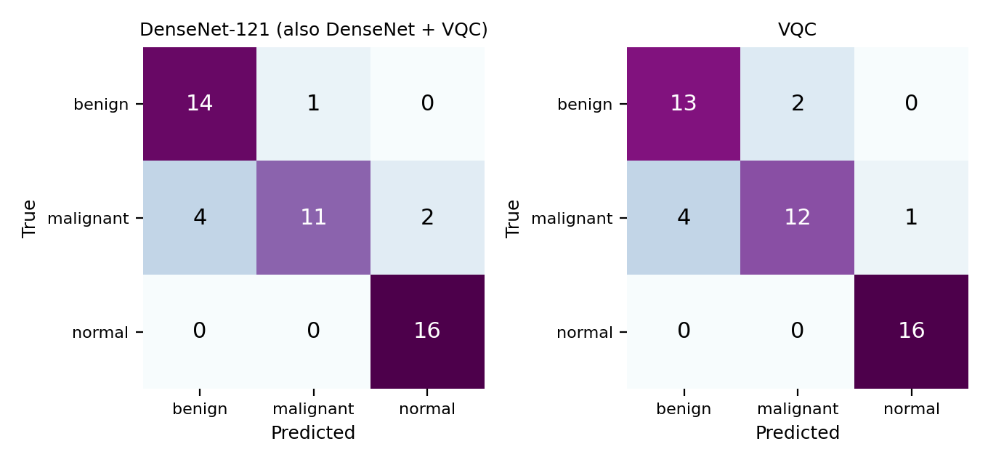
Figure 8. LIDC test confusion matrices with counts reconstructed from the printed precision, recall and support. The fused model matches DenseNet-121.
• DenseNet-121 and the fused model both make 7 errors out of 48: 4 malignant images predicted as benign, 2 malignant images predicted as normal and 1 benign image predicted as malignant.
• The VQC also makes 7 errors: 4 malignant images predicted as benign, 1 malignant image predicted as normal and 2 benign images predicted as malignant.
• Malignant is the weakest class for both models, with recall of 64.71% for DenseNet-121 and 70.59% for the VQC. No normal image was misclassified by either model.
• The two models tie on accuracy. The VQC leads macro F1 by 0.0027 and the DenseNet leads precision on malignant, a gap that sits within the noise of a 48-image test set.
• Fusion changed no prediction relative to DenseNet-121, so it did not improve any metric.

6.6 Uncertainty layer
The layer flagged 3 of the 48 test predictions for manual review (6.25%) and left 45 unflagged. In the first ten rows printed by the notebook every prediction is correct and none is flagged. The notebook output does not show which of the three flagged rows are among the 7 errors.
Table 15. First ten LIDC test rows as printed in the notebook
Source ID | True class | Predicted | Confidence | Norm. entropy | Flagged for review
000003 | benign | benign | 0.9875 | 0.0692 | No
000004 | benign | benign | 0.9684 | 0.1391 | No
000054 | benign | benign | 0.9961 | 0.0254 | No
000075_1 | benign | benign | 0.7589 | 0.6112 | No
01_03 | malignant | malignant | 0.9714 | 0.1358 | No
01_123 | malignant | malignant | 0.9907 | 0.0537 | No
01_41 | malignant | malignant | 0.9720 | 0.1333 | No
01_71 | malignant | malignant | 0.9582 | 0.1838 | No
03_07 | normal | normal | 0.9825 | 0.0908 | No
03_128 | normal | normal | 0.9572 | 0.1864 | No

6.7 Grad-CAM++ examples
Table 16. LIDC Grad-CAM++ examples (first test image of each class)
True class | DenseNet-121 prediction | Confidence | Outcome
benign | benign | 98.9% | Correct
malignant | malignant | 96.8% | Correct
normal | normal | 99.3% | Correct

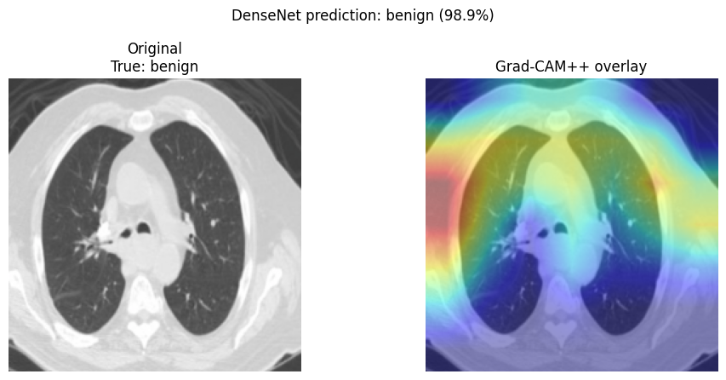 | 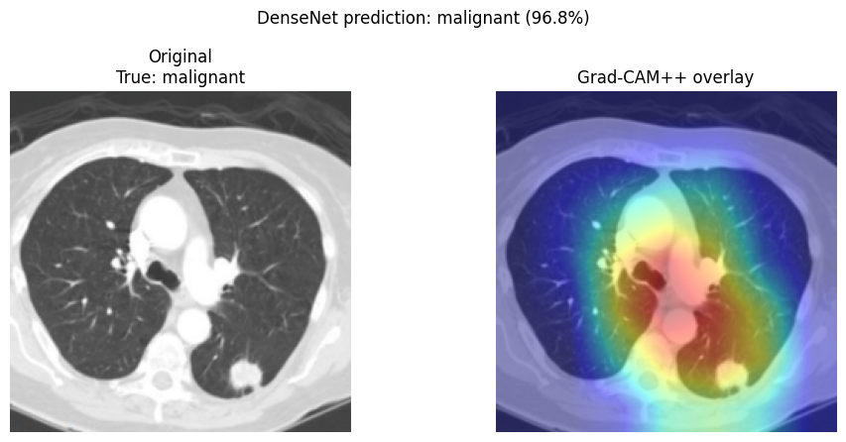
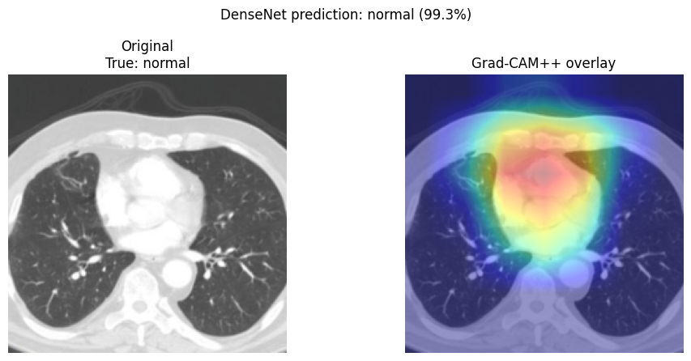

Figure 9. LIDC Grad-CAM++ overlays for benign (top left), malignant (top right) and normal (bottom left)
• In the benign example the strongest heat lies along the left chest wall, outside the lung fields.
• In the malignant example the heat covers the central chest and extends toward the lower lung, and it is not confined to a single spot.
• In the normal example the heat sits over the centre of the chest.
• These maps do not show that the network used the lesion. Heat outside the lung fields in the benign example is a reason for caution, and no clinician reviewed the maps.

7. Experiment 3: Y-Net Capsule images

7.1 Dataset audit and split
The Y-Net_Capsule archive holds 1,608 image files in Train and Val folders, each with Benign_new, Malignant and Normal subfolders. Benign_new maps to the class benign. The notebook pools both folders and re-splits them, because the archive has no test set and an audit found four source IDs whose copies sit in both Train and Val (27119 and Malignant case 177, 178 and 179 Cropped). Using the original split would leak those images. No source ID appears under more than one class, so none was excluded. Choosing one canonical file per source ID leaves 615 source images, split 70/15/15 by class at the source-image level.
Table 17. Capsule files, source images and split
Class | Files in Train | Files in Val | Source images | Train | Validation | Test
benign | 473 | 119 | 99 | 69 | 15 | 15
malignant | 480 | 120 | 100 | 70 | 15 | 15
normal | 332 | 84 | 416 | 291 | 62 | 63
Total | 1,285 | 323 | 615 | 430 | 92 | 93

The classes are imbalanced: normal has about four times as many source images as benign or malignant, and the test set holds 15 benign, 15 malignant and 63 normal images. One test image moves accuracy by 1.1 percentage points.
Table 18. Capsule image sizes of the canonical images
Class | Dominant size (width x height) | Images
benign | 256 x 256 | 99 of 99
malignant | 256 x 256 | 100 of 100
normal | 512 x 512 | 415 of 416 (one image is 506 x 331)

The size difference between normal and the other classes is a possible shortcut, because a network could learn the image size and ignore the content. The notebook sends every image through the same resize chain (256 x 256, then 224 x 224) to reduce this risk, and it states that resolution or source differences can still remain. The variant suffixes in the raw files are the empty suffix (615 files), cropped (97), hflip, rotateflip, rotatflip and vflip (199 each) and resizedn (100).

7.2 DenseNet-121 and VQC training
DenseNet-121 started with a validation accuracy of 0.9783 and macro F1 of 0.9554 after epoch 1, and reached 1.0 on both at epoch 2, where its last checkpoint was saved. Validation macro F1 equalled 1.0 in 95 of the 100 epochs. The first epoch took 39.4 seconds because it included the weight download, and later epochs took about 3 seconds. The early-stopping message appears at epoch 100, which is the last epoch anyway.
The VQC reads four principal components that keep 36.18% of the embedding variance. Its validation macro F1 passed 0.92 at epoch 2 and reached 1.0 at epoch 6, where its checkpoint was saved, and it equalled 1.0 in 91 of the 100 epochs.
Table 19. Capsule training outcomes
Model | Checkpoint epoch | Val macro F1 at checkpoint | Final train loss | Val macro F1 range | Run time
DenseNet-121 | 2 | 1.0000 | 0.0004 | 0.9554 to 1.0000 | 332 s
VQC | 6 | 1.0000 | 0.0081 | 0.7717 to 1.0000 | 60 s

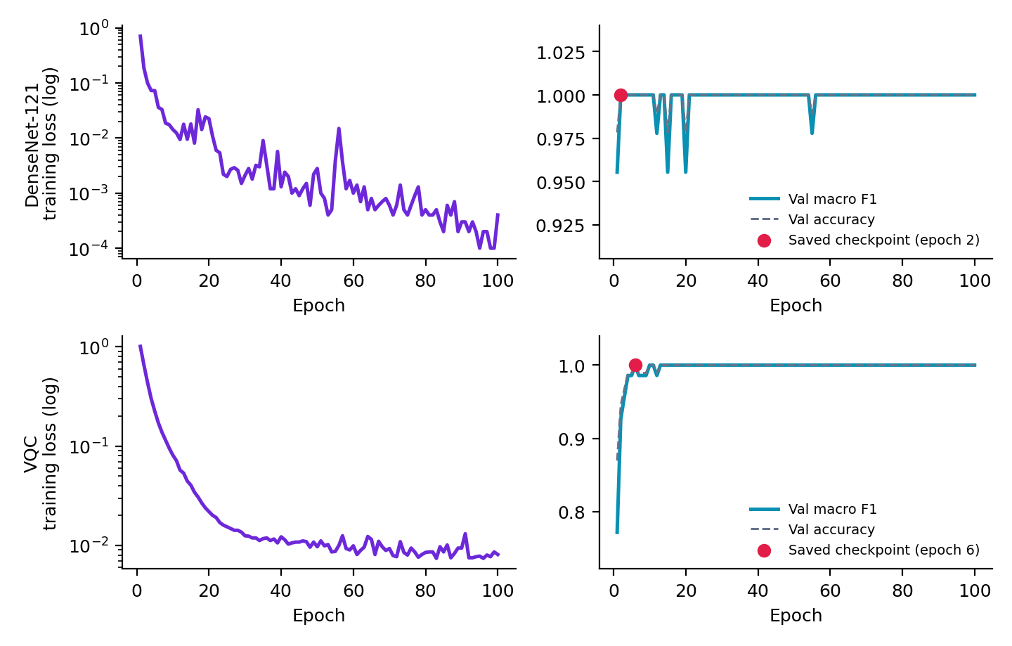
Figure 10. Capsule training histories. Top row: DenseNet-121. Bottom row: VQC. The red dot marks the saved checkpoint.

7.3 Fusion
Both models reach a validation macro F1 of 1.0, so the validation set cannot rank them or the candidate weights. The search selected a DenseNet weight of 0.10 and a VQC weight of 0.90, which gave test predictions identical to the VQC alone. The search table is not part of the notebook output, so the tie handling cannot be inspected.

7.4 Test results
Table 20. Capsule test metrics (93 images)
Model | Accuracy | Macro precision | Macro recall | Macro F1 | Weighted F1
DenseNet-121 | 0.9892 | 0.9792 | 0.9778 | 0.9778 | 0.9892
VQC | 0.9785 | 0.9740 | 0.9556 | 0.9628 | 0.9779
DenseNet + VQC | 0.9785 | 0.9740 | 0.9556 | 0.9628 | 0.9779

Table 21. Capsule per-class precision, recall and F1 on the test set
Class | Support | DenseNet-121 (P / R / F1) | VQC (P / R / F1) | DenseNet + VQC (P / R / F1)
benign | 15 | 1.0000 / 0.9333 / 0.9655 | 1.0000 / 0.8667 / 0.9286 | 1.0000 / 0.8667 / 0.9286
malignant | 15 | 0.9375 / 1.0000 / 0.9677 | 0.9375 / 1.0000 / 0.9677 | 0.9375 / 1.0000 / 0.9677
normal | 63 | 1.0000 / 1.0000 / 1.0000 | 0.9844 / 1.0000 / 0.9921 | 0.9844 / 1.0000 / 0.9921

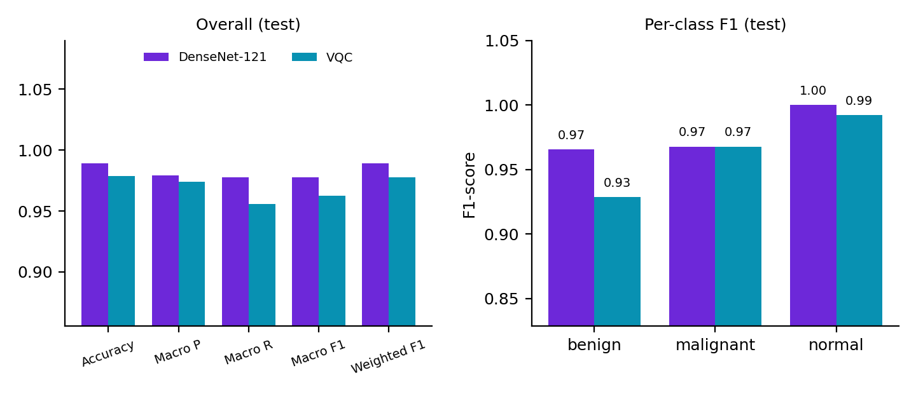
Figure 11. Capsule test metrics. The fused model matches the VQC exactly and is not drawn separately.
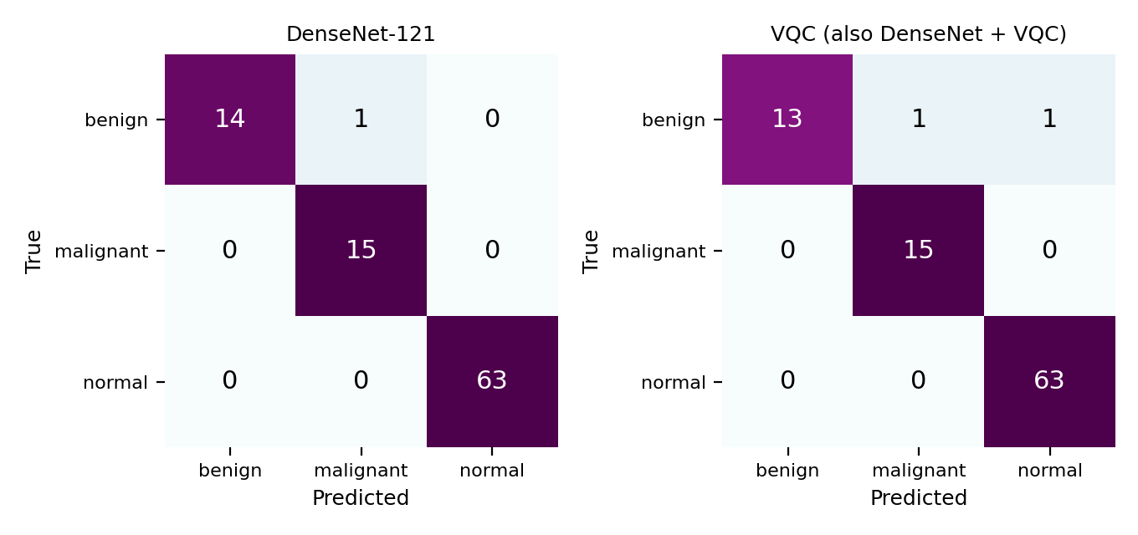
Figure 12. Capsule test confusion matrices with counts reconstructed from the printed precision, recall and support. The fused model matches the VQC.
• DenseNet-121 makes 1 error out of 93 (one benign image predicted as malignant). The VQC and the fused model make 2 errors (one benign image predicted as malignant and one benign image predicted as normal).
• Every malignant and every normal image is classified correctly by all three models. The only misses are benign images.
• The fused model scores 0.0107 lower accuracy than DenseNet-121, which is one test image. Fusion therefore did not help on this test set.

7.5 Uncertainty layer
The layer flagged 6 of the 93 test predictions (6.45%) and left 87 unflagged. In the first ten rows printed by the notebook, one prediction is wrong (source 444-112, a benign image predicted as normal with confidence 0.5190 and normalized entropy 0.9314), and it is flagged by both rules. The other nine are correct and unflagged. All ten rows are benign images, because the test table is ordered by source ID.
Table 22. First ten Capsule test rows as printed in the notebook
Source ID | True class | Predicted | Confidence | Norm. entropy | Flagged for review
000004 | benign | benign | 0.9195 | 0.3050 | No
000075_1 | benign | benign | 0.6317 | 0.6996 | No
2779 | benign | benign | 0.8039 | 0.5220 | No
345-118 | benign | benign | 0.9368 | 0.2484 | No
396-58 | benign | benign | 0.8271 | 0.4674 | No
419-006 | benign | benign | 0.8238 | 0.4926 | No
419-97 | benign | benign | 0.9233 | 0.2907 | No
444-112 | benign | normal | 0.5190 | 0.9314 | Yes (LOW_CONFIDENCE, HIGH_UNCERTAINTY)
444-26 | benign | benign | 0.9238 | 0.2768 | No
6104 | benign | benign | 0.9175 | 0.3098 | No

7.6 Grad-CAM++ examples
Table 23. Capsule Grad-CAM++ examples (first test image of each class)
True class | DenseNet-121 prediction | Confidence | Outcome
benign | benign | 90.3% | Correct
malignant | malignant | 80.6% | Correct
normal | normal | 96.2% | Correct

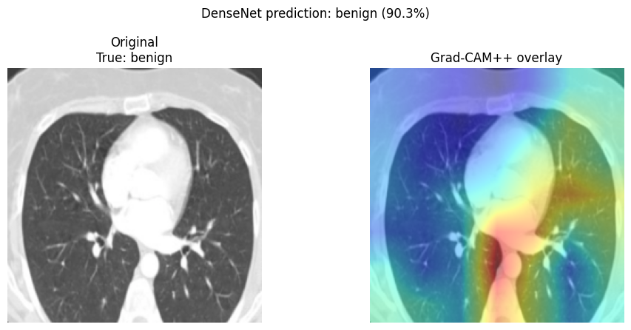 | 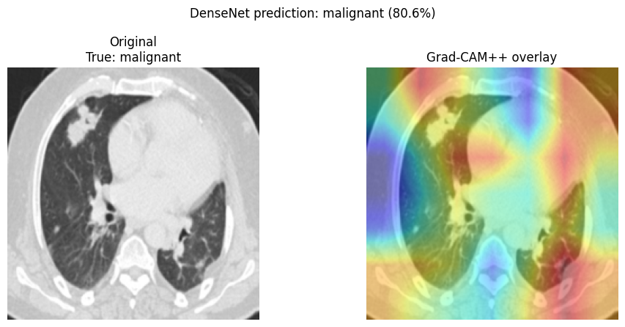
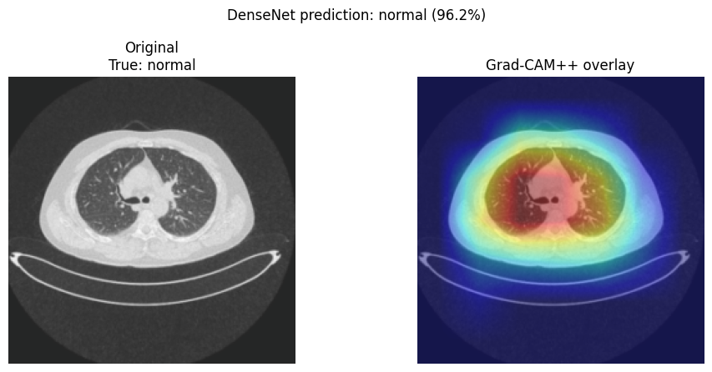

Figure 13. Capsule Grad-CAM++ overlays for benign (top left), malignant (top right) and normal (bottom left)
• The benign example puts its heat on the central chest and lower middle of the image, and the malignant example spreads heat over several regions of the lower chest.
• The normal example shows a ring of heat centred on the chest, and the image is framed differently from the other two, with a smaller body outline and the scanner table in view. This fits the notebook warning about size and source differences between classes.
• The maps cannot tell whether the network used the content or the framing, and no clinician reviewed them.

8. Cross-experiment comparison
The three experiments differ in task, class count, image size, data volume and test-set size, so the scores below are not a controlled comparison. They show how the same pipeline behaves in each setting.
Table 24. Test results of the three experiments
Experiment | Test images | DenseNet-121 (accuracy / macro F1) | VQC (accuracy / macro F1) | Fusion (weights DenseNet / VQC)
DR (DDR) | 3,725 | 0.8091 / 0.6579 (model C) | 0.6948 / 0.5711 | Not used in this notebook
LIDC lung | 48 | 0.8542 / 0.8494 | 0.8542 / 0.8521 | 0.8542 / 0.8494 (0.90 / 0.10), same as DenseNet
Capsule | 93 | 0.9892 / 0.9778 | 0.9785 / 0.9628 | 0.9785 / 0.9628 (0.10 / 0.90), same as VQC

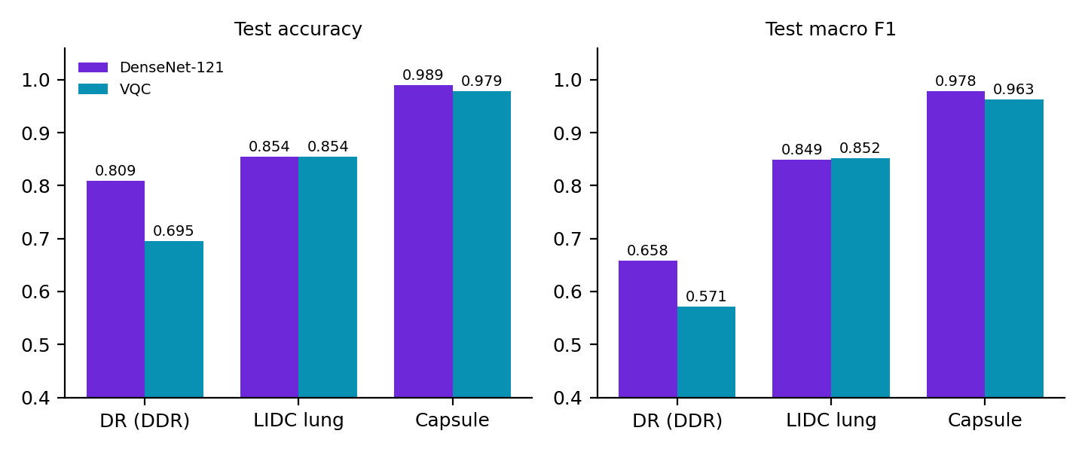
Figure 14. Test accuracy and macro F1 of DenseNet-121 and the VQC in the three experiments
• The VQC does not beat the DenseNet in any experiment. It trails clearly on DR (11.4 points of accuracy), ties on LIDC accuracy, and trails by one image on Capsule.
• On LIDC the VQC has the higher macro F1 by 0.0027 while the DenseNet has the higher precision on malignant. With 48 test images this is a tie.
• The VQC works from four numbers per image that keep about a third of the embedding variance in the two three-class experiments, and it has 39 trainable parameters. That it comes close to the DenseNet there says the DenseNet features already separate these classes well.
• Fusion matched one of its two inputs in both experiments where it was used. Its weights came from validation sets that were saturated or close to it, so the search carried little information.
• The minority classes are the hard cases. DR Mild has F1 of 0.3246 for the best model, LIDC malignant has recall of 64.71% for the DenseNet, and the only Capsule errors are benign images.

9. Limitations
• Every number comes from one seed and one test set per experiment, with no confidence intervals or repeated runs.
• The LIDC and Capsule test sets are small (48 and 93 images, with 15 or 17 images in the minority classes), so one image moves accuracy by 2.1 and 1.1 points.
• Validation sets in the two three-class experiments saturate at macro F1 of 1.0. That weakens checkpoint selection and fusion-weight selection. The DenseNet checkpoints came from epoch 15 (LIDC) and epoch 2 (Capsule), and the LIDC test macro F1 of 0.8494 is well below its validation value of 1.0.
• Splits group images by the source ID in the filename. The notebooks have no patient identifiers, so images from one patient could still land in different splits.
• Capsule classes differ in image size and framing. The very high Capsule scores may partly reflect that, and the notebook says so itself.
• Neither Y-Net archive has segmentation masks, so no segmentation model was trained, and the notebooks do not state the imaging modality of either archive.
• The DR notebook does not print validation scores for the checkpoint it started from, class counts for its training and validation splits, or how DenseNet B and C differ.
• The uncertainty thresholds are illustrative and untuned, and a confident error passes the rules. The DR example rows show two such errors.
• Grad-CAM++ maps are post-hoc and were shown for one image per class, so they cannot support general claims about what the networks learned.
• This is a research prototype and must not guide medical decisions.
Natural next steps follow from these limits: patient-level splits, repeated seeds or cross-validation, larger held-out sets, a size-matched check of the Capsule classes, and masks for a real segmentation model.

10. Reproducibility
Each notebook is written for Google Colab with Google Drive mounted and runs from top to bottom. All three use seed 42. The LIDC and Capsule notebooks need only their dataset ZIP in the root of My Drive, install timm, pennylane, scikit-learn, joblib, matplotlib, pandas, pillow and torchvision, and write their results to Drive. The DR notebook also needs its DDR_work folder with checkpoints, CSV files, VQC features and the cache_512_clahe archive, and its text says the default is a two-epoch smoke test while the executed cell sets EPOCHS to 100.
Table 25. Notebooks and result folders
Notebook | Result folder
Copy_of_DR_Final_DenseNetC_VQC_NeuroSymbolic_GradCAMPP_Training.ipynb | DDR_work
LIDC_YNet_DenseNet_VQC_Classification.ipynb | LIDC_YNet_Results
YNet_Capsule_DenseNet_VQC_Classification.ipynb | YNet_Capsule_Results

• DR notebook outputs: densenet_c_finetuning_history.csv, dn121_512_c_finetuned_best.pt, neuro_symbolic_test_predictions.csv, gradcam_plus_plus_examples_index.csv and the Grad-CAM++ figures.
• LIDC notebook outputs: dataset_split_manifest.csv, excluded_conflicting_source_ids.csv, densenet121_lung3class_best.pt, vqc_lung3class_best.pt, vqc_feature_preprocessing.joblib, lung_vqc_features.npz, fusion_weight_validation_search.csv, final_test_model_comparison.csv, final_test_classwise_comparison.csv, combined_model_uncertainty_flags.csv and gradcam_plus_plus_examples.csv.
• Capsule notebook outputs: the same files with capsule in the names (densenet121_capsule3class_best.pt, vqc_capsule3class_best.pt, capsule_vqc_features.npz), plus source_ids_spanning_original_train_val.csv.
The LIDC and Capsule notebooks also save the per-model prediction files, confusion matrix CSV and PNG files, training history CSV files and one Grad-CAM++ figure per class (gradcampp_true_<class>_testidx_<n>.png).

