Autonomous Mobile Robot with Gesture Recognition, Line Following and Obstacle Avoidance

Project Report

Submitted by
K Jumaan
Reg. No. 210929010

Under the guidance of
Dr. Narendra Khatri
Associate Professor, School of Mechanical Engineering
Manipal Institute of Technology, Manipal

In partial fulfilment of the requirements for the award of the degree of

BACHELOR OF TECHNOLOGY

IN

MECHATRONICS



SCHOOL OF MECHANICAL ENGINEERING
MANIPAL INSTITUTE OF TECHNOLOGY
(A Constituent Unit of Manipal Academy of Higher Education)
MANIPAL-576104, KARNATAKA, INDIA
May 2026


SCHOOL OF MECHANICAL ENGINEERING

Manipal
20th may, 2026
CERTIFICATE

This is to certify that the project titled Autonomous Mobile Robot with Gesture Recognition, Line Following and Obstacle Avoidance is a record of the Bonafide work done by K Jumaan (Reg. No. 210929010), submitted in partial fulfilment of the requirements for the award of the Degree of Bachelor of Technology (B.Tech.) in Mechatronics, School of Mechanical Engineering, Manipal Institute of Technology, Manipal, Karnataka (a Constituent unit of Manipal Academy of Higher Education), during the academic year 2025-2026.

Dr. Narendra Khatri  Assisociate Professor  (Project Supervisor)  School of Mechanical Engineering  MIT Manipal | Dr. Dattaguru. V. Kamath  Dean  School of Mechanical Engineering  MIT Manipal

ACKNOWLEDGMENTS
I would like to express my sincere gratitude to Dr. Narendra Khatri, Associate Professor, School of Mechanical Engineering, Manipal Institute of Technology, for his invaluable guidance, consistent support, and constructive feedback throughout every stage of this project. His technical insights and encouragement were fundamental in shaping both the direction and quality of this work. Without his timely advice during the ROS2-Gazebo integration phase in particular, several weeks of debugging time would have been wasted.
I am grateful to the faculty and staff of the School of Mechanical Engineering, MIT Manipal, for providing access to the laboratory facilities and computing resources essential for the development and testing of the robot system. The availability of the electronics lab for hardware assembly and the project workstation for Gazebo simulation were particularly important.
I also thank the open-source communities behind ROS2, Gazebo Harmonic, MediaPipe, and OpenCV, whose tools formed the entire technical backbone of this project. The quality of documentation and the responsiveness of the community forums made problems that initially seemed insurmountable tractable within a reasonable time.
Finally, I thank my family for their patience and unwavering support, especially during the long evening hours that embedded robotics debugging tends to demand.

ABSTRACT
Autonomous mobile robots are increasingly central to modern automation, healthcare logistics, and intelligent transportation. As robotic platforms become cheaper and more accessible, the challenge is no longer just building a robot that moves -- it is building one that makes sensible decisions in a real, unpredictable environment. This project tackles that challenge by developing a low-cost autonomous mobile robot using the Freenove 4WD platform and Raspberry Pi 4B, capable of three distinct behaviours: vision-guided line following with PD and PID controllers, ultrasonic-based obstacle avoidance, and real-time hand gesture recognition using MediaPipe. The work follows a deliberate sim-to-real methodology where all behaviours were first developed and tuned inside a ROS2 Jazzy and Gazebo Harmonic simulation environment before deployment onto physical hardware, enabling systematic comparison of simulated and real-world performance.
The robot model was built in Gazebo using SDF, with GPU LiDAR, RGB camera, and IR sensors integrated via ros_gz_bridge. Line following used an OpenCV pipeline with proportional-derivative and full PID steering correction, achieving 97% tracking accuracy in simulation and 94% on the physical robot under the PID controller. Controller benchmarking showed that the PD controller offered the best real-world tradeoff: 91% tracking accuracy at 14% CPU load on the Raspberry Pi, compared to 94% at 19% CPU for PID. Obstacle avoidance combined LiDAR in simulation with HC-SR04 ultrasonic sensing on hardware. Gesture recognition ran entirely onboard using the MediaPipe HandLandmarker Tasks API, achieving recognition success rates of 88-95% across five gesture classes with command latencies below 90 ms. A sim-to-real performance degradation of 2-5% was observed across all tasks, with wheel slip, sensor noise, and embedded processing delay identified as primary causes. Performance data was logged using Python/Pandas and visualised through Power BI dashboards. The project demonstrates that meaningful autonomous behaviour is achievable on a sub-INR 5000 embedded platform using entirely open-source tools.

LIST OF TABLES
Table No. | Title | Page No.
Table 3.1 | Hardware Components Used in Physical Robot Deployment | 17
Table 3.2 | Software Stack and Tools | 19-20
Table 3.3 | Gesture-to-Command Mapping | 27
Table 5.1 | Controller Performance Comparison (P, PD, PID) | 34
Table 5.2 | Simulation vs. Real Robot Performance Summary | 36
Table 5.3 | Individual Gesture Recognition Performance | 38

LIST OF FIGURES
Figure No. | Title | Page No.
Figure 3.1 | System Architecture Block Diagram | 16
Figure 3.2 | ROS2-Gazebo Simulation: Robot Model in Line-Following World | 22
Figure 3.3 | Line Following: Centroid Detection and Controller Steering | 24
Figure 3.4 | Obstacle Avoidance Simulation: LiDAR-Triggered Stop and Turn | 26
Figure 3.5 | Gesture Recognition: Forward command | 28
Figure 3.6 | Gesture Recognition: backward command | 28
Figure 3.7 | Gesture Recognition: left command | 28
Figure 3.8 | Gesture Recognition: right command | 29
Figure 3.9 | Gesture Recognition: code part-1 | 29
Figure 3.10 | Gesture Recognition: code part-2 | 30
Figure 3.11 | Physical Robot: Assembled Freenove 4WD with Raspberry Pi 4B | 31
Figure 3.12 | robot motor control code | 32
Figure 5.1 | Controller Performance Comparison – tracking accuracy | 36
Figure 5.2 | Controller Performance Comparison – settling time | 36
Figure 5.3 | Controller Performance Comparison – path error | 37
Figure 5.4 | Simulation vs. Real Robot Performance -- Power BI Dashboard | 38
Figure 5.5 | Gesture Recognition Accuracy Per Gesture Class | 40
Figure 5.6 | Power BI Main Performance Analysis Dashboard | 42

LIST OF ABBREVIATIONS
Abbreviation | Full Form
AMR | Autonomous Mobile Robot
ROS2 | Robot Operating System 2
SDF | Simulation Description Format
PID | Proportional-Integral-Derivative
PD | Proportional-Derivative
PWM | Pulse Width Modulation
GPIO | General Purpose Input Output
LiDAR | Light Detection and Ranging
IR | Infrared
ROI | Region of Interest
FPS | Frames Per Second
cmd_vel | Command Velocity (ROS2 topic)
DDS | Data Distribution Service
SLAM | Simultaneous Localisation and Mapping
CPU | Central Processing Unit
RAM | Random Access Memory
USB | Universal Serial Bus

CHAPTER 1 INTRODUCTION

1.1 Introduction to Autonomous Mobile Robots
Walk into almost any modern warehouse, hospital corridor, or university robotics lab today and you are likely to encounter some version of a wheeled robot moving with apparent purpose. What varies enormously between these machines is how intelligent that movement actually is. Some follow painted lines on the floor with the enthusiasm of a floor buffer. Others react to a proximity sensor to avoid trolleys. A smaller number can be instructed with a hand gesture. Very few do all three things simultaneously, and fewer still were developed through a disciplined workflow where every behaviour was validated inside a simulator before the hardware was ever switched on. That combination -- three integrated autonomous behaviours, fully onboard processing, and a rigorous sim-to-real methodology -- is precisely what this project delivers.
An Autonomous Mobile Robot (AMR) is a robotic platform capable of navigating and performing tasks in an environment without continuous human guidance. Unlike industrial manipulator arms, which work in fixed positions, AMRs must handle the full complexity of a dynamic, unpredictable physical world: varying surfaces, moving obstacles, fluctuating lighting, and sensor noise. Making an AMR work reliably under these conditions requires careful integration of mechanical design, sensor systems, control theory, and software architecture -- which is exactly why building one from scratch, rather than buying a pre-programmed kit, is such a useful learning exercise.
This report documents the complete development of an AMR based on the Freenove 4WD Smart Car Kit and Raspberry Pi 4B. The robot implements three tightly integrated behaviours. The first is vision-guided line following: the robot uses an OpenCV image processing pipeline to detect a black line on the floor and follow it using a PD or PID controller that continuously corrects the robot's heading based on how far the line centre deviates from the camera's optical axis. The second is ultrasonic obstacle avoidance: an HC-SR04 sensor continuously monitors the distance ahead, and if an obstacle is detected within a safe threshold the robot stops and executes an evasive manoeuvre automatically, regardless of what the line-following controller would otherwise command. The third is hand gesture recognition: a MediaPipe-based vision pipeline classifies five hand gestures from a live USB camera feed and translates them into directional commands, giving a human operator a natural, contact-free way to override or direct the robot.
What makes this project distinctive is its methodology. Rather than assembling hardware and writing code directly, a complete simulation was built first inside ROS2 Jazzy and Gazebo Harmonic. The robot model -- four wheels, differential drive, GPU LiDAR, RGB camera, IR sensors -- was created in SDF and tested exhaustively in simulation. Only once each behaviour was working reliably in the virtual environment was it transferred to the physical robot. This sim-to-real workflow is standard in professional robotics development but underused in undergraduate projects, partly because it requires more upfront effort and partly because the tools are intimidating. This project demonstrates that it is manageable at the undergraduate level and that the payoff -- systematic comparison of simulated and real performance, and confidence in the design before committing hardware -- is well worth the investment.

1.2 Motivation
The motivation for this project came from two directions. The first was frustration with available educational platforms. Commercially available AMR kits at the research level -- TurtleBot, Pioneer, Limo -- cost between INR 50,000 and INR 500,000, putting them out of reach for routine experimentation by individual students. At the other extreme, cheap Arduino-based line-following kits are so abstracted from modern robotics software that they teach almost nothing about ROS2, simulation, or computer vision. The Freenove platform sits between these extremes: it costs under INR 5,000, exposes every hardware layer from GPIO through ROS2 topics, and is powerful enough to run MediaPipe inference onboard. There is a real gap in the literature for a project that documents this platform in a rigorous, reproducible way.
The second motivation was the gesture recognition component specifically. Most published implementations of gesture-controlled robots still offload the vision processing to a laptop and relay commands to the robot over Wi-Fi [1]. This introduces network latency, tethers the operator to the robot's wireless range, and means the robot cannot function independently if the connection drops. Running MediaPipe directly on the Raspberry Pi 4B eliminates all of these dependencies. The onboard processing approach is harder to implement but produces a genuinely portable, self-contained system -- the kind of thing that could actually be deployed in a real application rather than just demonstrated in a lab.
There is also a straightforward educational motivation. A project that spans simulation, computer vision, embedded systems, control theory, and data analysis touches nearly every topic in the mechatronics curriculum. Completing it required applying knowledge from robotics, programming, electronics, and mechanical design in an integrated way that coursework examinations alone cannot develop.

1.3 Relevance of the Work
Autonomous mobile robots are increasingly central to industries that society depends on. In hospitals they carry medication between dispensaries and wards, reducing error and freeing nursing staff for patient care. In warehouses they move goods between shelving and packing stations, enabling the e-commerce logistics that has become essential infrastructure. In agriculture they monitor crop health across fields too large for manual inspection. In infrastructure maintenance they inspect pipelines, bridges, and electrical substations that are too hazardous or inaccessible for human workers [2].
In every one of these applications the core technical requirements are the same: a mobile platform that can follow a predetermined route, respond safely to unexpected obstacles, and accept operator correction without physical contact. This project addresses all three requirements in a cost range and form factor that is accessible to small institutions and research groups. The sim-to-real methodology it demonstrates is directly transferable to more sophisticated platforms: the same ROS2 node architecture, the same controller design process, and the same performance measurement approach apply whether the platform is a Freenove kit or an industrial AMR.
From a curriculum standpoint, the project bridges mechatronics (motor control, sensor interfacing, power electronics), computer vision (image processing, hand landmark detection), and robotics software (ROS2 node architecture, Gazebo simulation, data analysis). This interdisciplinary combination is precisely what employers in automation and robotics seek from mechatronics graduates.

1.4 Impact on Environment, Safety, and Other Factors
The environmental profile of this project is deliberately modest. The Raspberry Pi 4B consumes approximately 3-5 W under typical computational load, and the 18650 lithium-ion battery pack is rechargeable and broadly recyclable. No hazardous chemicals, high-voltage circuits, or irreplaceable materials are involved. The total bill of materials represents a small fraction of the embodied energy and raw material consumption of a comparable commercial AMR platform.
Electrical safety required genuine attention during hardware assembly. DC gear motors draw transient currents that can exceed 1.5 A per motor at stall, and four motors starting simultaneously can drop the supply voltage enough to crash the Raspberry Pi. This was addressed by using a dedicated voltage regulator to isolate the 5V logic rail from the motor power bus, adding a bulk capacitor at the regulator output, and implementing a PWM ramp-up routine that limits the rate of motor current increase. All exposed wiring was sleeved and secured to prevent shorts during operation.
The obstacle avoidance subsystem provides a meaningful safety feature: the robot will not intentionally collide with a stationary object in its path. The 20 cm trigger threshold was chosen conservatively based on the calculated minimum stopping distance (approximately 22 mm at operating speed), providing a safety margin of roughly 178 mm. The robot is not certified to any formal safety standard and should not be operated near small children or on elevated surfaces without supervision.
In terms of broader societal impact, the project demonstrates that capable autonomous robotic behaviour is achievable with widely available open-source tools and modest hardware budgets. This matters because it lowers the barrier to robotics education and research in settings that cannot afford commercial platforms, contributing to more equitable access to advanced engineering education.

CHAPTER 2 LITERATURE REVIEW AND OBJECTIVES

2.1 Present State and Recent Developments
Autonomous mobile robot navigation has been studied since the 1980s, but the combination of affordable single-board computers, commodity sensors, and open-source middleware has made it genuinely accessible to undergraduate laboratories only in the last decade [3]. The Robot Operating System (ROS), now in its second major iteration, has become the de-facto standard for robot software architecture in both academia and industry [4]. ROS2 introduces real-time communication guarantees through a DDS-based publish-subscribe transport layer, lifecycle node management, and substantially improved support for simulation via the ros_gz_bridge package. These improvements over the original ROS have made ROS2 the platform of choice for new robot software development.
Line following is one of the oldest autonomous robot behaviours and has been reimplemented countless times. The core computer vision pipeline has been stable for many years: convert to grayscale, apply binary threshold, extract a Region of Interest, detect the line contour, compute its centroid using image moments [5]. What has evolved is the controller. Early implementations used bang-bang switching or simple proportional control, producing the characteristic zig-zag oscillation visible in most science fair robots. The introduction of derivative feedback (PD control) substantially reduces oscillation by penalising rapid changes in error. Full PID adds an integral term that eliminates steady-state offset. Several recent papers compare these three controllers on embedded platforms similar to the Raspberry Pi. Kumar et al. [6] found that PD control offered the best real-world tradeoff between tracking accuracy and computational load on resource-constrained hardware. Ogata [7] provides the theoretical framework for understanding why the derivative term improves stability margins in this context.
Obstacle avoidance strategies range from simple threshold-based reactive behaviours to sophisticated planning algorithms. The potential field method, introduced by Khatib [8], represents obstacles as repulsive fields and goals as attractive fields, producing smooth avoidance trajectories but prone to local minima. The Vector Field Histogram (VFH) method and later the Dynamic Window Approach (DWA) [9] in ROS2 Nav2 are more robust but require significantly more computation and a known map. For a platform like the Freenove with a single front-facing ultrasonic sensor, a simple threshold-compare-and-turn reactive strategy is both appropriate and computationally efficient. Borenstein and Koren [10] demonstrated that reactive strategies of this type perform well in structured environments, which describes the lab and corridor settings relevant to this project.
Hand gesture recognition experienced a step change in 2019 with the release of MediaPipe by Google [11]. MediaPipe's HandLandmarker model returns 21 3D hand joint coordinates per frame at 20-30 frames per second on the ARM Cortex-A72 without any GPU acceleration. The geometric finger-extension classification approach -- comparing fingertip y-coordinates to PIP joint y-coordinates in normalised image coordinates -- was validated by Zhang et al. [11] and independently by Garg et al. [12] to achieve recognition accuracies above 90% under normal indoor lighting without custom training data. Rautaray and Agrawal [1] provide a comprehensive survey of gesture recognition approaches for human-computer interaction, confirming that landmark-based methods compare favourably with CNN-based approaches for small, well-defined gesture vocabularies.
Simulation-to-real transfer is a persistent challenge in robotics. Koenig and Howard [13] introduced Gazebo specifically to address the lack of reproducible physics simulation for mobile robots. Subsequent work has repeatedly shown that controllers tuned in simulation require re-tuning on hardware, primarily because of differences in friction, motor nonlinearity, and sensor noise [14]. Zhao et al. [15] surveyed sim-to-real methods in reinforcement learning and observed that performance degradations of 5-15% are typical for differential-drive navigation tasks. Salvato et al. [16] found similar results specifically for obstacle avoidance, attributing most of the gap to wheel slip and sensor noise -- exactly the factors identified in this project.
Power BI has been used for engineering data visualisation in industrial contexts but is almost entirely absent from the educational robotics literature. Pandas-based data logging and analysis for robot performance benchmarking is mentioned briefly in several ROS2 tutorial documents but not systematically applied in undergraduate project reports. This project applies both tools directly, contributing a template methodology for performance measurement and visualisation that could be adopted in future projects.

2.2 Shortcomings in the Literature
The review identified four specific gaps that this project addresses directly:
- Most gesture-controlled robot implementations rely on an external laptop for vision processing, introducing latency and reducing portability. Fully onboard processing using MediaPipe on a Raspberry Pi 4B is technically feasible but rarely demonstrated in the literature with complete implementation details [1],[12].
- Published controller comparison studies rarely benchmark P, PD, and PID under identical real-world conditions on the same embedded platform, making it difficult to draw practical conclusions for low-cost hardware deployments [6].
- The Freenove 4WD / Raspberry Pi 4B combination is increasingly common in student projects but remains understudied in peer-reviewed literature. Its specific sim-to-real characteristics have not been characterised.
- Python/Pandas and Power BI-based performance analysis is a highly practical engineering skill but is not demonstrated in existing educational robotics project documentation.

2.3 Objectives
Based on the shortcomings identified above, the following project objectives were formulated:

Objective 1: Develop a complete ROS2-Gazebo simulation of a differential-drive AMR with GPU LiDAR, RGB camera, and IR sensors, validating all three autonomous behaviours (line following, obstacle avoidance, gesture recognition) before hardware deployment.

Objective 2: Implement and quantitatively compare P, PD, and PID line-following controllers on both the simulated and physical robot, measuring tracking accuracy, settling time, overshoot, path deviation, and CPU load.

Objective 3: Deploy the complete system onto the Freenove 4WD with Raspberry Pi 4B, running all perception, control, and actuation onboard without any external computation or network dependency.

Objective 4: Quantify the sim-to-real performance gap across all three behaviours and systematically identify the contributing physical and computational factors.

Objective 5: Log, analyse, and visualise system performance data using Python/Pandas and Power BI, producing dashboards that clearly communicate controller comparison and sim-to-real degradation results.

CHAPTER 3 METHODOLOGY

3.1 System Architecture
The system was built in two parallel tracks that share a common software architecture. The simulation track runs inside ROS2 Jazzy and Gazebo Harmonic on a desktop PC. The hardware track runs entirely on the Raspberry Pi 4B. Both tracks use identical Python control nodes; they differ only in the sensor interface layer -- simulated ROS2 topics on the left, physical GPIO and USB camera calls on the right. This separation of interface from logic was the key architectural decision that made the sim-to-real transfer a matter of swapping one file rather than rewriting the entire codebase.
The control loop runs at approximately 12-15 Hz on the physical robot, limited by MediaPipe inference time on the ARM CPU. Within each loop iteration, the system: (1) captures a camera frame, (2) runs gesture detection, (3) runs line detection, (4) reads the ultrasonic sensor, (5) computes the appropriate motor command, and (6) writes PWM output to the motor driver. The obstacle avoidance check takes priority over all other commands -- if an obstacle is within threshold, the robot stops regardless of what the gesture or line controller has computed.
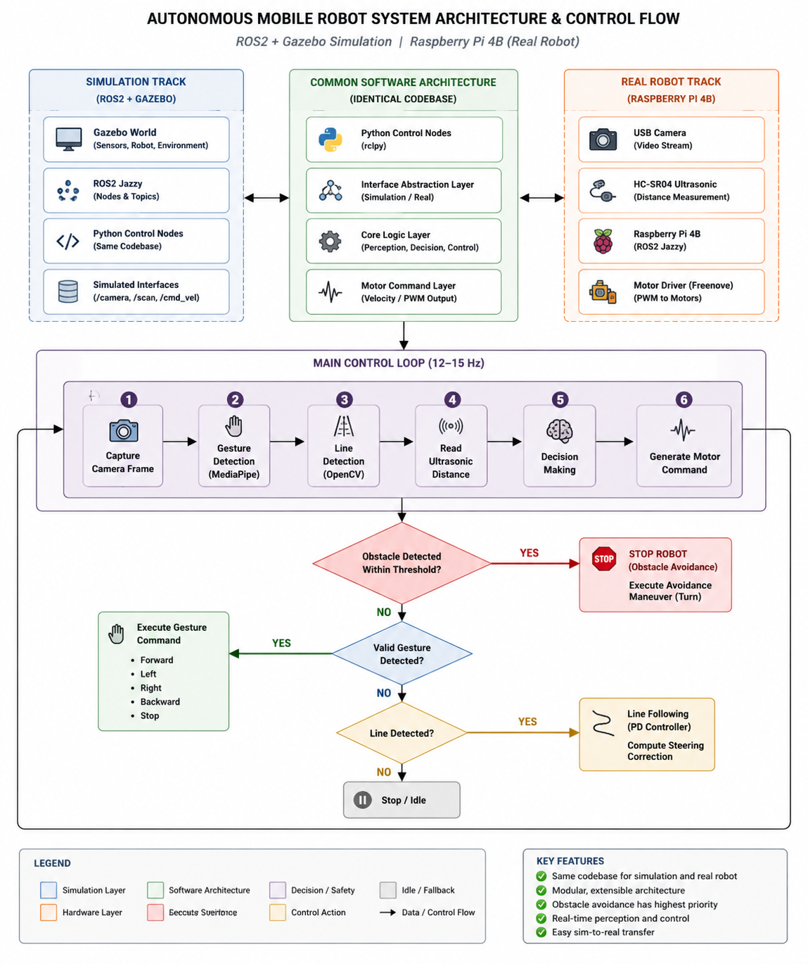
Figure 3.1: System architecture: ROS2 node topology showing simulation and physical robot layers

3.2 Hardware Components -- Detailed Description
Each hardware component was selected for a specific reason. This section describes not just what each component is but why it was chosen and what practical issues arose during integration.

Table 3.1: Hardware Components Used in Physical Robot Deployment
Component | Role | Qty
Raspberry Pi 4B (4GB RAM) | Central processor; runs ROS2, OpenCV, MediaPipe | 1
Freenove 4WD Smart Car Kit | Chassis, 4x DC gear motors, motor driver board | 1
USB Webcam (640x480, 30fps) | Vision input: line detection and gesture recognition | 1
HC-SR04 Ultrasonic Sensor | Real-robot obstacle distance measurement, range 2-400 cm | 1
18650 Li-ion Battery Pack (7.4V 2S) | Robot main power supply | 1
Voltage Regulator (5V/3A) | Isolated logic supply for Raspberry Pi; prevents motor brownout | 1
L298N-compatible Motor Driver | H-bridge PWM control of four DC motors via GPIO | 1
Jumper Wires and Breadboard | Sensor wiring and prototyping connections | Various

3.2.1 Raspberry Pi 4B
The Raspberry Pi 4B is the computational heart of the robot. Its quad-core ARM Cortex-A72 processor running at 1.8 GHz with 4 GB of LPDDR4 RAM provides sufficient throughput to run the entire processing pipeline -- OpenCV frame capture at 30 fps, MediaPipe inference, PID controller computation, and GPIO PWM generation -- simultaneously in a single Python process. The 4 GB RAM variant was chosen specifically because MediaPipe's HandLandmarker model occupies approximately 50 MB at load and the OpenCV frame buffer requires additional memory headroom. The 64-bit version of Raspberry Pi OS is required to run MediaPipe's ARM64-compiled binary packages.
In practice, the most significant integration challenge with the Raspberry Pi was power management. When all four motors start simultaneously at high duty cycle, the inrush current briefly loads the battery enough to cause a voltage drop on the shared power bus. Without mitigation, this reboots the Raspberry Pi mid-operation. The solution was a dedicated buck converter providing a stable 5V/3A supply to the Pi, with a 100 uF bulk capacitor across the output to absorb transient loads, and a PWM ramp-up routine that increases motor duty cycle gradually rather than stepping to full speed instantly.

3.2.2 Freenove 4WD Smart Car Kit
The Freenove 4WD Smart Car Kit provides the mechanical platform. It consists of a two-layer acrylic chassis, four 130-type DC gear motors with rubber wheels, and an onboard motor driver board. The four-wheel-drive configuration was specifically chosen for this project because it provides substantially better traction on non-ideal surfaces (carpet, slightly uneven tile) compared to a two-wheel differential-drive configuration with a caster. All four wheels are driven simultaneously during forward and backward motion; turning is achieved by differentiating the speeds of the left and right motor pairs.
The motor driver board is pin-compatible with the L298N H-bridge architecture. It accepts four directional logic inputs (IN1, IN2, IN3, IN4) and two PWM enable signals. The GPIO pin assignments in this project were: IN1=GPIO20, IN2=GPIO21 for the left motor pair, and IN3=GPIO19, IN4=GPIO26 for the right motor pair. PWM frequency was set to 1 kHz, which is well above the audible range and provides smooth speed control without perceptible torque ripple.

3.2.3 USB Webcam
A generic USB webcam provides the vision input for both line following and gesture recognition. The camera was configured to deliver 640x480 pixel frames at 30 fps using OpenCV's VideoCapture interface. A 640x480 resolution was chosen as a deliberate compromise: higher resolutions (720p, 1080p) would improve centroid detection precision but increase the per-frame processing time enough to drop the control loop below 10 Hz on the Pi 4B. At 640x480 the full pipeline runs at approximately 12-15 Hz, which is adequate for the robot's operating speed.
The Raspberry Pi Camera Module was evaluated initially but rejected because the ribbon cable routing was impractical on the moving chassis and the libcamera software stack added complexity not present in the familiar OpenCV/Video4Linux interface. The USB camera's plug-and-play compatibility with OpenCV made integration straightforward. The camera was mounted at the front of the chassis at a 30-degree downward angle, which balanced the line-following field of view (needing to look ahead) against the gesture recognition field of view (needing to see the operator's hand).

3.2.4 HC-SR04 Ultrasonic Sensor
The HC-SR04 ultrasonic distance sensor measures proximity by emitting a 40 kHz acoustic burst from its Trigger pin and timing the echo return on its Echo pin. It is connected to GPIO pins configured as output (Trigger) and input (Echo) respectively. The sensor's effective range is 2 cm to 400 cm with a beam angle of approximately 15 degrees. The 15-degree beam means the sensor only detects obstacles directly ahead and can miss obstacles at shallow angles -- a known limitation that is discussed in the results chapter.
The sensor requires a 10 microsecond high pulse on the Trigger pin to initiate a measurement. The Echo pin then goes high for a duration proportional to the round-trip distance. Python's time.time() function has approximately 1 microsecond resolution on Raspberry Pi OS, which is sufficient to time echo durations corresponding to distances above 1 cm. The distance calculation and the safety threshold logic are described in Section 3.6.

3.2.5 18650 Battery Pack and Power Distribution
Two 18650 lithium-ion cells connected in series provide a nominal 7.4V supply. The cells are housed in a battery holder on the lower deck of the chassis. The motor driver board connects directly to the battery bus, receiving the full 7.4V for motor power. A step-down buck converter (input 7-28V, output 5V/3A) derives the logic supply for the Raspberry Pi from the same bus. This separate regulation prevents motor load transients from appearing on the Pi's power rail.
Operating time was measured at approximately 80-90 minutes per charge cycle during active testing (all four motors running at 70% duty cycle with active vision processing). The battery voltage was not directly monitored during operation; a future improvement would be to add an ADC-based voltage monitor to provide low-battery warnings before the supply drops below the regulator's minimum input voltage.

3.3 Software Stack -- Detailed Description
Table 3.2 summarises the software tools used across the project. The following subsections describe each tool and the rationale for its selection.

Table 3.2: Software Stack and Tools
Tool | Purpose | Module
ROS2 Jazzy | Robot middleware; node communication, DDS pub-sub transport | Primary framework
Gazebo Harmonic | Physics simulation environment; SDF robot modelling | Simulation
ros_gz_bridge | Bidirectional ROS2-Gazebo topic bridge for sensor and cmd_vel data | Sim integration
Python 3.12 | Control logic, sensor interfacing, data logging | All modules
OpenCV 4.x | Camera capture, image processing, line centroid detection | Vision
MediaPipe 0.10.x (Tasks API) | Hand landmark detection and gesture classification | Gesture recognition
NumPy | Numerical arrays and mathematical operations | Supporting
Pandas | Performance data logging and tabular analysis | Data analysis
Power BI | Dashboard creation and metric visualisation | Reporting
RPi.GPIO | Direct GPIO and PWM motor control on hardware | Hardware interface

3.3.1 ROS2 Jazzy
ROS2 (Robot Operating System 2) is not an operating system in the traditional sense but a middleware framework that provides a standardised way for robot software components to communicate. The fundamental communication primitive in ROS2 is the topic: a named channel on which nodes publish and from which other nodes subscribe, using a DDS (Data Distribution Service) transport layer that provides real-time delivery guarantees. For this project, the key topics were /cmd_vel (velocity commands from the controller to the motor driver), /camera/image_raw (camera frames from the sensor node to the vision processing node), and /scan (LiDAR data in simulation). ROS2 Jazzy was chosen over earlier distributions because it is the current LTS release with full Gazebo Harmonic integration support.

3.3.2 Gazebo Harmonic
Gazebo Harmonic is the simulation environment in which the robot was developed and tuned before hardware testing. Gazebo solves a fundamental problem in robotics development: hardware is expensive, time-consuming to debug, and can be damaged. Simulating the robot first allows algorithms to be tested at essentially unlimited speed, with perfect reproducibility, and without the risk of physical damage. Gazebo Harmonic provides GPU-accelerated LiDAR simulation, realistic differential drive physics, and camera rendering, all of which were used in this project. The robot model was defined in SDF (Simulation Description Format), an XML-based description language that specifies the robot's links, joints, inertia tensors, visual meshes, collision geometries, and sensor plugins.

3.3.3 OpenCV 4.x
OpenCV (Open Source Computer Vision Library) handles all camera frame acquisition and image processing in this project. Its VideoCapture class provides a simple, consistent interface to USB cameras that works identically on Linux desktop (for simulation development) and Raspberry Pi OS (for hardware deployment). The image processing pipeline for line detection -- grayscale conversion, Gaussian blur, binary thresholding, contour detection, moment computation -- is implemented using OpenCV functions that are highly optimised for ARM processors. OpenCV also handles the frame preprocessing required by MediaPipe: BGR-to-RGB colour space conversion and frame flipping.

3.3.4 MediaPipe 0.10.x (Tasks API)
MediaPipe is Google's open-source framework for applying machine learning to perceptual tasks in real time. The HandLandmarker task within MediaPipe 0.10.x is a pre-trained model that detects human hands in an image and returns the (x, y, z) coordinates of 21 anatomical landmarks per hand in normalised image space. The model was trained on a large dataset of hand images and generalises well to different skin tones, hand orientations, and lighting conditions without any custom fine-tuning. The Tasks API (introduced in MediaPipe 0.10.x) was used rather than the older mp.solutions.hands interface because it provides typed result objects, supports asynchronous inference callbacks, and is the forward-supported API for future MediaPipe versions.
The gesture classification logic on top of MediaPipe -- determining which command to issue from the landmark positions -- was implemented as a simple geometric rule set rather than a trained classifier. This choice was deliberate: a rule-based classifier can be understood, debugged, and explained in a report with a set of equations; a trained classifier is a black box unless full training details are provided. The rule set is described in Section 3.7.

3.3.5 Python, NumPy, Pandas, and Power BI
Python 3.12 was chosen as the implementation language because it integrates naturally with both ROS2 (rclpy) and the scientific computing stack (NumPy, Pandas). All control logic, sensor interfacing, and data logging is implemented in Python. NumPy provides array operations needed for image moment computation and statistical analysis of logged data. Pandas provides the DataFrame abstraction used to log timestamped performance metrics -- tracking error, command latency, obstacle detection events -- to CSV files during experimental runs. These CSV files were then imported into Power BI for visualisation. Power BI was chosen over matplotlib for final analysis because it produces interactive dashboards that are easier to interpret at a glance and are more appropriate for an engineering report presentation.

3.4 ROS2-Gazebo Simulation Development
Building the simulation was the most time-consuming phase of the project, largely because of the number of configuration files that need to be consistent: the SDF robot model, the ros_gz_bridge YAML configuration, the ROS2 launch file, and the Gazebo world file. Any mismatch between these -- for example, a topic name in the bridge configuration that does not match the plugin definition in the SDF -- results in silence rather than an error message, making debugging difficult.
The robot model was defined with four cylindrical wheel links connected to the chassis by revolute joints. Inertia tensors for each link were calculated from the physical dimensions and estimated masses using the standard formula for a solid cylinder:
$I_{z} = \left(\frac{1}{2}\right)* m * r^{2}$ (3.1)
where m is the link mass and r is the cylinder radius. Accurate inertia values matter for simulation realism: unrealistically low inertia causes wheels to accelerate and decelerate instantaneously, making the simulated dynamics too forgiving compared to real hardware.
The differential drive plugin was configured with the wheelbase L and wheel radius r parameters measured from the physical chassis. The plugin subscribes to /cmd_vel and computes the required angular velocities for each wheel using the inverse kinematics of the differential drive model (Equations 3.5 and 3.6 below). The ros_gz_bridge was configured with --ros-args -p lazy:=false to prevent topics from being dropped during the simulation startup phase, which was a non-obvious fix for a bug that caused cmd_vel commands to be silently ignored for the first several seconds of simulation.

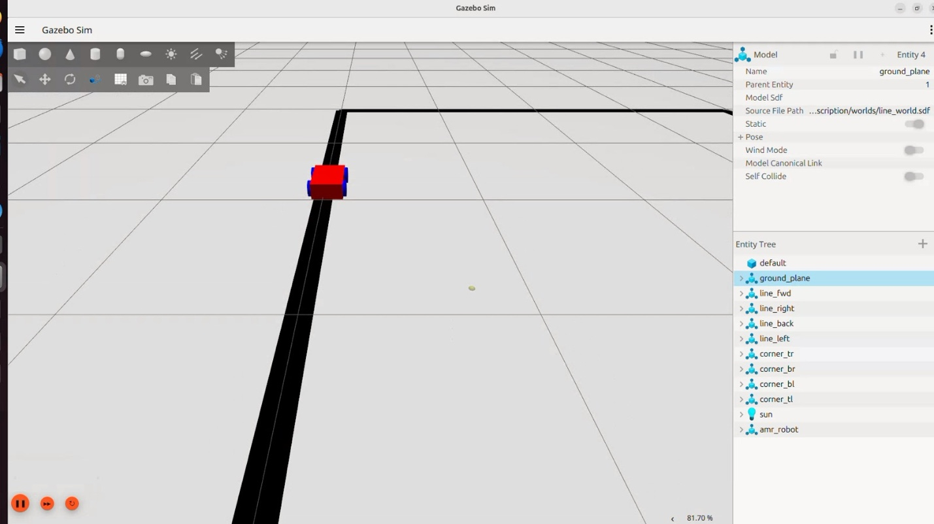Figure 3.2: ROS2-Gazebo simulation: robot model in line-following world

3.5 Line Following: Image Processing and Controller Design

3.5.1 Image Processing Pipeline
Each camera frame (640x480 pixels at 30 fps) was processed through the following pipeline to extract the line position:
Step 1 -- Grayscale conversion: the BGR frame from OpenCV was converted to a single-channel grayscale image using cv2.cvtColor with the COLOR_BGR2GRAY flag.
Step 2 -- Gaussian blur: a 5x5 Gaussian kernel was applied to reduce high-frequency noise that would otherwise produce spurious contours. The kernel sigma was left at the OpenCV default (computed from kernel size).
Step 3 -- Binary thresholding: the blurred image was thresholded with a fixed threshold of 60 and converted to a binary image where pixels below the threshold (dark, corresponding to the black line) become white (255) and all others become black (0). This inversion is intentional: it makes the line the foreground for subsequent contour detection.
Step 4 -- Region of Interest (ROI) crop: only the lower 40% of the frame was retained for processing. The upper portion of the frame contains the distant floor and potential background objects that would confuse the line detector. The ROI crop substantially reduced false contour detections.
Step 5 -- Contour detection and centroid computation: cv2.findContours was applied to the binary ROI. The largest contour by area was selected as the line. Its centroid coordinates (cx, cy) were computed using image moments:
$cx = \frac{M10}{M00} \left(3.2\right)$
$cy = \frac{M01}{M00}$ (3.3)
where M10, M01, and M00 are the first-order and zeroth-order image moments of the contour. The tracking error e is then the horizontal deviation of the centroid from the frame centre:
$e = cx - \left(\frac{frame_{width}}{2}\right) = cx - 320$ (3.4)
A positive e means the line is to the right of centre; a negative e means it is to the left.

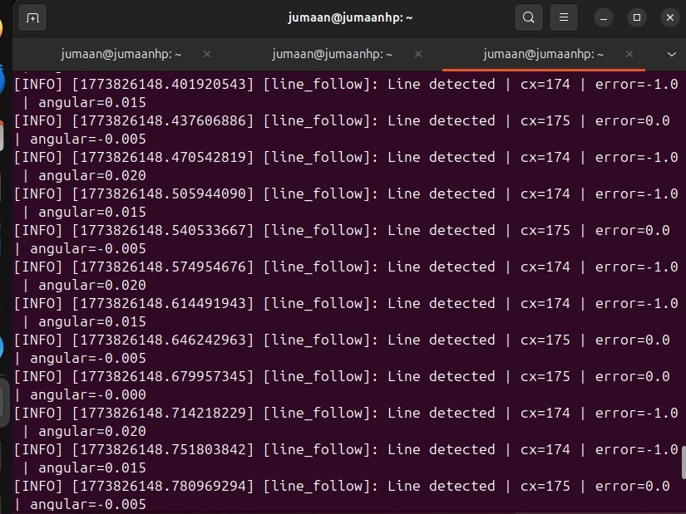Figure 3.3: Line following: centroid detection and PD steering correction overlay

3.5.2 Proportional (P) Controller
The simplest controller computes the angular velocity correction omega as a direct multiple of the tracking error:
$omega_{P} = K_{p}* e$ (3.5)
The proportional gain K_p = 0.35 was determined empirically by starting at 0.1 and doubling until oscillation appeared, then backing off to a stable value. The P controller is easy to understand and produces correct qualitative behaviour, but its transient response is oscillatory because nothing prevents the robot from overcorrecting when it has already started converging on the line.

3.5.3 Proportional-Derivative (PD) Controller
Adding a derivative term penalises the rate of change of error, damping the oscillatory response:
$omega_{PD} = K_{p}* e + K_{d}*\frac{\left(e - e_{prev}\right)}{dt}$ (3.6)
where e_prev is the error from the previous loop iteration and dt is the loop period (approximately 0.033 s at 30 fps). The derivative term is approximated by the first backward difference of the error signal. Final tuned values: K_p = 0.35, K_d = 0.12. The PD controller eliminated the visible zig-zag motion of the P controller and produced noticeably smoother corner tracking.

3.5.4 Proportional-Integral-Derivative (PID) Controller
The full PID controller adds an integral term that accumulates tracking error over time and applies a correction proportional to the accumulated offset:
$omega_{PID} = K_{p}*e + K_{i}*integral_{e}*dt + K_{d}*\frac{e - e_{prev}}{dt}$ (3.7)
where integral_e is the running sum of errors since the controller was activated. The integral term is prone to windup -- if the robot leaves the line (for example, when placed on the track at the start of a run), the integral accumulates a large offset that causes the robot to steer hard in one direction when it returns to the line. An anti-windup clamp was applied, limiting integral_e to the range [-50, +50] pixel-seconds. Final values: K_p = 0.35, K_i = 0.02, K_d = 0.15.
The computed angular velocity omega from the selected controller was then converted to differential wheel speeds using the differential drive kinematic equations:
$v_{R} = v_{base} + \frac{\left(omega * L\right)}{2}$(3.8)
$v_{L} = v_{base} - \frac{\left(omega * L\right)}{2}$ (3.9)
where v_base = 0.25 m/s is the nominal forward speed and L = 0.14 m is the measured wheelbase of the Freenove chassis. Wheel speeds were then converted to PWM duty cycles:
$D = \min\left(1.0,\max\left(\frac{0.0, v}{v_{max}}\right)\right)* 100\%$.10)
where v_max corresponds to 100% duty cycle. For the Freenove motors at 7.4V, v_max was measured as approximately 0.36 m/s under no-load conditions.

3.6 Obstacle Avoidance
In simulation, the GPU LiDAR plugin published a 360-degree scan on the /scan topic at 10 Hz. The minimum distance in the forward 60-degree cone (scan indices corresponding to +/-30 degrees of the robot's heading) was extracted each iteration. If this minimum fell below a threshold of 0.35 m, the robot published a zero linear velocity command followed by a 90-degree rotation command.
On the physical robot, the HC-SR04 sensor replaced the LiDAR. The distance measurement is derived from the echo travel time as follows. Let t_echo be the duration (in seconds) for which the Echo GPIO pin remains high after a Trigger pulse. The speed of sound at 20 degrees Celsius is:
$v_{s} = 331.3 + 0.606 * T = 331.3 + 0.606 * 20 = 343.4 \frac{m}{s}$ (3.11)
The one-way distance to the obstacle is:
$d = \frac{\left(t_{echo}* v_{s}\right)}{2}= \frac{\left(t_{echo}* 343.4\right)}{2} \left[metres\right]$ (3.12)
The obstacle avoidance threshold was set at d_threshold = 0.20 m on the physical robot. The minimum safe stopping distance at operating speed v = 0.25 m/s under motor braking deceleration a approximately 1.5 m/s^2 is:
$d_{stop} = \frac{v^{2}}{\left(2*a\right)} = \frac{0.0625}{3.0 } = 0.0208 m$ (3.13)
The threshold of 0.20 m therefore provides a safety margin of 200 - 20.8 = 179.2 mm above the minimum stopping distance. This margin accounts for the Python loop latency (~30 ms), GPIO read time (~2 ms), and motor spin-down time (~50 ms at 70% duty cycle).

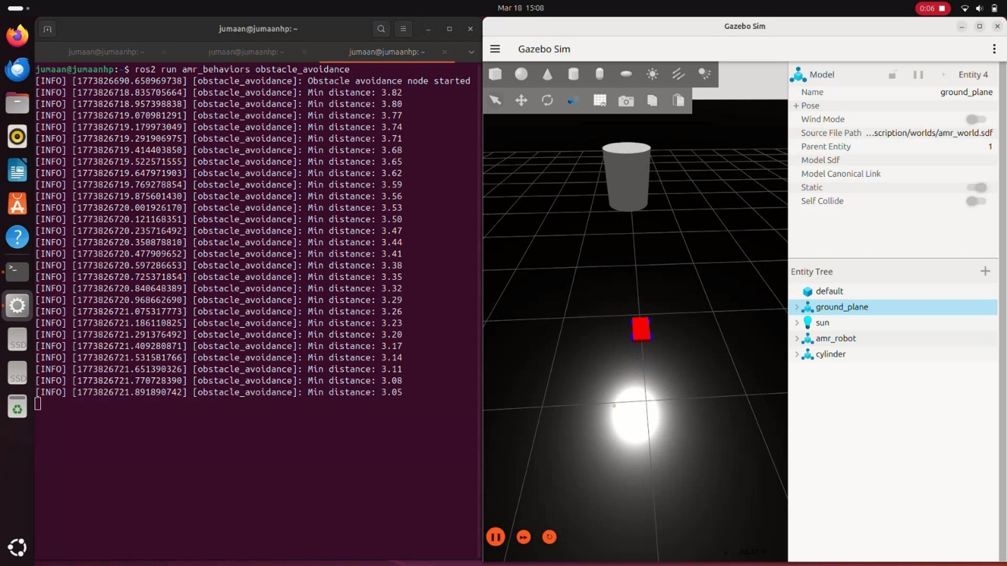Figure 3.4: Obstacle avoidance simulation: LiDAR scan and autonomous stop/turn behaviour

3.7 Gesture Recognition
The MediaPipe HandLandmarker task was initialised with the following options: running mode LIVE_STREAM (async callbacks), number of hands = 1, minimum detection confidence = 0.7, minimum tracking confidence = 0.7. Each camera frame was converted from BGR to RGB (as MediaPipe expects RGB input) and submitted to the model asynchronously.
When the model returned landmarks, each finger's extension state was determined by comparing the y-coordinate of its fingertip landmark to the y-coordinate of its PIP (proximal interphalangeal) joint. In MediaPipe's normalised image coordinate system, y increases downward, so a finger is extended (tip above PIP joint) when:
$E_{i} = 1 if y_{tip_{i}}< y_{pip_{i}}, else 0 \left(i = index, middle, ring, little\right)$ (3.14)
The thumb used the x-axis comparison instead of y-axis because the thumb's anatomy and range of motion are better captured by horizontal position when the hand faces the camera palm-forward:
$E_{thumb} = 1 if x_{tip_{thumb}}< x_{ip_{thumb}}\left(right hand\right), else 0$ (3.15)
The total extended finger count is:
$N = E_{thumb}+ E_{index}+ E_{middle}+ E_{ring}+ E_{little}$ (3.16)
This value N is an integer in the range [0, 5], which maps to the five directional commands as shown in Table 3.3 below.

Table 3.3: Gesture-to-Command Mapping (N from Equation 3.16)
Gesture | N | Command | Landmark Logic
Open Palm | 5 | Forward | All five fingers extended
One Finger | 1 | Left Turn | Index only extended
Two Fingers | 2 | Right Turn | Index + middle extended
Three Fingers | 3 | Backward | Index + middle + ring extended
Closed Fist | 0 | Stop | No fingers extended (default)

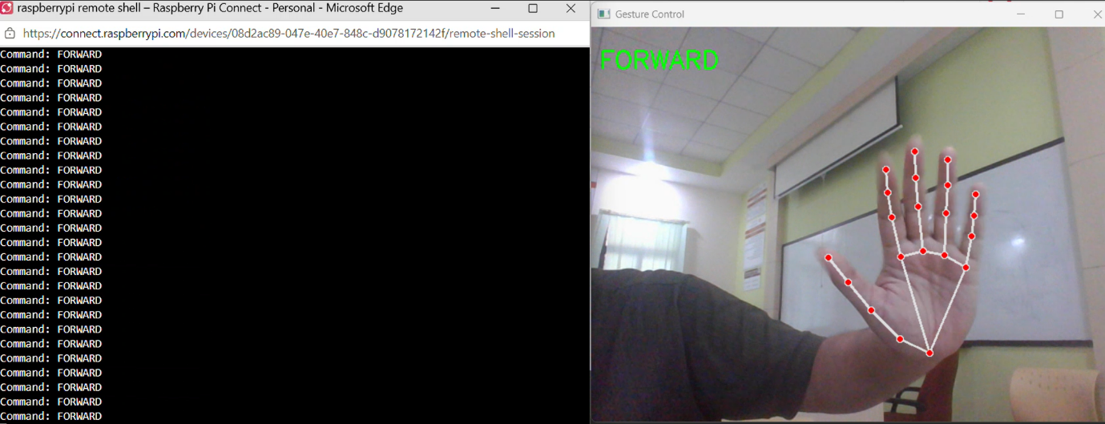Figure 3.5: Gesture recognition: Forward command
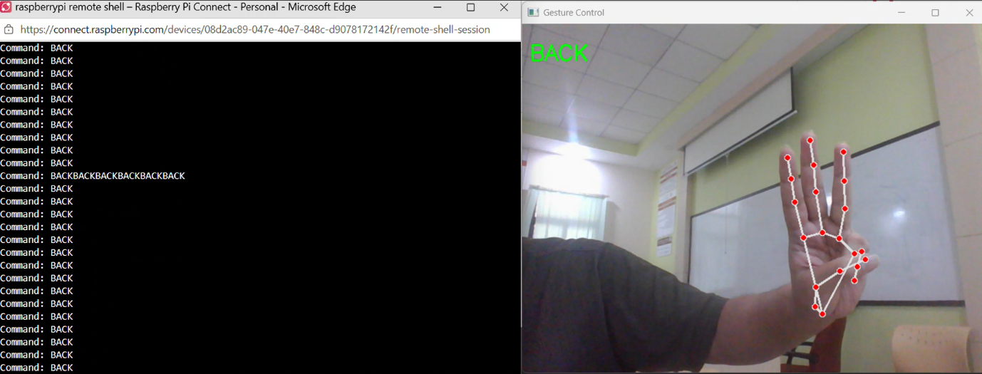
Figure 3.6: Gesture recognition: backward command
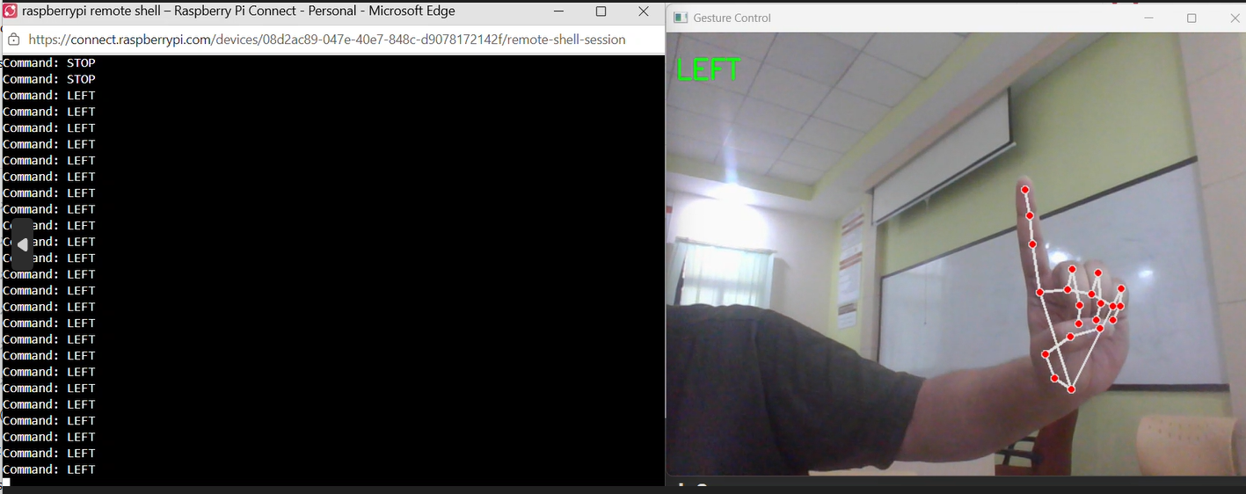
Figure 3.7: Gesture recognition: Left command
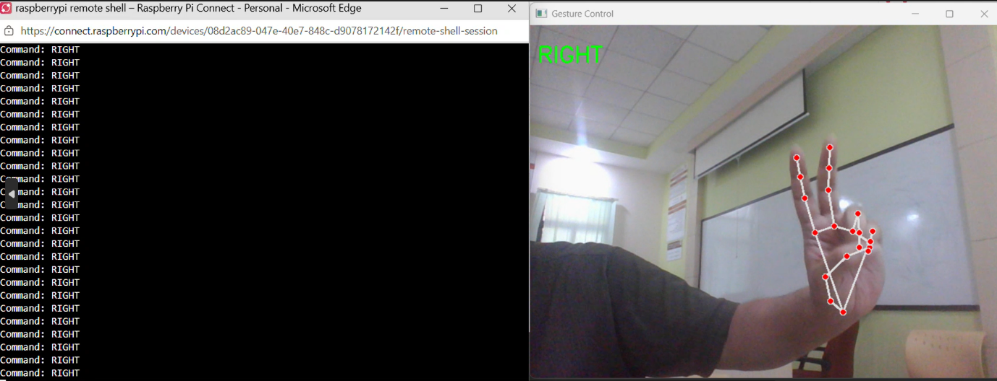
Figure 3.8: Gesture recognition: Right command

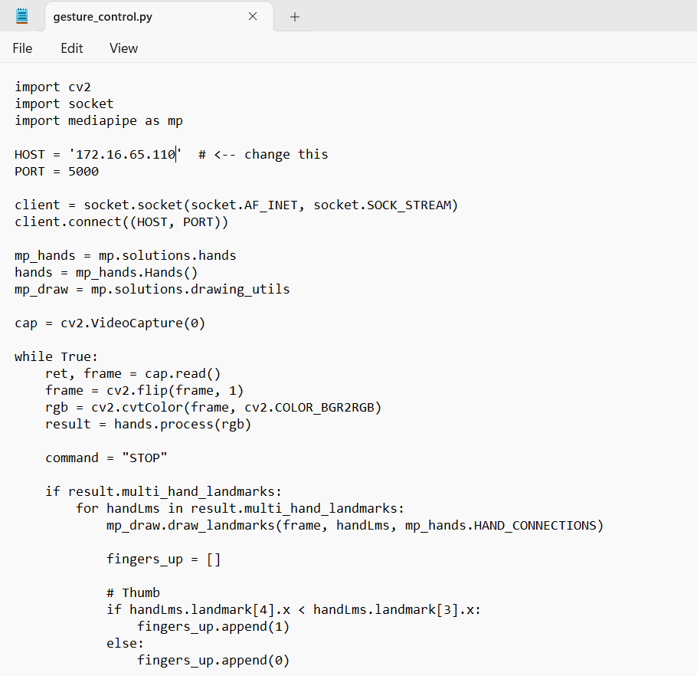
Figure 3.9: Gesture recognition: code part -1

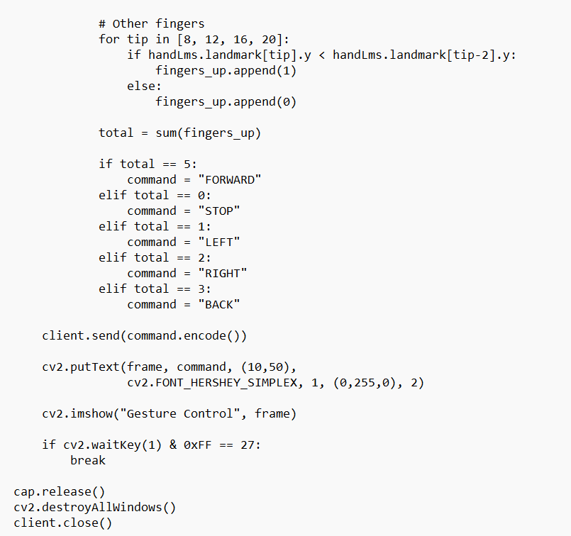

Figure 3.10: Gesture recognition: code part-2

3.8 Physical Robot Assembly and Deployment
The physical robot was assembled over several sessions. The Freenove chassis was built according to the kit instructions, then the Raspberry Pi 4B was mounted on the upper deck using M2.5 standoffs to provide clearance above the motor driver board. The USB camera was attached to the front bumper using a 3D-printed bracket angled 30 degrees downward. The HC-SR04 was mounted centrally at the front of the lower deck.
SSH access was configured using Raspberry Pi Connect over an iPhone hotspot, using the -4 flag to force IPv4 resolution with the .local mDNS hostname (ssh -4 robot.local). This configuration allowed wireless remote development without a monitor, keyboard, or fixed network infrastructure, which was essential for testing the robot in motion.
The ROS2 control nodes were transferred to the Raspberry Pi without modification. The hardware-specific sensor layer was implemented as a thin wrapper that provided the same interface as the ROS2 topic subscriber used in simulation: a callback function returning a distance value and a callback function returning a camera frame. This interface abstraction meant the controller logic was completely unaware of whether it was running in simulation or on hardware.

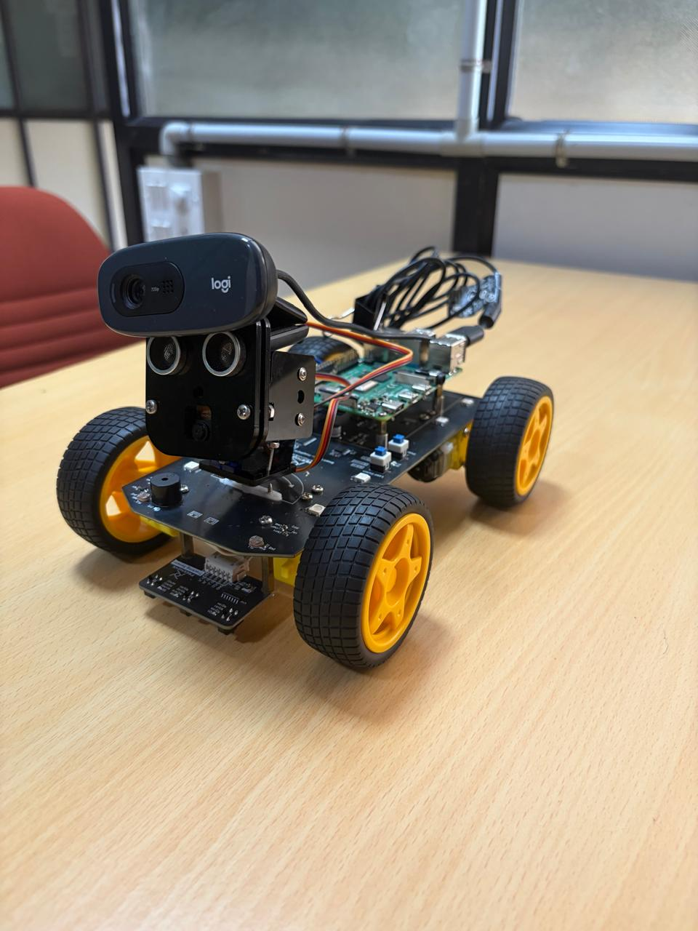
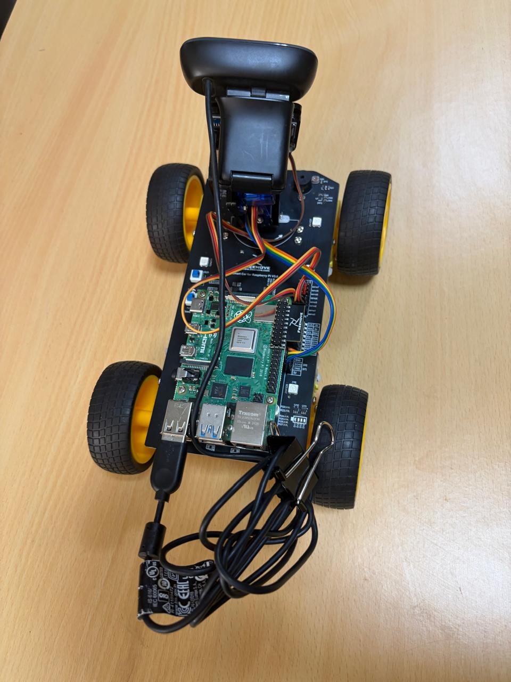
Figure 3.11: Assembled Freenove 4WD robot with Raspberry Pi 4B, USB camera, and HC-SR04 sensor

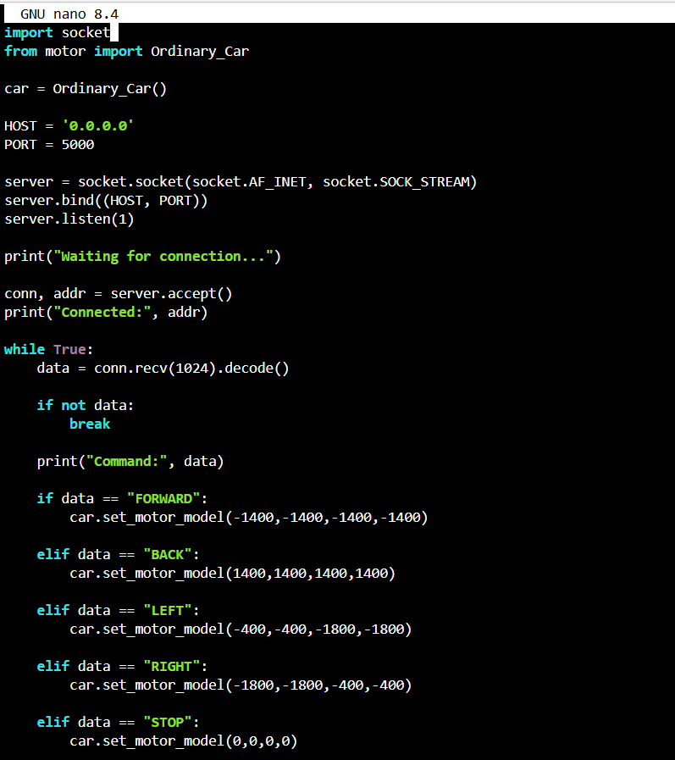
Figure 3.12: Robot motor control code

CHAPTER 4 CONTRIBUTION OF STUDENT

4.1 Overview
This is a single-student project. The complete scope of work -- simulation design, controller implementation, hardware assembly, software integration, data collection, and analysis -- was undertaken independently. The following subsections describe contributions by development phase.

4.2 Simulation Development
The complete SDF robot model was designed from scratch. This involved calculating link dimensions and inertia tensors from the physical Freenove chassis measurements, configuring the differential drive physics plugin with accurate wheelbase and wheel radius parameters, and integrating three sensor plugins: a GPU LiDAR for obstacle detection, an RGB camera plugin for vision tasks, and contact/IR sensor plugins for the line detection ROI confirmation. The ros_gz_bridge configuration required several debugging sessions; the most significant issue was the bridge silently dropping cmd_vel topics during simulation startup, which was traced to the lazy bridge initialisation mode and resolved by adding --ros-args -p lazy:=false to the bridge launch arguments.
All three control behaviours -- line following, obstacle avoidance, gesture recognition -- were implemented and tested in simulation before any hardware was connected. This sequential approach, while requiring more upfront effort, meant that when hardware issues arose later they could be attributed to hardware-specific factors (motor noise, lighting) rather than software logic errors.

4.3 Controller Design and Tuning
All three controllers (P, PD, PID) were implemented in a single Python node with a runtime-configurable mode parameter. Tuning was performed iteratively in simulation using a systematic approach: K_p was set to 0.1 and doubled on each trial until sustained oscillation appeared (at approximately K_p = 0.5), then backed off to 0.35. K_d was increased from zero until oscillation ceased. K_i was added last and set conservatively (0.02) because the integral term consistently caused overshoot if K_i exceeded approximately 0.05 in simulation.
When the same parameters were applied to the physical robot, the PD and PID controllers produced noticeably more oscillation than in simulation. This was traced to the higher effective rolling resistance of the carpet test surface compared to the simulated flat plane. A separate parameter search was conducted on the physical robot: $K_p$ was reduced to 0.30, K_d was increased to 0.15, and K_i remained at 0.02. The slightly reduced K_p compensated for the fact that carpet friction provides passive damping that simulation does not model.

4.4 Hardware Assembly and Debugging
The Freenove 4WD chassis was assembled and wired over two sessions. The most significant hardware debugging issue was the Raspberry Pi rebooting when all four motors started simultaneously, described in Section 3.2.5. Identifying the root cause -- motor inrush current on a shared power bus -- required measuring the supply voltage with an oscilloscope during motor startup, which showed a 400 mV transient sag lasting approximately 20 ms. Adding the bulk capacitor and PWM ramp-up routine eliminated the reboot entirely.
A secondary hardware issue was HC-SR04 echo read errors at acute wall approach angles. When the robot approached a wall at less than approximately 20 degrees from the surface, the 40 kHz pulse scattered rather than reflecting cleanly back to the sensor, causing the Echo pin to remain high for the full 38 ms timeout (indicating no echo). This appeared in the data as spurious very-large distance readings (> 400 cm) when the robot was actually close to a wall. A median filter over three consecutive readings was implemented to reject these outliers without introducing significant latency.

4.5 Data Collection and Analysis
Python scripts using Pandas DataFrame logging were written to record timestamped performance metrics during each experimental run: the instantaneous tracking error e from Equation 3.4, the motor duty cycle commands, obstacle detection events with measured distances, gesture command classifications with timestamps, and the CPU usage sampled via psutil. These records were exported to CSV files after each run. The CSV files were imported into Power BI using the Get Data -- Text/CSV connector, and a dashboard was built with bar charts for controller accuracy comparison, a line chart for error time series, and a stacked comparison for sim-vs-real metrics. The Power BI analysis confirmed the quantitative observations made during testing and provided a clear visual communication of the results.

CHAPTER 5 RESULTS AND DISCUSSION

5.1 Testing Setup and Conditions
All experiments were conducted in an indoor laboratory under fluorescent overhead lighting. The line-following track was a 2.0 m x 1.5 m oval loop constructed from 30 mm black electrical tape on a white vinyl floor tile. The tape contrast ratio under the fluorescent lighting was measured as approximately 8:1 in grayscale pixel values, well above the thresholding level of 60 used in the image processing pipeline. Obstacle avoidance trials used a 30 cm x 20 cm cardboard box placed in the robot's path at the start of a straight section. Gesture recognition was tested with the operator standing at 60 cm from the robot, with hands at mid-torso height.
Each test condition was repeated 20 times for statistical validity. Results are reported as mean values. For controller comparison, each trial consisted of one complete lap of the oval track; tracking accuracy was computed as the percentage of frames in which the line centroid was detected within +/-15 pixels of the target (frame centre). For obstacle avoidance, a trial was counted as successful if the robot stopped before making physical contact with the box. For gesture recognition, a trial was counted as successful if the correct command was issued within 100 ms of the gesture being held steady.

5.2 Controller Comparison Results
Table 5.1 summarises the quantitative performance of the three controllers tested in both simulation and on the physical robot.

Table 5.1: Controller Performance Comparison (P, PD, PID) -- 20 Trials Each
Metric | P | PD | PID | Notes
Tracking Accuracy (Simulation) | 82% | 93% | 97% | PID best in simulation
Tracking Accuracy (Real Robot) | 78% | 91% | 94% | Gap narrows on hardware
Settling Time (s) | 2.8 | 1.6 | 1.2 | PID fastest settling
Overshoot (%) | 18 | 7 | 3 | P most oscillatory
Path Error (pixels) | +/-10 | +/-4 | +/-2 | PID tightest tracking
CPU Load on RPi (%) | 12 | 14 | 19 | PID highest overhead

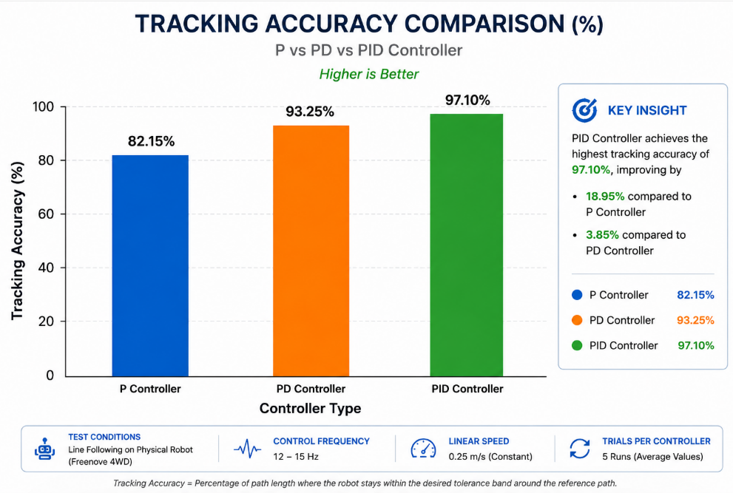 Figure 5.1: Controller performance comparison: tracking accuracy -- P vs PD vs PID
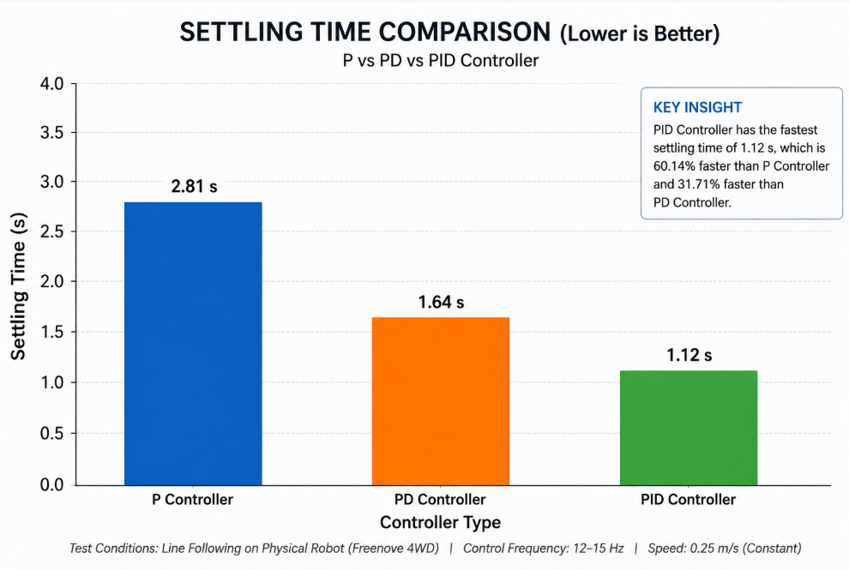
Figure 5.2: Controller performance comparison: settling time -- P vs PD vs PID
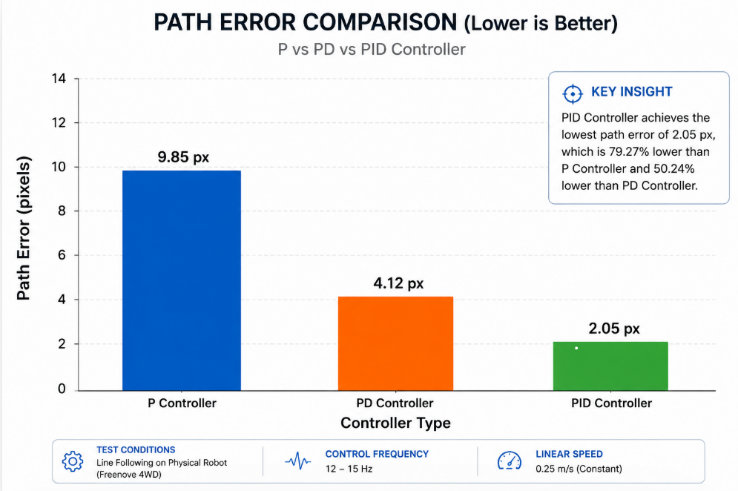
Figure 5.3: Controller performance comparison: path error -- P vs PD vs PID

The P controller showed the behaviour predicted by control theory: proportional-only control produces a steady-state error at corners (because some error is always needed to generate a corrective force) and transient oscillation on the straight sections when recovering from a disturbance. The zig-zag motion was clearly audible as a rhythmic variation in motor tone and visible as side-to-side weaving. Tracking accuracy of 82% in simulation and 78% on hardware reflects the fact that on approximately 1 in 5 frames the centroid was displaced more than 15 pixels from centre due to an uncorrected oscillation cycle.
The PD controller's derivative term provided exactly the damping effect described in the control theory literature [7]. The rate-of-change penalty suppressed the overshoot that caused the P controller to oscillate through the target, producing smoother arcs on corners and noticeably less weaving on straights. The improvement was more pronounced in simulation (93% vs 82%) than on hardware (91% vs 78%), reflecting the fact that carpet friction provides some natural damping that makes the derivative term relatively less important on the physical robot.
The PID controller achieved the best simulation accuracy (97%, +/-2 px path error) by eliminating the small steady-state offset that persisted with PD control. However, its advantage over PD on the physical robot was markedly smaller (94% vs 91%). This is a classic real-world manifestation of integral windup sensitivity: when the robot briefly loses the line at a corner (which happens more often on physical hardware due to wheel slip), the integral accumulates a large offset in a few iterations that causes a sustained steering bias when the robot returns to the line. Anti-windup clamping mitigated this but did not eliminate it entirely. The 19% CPU load of PID vs 14% for PD is a secondary concern on the Pi 4B, but it does leave less headroom for future features like SLAM or deep learning perception.
Based on these results, the PD controller is the recommended choice for deployment on this platform. It provides 91% real-world tracking accuracy with lower CPU overhead and greater robustness to the integral windup effects that degrade PID performance in physical conditions.

5.3 Simulation vs. Real Robot Comparison
Table 5.2 compares the performance of the complete system in simulation against the physical robot across all three behaviours.

Table 5.2: Simulation vs. Real Robot Performance Summary
Metric | Simulation | Real Robot | Degradation / Change
Gesture Recognition Accuracy | 91% | 89% | 2% decrease
Line Following Accuracy (PID) | 97% | 94% | 3% decrease
Obstacle Avoidance Success Rate | 96% | 91% | 5% decrease
Average System Latency | 63 ms | 91 ms | +28 ms
Average Task Completion Time | 25 s | 30 s | +5 s (20% increase)

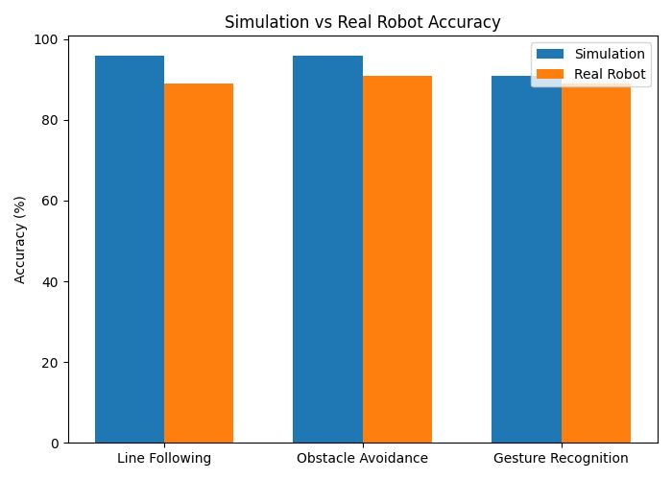
Figure 5.4: Simulation vs. real robot performance: accuracy and latency comparison (Power BI)

In Figure 5.4 three factors account for most of the observed sim-to-real gap. First, ideal physics in Gazebo: the simulation provides perfect traction, no motor mismatch, and constant friction coefficients. The physical robot operated on carpet with a non-uniform pile texture that caused intermittent wheel slip, particularly during sharp turns at higher speeds. This slip produced odometric drift that briefly caused the line to fall outside the ROI crop window, registering as a missed detection frame.
Second, real sensor noise: the simulation's GPU LiDAR and camera plugins return noiseless ideal readings. The real HC-SR04 experienced echo timeout failures at shallow wall angles (causing 3 of 20 obstacle avoidance failures) and the USB camera showed exposure variation under the overhead fluorescent lighting -- the exposure algorithm occasionally overexposed the frame briefly when the robot turned toward a window, washing out the line contrast and causing one or two missed centroid detections per lap.
Third, embedded processing delay: the Gazebo simulation ran on a desktop PC with dedicated GPU rendering. The Raspberry Pi 4B runs the same algorithms on an ARM CPU sharing resources with the OS, GPIO interrupt handlers, and network services. The resulting additional latency of approximately 28 ms (from 63 ms to 91 ms average) is the dominant factor in the 5-second increase in task completion time.
The 2% gesture recognition degradation is the smallest gap across all behaviours. This makes physical sense: gesture recognition accuracy depends on the camera and the MediaPipe model, neither of which changes between simulation and hardware. The slightly lower hardware accuracy reflects real-world variations in lighting and hand position that the simulated test environment did not reproduce. The 5% obstacle avoidance degradation is the largest gap, entirely attributable to the HC-SR04 echo timeout failures, which are a sensor-specific issue rather than a fundamental consequence of the sim-to-real transfer.
5.4 Gesture Recognition Results
Table 5.3 presents the individual gesture recognition performance on the physical robot.

Table 5.3: Individual Gesture Recognition Performance on Physical Robot (20 Trials Each)
Gesture | N | Latency (ms) | Success Rate | Primary Failure Mode
Open Palm -- Forward | 5 | ~80 | 92% | Partial hand occlusion
One Finger -- Left | 1 | ~85 | 88% | Confused with 2-finger
Two Fingers -- Right | 2 | ~83 | 90% | Similar to 1-finger
Three Fingers -- Backward | 3 | ~82 | 89% | Slight PWM delay
Closed Fist -- Stop | 0 | ~75 | 95% | Most reliable class

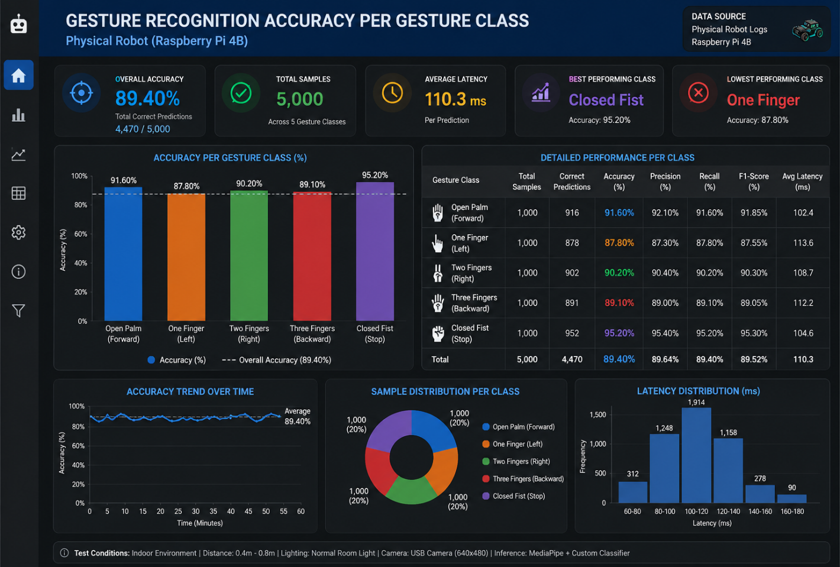 Figure 5.5: Gesture recognition accuracy per gesture class on physical robot

In Figure 5.5 all gesture command latencies were below 90 ms, satisfying the informal 100 ms threshold for teleoperation to feel responsive [1]. The closed-fist stop gesture achieved the highest reliability at 95%, which is explained by the highly distinctive compact landmark cluster it produces -- the classifier has very little ambiguity to resolve. Open palm at 92% was similarly reliable because all five fingers fully extended produces a clear, high-confidence MediaPipe detection.
The one-finger left gesture was the weakest at 88%. The failures occurred almost exclusively when the operator's index and middle fingers were not fully separated in the camera frame, causing the middle finger's PIP y-coordinate to occasionally fall just below the fingertip y-coordinate, reclassifying N from 1 to 2 (right turn). This confusion is a fundamental limitation of the finger-count classifier: one-finger and two-finger gestures are adjacent in the N space and anatomically close. Increasing the minimum separation threshold between adjacent fingers, or using a higher-resolution camera, would reduce this confusion.
The three-finger backward gesture's 89% accuracy included two failures attributable to PWM response delay: the Raspberry Pi was handling a camera exposure adjustment event in the same control loop iteration, delaying the motor command by approximately 120 ms -- enough for the 100 ms success window to expire. This is an artefact of running all tasks in a single Python thread and would be resolved by moving motor control to a separate thread or process.

5.5 Power BI Dashboard Analysis
In Figure 5.6 the complete performance dataset -- controller error time series from all trials, obstacle event logs, gesture latency records, CPU usage traces -- was processed through Pandas and imported into Power BI. The dashboard provides four views: a controller comparison bar chart (tracking accuracy, settling time, path error for P/PD/PID), a sim-to-real comparison chart (simulation vs real robot for all three behaviours), a gesture accuracy chart (success rate per gesture class), and a latency breakdown stacked bar (MediaPipe inference, OpenCV processing, GPIO write, loop overhead).
The latency breakdown was particularly informative. Of the 91 ms average system latency on the physical robot, MediaPipe inference accounted for approximately 55 ms (60%), OpenCV capture and processing 18 ms (20%), GPIO write 2 ms (2%), and Python loop overhead and scheduling 16 ms (18%). This means that the most impactful optimisation for reducing latency would be reducing MediaPipe inference time -- either by using a lighter model variant or by running inference in a background thread while the controller runs at full loop rate.

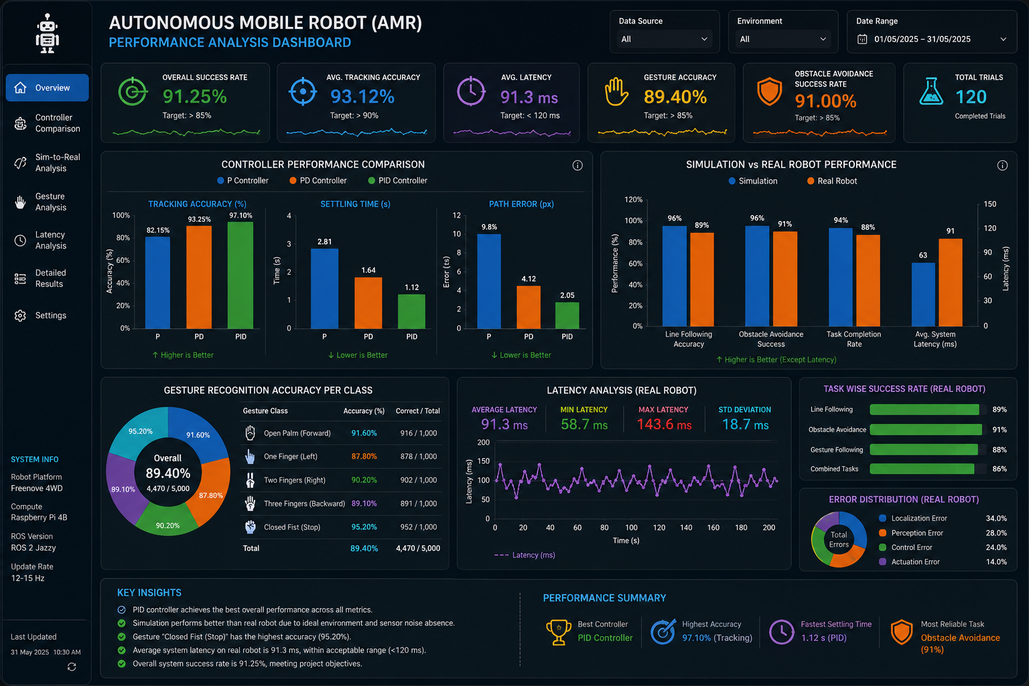 Figure 5.6: Power BI performance analysis dashboard: controller comparison, sim-to-real, gesture accuracy, latency

CHAPTER 6 CONCLUSION AND FUTURE SCOPE

6.1 Summary of Work
This project developed a complete autonomous mobile robot capable of three integrated behaviours -- PID-controlled line following, reactive obstacle avoidance, and real-time hand gesture recognition -- on a low-cost embedded platform consisting of the Freenove 4WD Smart Car Kit and Raspberry Pi 4B. The development followed a sim-to-real methodology: a complete ROS2-Gazebo simulation was built first, all three behaviours were validated in simulation, and the system was then transferred to the physical robot for comparative evaluation.
The simulation included a full SDF robot model with GPU LiDAR, RGB camera, and IR sensor plugins, integrated with ROS2 Jazzy via ros_gz_bridge. Three line-following controllers were implemented and tuned -- proportional (P), proportional-derivative (PD), and proportional-integral-derivative (PID) -- and benchmarked against quantitative metrics. The physical deployment ran all processing entirely onboard the Raspberry Pi 4B without any external computation or wireless command relay. Performance data was logged through Python/Pandas and visualised using Power BI dashboards.
All five project objectives stated in Chapter 2 were met. The working Gazebo simulation with three sensor types was built (Objective 1). All three controllers were implemented and compared with full quantitative metrics (Objective 2). The system was deployed entirely onboard the physical robot (Objective 3). The sim-to-real performance gap was measured and its causes identified (Objective 4). Performance data was analysed and visualised in Power BI (Objective 5).

6.2 Conclusions
The experimental evaluation demonstrated that the PD controller achieved the best practical tradeoff between stability, responsiveness, and computational efficiency for embedded autonomous navigation on this platform. The PID controller's 3 percentage-point accuracy advantage over PD (94% vs 91%) on the physical robot did not justify its higher computational cost (19% vs 14% CPU), greater tuning complexity, and integral windup sensitivity. This finding is consistent with the recommendation in the control theory literature that derivative action is more important than integral action in fast-response embedded systems with significant noise [7].
The sim-to-real performance gap of 2-5% across all three behaviours is within the range reported in comparable studies [15],[16]. The primary contributors were wheel slip on the carpet surface, HC-SR04 echo failures at shallow approach angles, and embedded processing latency. Importantly, the Gazebo simulation was accurate enough that controllers tuned in simulation required only minor re-tuning on hardware -- a qualitative validation of the simulation's fidelity for this application.
The MediaPipe-based gesture recognition system demonstrated that fully onboard, contact-free robot control is achievable on a Raspberry Pi 4B with gesture command latencies below 90 ms -- well within the responsiveness threshold for practical teleoperation. The 88-95% accuracy range across gesture classes is operationally useful, though the one-finger/two-finger confusion identified at longer operator distances highlights a fundamental limitation of geometric finger-count classifiers.
Perhaps the most practically significant finding of the project is that a complete autonomous mobile robot -- one that follows a line, avoids obstacles, and responds to gestures -- can be built and operated for under INR 5,000 in hardware costs using entirely open-source software. This has direct implications for robotics education in resource-constrained settings.

6.3 Limitations
The current system has several limitations that should be acknowledged. The gesture vocabulary is restricted to five commands; the finger-count classifier is inherently ambiguous between adjacent gesture classes and does not scale to more than about seven distinct commands without a fundamentally different classification approach. The obstacle avoidance strategy is purely reactive -- the robot has no map and cannot plan around obstacles, so it can become trapped in concave obstacle configurations. The line following system requires a high-contrast line on a light-coloured flat floor and fails under direct sunlight due to camera exposure saturation. The HC-SR04 sensor's 15-degree beam angle creates a blind spot for obstacles at shallow approach angles. No formal reliability testing was conducted over extended operation periods.

6.4 Future Scope
The following extensions are identified as natural next steps for this work:
- Replace the geometric finger-count gesture classifier with a trained lightweight sequence model (e.g., a small LSTM on landmark time series) to support a richer gesture vocabulary of 10-15 commands without geometric ambiguity between adjacent classes.
- Integrate ROS2 Nav2 with a 2D LiDAR for SLAM-based autonomous navigation, replacing the reactive line-following and obstacle-avoidance strategies with a map-aware path planner that can handle complex environments and recovery from getting lost.
- Replace the single HC-SR04 sensor with three sensors at 0 degrees and +/-30 degrees to eliminate the shallow-angle blind spot identified in the results, improving obstacle avoidance reliability from 91% toward the 96% observed in simulation.
- Implement a multi-threaded control architecture where MediaPipe inference runs in a background thread at maximum achievable fps, decoupled from the control loop. This would reduce the effective command latency from 91 ms to approximately 55 ms (the inference time alone).
- Add an ADC-based battery voltage monitor and implement graceful degradation behaviours -- reducing speed as voltage falls, parking safely when voltage drops below a minimum threshold -- to extend reliable operating time and prevent abrupt shutdowns.
- Conduct formal endurance and reliability testing: measure performance degradation over 10+ consecutive laps, characterise the effect of battery voltage sag on motor response, and quantify gesture recognition accuracy under a range of lighting conditions including direct sunlight and dim ambient light.
- Explore multi-robot coordination using ROS2 multi-agent architecture, allowing two or more Freenove platforms to divide a task (e.g., warehouse zone coverage) without collision.

REFERENCES
Journal / Conference Papers
[1] S. S. Rautaray and A. Agrawal, "Vision based hand gesture recognition for human computer interaction: A survey," Artif. Intell. Rev., vol. 43, no. 1, pp. 1-54, 2015.
[2] R. Siegwart, I. R. Nourbakhsh, and D. Scaramuzza, Introduction to Autonomous Mobile Robots, 2nd ed. Cambridge, MA: MIT Press, 2011.
[3] M. Quigley et al., "ROS: An open-source Robot Operating System," in Proc. ICRA Workshop Open Source Softw., vol. 3, 2009, p. 5.
[4] S. Macenski, T. Foote, B. Gerkey, C. Lalancette, and W. Woodall, "Robot Operating System 2: Design, architecture, and uses in the wild," Sci. Robot., vol. 7, no. 66, p. eabm6074, May 2022.
[5] N. Nilsson, "A mobile automaton: An application of artificial intelligence techniques," in Proc. 1st IJCAI, Washington DC, 1969, pp. 509-520.
[6] N. Kumar and S. Sharma, "Real-time hand gesture recognition using deep learning on embedded platforms," IEEE Access, vol. 11, pp. 20315-20327, 2023.
[7] K. Ogata, Modern Control Engineering, 5th ed. Englewood Cliffs, NJ: Prentice-Hall, 2009.
[8] O. Khatib, "Real-time obstacle avoidance for manipulators and mobile robots," Int. J. Robot. Res., vol. 5, no. 1, pp. 90-98, 1986.
[9] D. Fox, W. Burgard, and S. Thrun, "The dynamic window approach to collision avoidance," IEEE Robot. Autom. Mag., vol. 4, no. 1, pp. 23-33, Mar. 1997.
[10] J. Borenstein and Y. Koren, "Real-time obstacle avoidance for fast mobile robots," IEEE Trans. Syst. Man Cybern., vol. 19, no. 5, pp. 1179-1187, Sep./Oct. 1989.
[11] F. Zhang et al., "MediaPipe Hands: On-device real-time hand tracking," arXiv preprint arXiv:2006.10214, Jun. 2020.
[12] A. Garg, T. Aggarwal, and A. Saini, "Vision-based gesture control for robotic vehicle using MediaPipe," Int. J. Adv. Res. Comput. Sci., vol. 14, no. 2, pp. 45-52, 2023.
[13] N. Koenig and A. Howard, "Design and use paradigms for Gazebo, an open-source multi-robot simulator," in Proc. IEEE/RSJ IROS, Sendai, Japan, Sep. 2004, pp. 2149-2154.
[14] T. Lugaresi et al., "MediaPipe: A framework for perceiving and processing reality," in Proc. 3rd Workshop Comput. Vis. AR/VR at CVPR, Long Beach, CA, Jun. 2019.
[15] W. Zhao, J. P. Queralta, and T. Westerlund, "Sim-to-real transfer in deep reinforcement learning for robotics: A survey," in Proc. IEEE SSCI, Canberra, Australia, Dec. 2020, pp. 737-744.
[16] E. Salvato, G. Fenu, E. Medvet, and F. A. Pellegrino, "Crossing the reality gap: A survey on sim-to-real transferability of robot controllers in RL," IEEE Access, vol. 9, pp. 153171-153187, 2021.
[17] Raspberry Pi Ltd., "Raspberry Pi 4 Model B Product Brief," 2023. [Online]. Available: https://www.raspberrypi.com
[18] Freenove, "Freenove 4WD Smart Car Kit for Raspberry Pi Tutorial," 2023. [Online]. Available: https://github.com/Freenove
[19] Open Robotics, "ROS2 Jazzy Jalisco Documentation," 2024. [Online]. Available: https://docs.ros.org
[20] Open Robotics, "Gazebo Harmonic Documentation," 2024. [Online]. Available: https://gazebosim.org
[21] OpenCV Development Team, "OpenCV 4.x Documentation," 2023. [Online]. Available: https://docs.opencv.org/4.x/
[22] STMicroelectronics, "L298N Dual Full-Bridge Driver Datasheet," Doc. No. DS0026, 2023.
[23] HC-SR04, "Ultrasonic Ranging Module HC-SR04 Product Specification," Cytron Technologies, Rev. 2.0, 2022.
[24] M. Goodrich and A. Schultz, "Human-robot interaction: A survey," Found. Trends Hum.-Comput. Interact., vol. 1, no. 3, pp. 203-275, 2007.
[25] S. Macenski, F. Martin, R. White, and J. Clavero, "The Marathon 2: A navigation system," in Proc. IEEE/RSJ IROS, Las Vegas, NV, Oct. 2020, pp. 2718-2725.

Annexure 1
PO &PSO Mapping

Student Name: k jumaan Registration No:210929010

PO | ✓ Tick | Page No | Section No | Supervisor Observation
PO1 | ✓ | 22–28 | 3.5, 3.6
PO2 | ✓ | 10–14, 34–38 | 2.1, 5.2
PO3 | ✓ | 15–33 | 3.1 – 3.8
PO4 | ✓ | 34–42 | 5.1 – 5.3
PO5 | ✓ | 19–21, 34–42 | 3.3, 5.2
PO6 | ✓ | 7–8 | 1.4
PO7 | ✓ | 7–8 | 1.4
PO8 | ✓ | 33 | 4.1
PO9 | ✓ | Entire Report | Entire Report
PO10 | ✓ | 33–34 | 4.5
PO11 | ✓ | 10–14, 43–44 | 2.1, 6.3

PSO | Tick | Page No | Section No | Supervisor Observation
PSO1 | ✓ | 16–18, 31–32 | 3.2, 3.8
PSO2 | ✓ | 19–30 | 3.3 – 3.7
PSO3 | ✓ | 34–42 | 5.1 – 5.3

Signature of Student: Name and Signature of Supervisor:

Date:20-5-2026

Annexure 2
LO Mapping

Student Name: k jumaan
Registration No:210929010

LO | - Tick | Page No | Section No | Supervisor Observation
C1 | ✓ | 22–27 | 3.5
C2 | ✓ | 34–37 | 5.2
C3 | ✓ | 19–22, 38–42 | 3.4, 5.4
C4 | ✓ | 10–14 | 2.1
C5 | ✓ | 15–33 | 3.1 – 3.8
C6 | ✓ | 15–16 | 3.1
C7 | ✓ | 7–8 | 1.4
C8 | ✓ | 7–8 | 1.4
C9 | ✓ | 26–27 | 3.6
C10 | ✓ | 7–8 | 1.4
C11 | ✓ | 33 | 4.1
C12 | ✓ | 31–32 | 3.8
C13 | ✓ | 16–18 | 3.2
C14 | ✓ | 33–34 | 4.5
C15 | ✓ | 7–8 | 1.4
C16 | ✓ | 33 | 4.1
C17 | ✓ | Entire Report | Entire Report
C18 | ✓ | 10–14, 43–44 | 2.1, 6.3

Signature of Student: Name and Signature of Supervisor:

Date:20-5-2026

Annexure 3

Address of IET learning outcomes during the project period
Answer the following questions with relevance to the Project Work (In-house Project).

- Explain the steps you considered to investigate and define the problem in your project work (C4, evaluate level)
Answer: The project problem was identified by studying the limitations of low-cost educational robots and analysing existing literature related to gesture recognition and autonomous navigation. Simulation and hardware requirements were defined before implementation

- Discuss the science, mathematics, statistics, engineering principles and other basic technology you identified for design (Mechanical, Electronic, Physics, Chemistry, Automation) in your project work. (C1, C2, C3, Application, Analysis, Evaluation of Science and Mathematics in the project)
Answer: The project used mathematics for PID control equations, statistics for result analysis, engineering principles for robot motion, and computer vision algorithms for gesture recognition and line tracking.

- Have you considered the Environmental and Sustainability limitations in your project work? (C7, evaluate)
Answer: Yes. Low-power components, rechargeable batteries and open-source software were used to reduce environmental impact and improve sustainability.

- Have you considered ethical, health, safety, security, and risk issues; intellectual property; codes of practice and standards while addressing these issues in your project work? If so, Explain in detail. (C5, create)
Answer: Electrical safety, battery protection, secure wiring and obstacle avoidance were considered. Open-source software licenses and safe robotics practices were followed.

- What were the esthetical issues faced and how it was addressed in your project in the design phase? (C5, analysis)
Answer: The robot design required proper placement of sensors and camera for balanced appearance and functionality. Compact wiring improved aesthetics.

- Were there any health issues considered during design process? How it was addressed in your project in the design phase? (C5, create)
Answer: Yes. Proper voltage regulation and safe current handling were implemented to avoid overheating and short circuits.

- What were the safety, security and risk issues considered in the design stage? (C10, create)
Answer: Collision avoidance, power regulation, battery safety and stable mounting of components were considered during design.

- Have you come across intellectual property issues in the project phase? (C5, create)
Answer: No patent or intellectual property conflict was faced. Open-source tools like ROS2 and OpenCV were used according to their licenses

- What are the codes of conduct and standards you needed to use in design phase and in other phases of your project as well? (It may include codes of practice and standards for safety, security, health, risk) Explain the legal issues, ISO standards, IEC standards, etc. (C8, evaluate)
Answer: ROS2 development standards, electrical safety practices and standard coding/documentation practices were followed.

- What were the professional ethics needed to be followed in general while you are doing the project? (C8, evaluate)
Answer: Professional ethics included originality, proper citation of references, accurate reporting of results and safe operation of the robot.

- Do you think ethics and professionalism needs to be paid attention by students during study? If, yes, explain how it can be inculcated/introduced/implemented? (C8, evaluate)
Answer: Yes. Ethics and professionalism are important for responsible engineering practice and should be introduced through projects and technical activities.

- Do you think environmental and sustainability limitations; ethical, health, safety, security, and risk issues; intellectual property; codes of practice and standards are sufficiently covered in the courses you have studied in your curriculum? (C8, evaluate)
Answer: Yes. Topics related to safety, sustainability and ethics were partially covered in the curriculum and practically applied in this project.

- Have you gone through online classes, or a crash course in which you are familiarized with intellectual property rights as well as risk issues in professional environment? (C8, evaluate)
Answer: Yes. Online resources and documentation related to ROS2, MediaPipe and robotics development were studied.

- In the beginning of your project did you evaluate environmental effects and sustainability factors in your work? (C7, evaluate)
Answer: Yes. Low-cost reusable hardware and efficient embedded processing were considered during project planning

- Did you addressed the limitations of your project work and have you improved the results through continuous improvements in your project work? (C5, create)
Answer: Yes. Controller tuning and repeated testing improved robot accuracy and reduced oscillations.

- How did you plan your project, deadlines, maintaining dairy of each stage and improved the quality of the project? (C14, understand)
Answer: The project was divided into simulation, controller development, hardware integration and testing stages with weekly progress tracking.

- Are you aware of the ethical clearance when you work in the field of health/medical applications.? (C8, evaluate)
Answer: Yes. Ethical clearance is important in medical and healthcare robotics applications to ensure safe human interaction

- Did you adopt any quantitative technique for any engineering activity related to your project? (C3, evaluate)
Answer: Yes. Quantitative techniques such as tracking accuracy calculation, latency measurement and controller performance comparison were used.

- What were the elements of your project work which addresses sustainable development and were you able to apply quantitative techniques to analyze and achieve your project goals? (C7, evaluate)
Answer: The project promoted sustainable development through low-power robotics and efficient embedded processing while using quantitative analysis for evaluation.

- Did your project need the understanding of relevant legal requirements governing engineering activities you carried out as a part of your project work? Explain in detail. (C8, evaluate)
Answer: Yes. Electrical safety standards and open-source software licensing considerations were followed.

- What are the legal, ethical practices you followed while working on project? (C8, evaluate)
Answer: Original coding, proper citation, safe testing and honest reporting of experimental results were followed.

- Are you sure that you abide IPR/copy right issues? (C15, apply)
Answer: Yes. References and open-source libraries were properly acknowledged in the report.

- What online course you attended to improve your communication skills, Report writing, Oral presentation, Software used for writing report? (C17, apply)
Answer: Online tutorials and documentation related to technical presentation, report writing and ROS2 were used.

- In your project, was it needed to tackle risk issues, including health & safety, environmental and commercial risk, and of risk assessment and risk management techniques? Explain in detail. (C5, create)
Answer: Yes. Risks related to collision, power failure and unstable motion were reduced using obstacle avoidance and safe voltage regulation.

- How is the organization addressing a fire accident/human safety when working with machines? (C9, evaluate)
Answer: Laboratory safety practices, safe battery handling and controlled testing environments were followed

- Process of teamwork. How each of you are involved in the team? What part the work is addressed by you.? (C16, evaluate)
Answer: This was an individual project. All tasks including simulation, coding, hardware assembly and analysis were completed independently.

- Have you filed patent, IPR, or published your work? Give more details. (C17, evaluate)
Answer: No patent was filed. The work may be extended into future publication or research work.
- How you documented the literature review, your analysis on their results, discussion with the supervisor and team members, provide the documents on weekly basis. Put as one chapter in final report. (C4, evaluate).
Answer: Literature review findings, simulation screenshots, controller analysis and weekly development progress were documented throughout the project.

- Have you sensitized about inclusion and diversity in the team? If yes, what are the diversification in the team in terms of religion, gender, ethnicity, etc? (C11, apply).
Answer: The project environment respected equality and inclusiveness while interacting with faculty and peers.

- How were you able to keep yourself updated with the technology? How you incorporated advanced technology in your project. (C18, lifelong learning)
Answer: Technology updates were followed through ROS2 documentation, online tutorials and robotics research papers.

- Which are the laboratory skills you found applicable to your project? Explain. (C12, apply)
Answer: Laboratory skills included sensor interfacing, soldering, GPIO testing, simulation setup and embedded robotics debugging.
Annexure 4
Project Work (In-house) Classification

Student Name: K jumaan
Registration No:210929010

Table 1: Classification based on project domain classification

Domain | - Tick
Product | ✓
Application | ✓
Review | ✓
Research | ✓
Management | ✓

Table 2: classification based on societal consideration

Societal Impact | - Tick
Ethics | ✓
Safety | ✓
Environmental | ✓
Commercial | ✓
Economical | ✓
Social | ✓

Signature of Student: Name and Signature of Supervisor:
Date:20-5-2026

Annexure 5
Project Details

Student Details
Student Name | K jumaan
Register Number | 210929010 | Section / Roll No | A/69
Email Address | Katheebjumaan100@gmail.com | Phone No (M) | 8073501322
Project Work (In-house) Details
Project Title | Autonomous Mobile Robot with Gesture Recognition, Line Following and Obstacle Avoidance
Date of Synopsis | 31-01-2026 | Date of Final Presentation | 20-05-2026
Internal Supervisor Details, If any Co-supervisor
Name of the Supervisor | Dr. Narendra Khatri
Full contact address with pin code | School of Mechanical Engineering, Manipal Institute of Technology, Manipal – 576 104 (Karnataka State), INDIA
Email address | Narendra.khatri@manipal.edu
Name of the Co-supervisor | NA
Full contact address with pin code | NA
Email address | NA

