Virtual Simulator Extreme
(VirSim EX)

Cs337 Software Engineering

Functional Requirements, Design and Test Plan Document

Prepared by
Diep, Kevin
Behdinian, Bahin

June 12, 2009

CALIFORNIA STATE UNIVERSITY
LOS ANGELES

Los Angeles, California

Virtual Simulator Extreme
(VirSim EX)

Prepared By:

Behdinian, Bahin
Diep, Kevin

Approved By:

_______________ _____6/15/2009_
Jose Macias Date

Concurrence By:

_______________ _____6/15/2009
Steven Emory Date

Document Change Log

Update | Date Released | Changes
Draft #1 | 4/15/2009 | Delivery of the Software Requirements document
Draft #2 | 6/12/2009 | Delivery of the 2nd draft of VirSim Ex document
Final | 6/15/2009 | Final Draft

List of TBD Items

Page | Item | Description | Status
1-20 | Implementation | A more in depth pseudo code for the decoder | TBD
1-21 | Implementation | A more in depth pseudo code for the audio/image processing | TBD
1-21 | Implementation | A more in depth pseudo code for the motion capturing | TBD
1-21 | Implementation | A more in depth pseudo code for the haptic system | TBD

Table of Contents

1.0 INTRODUCTION

1.1 Purpose 1-1

1.2 Scope 1-1
1.2.1 Document Organization 1-1
1.2.2 Relationship to Other Documents 1-1

1.3 VirSim Ex System Architecture 1-2
1.3.1 Context Diagram (Level 0 DFD)
1.3.2 Description of VirSim Ex Major Units

1.4 Requirement Development Process 1-3

1.5 References 1-4
1.5.1 Controlling Documents 1-4
1.5.2 Applicable Documents 1-4
1.5.3 Standards

2.0 DETAILED FUNCTIONAL DESCRIPTION OF THE VirSim Ex

2.1 Detailed VirSim Ex Functional Description 1-5
2.1.1 Higher Level DFDs 1-5
2.1.2 Detailed Functional Description of Major Sub-Units 1-6

3.0 VirSim Ex REQUIREMENTS

3.1 VirSim Ex FUNCTIONAL REQUIREMENTS 1-9

3.2 VirSim Ex NON-FUNCTIONAL REQUIREMENTS 1-12

3.3 VirSim Ex HARDWARE REQUIREMENTS 1-13

4.0 VirSim Ex DETAILED DESIGN

4.1 Introduction 1-14

4.2 VirSim Ex External Interface Descriptions 1-14

5.0 VirSim Ex ELEMENTS OF IMPLEMENTATION

5.1 Introduction 1-20

5.2 Implementation Goals 1-20

6.0 VirSim Ex TEST PLAN

6.1 Introduction 1-23

6.2. Functional and Performance Requirements Validation Matrix 1-23

A. ACRONYMS 1-28

B. DATA DICTIONARY 1-29

List of Figures

Figure 1.1 DFD Level 0
Figure 2.1 DFD Level 1
Figure 4.1 DFD Level 2 for the login module
Figure 4.2 DFD Level 2 for the heart rate module
Figure 4.3 DFD Level 2 for the temperature module
Figure 4.4 DFD Level 2 for the main controller

List of Tables

1. INTRODUCTION

1.1 Purpose

The purpose of this document is four-fold:

a) Completely define a full set of requirements for the VirSim Ex – Section 3.0.
(These sections correspond to a Software Requirements Document, SRD).

b) Completely define the design for the VirSim Ex – Section 4.0.
(These sections correspond to a Software Design Document, SDD).

c) Define and partially implement feasible modules for the VirSim Ex – Section 5.0.
(These sections correspond to the Software Implementation Document, SID).

d) Completely define the Test Plan for the VirSim Ex – Section 6.0.
(These sections correspond to a Software Test Plan, STP).

The complete definition of all VirSim Ex requirements provides the source requirement inputs for the development of the subsequent supporting software subsystems documents.

1.2 Scope

The documentation developed as part of this cs437 class, starts from the SRD prepared in cs337 or in previous cs437 classes with a much reduced scope.

The scope of this document includes the following:

- All functional and non-functional requirements on the VirSim Ex are captured. This includes Verification & Validation (V&V) requirements, as well as inter-software subsystems requirements.
- A complete set of VirSim Ex Requirements, derived and traceable to the incoming cs437 class requirements. These requirements are organized by key VirSim Ex functional units shown on the Level 1 DFD. The Level 1 DFD is shown on page [TBD].
- A trace matrix, relating all VirSim Ex functional requirements to functional subunits as expanded in lower level DFDs. Level 2 and 3 DFDs are provided on pages [TBD].
- The functional requirements defined in the VirSim Ex Requirements section have been expanded to include more specific hardware requirements.

1.2.1 Document Organization

The organization of this document provides a natural 'flow' or allocation of requirements to each succeeding section.

1.2.2 Relationship to Other Documents

The VirSim Ex SRD/SDD/STP/SID is a complete self contained document. Some relationships to other documents in the literature are indicated below by section.

1.3 Project Name Architecture

1.3.1 Detailed Context Diagram (DFD Level 0)

The VirSim Ex architecture is summarized in the Context Diagram (DFD Level 0) given below.

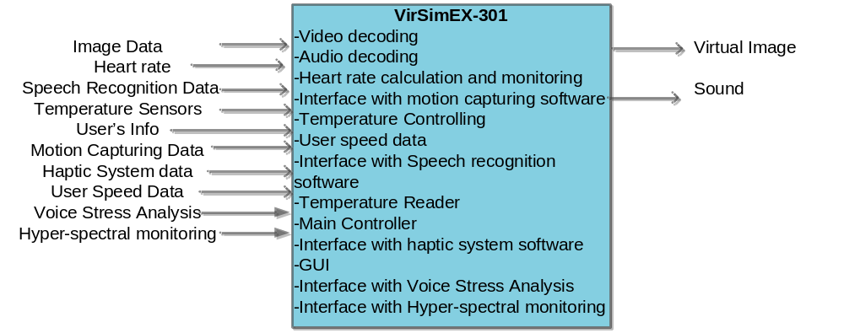
Figure 1.1 Level 0 DFD (Context Diagram)

1.3.2 Description and major functions of the VirSim Ex

Virtual Simulator Extreme (VirSim EX) is the next generation of hologram projection and 3D video imaging system. It provides the average person the ability to go anywhere and do anything at anytime without ever leaving the room. Through an amazing imaging processing software, the user will be able to see and hear an actual environment where in reality it is just a hologram projection. With holographic technology users no longer require to wear special glasses to see a virtual image. The image processing software has the ability to refresh the image at a high rate so the user will not see any delay in the image. There is also an added haptic system that allows the user to touch and move objects inside the environment.
When the user first launches the software a login page will prompt the user to enter their username and password. If the user is a new user, he/she need to register with the system. Once the user logs in, another page will prompt the user to select the environment they want. After selecting the environment the user walks into the room.
Once inside the room, the user will need to wear a body suit and a special cyber glove to interact with the environment. The motion capturing software along with special cameras will capture the user movement and recalibrate the image accordingly. The haptic system works in the same way. The sensors from the glove will send data to the main controller as the user move his/her hands. The main controller will analyze the data and recalibrates the image accordingly. There will be a platform in the room for the user to stand, walk or run on. There will be sensors attached to the platform that measure the speed of the user. The software then uses the speed to recalibrates the image.
For safety reason the user will need to wear a heart monitor strap so the software can monitor the user’s heart rate. The system will enter a shutdown sequence if the user’s heart rate goes above a threshold value. This value varies depending on the user’s age.
There is also a voice stress analyzer and a hyper-spectral monitoring software that constantly monitoring the user status. The voice stress analyzer has the ability to determine if the user is in any kind of stress. If the software determined that the user is under any kind of stress the software will call the main controller to enter the shutdown sequence. The hyper-spectral monitoring is checking for the user perspiration level. If the user begins to perspire a lot the software will also call the main controller to enter the shutdown sequence stage.
The software also has voice command capability so the user can start and shutdown the system anytime they want. Another safety feature is the temperature sensor. The sensor will constantly monitor the temperature of the room. If the room temperature goes above 90 degree Fahrenheit or below 40 Fahrenheit the system will shutdown automatically as precaution .
In summary with VirSim Ex the users are totally immerse into our system. They can interact with the environment and the environment will respond accordingly to the users’ action. There are also safety features that protect the users from any harm and dangerous condition. Some of those major functions are listed below:

- Heart rate monitoring to monitor user’s heart rate.
- Motion capturing to monitor the user’s movement.
- Haptic system to monitor the user’s hand movement.
- Voice recognition to allow the user using their voice command
- Voice Stress Analysis to regulate user stress level
- Hyper-spectral monitoring to regulate user perspiration level.

.

1.4 Documentation Development Process

The VirSim Ex detailed functional description is documented in section 2.0. Basically, Section 2 is a succinct software description document. The overall detailed functional description is based on higher level DFDs (above level 1). All major functional sub-units are described in detail in this part of the document.

In general, all requirements affecting VirSim Ex are captured in Section 3.0 of this document. These requirements are a refinement and completion of requirements first collected as part of a previous Software Engineering project. The document is cited in Section 1.2.2. This section is the one worked in most detail to become a reasonably complete Software Requirements Document (SRD). It includes both functional and non-functional software requirements together with several detailed “rational” paragraphs whenever necessary to complete the understanding of each requirement.

Section 4 is the VirSim Ex detailed Design Description Document (SDD). This part of the document includes all higher level DFDs as described in section 2 plus all interface units. The document is highly technical and it is based on section 2 descriptions. An important component is the addition of a SIS (software interface specification) document in sub-section 4.2.

Section 5 includes elements of a partial implementation of VirSim Ex. This section includes the various constraints that effectively limit the implementation as well as the sub-units that will be coded. The implementation goals are defined and the code is included as an attachment to this section.

Section 6 is the last major section in this document and includes the overall Test Plan (TP) of the VirSim Ex. The test plan details the various techniques used to test the requirements and it also includes a Validation Matrix where each requirement specified in section 3 is listed with its corresponding validation method. In addition, TP specifies the mandated peer reviews needed to validate the stakeholders’ part of the requirements.

1.5 References

List of motion and gesture file formats < http://en.wikipedia.org/wiki/List_of_motion_and_gesture_file_formats>
- Heart Rate. December 2006 <http://en.wikipedia.org/wiki/Heart_rate>
- Strickland, Jonathan. How Virtual Reality Works. http://electronics.howstuffworks.com/gadgets/other-gadgets/virtual-reality.htm
- CyberGlove II. <http://www.vrealities.com/cyber.html
- http://www.naturalpoint.com/optitrack/products/full-body-mocap.html
- http://www.athleticgps.com/faq/q0128.shtml
- www.youngmonkey.ca/hands/restaurant/plugins/HolographicProjector/ - 8k
1.5.1 Controlling Documents

1) There is no document controlling this document.

1.5.2 Applicable Documents

1) No additional applicable document has been used in the production of this document.

1.5.3 Standards

No Standard has been used in the creation of this document. However, some Standards described in textbooks have been examined as a reference. In particular, the IEEE standard has been briefly discussed in class.

2.0 DETAILED FUNCTIONAL DESCRIPTION OF THE VirSim Ex

2.1 Detailed Functional Description

The major tool used to design VirSim Ex is the Data Flow Diagram, DFD. The rational behind the selection of DFDs as the preferred design tool was their simplicity and versatility. In the future more sophisticated tools may be used particularly if a stronger correlation from Design to Requirement to Implementation and Testing is required.

2.1.1 Higher Level DFDs

The VirSim Ex major functional subunits are shown in the DFD Level 1 depicted below:

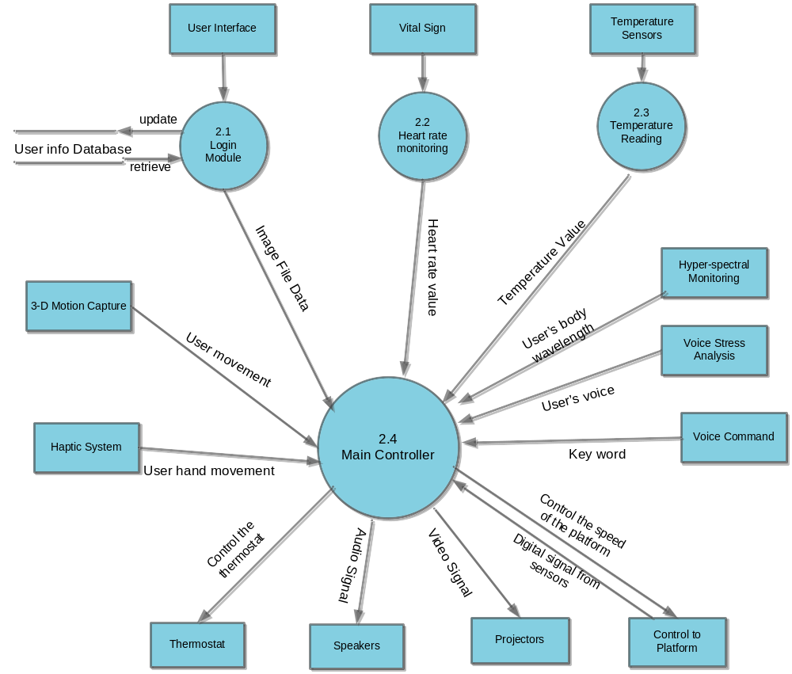
Figure 2.1: Level 1 DFD

2.1.2 Detailed Functional Description of Major Sub-Units

The description of the function of the VirSim Ex major functional units shown in Figure 2 follows

Login Module – Module 2.1

The storage array composed of a hard drive that holds all the images and a decoder program. The module also contains web pages that act as a GUI to interact with the user. When the user first launches the software a login web page will be loaded. At the login page the user will enter their username and password. After they completed logging into the system without any error, they will be taken to another page. At this page the user will pick from a list of available images to be load. Once the user selects the image the decoder will uncompress the file and sent it to the main controller to be displayed.

Heart Rate Monitor– Module 2.2

The heart rate monitor module is use to monitor the user heart rate. Before the user begins the virtual environment they will be require to strap into a heart monitor strap. This strap will have multiple sensor pads on them. These sensor pads are used to monitor the user heart beat. Each time the user heart beat, it will send out pulse signal. This signal is then picked up by the sensor pads. This module will use the signal that picked up by the sensor pads as input to the module. It will calculate the number of pulses in a 60 seconds time frame. From this equation the software can determine the user heart rate per minute. This module will continue to monitor the user heart beat until the heart beat goes above a threshold value (maximum heart rate allow for the user). Once the user heart rate goes above this threshold value an error flag will be send to the main controller to shut down the simulator immediately. This feature is known as Safety Shutdown. The equation that will be used to calculate the threshold limit for heart rate is HR_{max} = 206.3 − (0.711 × age)^{[2]}.

Temperature Sensors – Module 2.3

The temperature module primary function is to monitor the room temperature. It will send an error flag to the main processor if the temperature in the room goes above 90 degree Fahrenheit or below 40 degree Fahrenheit. The module wills constantly monitoring the fluctuation of the temperature in the room, since the temperature inside the room changes depending on the virtual environment that the user select. The algorithm will have a Boolean check condition for the input value, if the value is over 90 or under 40 the algorithm will generate an error flag and it is send to the main controller module.

Main Controller – Module 2.4

The main controller module is the brain for the system. It has many primary roles and composes of many sub functions. One of its main functions is to project the hologram image and send the audio signal to the speaker after it receive the data file from the storage array. The function will project the image data via the projectors in the room and send the audio signal to the surround sound system. Its secondary function is to interface with the motion capture software to recalibrate the image depending on the user movement. Its third function is to act as a safety monitor and check for any error flag send by the heart rate monitoring module, temperature module, and voice command module. Upon receiving an error from any one of the three modules, the main function will stop immediately. It will stop the moving the platform, the image and sound.

The description of the function of the VirSim Ex major external units shown in Figure 2 follows

Voice Command –The ability to recognize the user speech is very important in this system because this is one of the safety features. The voice command software has the ability to recognize the user speech pattern and look for key words. For example, those key words could be stop or start. Once the user is strapped into the heart rate monitoring device, he/she is ready to go. However, instead of having to push a button or click a mouse, the user simply just needs to say “start”. The voice recognition software will send the key word to the main controller. The main controller will recognize that “start” is a key word to start the environment. This feature is also used for safety purpose. For example, during the process if the user for any reasons doesn’t want to continue on with the simulation they can simply say “stop” and the environment will stop.

Motion Detecting – Motion detecting captures the movement of the user and translates the movement into a 3D object model presentation. There is available software for this function. Our goal here is not to reinvent the wheel but to integrate the motion capture software with our own software. There will be multiple cameras placed inside the room to capture the user movement from multiple angles. This is an important part of the whole system because half of this project depends on the ability to recognize user movement and the ability to capture that movement and process it. As the user move any part of their body, the motion capture software will capture that movement, analyze it, process it, and then send the data to the main controller.

Haptic System – The word haptic is from Greek “hapteshi,” meaning to touch. A haptic system gives the user the ability to touch and move objects inside the virtual environment. User interaction is an important part of a successful virtual reality. For example, if a user happens to walk along a road and they see an apple tree, the user can walk toward the apple and pick the apple. When they pick the apple and bring it toward them, the user will see the apple in their hands and moving toward them. For this feature to work, the user will need to wear a special cyber glove. The glove will have multiple sensors that’s use to measure joint-angle measurement. The glove will transform hand and finger motions into real-time digital join-angle data.^{[3]} The main controller will read these data values and recalibrate the image correctly depend on these data.

Database – The database is use to store the user’s username, password, and personal information. The user must first create an account where he/she will create a username, password, address, phone, age, and email. After the user has created their information it will then be store in the database system. The age value is especially important because it will be used to calculate the maximum heart rate acceptable before sending out error flag.

User Interface – The user interface is a web page with a username and password field. Prior to using the system, the user must create an account. If the user already created an account, they can login into the system with their login credential. If the user is a new user they will need to register with the system. There is a link for the new user and when they click on the link it will take them to another page where they will fill in all the require information and submitted to the system.

Speaker System – The surround sound system will add a 3D sound system to the room. It will enhance all the sounds to make it crystal clear. The user will be able to hear the birds singing, airplanes going by, or perhaps a police siren going by. The sound system will have high definition, meaning it will have the ability to project different sound decibels depending whether the sound source is nearby or far away. For example if a bird is singing near the user, he/she will be able to hear it louder where if the bird is farther away the sound will be faint. The sound system will also adopt the Doppler effect, for example if a car is coming toward you the sound will be low and as the car is coming closer and closer to you the sound will be louder and louder. Once the car pass and goes away from the user the sound he/she heard will be lower again.

Projectors – The projectors is use to display the image. There will be 5 projectors in the room and each projector will project a piece of the image. The image will recalibrate using the XYZ plane. If the user walks in the positive X direction, the projector in the positive X direction will recalibrate (note: the projector is not actually recalibrate the image but the main controller is. The main controller will move and adjust the image according to the user movement and point of view). If the user walks in the negative X direction the projector in the negative X direction will recalibrate. The same thing applies for the Y direction, however for the Z direction the image will be fix. There won’t be any adjusting in the Z direction because we are assuming that the user can’t fly or dig hole in the ground.

Platform - The hydraulic platform is used to determine the speed the user walks. The image will recalibrate depending on the speed of the user. If he/she walks fast, the image will recalibrate faster. If he/she walks slowly, the image will recalibrate slower. Our goal is to have a latency time less than 50 milliseconds ^{[3]}. If the latency time is any longer he/she will know that they are in a fake environment. The platform also have the ability to move from X direction to the Y direction. There is a switch on the handle bar that allows the user to rotate the platform if they want. The purpose of this is to give the user the choice of moving in two directions rather than just one. This rotation will be a 90 degree angle rotation.

Thermostat - The thermostat is use to control the temperature of the room. The main controller will control the thermostat. The temperature of the room will change depending on the environment. When the programmer creates the environment they will also add temperature feature to the environment. For example if the environment is in a hot place then the temperature will be high and vice versa. When the main controller receives the data file from the storage array it knows what the temperature for the image is and it will change it automatically to match the environment.

Voice Stress Analyzer- This third party software is use to determine the user stress level by checking the user voice frequency. For a normal user their frequency will have a level of 8-9 Hz. If the user is under any king of stress their vocal cord will stretch and they will have a frequency level of 11-12 Hz. By checking the output value from this software the system can determine if the user is under stress while using the system.

Hyper-spectral monitoring- This third party software is use to determine the user perspiration level. There is a camera that captured the user heat level and checking the user wavelength he/she emitted. By determine the color of the wavelength we can tell the temperature or intensity level of the user.

3.0 VirSim Ex Functional REQUIREMENTS

3.1 Virtual Simulator Extreme FUNCTIONAL REQUIREMENTS

Requirements Related to Design Module 2.1: Login Module

Requirement Number | Requirement Description
 | User Account & Login
3.1-1 | A login page shall display every time the software is launch.
3.1-2 | The login page shall have a field for the username
3.1-3 | The software shall compare username with existing username in the user info database
3.1-4 | The software shall return an error message if the username is not found in the user info database
3.1-5 | The login page shall have a field for the password.
3.1-6 | The software shall compare the password with the existing password in the user info database
3.1-7 | The software shall return an error message if the password is not found in the user info database.
3.1-8 | The login page shall have a link for the new user
3.1-9 | The software shall launch a registration page when the user clicks on the new user link
3.1-10 | The registration page shall have a field for the user’s name
3.1-11 | The registration page shall have a field for the user’s address.
3.1-12 | The registration page shall have a field for the user’s phone number.
3.1-13 | The registration page shall have a field for the user’s email address.
3.1-14 | The registration page shall have a field for the user’s age
3.1-15 | The registration page shall have a field for the username.
3.1-16 | The username shall be at least 6 characters and containing only lowercase letters and numbers
3.1-17 | The software shall return an error message if the username is less than 6 characters
3.1-18 | The registration page shall have a field for the password
3.1-19 | The password shall be at least 6 characters and containing a combination of numbers, lowercase letters, and uppercase letters.
3.1-20 | The password shall contain at least 1 uppercase letter, 1 lowercase letter, and 1 number
3.1-21 | The software shall return an error message if the password is less than 6 characters
3.1-22 | The software shall return an error message if the password doesn’t contain at least 1 uppercase letter, 1 lowercase letter, and 1 number.
3.1-23 | The registration page shall have a submit button
3.1-24 | The user information shall be upload to the database server once the user click the submit button
3.1-25 | The software shall return a successful message when the user information successfully uploads to the database server.
3.1-26 | Another web page shall be display once the user login.
3.1-27 | There shall be a drop down box on this page
3.1-28 | The drop down box shall list all the available images in the hard drive.
3.1-29 | The software shall send the name of the selected image to the decoder.
3.1-30 | All images shall be store in the storage array
 | Audio & Video Decoding
3.1.1.2.1 | The decoder shall select the image according to the user selection
3.1.1.2.2 | The decoding module shall uncompress the audio bit stream from the image file
3.1.1.2.3 | The decoding module shall uncompress the video bit stream from the image file
3.1.1.2.4 | The decoding module shall send uncompress audio file to the main controller
3.1.1.2.5 | The decoding module shall send uncompress video file to the main controller

Requirements Related to Design Module 2.2: Heart Rate Monitoring

Requirement Number | Requirement Description
3.2-1 | The software shall read in the values from the sensor pads as double data type
3.2-2 | The software shall get the user’s age from the database using the user’s username and password
3.2-3 | The software shall use the following formula to calculate the threshold value, threshold value= 206.3 − (0.711 × age)
3.2-4 | The software shall constantly reading in the values from the sensor pads every second and comparing it to the threshold value
3.2-5 | The software shall call the main controller module if a value from the sensor pads is equal to the threshold value
3.2-6 | The software shall call the main controller module if a value from the sensor pads is greater than the threshold value.
3.2-7 | The software shall pass the threshold value as an input parameter to the main controller module

Requirements Related to Design Module 2.3: Temperature Reading

Requirement Number | Requirement Description
3.3-1 | The module shall read in the values from the temperature sensors as a double data type.
3.3-2 | The module shall constantly reading in the values until a value exceed 90 degree Fahrenheit or lower than 40 degree Fahrenheit
3.3-3 | The module shall call the main controller module if a value exceed 90 degree Fahrenheit or lower than 40 degree Fahrenheit
3.3-4 | The software shall pass that value as an input parameter to the main controller module.

Requirements Related to Design Module 2.4: Main Controller

Section Number | Requirement Description
 | System Startup:
3.4-1 | The main controller shall receive the uncompress video data from the storage array
3.4-2 | The main controller shall receive the uncompress audio data from the storage array
3.4-3 | The main controller shall check for any error on the image
3.4-4 | The main controller shall return an error message if an error is found on the image
3.4-5 | The main controller shall get the data from the speech recognition software
3.4-6 | The data shall be in the form of a string data type
3.4-7 | The main controller shall check if the string is equal to the word “on”.
3.4-8 | The main controller shall check if the string is equal to the word “off”.
3.4-9 | The main controller shall shutdown the system if the word is equal to “off”.
3.4-10 | The main controller shall send the video data to the projectors if the word is equal to “on”.
3.4-11 | The main controller shall send the audio signal to the speaker system if the word is equal to “on”.
3.4-12 | The main controller shall display the image file via the projectors
3.4-13 | The main controller shall read in the digital signal from the sensor on the treadmill.
3.4-14 | The main controller shall determine the speed of the user
3.4-15 | The main controller shall recalibrate the image at a rate that is proportional to the speed of the user
3.4-16 | The main controller shall get the output data from the camera that track the user eye movement
3.4-17 | The main controller shall get the data from the motion capturing software.
3.4-18 | BVH shall be accepted as a data file format.
3.4-19 | GMS shall be accepted as a data file format
3.4-20 | The main controller shall recalibrate the image according to the data from the motion capturing software.
3.4-21 | The main controller shall adjust the environment image to match the user point of view
3.4-22 | The latency time shall be less than 50 milliseconds.
3.4-23 | The main controller shall get the data from the haptic system software.
3.4-24 | The main controller shall recalibrate the image environment according to the data from the haptic system software
3.4-25 | The objects in the environment shall adjust to match with the user’s hands movement.
3.4-26 | The latency time shall be less than 50 milliseconds.
3.4-27 | The main controller shall be able to process RGB weighted Bi-colorization
3.4-28 | The main controller shall have the ability of image processing
3.4-29 | The main controller shall be able to enhance the image
3.4-30 | The main controller shall be able to rotate the image
3.4-31 | The main controller shall be able to change the image size
3.4-32 | The main controller shall be able to change the resolution of the image.
3.4-33 | The main controller shall detect the best position for the projectors
 | Safety Sequence:
3.4-34 | The main controller shall have the ability to shut down the system
3.4-35 | The main controller shall enter the shutdown sequence if receive a value from the Heart rate monitoring module
3.4-36 | The main controller shall enter the shutdown sequence if receive the word “off” from the Voice command.
3.4-37 | The main controller shall enter the shutdown sequence if receive a value from the Temperature reading module
3.4-38 | The main controller shall read the output data from the Voice Stress Analysis software.
3.4-39 | The main controller shall enter the shutdown sequence if receive a value of 12Hz or greater from the Voice Stress Analysis
3.4-40 | The main controller shall read the output data from the Hyper-spectral monitoring software.
3.4-41 | The main controller shall enter the shutdown sequence if receive a value from the Hyper-spectral monitoring module.
 | Thermostat Control:
3.4-42 | The main controller shall get the temperature data from the image data
3.4-43 | The main controller shall adjust the temperature of the room depending
 | Shutdown Sequence:
3.4-44 | The main controller shall freeze the image at its current position
3.4-45 | The main controller shall adjust the room temperature to 70 degree Fahrenheit.
3.4-46 | The main controller shall wait for 30 seconds before shutting down the system.

3.2 VirSim Ex NON-FUNCTIONAL REQUIREMENTS

This Section collects all the HDAMS Non-Functional Requirements. All hardware requirements are numbered “NF – n” where “n” indicates the n^{th} requirement.

NF-1 There shall be a sprinkler system in the room.
NF-2 There shall be an emergency exit in the room.
NF-3 The user shall go through an extensive physical test by our doctor.
NF-4 The user shall pass our entire physical test before allow to use the simulator.
NF-5 The user shall sign a liability document before using the simulator

3.3 VirSim Ex HARDWARE REQUIREMENTS

This Section collects all the VirSim Ex Hardware Requirements. All hardware requirements are numbered “H – n” where “n” indicates the n^{th} requirement.

H-1 Special cameras to capture the body motion of the user
H-2 Temperature Sensors for the room.
H-3 Holographic projectors to display the environment
H-4 7.1 Surround sound speakers system
H-5 Microphone to pick up the user’s voice for the voice recognition software
H-6 Heart rate sensor pads for monitoring the user heart rate
H-7 A manual tread mill for the user to walk on
H-8 Speed sensor to determine the speed of the user
H-9 Special camera to capture the thermo image of the user

4.0 Virtual Simulator Extreme DETAILED DESIGN

4.1 Introduction

In this section the VirSim Ex described in Section 2 with requirements listed in Section 3 will be designed in detail including several higher level DFDs. Each major module detailed design is included in correspondence with the design sections defined in Section 2 and responding to the requirements listed in its correlated sub-section in chapter 3.

4.1.1 Login Module

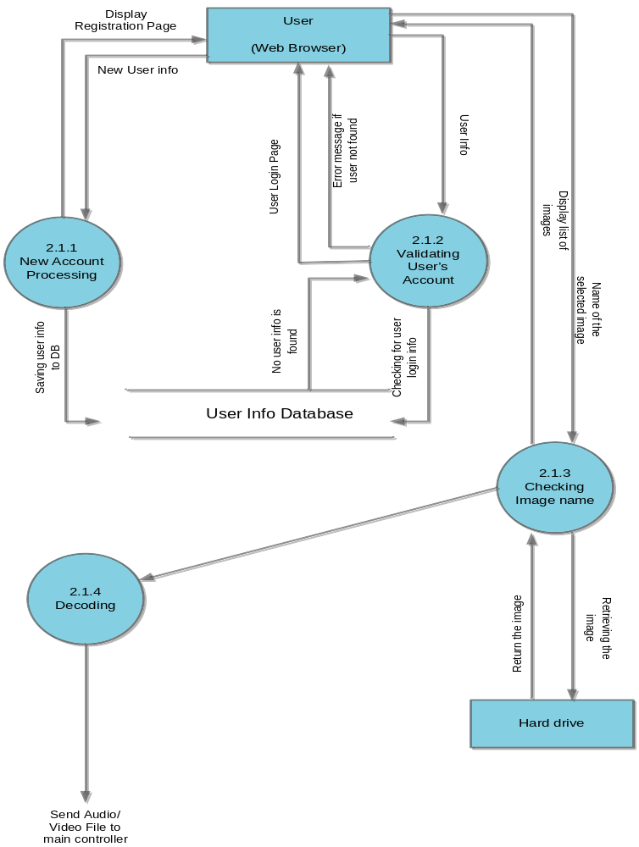

Figure 4.1 Level 2 DFD for the Login module

New Account Processing- Module 2.1.1

The new account processing module primary function is to check the username and password field from the registration page. The username and password must meet a certain criteria according to the requirement. If the criterion isn't met, the module will return an error to the user. If the criterion isn’t met the module will save the user’s info to the database.

Validating User Account- Module 2.1.2

This module is to check the user’s username and password at login. The module will search the user’s info database to find the matching username and password. If no password and/or username are found, the module will return an error message to the user.

Checking Image Name- Module 2.1.3

This module gets the name of the selected image from the user. It will use this name value and search through the hard drive to find the matching image file. Once found, this module will send the image file to the decoder.

Decoding- Module 2.1.4

This module decode and uncompress the image file from the hard drive.

Hard drive-

This is the place that stores all the images in the system.

4.1.2 Heart Rate Monitor

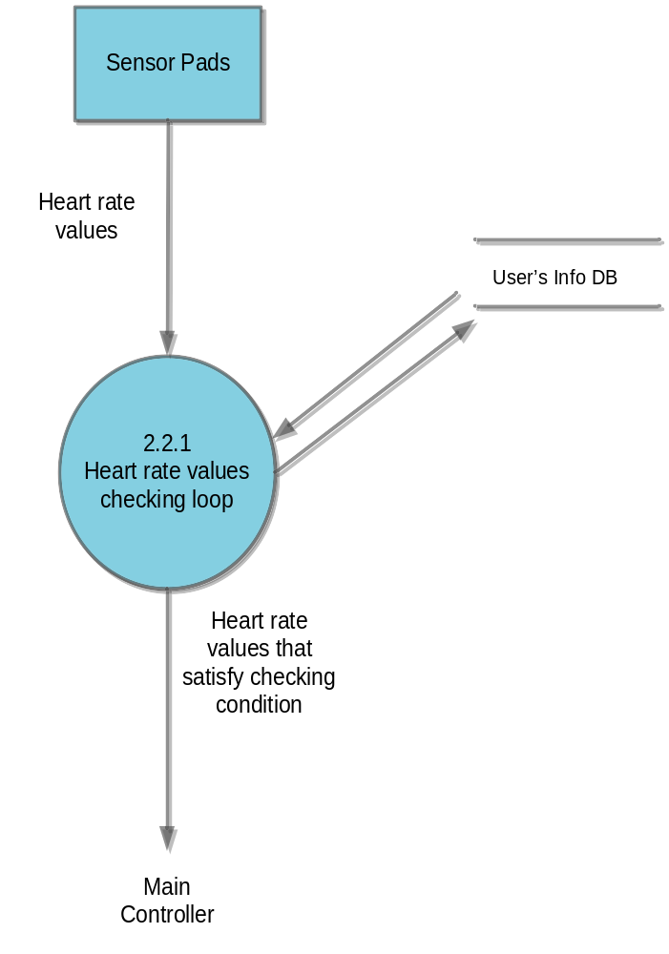

Figure 4.2 Level 2 DFD for Heart Rate monitor

Heart rate values checking loop- Module 2.2.1

This module read in the values from the sensor pads that is attach to the user. Originally at startup the module will retrieve the user’s age from the database using the user’s username and password. The module will use the user’s age to calculate the threshold limit value that is allowable by the system. If the user’s heart rate is above this threshold limit value, the system will sent a signal to the main controller to go into a shut down sequence. The loop will constantly read in values from the sensor pads until a value is greater than the threshold limit.

User’s Info DB- This database stores all the user’s info.

4.1.3 Temperature monitor

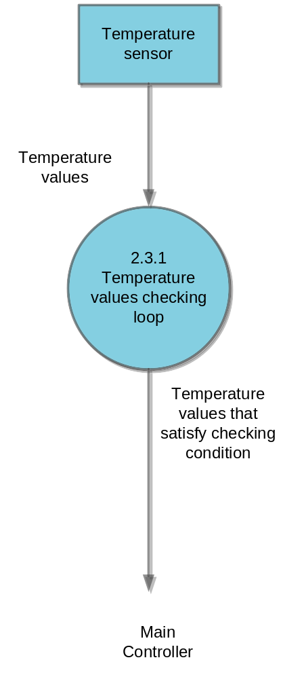
Figure 4.3 Level 2 DFD for Temperature monitor module

Temperature values check loop-Module 2.3.1

This module read in the values from the temperature sensor. The loop will constantly read in values from the sensor until a value is greater than 90 degree Fahrenheit or below 40 degree Fahrenheit. Once this condition is met the module will send a signal to the main controller to go into a shut down sequence.

4.1.4 Main Controller

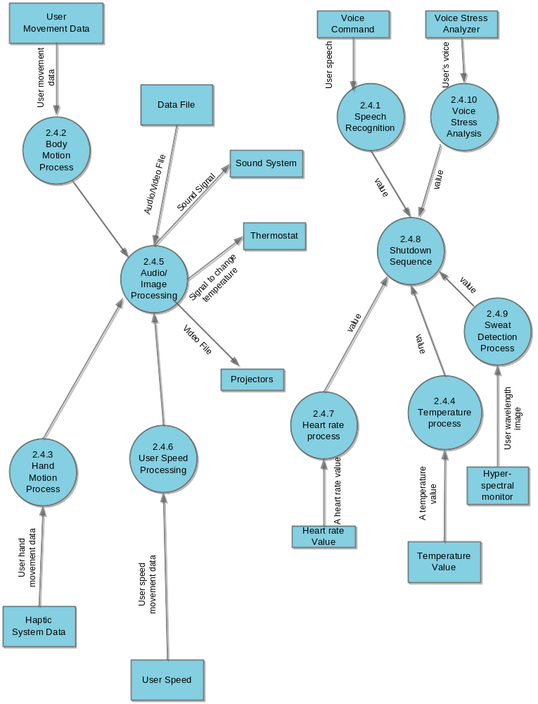
Figure 4.4 Level 2 DFD for the main controller module

Speech Recognition- Module 2.4.1

This module read in the output data from the voice recognition software. This module checks for certain key word from the software, if key word is “off” the system will go into a shut down sequence. If the key word is “on” the system will be turn on.

Body motion process- Module 2.4.2

This module read in the output from the motion capturing software. It will analyze the data and pass it to the Audio/Image processing.

Hand Motion Process- Module 2.4.3

This module read in the output from the haptic system software. It will analyze the data and pass it to the Audio/Image processing

Temperature Process- Module 2.4.4

This module is use to check if the temperature monitor module send a correct value. This module receive the value from the temperature monitor module and if this value is between 90 and 40 it will go into a shut down sequence.

Audio/Image processing- Module 2.4.5

This module use the data from the body motion capturing, the haptic system, and the user speed process to recalibrate the image according to the movement of the user.

User speed process- Module 2.4.6

This module read in the values from the sensor on the treadmill. The values determine the speed of the user. These values will be sent to the audio/image processing.

Heart rate process- Module 2.4.7

This module is use to check if the heart rate monitor module send a correct value. If this value is greater than 0 it will go into a shut down sequence.

Shutdown Sequence- Module 2.4.8

Shutdown sequence is a module for controlling the shutdown procedure for the system. First the system will freeze the image, second the main controller will adjust the room temperature back to 70 degree Fahrenheit. Lastly, it will wait for 30 seconds from the time it freeze the image to shutdown the system.

Sweet detection process- Module 2.4.9

This process read in the data from the Hyper-spectral monitor. The software will output data as a form of wavelength. Each different color wavelength determined the user intensity. Usually red mean the user have high intensity or perspiration. This module will check for the color and when it detected red, it will go into a shut down sequence.

Voice Stress Analysis- Module 2.4.10

This process read in the data from the Voice Stress Analyzer. The software will output data in a form of frequency. When the user experiences stress their voice frequency will increase. For a normal user their frequency is 8-9 Hz. However, when the user experience stress their voice frequency is 11-12 Hz. This module will check for the frequency and if the frequency is higher than 12 Hz it will go into a shut down sequence.

5.0 VirSim Ex ELEMENTS OF IMPLEMENTATION

5.1 Introduction

In this section (some of) the modules designed in Section 4 with requirements listed in Section 3 will be implemented initially at least at the level of pseudo code. Where possible, actual code will be provided. Each module is implemented in correspondence with the design sections defined in section 2 and responding to the requirements listed in its correlated sub-section in chapter 3.
.

5.2 Implementation

5.2.1 New Account Process

String username = request.getParameter (username)
If (username >= 6 characters) {
If (username contain lowercase and number)
Save to database
Else return error }
Else return error
String password = request.getParameter(password)
If (password >= 6 characters) {
If (password contain at least 1 uppercase letter, 1 lowercase letter, and 1 number)
Save to database
Else return error }
Else return error
Save user’s name, address, phone, and email to database

5.2.2 Validating User’s Account

String username = request.getParameter (username)
String password = request.getParameter (password)
Set user=username
Set pass=password
Connect to user’s info database
Select from User Info where user=username and pass=password
If (return is 0)
Return error message
Else display the image selection page

5.2.3 Checking image name

String name = request.getParameter (image_name)
If (name == image name in hard drive)
Return image
Pass image to decoder

5.2.4 Decoder

Uncompress the audio and video file
Return the audio and video file to main controller

5.2.5 Heart rate monitor

Gets the user’s age from the database using their username and password
Set variable threshold = 206.3 – (0.711 * age)
Double check = 0
Loop while (check<=threshold) {
check = get values from the sensor pads
}
mainController_heart_rate (check)

5.2.6 Temperature monitor

Double value = get values from temperature sensor
While (value<=90 && value>=40)
value = Get values from the temperature sensor.
mainController_temp(value)

5.2.7 Speech recognition

Read input value from Speech recognition software
Array of String token=text
Do while string token! = ””
{
If (text == shut down || text==Shutoff ||text== OFF) {
System shutdown
}
Else If (text== ON)
Start Simulator
}

5.2.8 Body motion process

Get values from body motion capturing software
Call Audio/image processing and pass motion value

5.2.9 Haptic system process

Get value from haptic system software
Call Audio/image processing and pass haptic value

5.2.10 Audio/Image processing

Get value from body motion process
Get value from haptic sytem process
Get value from user’s speed module
If (body motion! = 0 || haptic system! =0||speed! =0)
Recalibrate according to body motion
Recalibrate according to haptic system
Recalibrate according to user’s speed

5.2.11 User’s speed process

Double value = get values from speed sensor
Boolean test = true
While (test)
value = Get values from the speed sensor .
mainController_speed (value)

5.2.12 Sweet detection monitor

String color = get color wavelength from Hyper-spectral software
If (color. equal (“red”))
Go into shutdown sequence

5.2.13 Voice Stress Analysis

Double value = get frequency value form Voice Stress Analysis software
If (value >=12)
Go into shutdown sequence

6.0 Virtual Simulator Extreme TEST PLAN

6.1 Functional and Performance Requirements Validation Matrix

In this section the testing methodology to be used to V&V each of the requirements listed in section 3.0 has been identified.
The methodologies and testing strategies identified at this point include three major approaches with various variations to adapt to the HDMAS project:
- Testing using additional ad-hoc created software including a correlation testing unit.
- Demonstration of the specified capability
- Inspection of the software code possibly using additional inspection techniques

6.2 FUNCTIONAL REQUIREMENTS VALIDATION MATRIX

The VirSim Ex Functional and Performance Requirements Validation Matrix is given below.
6.2.1 Login Module

Requirement  Number | Requirement Description | Testing Mythology
 | User Account & Login
3.1-1 | A login page shall display every time the software is launch. | Demonstration
3.1-2 | The login page shall have a field for the username | Demonstration
3.1-3 | The software shall compare username with existing username in the user info database | Demonstration
3.1-4 | The software shall return an error message if the username is not found in the user info database | Demonstration
3.1-5 | The login page shall have a field for the password. | Demonstration
3.1-6 | The software shall compare the password with the existing password in the user info database | Demonstration
3.1-7 | The software shall return an error message if the password is not found in the user info database. | Demonstration
3.1-8 | The login page shall have a link for the new user | Demonstration
3.1-9 | The software shall launch a registration page when the user clicks on the new user link | Demonstration
3.1-10 | The registration page shall have a field for the user’s name | Demonstration
3.1-11 | The registration page shall have a field for the user’s address. | Demonstration
3.1-12 | The registration page shall have a field for the user’s phone number. | Demonstration
3.1-13 | The registration page shall have a field for the user’s email address. | Demonstration
3.1-14 | The registration page shall have a field for the user’s age | Demonstration
3.1-15 | The registration page shall have a field for the username. | Demonstration
3.1-16 | The username shall be at least 6 characters and containing only lowercase letters and numbers | Demonstration
3.1-17 | The software shall return an error message if the username is less than 6 characters | Demonstration
3.1-18 | The registration page shall have a field for the password | Demonstration
3.1-19 | The password shall be at least 6 characters and containing a combination of numbers, lowercase letters, and uppercase letters. | Demonstration
3.1-20 | The password shall contain at least 1 uppercase letter, 1 lowercase letter, and 1 number | Demonstration
3.1-21 | The software shall return an error message if the password is less than 6 characters | Demonstration
3.1-22 | The software shall return an error message if the password doesn’t contain at least 1 uppercase letter, 1 lowercase letter, and 1 number. | Demonstration
3.1-23 | The registration page shall have a submit button | Demonstration
3.1-24 | The user information shall be upload to the database server once the user click the submit button | Demonstration
3.1-25 | The software shall return a successful message when the user information successfully uploads to the database server. | Demonstration
3.1-26 | Another web page shall be display once the user login. | Demonstration
3.1-27 | There shall be a drop down box on this page | Demonstration
3.1-28 | The drop down box shall list all the available images in the hard drive. | Demonstration
3.1-29 | The software shall send the name of the selected image to the decoder. | Demonstration
3.1-30 | All images shall be store in the storage array | Demonstration
 | Audio & Video Decoding
3.1.1.2.1 | The decoder shall select the image according to the user selection | Demonstration
3.1.1.2.2 | The decoding module shall uncompress the audio bit stream from the image file | Demonstration
3.1.1.2.3 | The decoding module shall uncompress the video bit stream from the image file | Demonstration
3.1.1.2.4 | The decoding module shall send uncompress audio file to the main controller | Demonstration
3.1.1.2.5 | The decoding module shall send uncompress video file to the main controller | Demonstration

6.2.2 Heart rate monitor

Requirement Number | Requirement Description | Test Mythology
3.2-1 | The software shall read in the values from the sensor pads as double data type | Demonstration
3.2-2 | The software shall get the user’s age from the database using the user’s username and password | Demonstration
3.2-3 | The software shall use the following formula to calculate the threshold value, threshold value= 206.3 − (0.711 × age) | Demonstration
3.2-4 | The software shall constantly reading in the values from the sensor pads every second and comparing it to the threshold value | Testing
3.2-5 | The software shall call the main controller module if a value from the sensor pads is equal to the threshold value | Testing
3.2-6 | The software shall call the main controller module if a value from the sensor pads is greater than the threshold value. | Testing
3.2-7 | The software shall pass the threshold value as an input parameter to the main controller module | Testing

6.2.3 Temperature monitoring

Requirement  Number | Requirement Description | Test Mythology
3.3-1 | The module shall read in the values from the temperature sensors as a double data type. | Testing
3.3-2 | The module shall constantly reading in the values until a value exceed 90 degree Fahrenheit or lower than 40 degree Fahrenheit | Testing
3.3-3 | The module shall call the main controller module if a value exceed 90 degree Fahrenheit or lower than 40 degree Fahrenheit | Demonstration
3.3-4 | The software shall pass that value as an input parameter to the main controller module. | Testing

6.2.4 Main Control

Requirement  Number | Requirement Description | Test Mythology
 | System Startup:
3.4-1 | The main controller shall receive the uncompress video data from the storage array | Testing
3.4-2 | The main controller shall receive the uncompress audio data from the storage array | Testing
3.4-3 | The main controller shall check for any error on the image | Testing
3.4-4 | The main controller shall return an error message if an error is found on the image | Demonstration
3.4-5 | The main controller shall get the data from the speech recognition software | Testing
3.4-6 | The data shall be in the form of a string data type | Testing
3.4-7 | The main controller shall check if the string is equal to the word “on”. | Testing
3.4-8 | The main controller shall check if the string is equal to the word “off”. | Testing
3.4-9 | The main controller shall shutdown the system if the word is equal to “off”. | Demonstration
3.4-10 | The main controller shall send the video data to the projectors if the word is equal to “on”. | Demonstration
3.4-11 | The main controller shall send the audio signal to the speaker system if the word is equal to “on”. | Demonstration
3.4-12 | The main controller shall display the image file via the projectors | Demonstration
3.4-13 | The main controller shall read in the digital signal from the sensor on the treadmill. | Demonstration
3.4-14 | The main controller shall determine the speed of the user | Testing
3.4-15 | The main controller shall recalibrate the image at a rate that is proportional to the speed of the user | Demonstration
3.4-16 | The main controller shall get the output data from the camera that track the user eye movement | Testing
3.4-17 | The main controller shall get the data from the motion capturing software. | Testing
3.4-18 | BVH shall be accepted as a data file format. | Demonstration
3.4-19 | GMS shall be accepted as a data file format | Demonstration
3.4-20 | The main controller shall recalibrate the image according to the data from the motion capturing software. | Demonstration
3.4-21 | The main controller shall adjust the environment image to match the user point of view | Demonstration
3.4-22 | The latency time shall be less than 50 milliseconds. | Demonstration
3.4-23 | The main controller shall get the data from the haptic system software. | Demonstration
3.4-24 | The main controller shall recalibrate the image environment according to the data from the haptic system software | Demonstration
3.4-25 | The objects in the environment shall adjust to match with the user’s hands movement. | Demonstration
3.4-26 | The latency time shall be less than 50 milliseconds. | Demonstration
3.4-27 | The main controller shall be able to process RGB weighted Bi-colorization | Demonstration
3.4-28 | The main controller shall have the ability of image processing | analysis
3.4-29 | The main controller shall be able to enhance the image | Demonstration
3.4-30 | The main controller shall be able to rotate the image | Demonstration
3.4-31 | The main controller shall be able to change the image size | Demonstration
3.4-32 | The main controller shall be able to change the resolution of the image. | Demonstration
3.4-33 | The main controller shall detect the best position for the projectors | Demonstration
 | Safety Sequence:
3.4-34 | The main controller shall have the ability to shut down the system | Demonstration
3.4-35 | The main controller shall enter the shutdown sequence if receive a value from the Heart rate monitoring module | Testing
3.4-36 | The main controller shall enter the shutdown sequence if receive the word “off” from the Voice command. | Testing
3.4-37 | The main controller shall enter the shutdown sequence if receive a value from the Temperature reading module | Testing
3.4-38 | The main controller shall read the output data from the Voice Stress Analysis software. | Demonstration
3.4-39 | The main controller shall enter the shutdown sequence if receive a value of 12Hz or greater from the Voice Stress Analysis | Testing
3.4-40 | The main controller shall read the output data from the Hyper-spectral monitoring software. | Demonstration
3.4-41 | The main controller shall enter the shutdown sequence if receive a value from the Hyper-spectral monitoring module. | Testing
 | Thermostat Control:
3.4-42 | The main controller shall get the temperature data from the image data | Testing
3.4-43 | The main controller shall adjust the temperature of the room depending | Demonstration
 | Shutdown Sequence:
3.4-44 | The main controller shall freeze the image at its current position | Demonstration
3.4-45 | The main controller shall adjust the room temperature to 70 degree Fahrenheit. | Demonstration
3.4-46 | The main controller shall wait for 30 seconds before shutting down the system. | Demonstration

- Acronyms

VirSim Ex - Virtual Simulator Extreme

GUI- Graphical User Interface

3D- 3 Dimensional

HR- Heart Rate

Hz- Hertz (a unit measurement of frequency)

BVH- Biovision Hierarchy

RGB- Red Green Blue

- Data Dictionary

Haptic System- A way to determine the user’s hand movement, there are software that use in addition with hardware device to determine the user’s hand movement. From these info the image can recalibrate depend on the user’s hand movement.

Motion Capturing- Is a process to capture the movement of a user and translate that movement onto a digital model.

Voice Stress Analysis- A way to determine the stress a person is under by analysis their voice frequency. The voice frequency is different when a person is under normal condition compare to when a user is under stress.

Hyper-spectral monitoring- Is a process to collect image from a person. These images show the user different color wavelength. Depending on the color it can show how much intensity or “heat” the user is in.

Biovision Hierarchical Data (BVH)-The BVH format is mainly used as a standard representation of movements in the animation of humanoid structures.

GMS- The GMS format is a low-level, binary, minimal, but generic, format for storing Gesture and Motion Signals in a flexible, organized, optimized way. The GMS format takes into account the minimal features a format carrying movement/gesture information needs.

Latency Time- The time between a user make a movement to the when the environment recalibrate according to that movement.

