Price Data Analysis

Pankaj Kumar , Karl Jurek, Shawn Jung

5/31/2019

## Introduction

Using the Modeling.csv file we created the following models:

Stepwise

LASSO

Final

to predict the cost of housing in the predictionData.csv file.

## Data Description

The modelingData.csv file contains properties sold between August 20, 2011 and June 30, 2015.

25471 observations / rows

292 variables / columns

The predictionData.csv file contains properties sold between July 2015 and May2016.

5000 observations / rows

291 variables / columns

## Data Cleaning / Wrangling

** Initial import of the the modelingData.csv and predictionData.csv required stringsAsFactors=F

** Converting Time Stamp from integer based to date format (yyyy-mm-dd)

** modeling_df=transform(modeling_df, timestamp=as.Date(timestamp, origin = “1899-12-30”))

** projection_df=transform(projection_df, timestamp=as.Date(timestamp, origin = “1899-12-30”))

### Build_year -

** 14965 transformed to 1965

** 1691 transformed to 1991

** 20052009 transformed to 2007

### Kitch_sq

** 2013 deleted due to being the same as the build_year

** 2014 deleted due to being the same as the build_year

** 1974 deleted due to being the same as the build_year

** 1970 deleted due to being larger than the entire square footage of the building

### State

33 transformed to 3

Removed all apostrophe / single quotes from sub_area

There are Deleted 7991 rows where the max_floor, material, build_year, num_room, kitch_sq, and state all had a value of NA.

Deleted 1791 rows where the life_sq, build_year, and state all had a value of NA.

Deleted 1038 rows where the life_sq and build_year had a value of NA. Deleted 261 rows where the life_sq and state had a value of NA. Deleted 232 rows where the build_year and state had a value of NA.

## EDA

### Univariate Analysis

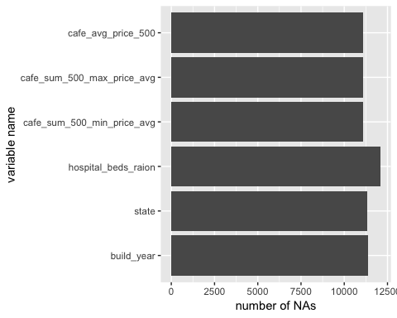

### Bivariate Analysis

## Warning: Removed 5333 rows containing non-finite values (stat_smooth).

## Warning: Removed 5333 rows containing missing values (geom_point).

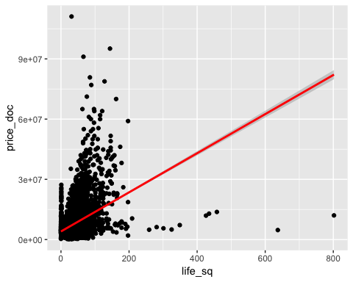

## Warning: Removed 7991 rows containing missing values (geom_point).

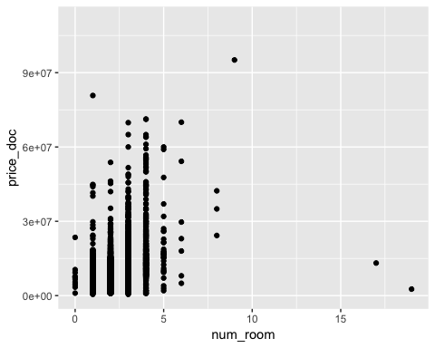

## Warning: Removed 7991 rows containing missing values (position_stack).

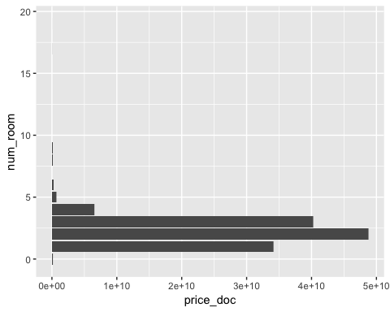

## Warning: Removed 7991 rows containing non-finite values (stat_smooth).

## Warning: Removed 7991 rows containing missing values (geom_point).

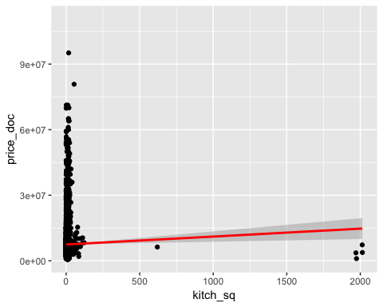

## Warning: Removed 146 rows containing missing values (position_stack).

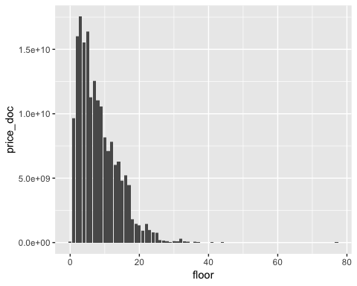

## Warning: Removed 7991 rows containing missing values (position_stack).

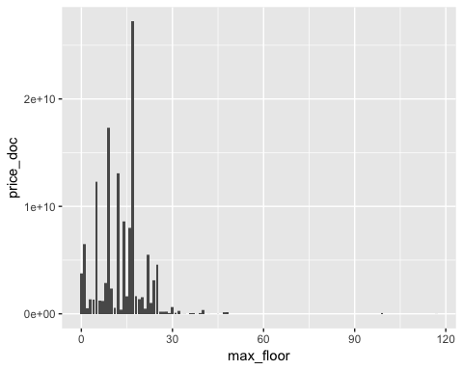

## Warning: Removed 11392 rows containing missing values (geom_point).

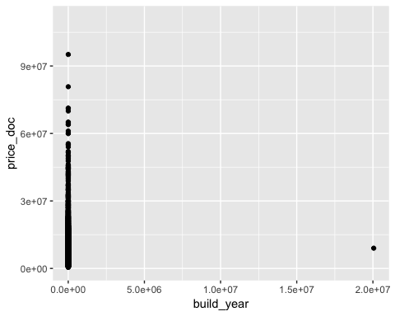

## Warning: Removed 11392 rows containing missing values (position_stack).

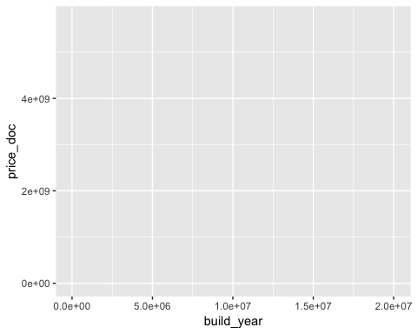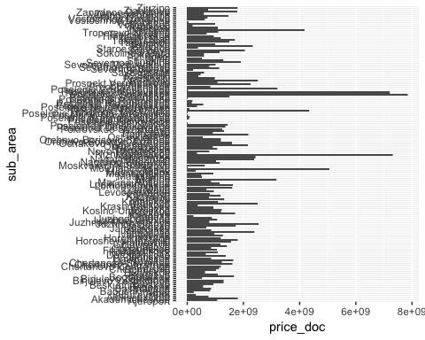

## Warning: Removed 11392 rows containing missing values (position_stack).

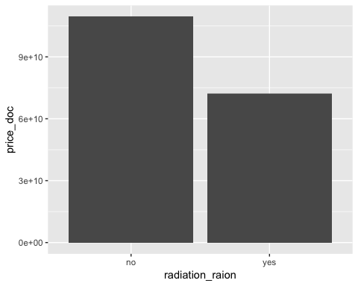

### Transformations

### Outliears

Outliers

Full_sq - 5326

##   
## Call:  
## lm(formula = price_doc ~ full_sq + work_all, data = price_modeling_data)  
##   
## Residuals:  
## Min 1Q Median 3Q Max   
## -207412189 -1794586 -650797 929911 103496673   
##   
## Coefficients:  
## Estimate Std. Error t value Pr(>|t|)   
## (Intercept) 3.943e+06 6.312e+04 62.46 <2e-16 ***  
## full_sq 3.915e+04 6.996e+02 55.96 <2e-16 ***  
## work_all 1.978e+01 7.524e-01 26.29 <2e-16 ***  
## ---  
## Signif. codes: 0 '***' 0.001 '**' 0.01 '*' 0.05 '.' 0.1 ' ' 1  
##   
## Residual standard error: 4511000 on 25468 degrees of freedom  
## Multiple R-squared: 0.1274, Adjusted R-squared: 0.1273   
## F-statistic: 1859 on 2 and 25468 DF, p-value: < 2.2e-16

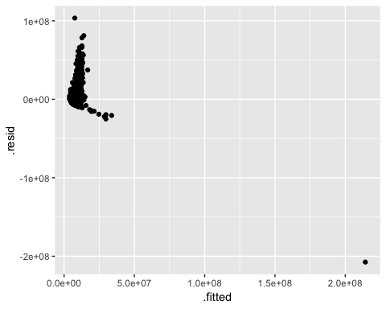

### Interaction Terms

## Modeling

OLS  
 LASSO

## Final Prediction