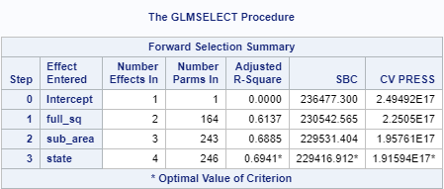

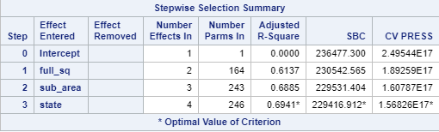

Variables left after Backwards selection:

* **full_sq**
* floor
* max_floor
* material
* build_year
* num_room
* kitch_sq
* **state**
* product_type
* **sub_area**
* area_m

