Stats2_Proj

Pankaj Kumar , Karl Jurek, Shawn Jung

6/15/2019

Table of Contents

Introduction 1

Data Description 2

Data Cleaning / Wrangling 2

Build_year 2

Kitch_sq 2

State 2

EDA 2

Outliers: 2

Multicollinearity: 2

Checking Assumptions: 3

Variable Selection: 4

Modeling 5

Modelling result for Backward Selection: 5

Modelling result for Stepwise Selection: 7

Modeling Result For Forward Selection : 7

Modelling result for LASSO 8

Final Prediction 9

Appendix 1 9

Appendix 2 10

SAS code to check Assumptions: 10

SAS Code to check Multi collinearity: 11

SAS Code for Data Wrangling : 11

SAS Code For Models: 12

## 

## Introduction

Using the Modeling.csv file we created the following models to predict the cost of housing in the predictionData.csv file.

## Data Description

1. The modelingData.csv file contains properties sold between August 20, 2011 and June 30, 2015.
2. 25471 observations / rows
3. 292 variables / columns
   * + - 1. The predictionData.csv file contains properties sold between July 2015 and May 2016.
         2. 5000 observations / rows
         3. 291 variables / columns

## Data Cleaning / Wrangling

### Build_year

### Kitch_sq

### State

## EDA

### Outliers:

We found some outliers in our analysis and either we changed it or dropped the values if they looked too unreasonable. The code details are in Data wrangling part.

The code to handle outliers are in data wrangling part.

### Multicollinearity:

We can see some of the independent variables are highly correlated to each other and they might impact coefficients for linear regressions.

Check appendix 2 for code :

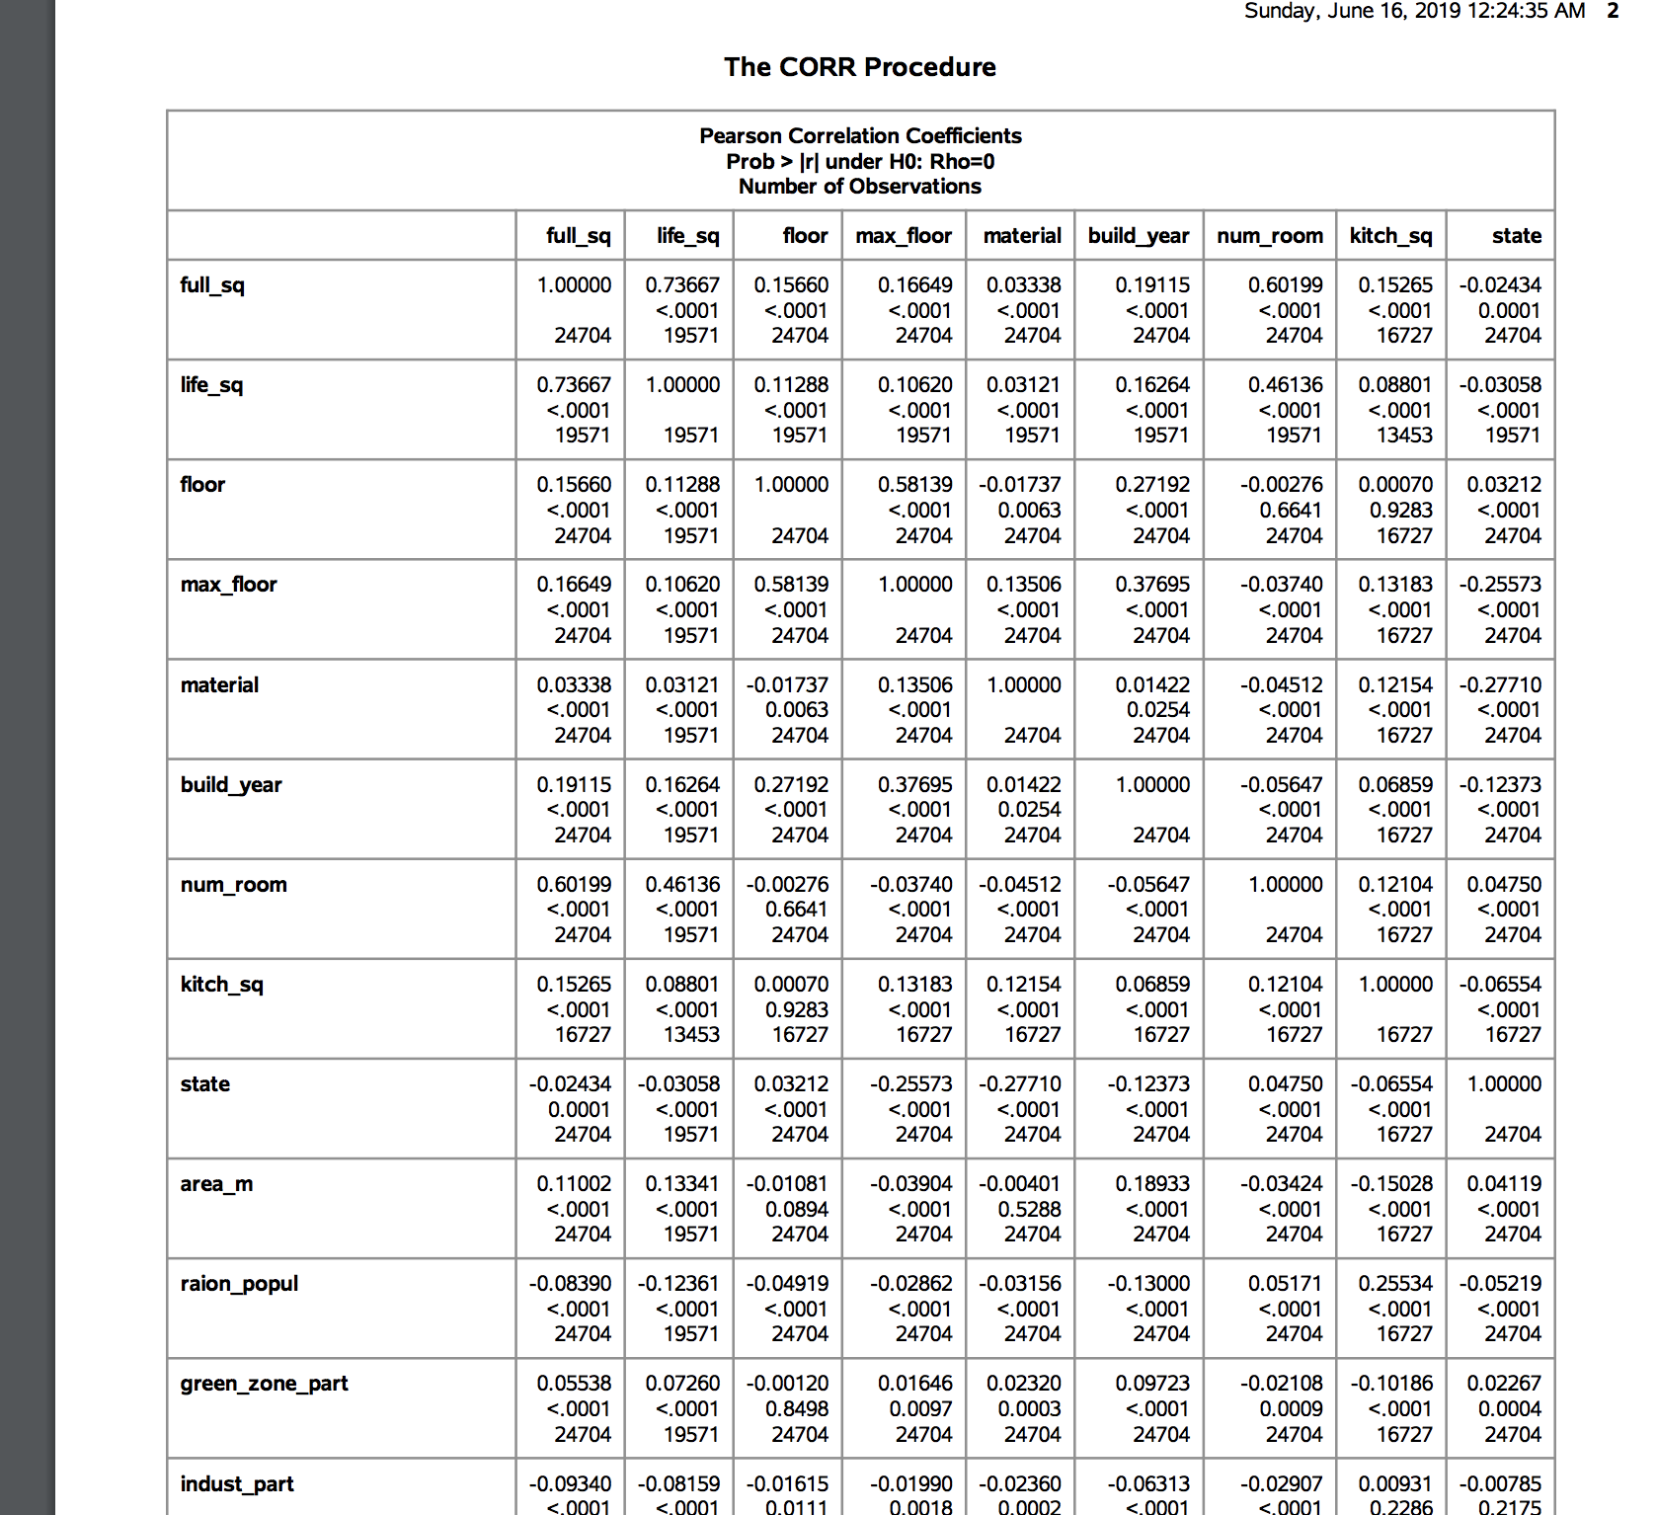



As we can see in above output correlation between life_sq and full_sq and num_room and full_sq are sufficiently high to produce effects due to multi collinearity.

### Checking Assumptions:

**Independence :**

For our analysis we assumed that the collected data are independently collected. There is no indication of data being dependent on other.

**Normal Distribution :**

The response variable is assumed to be normally distributed across the measurements taken for independent variables.

**Linearity**

We checked area parameters and they seem to be linearly correlated to our dependent variable: price doc. For the variables we considered we didn’t find any variable that needed transformation.

Following is an example of Scatter plot created for full_sq.

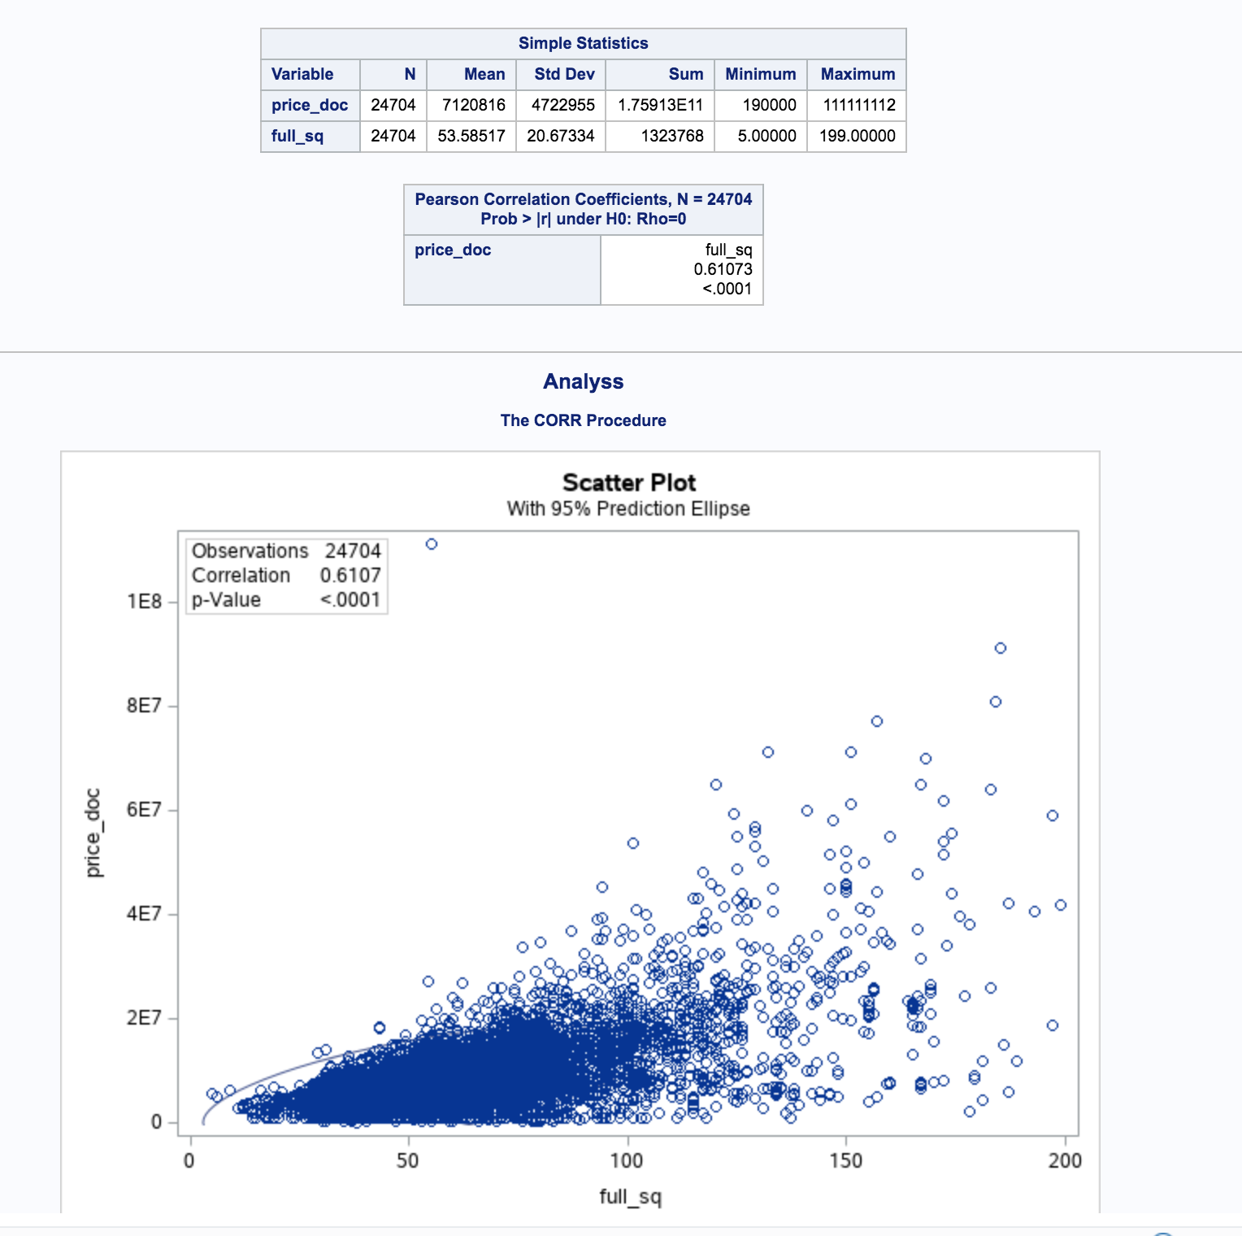

As we can see the price increases linearly as full_sq values increase. We can assume this data to be linearly related to Price doc and add this to the model without transformation.

### Variable Selection:

Selected 25 variables on which we did data wrangling to clean values corresponding to them.

full_sq life_sq

floor

max_floor

material

build_year

num_room

kitch_sq

state

product_type

sub_area

area_m

raion_popul

green_zone_part

indust_part children_preschool preschool_quota

children_school school_quota

school_education_centers_raion

hospital_beds_raion healthcare_centers_raion

university_top_20_raion

sport_objects_raion additional_education_raion

culture_objects_top_25

culture_objects_top_25_raion

shopping_centers_raion office_raion

thermal_power_plant_raion incineration_raion

oil_chemistry_raion

radiation_raion railroad_terminal_raion big_market_raion

nuclear_reactor_raion

detention_facility_raion

We used forward selection, backward selection, stepwise selection and Lasso for choosing relevant variables out of these based on their statistical significance..

Please Check appendix 2 for code selection.

## Modeling

Our models were crested using Forward selection , backward selection , stepwise selection and LASSO techniques. We Could see that the stepwise selection technique is giving us the best Adjusted R squared. Result.

### Modelling result for Backward Selection:

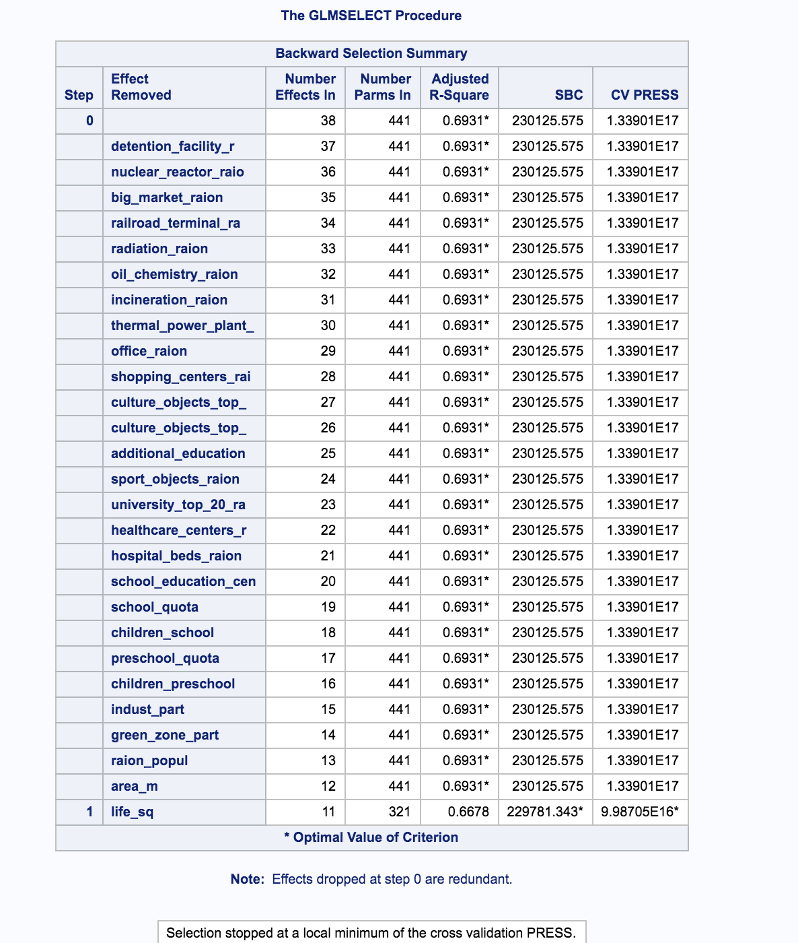

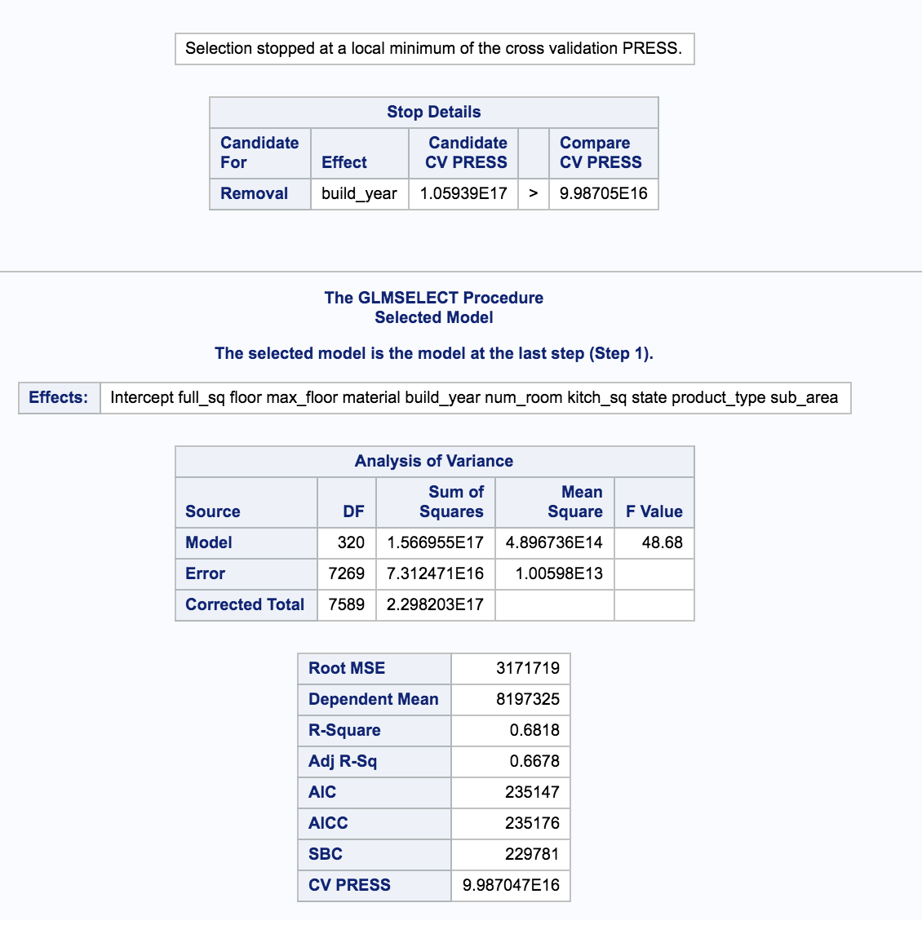

### Modelling result for Stepwise Selection:

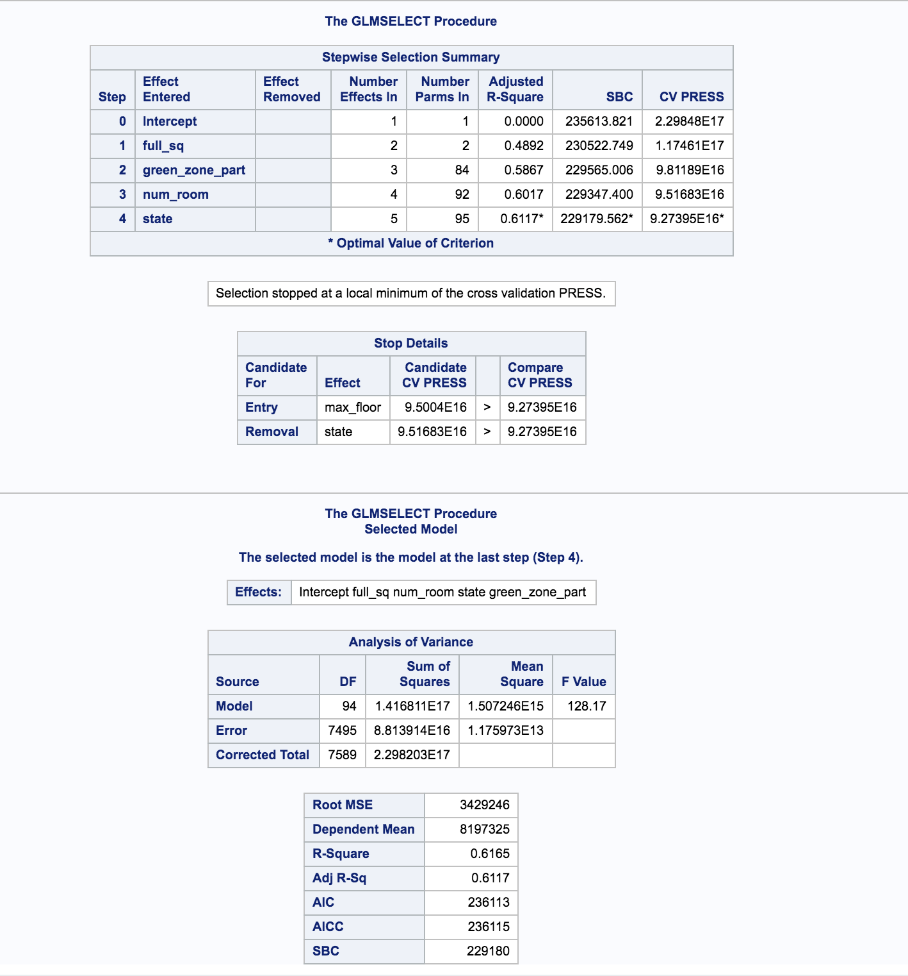

### Modeling Result For Forward Selection:

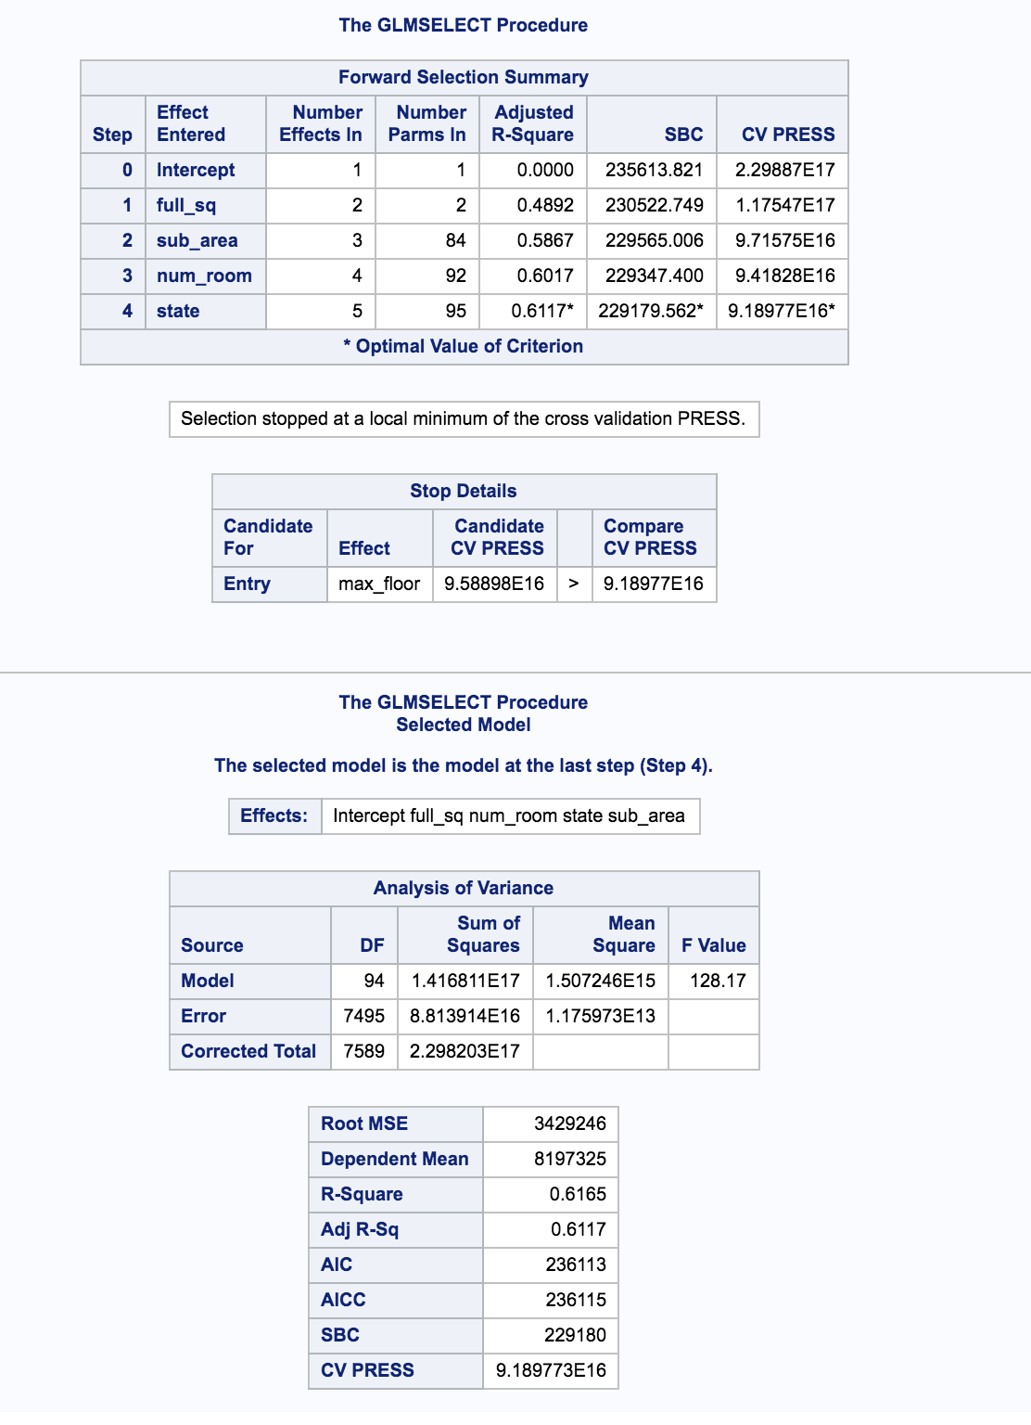

### Modelling result for LASSO

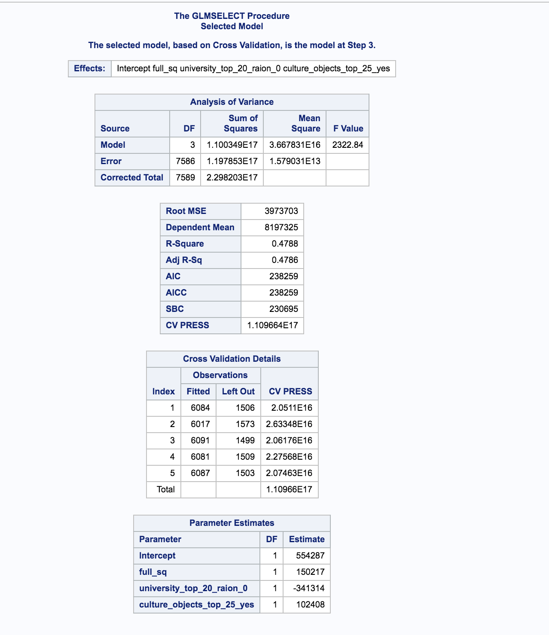

As we can see from above the best Adjusted R squared value is obtained from backward selection. We can also see that AIC and AICC values for this model are the lowest one.

## Final Prediction

We created different predictions based on selection models. Our final prediction is based on the backward selection model since that has the lowest Adjusted R squared Value. Some of the predictions have missing values. We have used some reasonable number to set values for these numbers.

## Appendix 1

## Appendix 2

### SAS code to check Assumptions:

**proc** **corr** data=housing.clean_modeling rank PEARSON

plots (maxpoints = **40000**)= scatter(alpha=**.05** );

var full_sq life_sq floor max_floor material;

with price_doc ;

title Analyss ;

**run**;

**proc** **corr** data=housing.clean_modeling rank PEARSON

plots (maxpoints = **40000**)= all;

var full_sq;

with price_doc ;

title Analyss ;

**run**;

**proc** **corr** data= housing.clean_modeling rank PEARSON

plots (maxpoints = **40000**)= scatter(alpha=**.05** );

var build_year num_room

kitch_sq state area_m

;

with price_doc ;

title Analyss ;

**run**;

**proc** **corr** data=work.refined_data rank PEARSON

plots (maxpoints = **40000**)= scatter(alpha=**.05** );

var raion_popul green_zone_part

indust_part children_preschool preschool_quota

children_school

;

with price_doc ;

title Analyss ;

**run**;

**proc** **corr** data=work.refined_data rank PEARSON

plots (maxpoints = **40000**)= scatter(alpha=**.05** );

var

children_school school_quota school_education_centers_raion

hospital_beds_raion healthcare_centers_raion

### SAS Code to check Multi collinearity:

**proc** **corr** data= housing.clean_modeling;

var full_sq life_sq floor max_floor material build_year num_room

kitch_sq state area_m raion_popul green_zone_part

indust_part children_preschool preschool_quota

children_school school_quota school_education_centers_raion

hospital_beds_raion healthcare_centers_raion university_top_20_raion

sport_objects_raion additional_education_raion

culture_objects_top_25_raion shopping_centers_raion ;

**run**;

**proc** **glm** data=housing.clean_modeling;

class preschool_quota children_school school_quota;

model price_doc = full_sq raion_popul life_sq preschool_quota children_school school_quota;

**run**;

### SAS Code for Data Wrangling :

**data** housing.clean_modeling ;

set housing.modeling;

region=compress(sub_area,"'");

if full_sq = **5326** then delete;

if missing(full_sq) then full_sq = **54.3**;

if full_sq >**200** then delete;

if full_sq <**2** then full_sq = **54.3**;

if missing(build_year) then build_year = **1985**;

if build_year = **4965** then build_year = **1965**;

if build_year = **20052009** then build_year = **2007**;

if build_year = **71** then build_year = **1971**;

if build_year < **220** then delete;

if state = **33** then state = **3**;

if missing(state) then state = **5**;

if kitch_sq > **500** then delete;

if missing(num_room) then num_room=**2**;

if missing(floor) then floor=**8**;

if floor = **0** then floor =**1**;

if missing(max_floor) then max_floor=floor;

if max_floor = **0** then max_floor =floor;

if missing(material) then material =**1**;

log_full_sq= log(full_sq);

idd = input(VAR1, **8.**);

**run**;

**data** housing.clean_projection ;

set housing.projection;

if missing(state) then state = **5**;

if missing(material) then material =**1**;

if build_year = **71** then build_year = **1971**;

idd = input(VAR1, **8.**);

if missing(num_room) then num_room=**2**;

if missing(state) then state = **5**;

if kitch_sq > **500** then delete;

if missing(num_room) then num_room=**2**;

if missing(floor) then floor=**8**;

if floor = **0** then floor =**1**;

if missing(max_floor) then max_floor=floor;

**data** housing.merged_data;

set housing.clean_modeling housing.clean_projection;

### SAS Code For Models:

/* Backward selection. */

**proc** **glmselect** data=housing.merged_data;

class life_sq floor max_floor material build_year num_room

kitch_sq state product_type sub_area area_m raion_popul green_zone_part

indust_part children_preschool preschool_quota

children_school school_quota school_education_centers_raion

hospital_beds_raion healthcare_centers_raion university_top_20_raion

sport_objects_raion additional_education_raion culture_objects_top_25

culture_objects_top_25_raion shopping_centers_raion office_raion

thermal_power_plant_raion incineration_raion oil_chemistry_raion

radiation_raion railroad_terminal_raion big_market_raion nuclear_reactor_raion

detention_facility_raion;

model price_doc = full_sq life_sq floor max_floor material build_year num_room

kitch_sq state product_type sub_area area_m raion_popul green_zone_part

indust_part children_preschool preschool_quota

children_school school_quota school_education_centers_raion

hospital_beds_raion healthcare_centers_raion university_top_20_raion

sport_objects_raion additional_education_raion culture_objects_top_25

culture_objects_top_25_raion shopping_centers_raion office_raion

thermal_power_plant_raion incineration_raion oil_chemistry_raion

radiation_raion railroad_terminal_raion big_market_raion nuclear_reactor_raion

detention_facility_raion

/ selection=Backward(stop=CV) cvmethod=random(**5**) stats=adjrsq;

output out = results p = predict ;

**run**;

**data** result_backward_selection ;

set results;

price_doc = predict;

if missing(predict) then price_doc = **140000**;

keep id price_doc;

where idd > **28000**;

**proc** **export** data=result_backward_selection dbms=csv

outfile="/folders/myfolders/stats2_hw/term_proj1/output/result_backward_selection.csv"

replace;

**run**;

**proc** **print** data = result_Backward_selection;

**run**;

/* Stepwise. */

**proc** **glmselect** data=housing.merged_data;

class life_sq floor max_floor material build_year num_room

kitch_sq state product_type sub_area area_m raion_popul green_zone_part

indust_part children_preschool preschool_quota

children_school school_quota school_education_centers_raion

hospital_beds_raion healthcare_centers_raion university_top_20_raion

sport_objects_raion additional_education_raion culture_objects_top_25

culture_objects_top_25_raion shopping_centers_raion office_raion

thermal_power_plant_raion incineration_raion oil_chemistry_raion

radiation_raion railroad_terminal_raion big_market_raion nuclear_reactor_raion

detention_facility_raion;

model price_doc = full_sq life_sq floor max_floor material build_year num_room

kitch_sq state product_type sub_area area_m raion_popul green_zone_part

indust_part children_preschool preschool_quota

children_school school_quota school_education_centers_raion

hospital_beds_raion healthcare_centers_raion university_top_20_raion

sport_objects_raion additional_education_raion culture_objects_top_25

culture_objects_top_25_raion shopping_centers_raion office_raion

thermal_power_plant_raion incineration_raion oil_chemistry_raion

radiation_raion railroad_terminal_raion big_market_raion nuclear_reactor_raion

detention_facility_raion

/ selection=Stepwise(stop=CV) cvmethod=random(**5**) stats=adjrsq;

output out = results p = predict ;

**run**;