1. **SUMMARY**

This Word document is the report for Project 1. Included alongside it in the Canvas submission are MATLAB scripts for analysis and figure generation.

TBD

1. **BASUC TEMPORAL FILTERING**

TBD

Text here

* 1. **Simple 1D Temporal Derivative Mask**

TBD

Statistics: mean 0.0819, median 0, std 8.8672, max 117, min -122.5

Possible to use 1-sigma when choosing a threshold value for motion detection.

*Figure 2.1.* Frame 32 of ‘RedChair’ Data, Grayscale. This frame contains an obvious example motion, with the person in the image walking left-to-right.

Obvious example to test motion detection. Ideally, detector shows an overlay that coincides with person walking. Using mask . Person walking corresponds to decrease in pixel value.

*Figure 2.2.* Response of Frame 32 to Simple 1D Derivative Mask. The colormap ranges from red (positive change) to blue (negative change). The response of Frame 32 clearly shows changes from Frame 31 and to Frame 33, respectively, but there is no response where the person is in Frame 32. Green indicates no change.

Shows a problem: motion detector will not show in current frame but either in previous or next frame, depending on threshold.

*Figure 2.3.* Motion Detection Result in Frame 32 with ±1- Threshold. The blue dots indicate in which pixels motion has been detected. These detections coincide with Frames 31 and 33, but not with Frame 32.

Current set-up allows motion detection in neighboring frames, but want implementation where thresholding response shows motion detection in *current* frame, i.e. have blue dots overlay person in Frame 32.

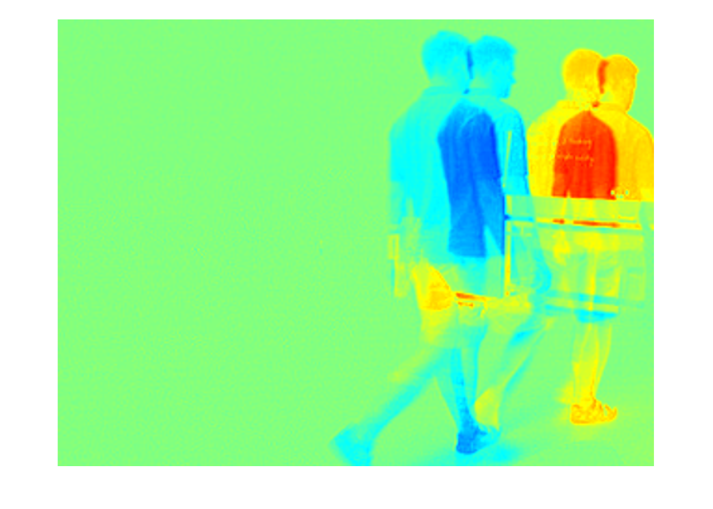

*Figure 2.4.* Frame 32 Response to Flipped Mask of Length 5. Increasing the mask length apparently causes the response to include changes from additional frames – in this case, Frames 30 and 34. Flipping the mask appears to change the direction of the response.

Adjusting mask by flipping or increasing length is insufficient. Averaging Frames 31 and 33 is also insufficient for 32 because they will average to zero. Possible solutions: re-run with mask with in different positions and adjust threshold accordingly, or offset motion detection by one frame.

*Figure 2.5*. Response to Adjusted Mask. The negative change in blue now overlays where the person is in Frame 32.

Adjusted mask to . Against convention, but now the negative response – i.e. the change in pixel values from Frames 31 to 32, in Frame 32, of person walking – coincides to where person is in Frame 32. Can threshold against responses lower than 1-sigma below median.

*Figure 2.6*. Motion Detection Result from Adjusted Mask, Thresholding for Values 1- Below Median. Hits now overlay where the person is in Frame 32.

Equivalent to offsetting motion detection by a frame. Better result, but some problems remain. Threshold has to mind direction of change, but pixel values may not always be decreasing; a solution should detect motion regardless of direction. Also, there is some apparent noise.

A particular type of noise is evident in Frame 190: flicker noise from light fluctuations.

*Figure 2.7.* Example of Flicker Noise. (a) Original Frame 190. (b) Frame 190 Response. There is a clear image gradient from light fluctuations over a still sequence of images. (c) Detections in Frame 190. This is not from motion.

Possible solution is spatial smooth pre-processing.

* 1. **1D Derivative of Gaussian**

TBD

Text here

Text here

1. **2D SPATIAL SMOOTHING**
2. **THRESHOLD VALUE**
3. **CONCLUSION**