1. Circle

Which of the following is an example of clustering?

Creating a new representation of the data with fewer features

Accumulate data into groups based on labels

Separate the data into distinct groups by similarity

Compress elongated clouds of data into more spherical representations

1  
point

2. Square

Which of the following are advantages to using decision trees over other models? (Select all that apply)

Decision trees can learn complex statistical models using a variety of kernel functions

Trees are naturally resistant to overfitting

Trees often require less preprocessing of data

Trees are easy to interpret and visualize

1  
point

3. Circle

What is the main reason that each tree of a random forest only looks at a random subset of the features when building each node?

To improve generalization by reducing correlation among the trees and making the model more robust to bias.

To increase interpretability of the model

To reduce the computational complexity associated with training each of the trees needed for the random forest.

To learn which features are not strong predictors

1  
point

4. Square

Which of the following supervised machine learning methods are greatly affected by feature scaling? (Select all that apply)

Neural Networks

KNN

Decision Trees

Support Vector Machines

Naive Bayes

1  
point

5. Square

Select which of the following statements are true.

For a model that won’t overfit a training set, **Naive Bayes** would be a better choice than a **decision tree**.

For a fitted model that doesn’t take up a lot of memory, **KNN** would be a better choice than **logistic regression.**

For having an audience interpret the fitted model, a **support vector machine** would be a better choice than a **decision tree**.

For predicting future sales of a clothing line, **Linear regression** would be a better choice than a **decision tree regressor**.

1  
point

6. Circle

Match each of the prediction probabilities decision boundaries visualized below with the model that created them.

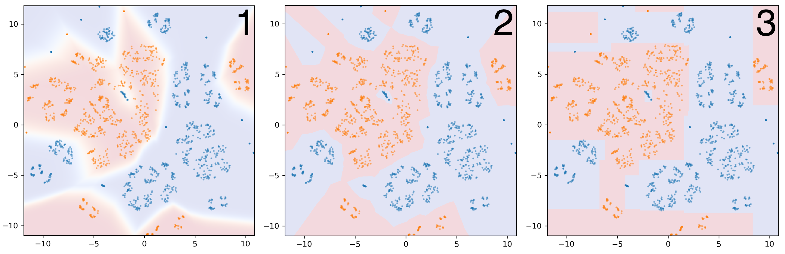

1. Neural Network
2. KNN (k=1)
3. Decision Tree
4. Neural Network
5. Decision Tree
6. KNN (k=1)
7. KNN (k=1)
8. Neural Network
9. Decision Tree
10. KNN (k=1)
11. Decision Tree
12. Neural Network

1  
point

7.

A decision tree of depth 2 is visualized below. Using the `value` attribute of each leaf, find the accuracy score for the tree of depth 2 and the accuracy score for a tree of depth 1.

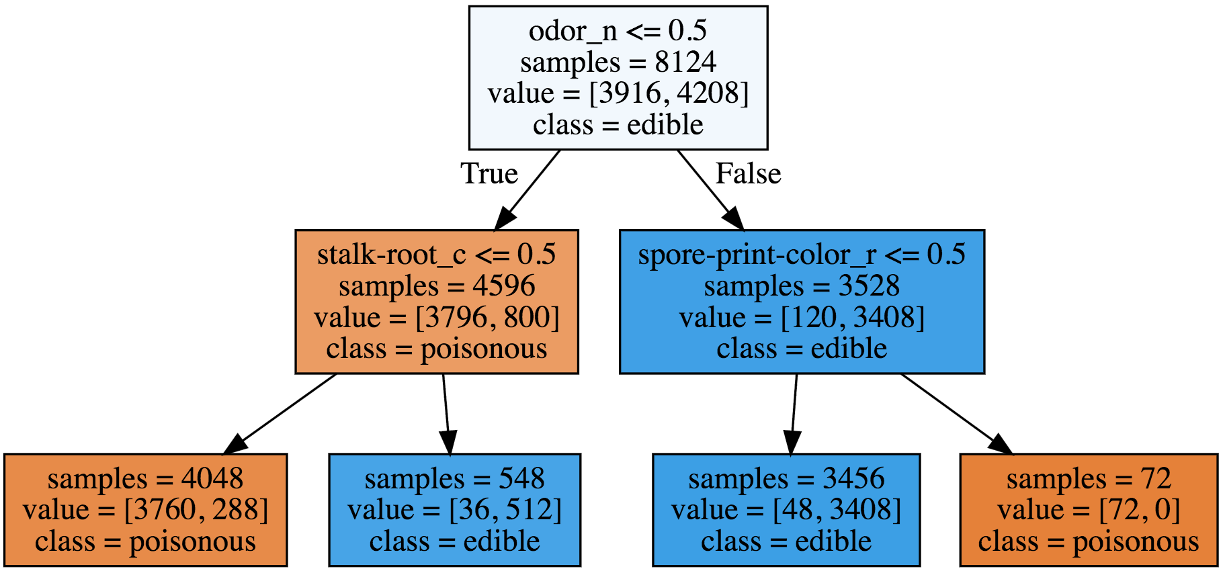

What is the improvement in accuracy between the model of depth 1 and the model of depth 2?

0.0674544559330379

# Question 7

denominator = 3760 + 288 + 36 + 512 + 48 + 3408 + 72

denominator # 8124

depth1_numerator = 3796 + 3408

accuracy_depth1 = depth1_numerator/denominator

accuracy_depth1 # 0.8867552929591335

depth2_numerator = 3760 + 512 + 3408 + 72

accuracy_depth2 = depth2_numerator/denominator

accuracy_depth2 # 0.9542097488921714

diff = accuracy_depth2 - accuracy_depth1

diff # 0.0674544559330379

# 0.0675

Out[3]:

8. Square

For the autograded assignment in this module, you will create a classifier to predict whether a given blight ticket will be paid on time (See the module 4 assignment notebook for a more detailed description). Which of the following features should be removed from the training of the model to prevent data leakage? (Select all that apply)

grafitti_status - Flag for graffiti violations

collection_status - Flag for payments in collections

ticket_issued_date - Date and time the ticket was issued

compliance_detail - More information on why each ticket was marked compliant or non-compliant

agency_name - Agency that issued the ticket

1  
point

9. Square

Which of the following might be good ways to help prevent a data leakage situation?

If time is a factor, remove any data related to the event of interest that doesn’t take place prior to the event.

Ensure that data is preprocessed outside of any cross validation folds.

Remove variables that a model in production wouldn’t have access to

Sanity check the model with an unseen validation set

1  
point

10. Circle

Given the neural network below, find the correct outputs for the given values of x1 and x2.

The neurons that are shaded have an activation threshold, e.g. the neuron with >1? will be activated and output 1 if the input is greater than 1 and will output 0 otherwise.

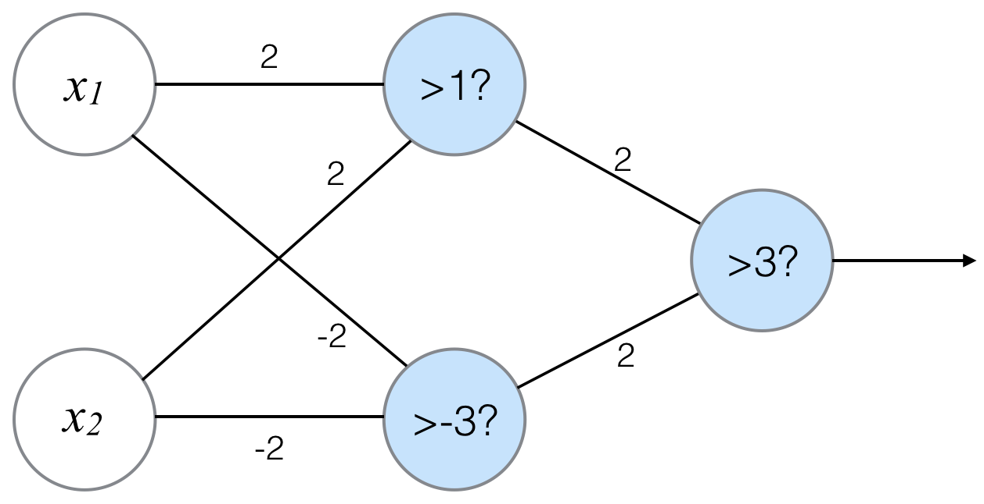

|  |  |  |
| --- | --- | --- |
| x1 | x2 | output |
| 0 | 0 | 0 |
| 0 | 1 | 1 |
| 1 | 0 | 1 |
| 1 | 1 | 0 |
| x1 | x2 | output |
| 0 | 0 | 0 |
| 0 | 1 | 1 |
| 1 | 0 | 1 |
| 1 | 1 | 1 |

|  |  |  |
| --- | --- | --- |
| x1 | x2 | output |
| 0 | 0 | 0 |
| 0 | 1 | 0 |
| 1 | 0 | 0 |
| 1 | 1 | 1 |
| x1 | x2 | output |
| 0 | 0 | 1 |
| 0 | 1 | 0 |
| 1 | 0 | 0 |
| 1 | 1 | 1 |

import numpy as np

#[0,1], [1, 0], [1,1]

input_data = np.array([1,1])

weights = {'top_node': np.array([2,2]), 'bottom_node': np.array([-2,-2])}

top_node_value = (input_data * weights['top_node']).sum()

bottom_node_value = (input_data * weights['bottom_node']).sum()

hidden_layer_outputs = np.array([top_node_value, bottom_node_value])

if top_node_value > 1:

next_top = 1

else:

next_top = 0

if bottom_node_value > -3:

next_bottom = 1

else:

next_bottom = 0

if (next_top*2 + next_bottom*2) > 3:

print(1)

else:

print(0)

# [0,0] output is 0

# [0,1] output is 1

# [1,0] output is 1

# [1,1] output is 0