HW6
Dongwook Hwang

Q1
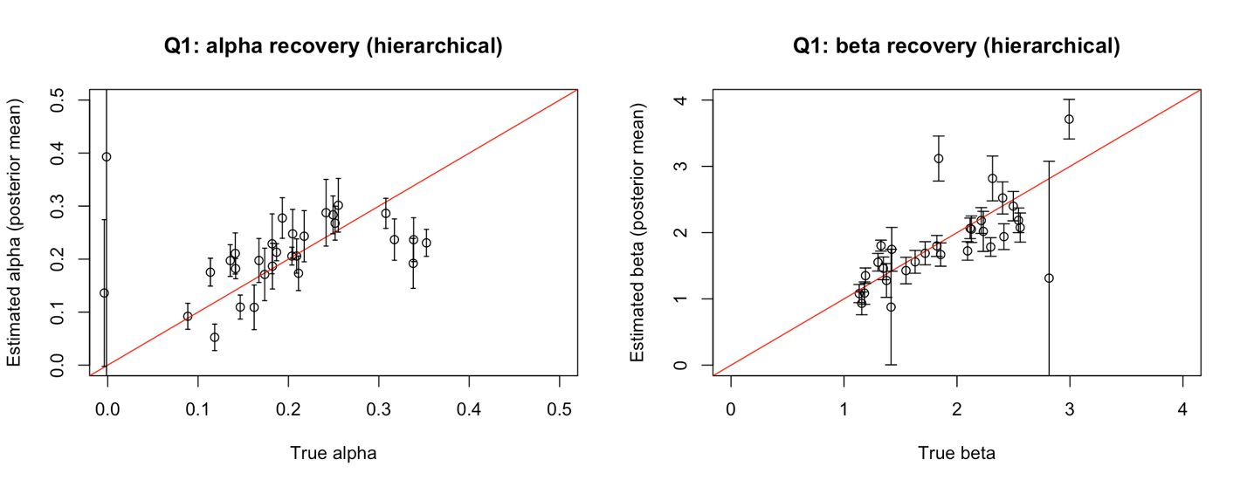
Both alpha and beta parameters were well recovered in own opinion. Estimated posterior means closely follow the y=x diagonal line, with error bars. It means the hierarchical Bayesian model successfully recovers individual-level parameters given 300 trials per subject.

Q2
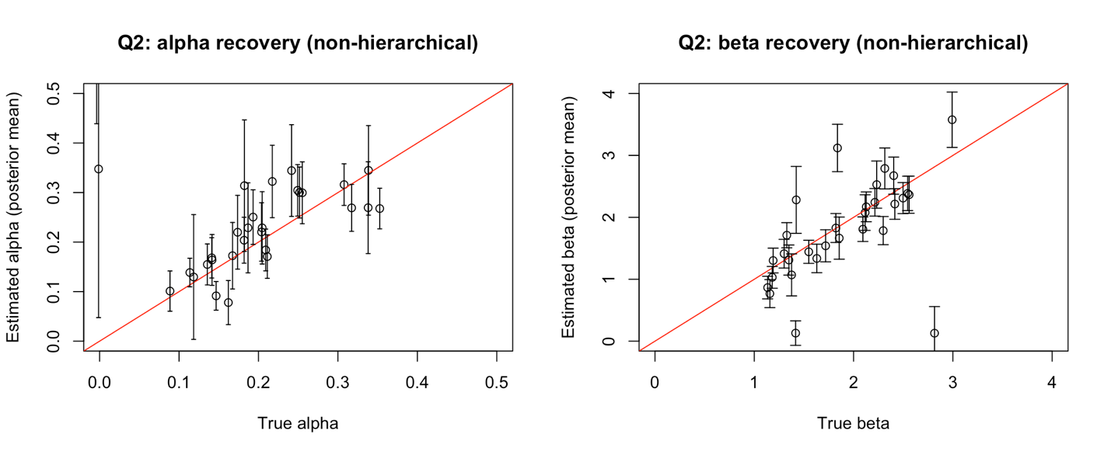
The non-hierarchical model shows wider error bars and more outliers compared to the hierarchical model. Some extreme estimates in the non-hierarchical model are pulled toward more reasonable values in the hierarchical version.

Q3
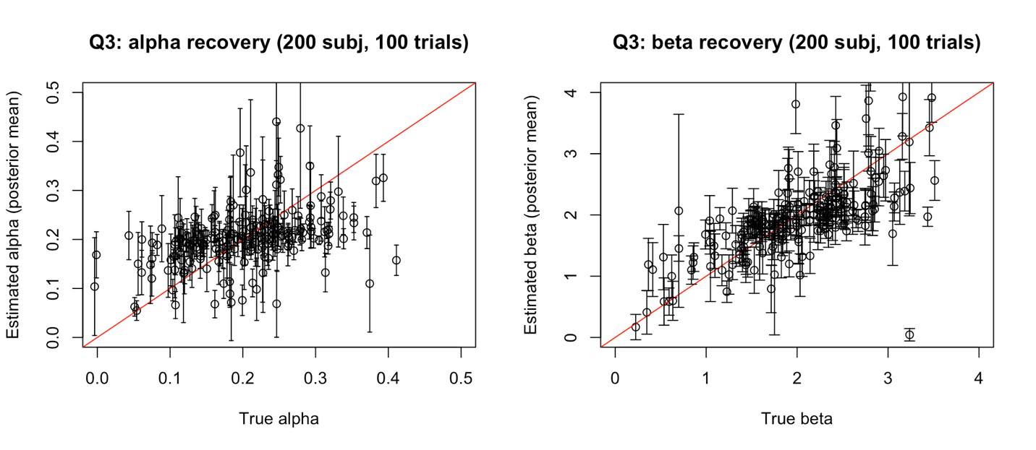

Q4

