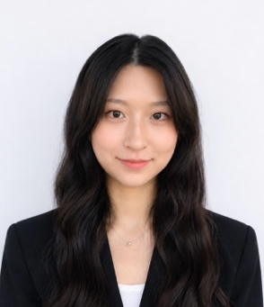
Jungyoon Kang (강정윤)
kjy200122@snu.ac.kr
1 Gwanak-ro, Gwanak-gu, Seoul, 08826, Republic of Korea
Computational Clinical Psychology Lab
+82) 01024167435

Education

Master’s Program in Clinical Psychology
Seoul National University, College of Social Sciences, Seoul, South Korea | 2025.09 ~ Present
- Major: Clinical Psychology
- Research interests: Addiction, Decision-Making, Computational Psychiatry, Neuromodulation

B.A. in Psychology
Chung-Ang University, College of Social Sciences, Seoul, South Korea | 2020.03 ~ 2025.02
- Major: Psychology
- GPA: 4.28/4.50
- Graduated summa cum laude

Research Experience

Computational Clinical Psychology Lab
Seoul National University, Seoul, South Korea
- Undergraduate Research Assistant | 2024.09 ~ 2025.01
- Lab Manager and Research Assistant | 2025.01 ~ 2025.08

Korean Undergraduate Psychology Association
Seoul, South Korea | 2024.09 ~ 2025.02
- Research Member
- Research Project: Association between short-form video addiction severity and delay discounting

Publications

- Kwon, M., Park, M., Kim, M., Kang, J., Ahn, W. Y., Chung, D., ... & Jung, Y. C. (2026). The effectiveness of transcranial photobiomodulation therapy (tPBM) and transauricular vagus nerve stimulation (taVNS) on reducing alcohol craving. Neurotherapeutics, 23(4), e00937.
- Kang et al. (2026) Computational Markers of Neuromodulation Response in Alcohol Craving. Manuscript in preparation.

Talks & Activities

[Oral Presentation]
“Computational Markers of Neuromodulation Response in Alcohol Craving”
- Oral Presentations, Korean Society for Digital Therapeutics | 2026.06
- Outstanding Oral Presentation Award

“A Computational Modeling Approach to Modulating Alcohol Craving”
- Oral Presentations, Korean Neuropsychiatric Association | 2025.10

Technical Skills

Programming
- R, Python

Certifications

English
- NEW TEPS Overall Score: 460 (2024.09.28)

