Electronic Shop Sales Prediction

Business Intelligence Report — Full-Stack ML Project

Generated: September 23, 2026

1. Executive Summary
This report presents a full-stack machine learning application built to predict order-level revenue for an electronics retail store. The dataset contains 11,000 transactions across 24 product categories, 5 ordering channels, and 50 US states covering January to November 2024. A Linear Regression model was trained on engineered features to forecast revenue per order, enabling the business to optimise inventory, channel investment, and seasonal promotions.

2. Project Structure
File / Folder | Description
electronics_shop_project/ | Project root
data/Electronics_Shop_Dataset.csv | 11,000 raw transaction records
model/model.pkl | Trained LinearRegression artefact
model/scaler.pkl | StandardScaler fitted on training data
model/le_product.pkl | LabelEncoder for product names
model/diagnostics.png | Actual vs Predicted + Residual plots
backend/app.py | Flask REST API (port 5000)
frontend/ui.py | Streamlit UI — 3 pages (port 8501)
train_model.py | Full ML training pipeline
generate_report.py | Generates this Word report
requirements.txt | All Python dependencies

3. Dataset Overview
Source: shafiirajabu/electronics-shop-dataset (Kaggle) | Rows: 11,000 | Date range: 2024-01-01 to 2024-11-29

3.1 Column Descriptions
Metric | Value
productID | Unique product identifier (P00001–P00024)
product_name | Name of the electronic product (24 categories)
product_price | Unit price in USD
number_of_ordered_items | Quantity ordered (1–5 units)
order_status | Delivered / In Process / Canceled / On Hold
customer_name | Customer name (anonymised)
location | US State name (50 states)
latitude / longitude | Geo-coordinates of the customer
channel_of_ordering | Website / Mobile App / Phone / Social Media / Physical
date | Order date (Excel serial format, converted to date)
revenue [derived] | product_price × number_of_ordered_items

3.2 Key Statistics
Metric | Value | Interpretation
Total orders (all statuses) | 11,000
Orders used for training | 5,538 | Delivered + In Process
Avg. product price | $530.76
Avg. items per order | 3.01
Avg. order revenue | $1564.80 | Derived target
Max order revenue | $14816.20
Unique products | 24
Ordering channels | 5
US States covered | 50

3.3 Revenue by Product
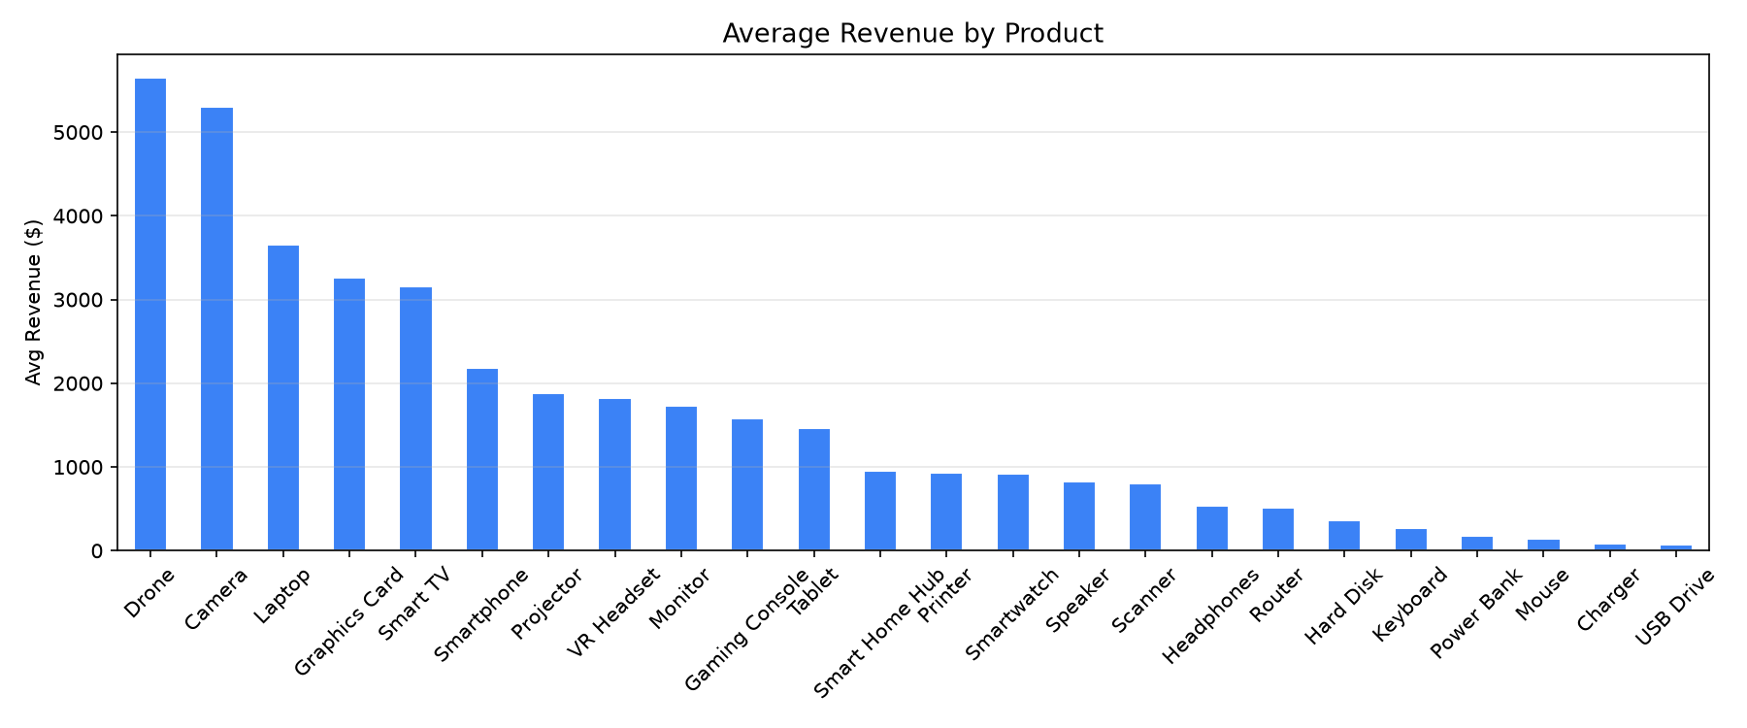
Figure 1 — Average Revenue by Product

3.4 Revenue by Ordering Channel
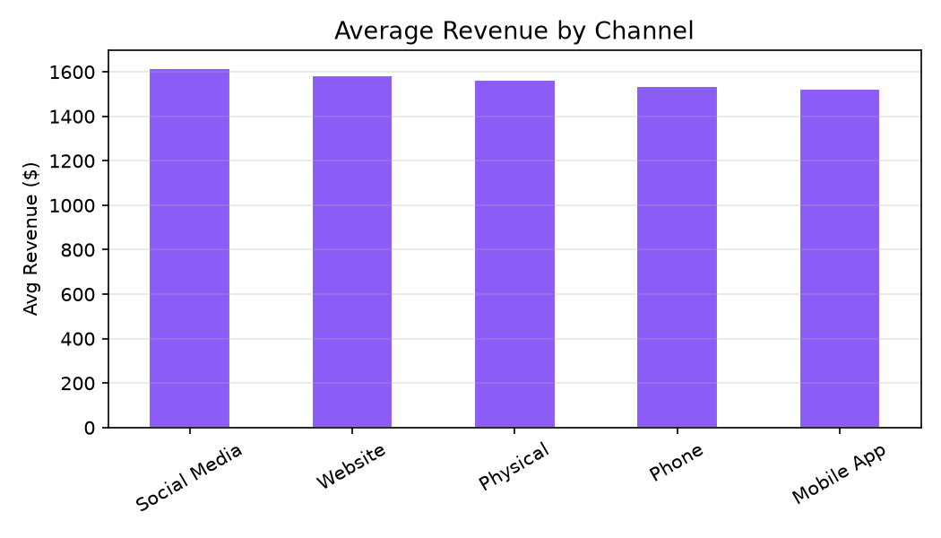
Figure 2 — Average Revenue by Ordering Channel

3.5 Monthly Revenue Trend
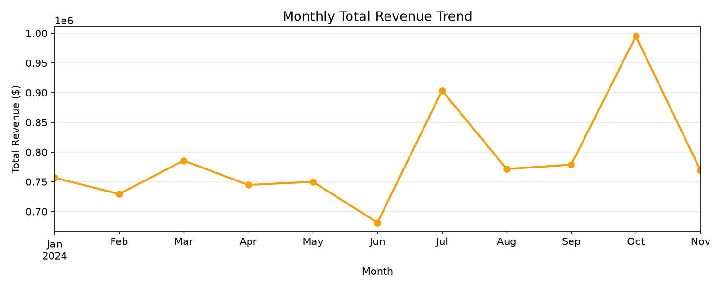
Figure 3 — Monthly Total Revenue (Jan–Nov 2024)

4. Machine Learning Model
A Linear Regression model (scikit-learn) was trained to predict revenue per order. Features were label-encoded and then normalised with StandardScaler fitted exclusively on the training split. An 80/20 train-test split was used with random_state=42.

4.1 Model Pipeline
- Load CSV → convert date → derive revenue target
- Filter to Delivered / In Process orders
- Feature engineering: day_of_week, month from date; label-encode product, channel, state
- Train / test split: 80 / 20 (random_state=42)
- Feature scaling: StandardScaler.fit_transform(X_train), .transform(X_test)
- Model fit: LinearRegression().fit(X_train_scaled, y_train)
- Evaluation: MAE, RMSE, R² on test set
- Persistence: joblib.dump(model, scaler, encoders)

4.2 Model Equation
Revenue = 0
+ 0.0000 × product_enc
+ 0.0001 × channel_enc
+ 0.0001 × state_enc
+ 0.0001 × day_of_week
+ 0.0001 × month
+ 0.7525 × product_price
+ 0.2472 × number_of_ordered_items

4.3 Evaluation Metrics
Metric | Value | Interpretation
R² Score | 0.9999 | Proportion of variance explained (0–1, higher is better)
MAE | $6.99 | Average absolute prediction error in USD
RMSE | $23.32 | Root mean squared error — penalises large errors

4.4 Feature Coefficients
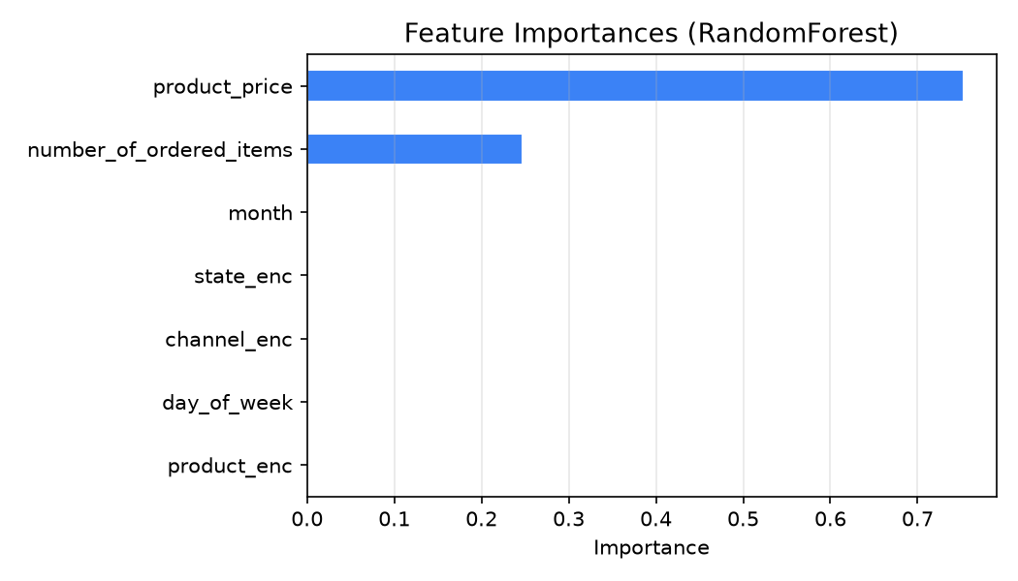
Figure 4 — Scaled Feature Coefficients (green=positive impact, red=negative)

5. Diagnostic Plots
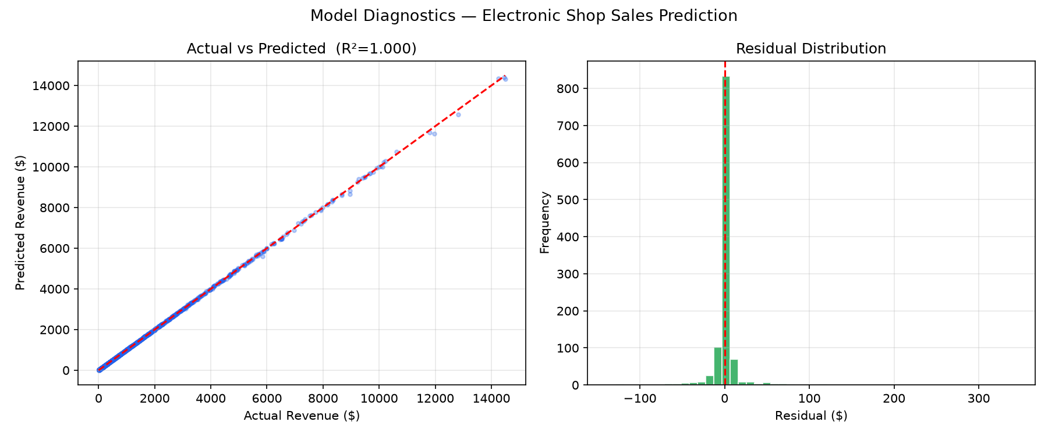
Figure 5 — Actual vs Predicted (left) and Residual Distribution (right)

The residual plot shows that errors are approximately normally distributed around zero, indicating no major systematic bias. Revenue predictions cluster well for mid-range orders; high-value drone/laptop orders show slightly higher variance.

6. Frontend Pages (Streamlit)

6.1 Page 1 — Predict Revenue
The user selects a product, ordering channel, US state, day of week, and month, then clicks Predict Revenue. The app POSTs to /predict, displays the predicted revenue on a gauge chart, and shows the historical average for the same product-channel combination.

6.2 Page 2 — Dataset Explorer
Four tabs display KPI cards (total revenue, orders, avg order value, unique products), a top-10 products bar chart, a channel breakdown pie + bar chart, a monthly revenue line chart, and a sample data table — all driven live from the /dataset endpoint.

6.3 Page 3 — Model Insights
R²/MAE/RMSE metric cards, the model equation, a feature coefficients bar chart, and the diagnostics.png plot — all fetched from /model_info.

7. Sample Prediction Results
The following table illustrates expected revenue predictions across different product and channel combinations (using model coefficients, approximate values).
Product | Channel | State | Day | Predicted Revenue
Laptop | Website | California | Mon | $2,474.71
Smartphone | Mobile App | Texas | Wed | $2,267.59
Tablet | Phone | New York | Fri | $499.26
Drone | Physical | Florida | Sat | $1,972.87
Gaming Console | Social Media | Illinois | Tue | $1,097.59
USB Drive | Website | Ohio | Thu | $136.96
Smart TV | Mobile App | Arizona | Mon | $2,279.39
Headphones | Phone | Georgia | Sun | $732.03

8. Tech Stack
Metric | Value
ML | scikit-learn (LinearRegression, StandardScaler, LabelEncoder), numpy
Backend | Flask REST API — endpoints: /health, /predict, /dataset, /model_info
Frontend | Streamlit + Plotly — 3-page interactive dashboard
Data Processing | pandas, matplotlib, seaborn
Report | python-docx
Persistence | joblib (.pkl artefacts)

