DocumentFLow

FOR ALL COLLEGE DEPARTMENT

Hierarchy (papunta sa pinakamataas na position ng employee)

Project Proposal:  
  
Creator ng Document: CSC President

Adviser (csc adviser)

SSC President

College Dean

Officer-in-Charge, Office of Student Affairs

Center for Performing Arts Organization

Vice President for Academic Affairs

Executive Vice-President/ Student Services

Communication Letter:

Creator ng Document: CSC President

Adviser (csc adviser)

SSC President

College Dean

Officer-in-Charge, Office of Student Affairs

Vice President for Academic Affairs

Executive Vice-President/ Student Services

Facility Request:

CSC President (BALI SA LAST PAGE NG FACILITY REQUEST YUNG PIRMA NG CSC PRESIDENT)

Itong College dean, tsaka OSA ito yung nasa first page ng paper   
College Dean (nakalagay sa paper Department Head pero college dean din siya)

Officer-in-Charge, Office of Student Affairs(OSA naman yung nakalagay sa paper)

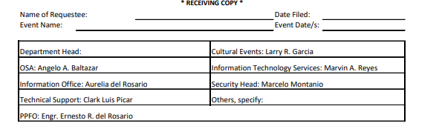

Ito naman dalawa nakalagay sa din sa last page kasama ng CSC President

Physical Plant and Facilities Office (PPFO yung nakalagay sa paper)

Executive Vice-President/ Student Services (sya rin yung PPFO Director sa paper)

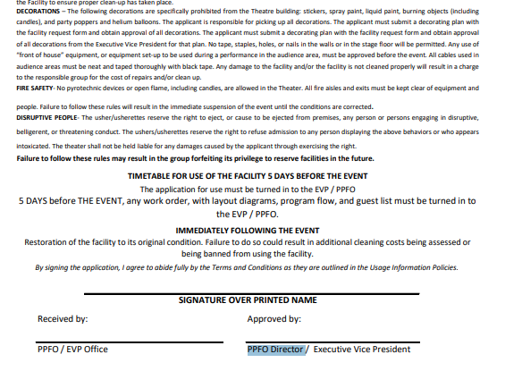  
  
yung signature over printed name yan din yung CSC President

SAF

**Dito naman boss, CSC tsaka SSC lang pwede gumawa ng paper**

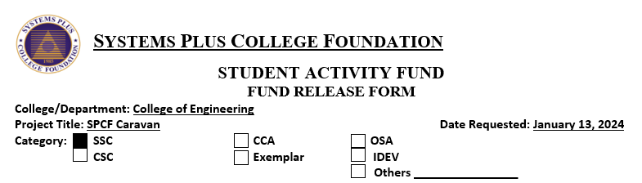

College Dean ((pero nakalagay sa paper DEAN/HEAD)

Officer-in-Charge, Office of Student Affairs (pero nakalagay sa paper HEAD, OSA)

Vice President for Academic Affairs (pero nakalagay sa paper VP-Academic Affairs

Executive Vice-President/ Student Services (pero nakalagay sa paper Executive Vice President)

MERON DING NAKALAGAY SA PAPER **Accounting Personnel** PERO DI NA KASAMA TO SA PIPIRMA

