COMPLIER DESIGN MINI PROJECT

“PARSER FOR JAVA”

SUBMITTED BY:

K K VISHNU (ROLLNO 2)

T N ANSHUMANTH RAO (ROLL NO 3)

SHREEKANTH N SHENOY (ROLL NO 4)

**OBJECTIVE:**

To design a parser for JAVA grammar using a top down or bottom up approach by using any available programming language.

**Grammar:**

The grammar to be used in BNF form is:

compilation_unit =

[ package_statement ]

< import_statement >

< type_declaration > .

package_statement =

"package" package_name ";" .

import_statement =

"import" ( ( package_name "." "*" ";" )

/ ( class_name / interface_name ) ) ";" .

type_declaration =

[ doc_comment ] ( class_declaration / interface_declaration ) ";" .

doc_comment = "/**" "... text ..." "*/" .

class_declaration =

< modifier > "class" identifier

[ "extends" class_name ]

[ "implements" interface_name < "," interface_name > ]

"{" < field_declaration > "}" .

interface_declaration =

< modifier > "interface" identifier

[ "extends" interface_name < "," interface_name > ]

"{" < field_declaration > "}" .

field_declaration =

( [ doc_comment ] ( method_declaration

/ constructor_declaration

/ variable_declaration ) )

/ static_initializer

/ ";" .

method_declaration =

< modifier > type identifier

"(" [ parameter_list ] ")" < "[" "]" >

( statement_block / ";" ) .

constructor_declaration =

< modifier > identifier "(" [ parameter_list ] ")"

statement_block .

statement_block = "{" < statement > "}" .

variable_declaration =

< modifier > type variable_declarator

< "," variable_declarator > ";" .

variable_declarator =

identifier < "[" "]" > [ "=" variable_initializer ] .

variable_initializer =

expression

/ ( "{" [ variable_initializer

< "," variable_initializer > [ "," ] ] "}" ) .

static_initializer =

"static" statement_block .

parameter_list =

parameter < "," parameter > .

parameter =

type identifier < "[" "]" > .

statement =

variable_declaration

/ ( expression ";" )

/ ( statement_block )

/ ( if_statement )

/ ( do_statement )

/ ( while_statement )

/ ( for_statement )

/ ( try_statement )

/ ( switch_statement )

/ ( "synchronized" "(" expression ")" statement )

/ ( "return" [ expression ] ";" )

/ ( "throw" expression ";" )

/ ( identifier ":" statement )

/ ( "break" [ identifier ] ";" )

/ ( "continue" [ identifier ] ";" )

/ ( ";" ) .

if_statement =

"if" "(" expression ")" statement

[ "else" statement ] .

do_statement =

"do" statement "while" "(" expression ")" ";" .

while_statement =

"while" "(" expression ")" statement .

for_statement =

"for" "(" ( variable_declaration / ( expression ";" ) / ";" )

[ expression ] ";"

[ expression ] ";"

")" statement .

try_statement =

"try" statement

< "catch" "(" parameter ")" statement >

[ "finally" statement ] .

switch_statement =

"switch" "(" expression ")" "{"

< ( "case" expression ":" )

/ ( "default" ":" )

/ statement >

"}" .

expression =

numeric_expression

/ testing_expression

/ logical_expression

/ string_expression

/ bit_expression

/ casting_expression

/ creating_expression

/ literal_expression

/ "null"

/ "super"

/ "this"

/ identifier

/ ( "(" expression ")" )

/ ( expression

( ( "(" [ arglist ] ")" )

/ ( "[" expression "]" )

/ ( "." expression )

/ ( "," expression )

/ ( "instanceof" ( class_name / interface_name ) )

) ) .

numeric_expression =

( ( "-"

/ "++"

/ "--" )

expression )

/ ( expression

( "++"

/ "--" ) )

/ ( expression

( "+"

/ "+="

/ "-"

/ "-="

/ "*"

/ "*="

/ "/"

/ "/="

/ "%"

/ "%=" )

expression ) .

testing_expression =

( expression

( ">"

/ "<"

/ ">="

/ "<="

/ "=="

/ "!=" )

expression ) .

logical_expression =

( "!" expression )

/ ( expression

( "ampersand"

/ "ampersand="

/ "|"

/ "|="

/ "^"

/ "^="

/ ( "ampersand" "ampersand" )

/ "||="

/ "%"

/ "%=" )

expression )

/ ( expression "?" expression ":" expression )

/ "true"

/ "false" .

string_expression = ( expression

( "+"

/ "+=" )

expression ) .

bit_expression =

( "~" expression )

/ ( expression

( ">>="

/ "<<"

/ ">>"

/ ">>>" )

expression ) .

casting_expression =

"(" type ")" expression .

creating_expression =

"new" ( ( classe_name "(" [ arglist ] ")" )

/ ( type_specifier [ "[" expression "]" ] < "[" "]" > )

/ ( "(" expression ")" ) ) .

literal_expression =

integer_literal

/ float_literal

/ string

/ character .

arglist =

expression < "," expression > .

type =

type_specifier < "[" "]" > .

type_specifier =

"boolean"

/ "byte"

/ "char"

/ "short"

/ "int"

/ "float"

/ "long"

/ "double"

/ class_name

/ interface_name .

modifier =

"public"

/ "private"

/ "protected"

/ "static"

/ "final"

/ "native"

/ "synchronized"

/ "abstract"

/ "threadsafe"

/ "transient" .

package_name =

identifier

/ ( package_name "." identifier ) .

class_name =

identifier

/ ( package_name "." identifier ) .

interface_name =

identifier

/ ( package_name "." identifier ) .

integer_literal =

( ( "1..9" < "0..9" > )

/ < "0..7" >

/ ( "0" "x" "0..9a..f" < "0..9a..f" > ) )

[ "l" ] .

float_literal =

( decimal_digits "." [ decimal_digits ] [ exponent_part ] [ float_type_suffix ] )

/ ( "." decimal_digits [ exponent_part ] [ float_type_suffix ] )

/ ( decimal_digits [ exponent_part ] [ float_type_suffix ] ) .

decimal_digits =

"0..9" < "0..9" > .

exponent_part =

"e" [ "+" / "-" ] decimal_digits .

float_type_suffix =

"f" / "d" .

character =

"based on the unicode character set" .

string =

"''" < character > "''" .

identifier =

"a..z,$,_" < "a..z,$,_,0..9,unicode character over 00C0" >

**PROGRAMMING LANGUAGES USED:**

* **Bison**: It is a general-purpose parser generator that converts a grammar description for an LALR (1) context-free grammar into a C program to parse that grammar. The Bison parser is a bottom-up parser. It tries, by shifts and reductions, to reduce the entire input down to a single grouping whose symbol is the grammar's start-symbol. We use it to see if the given grammar could be parsed.
* **FLEX**: It is a free and open-source software alternative to Lex. It is a computer program that generates lexical analyzers. We use it to generate tokens.
* **C**: It is a general-purpose, imperative computer programming language, supporting structured programming, lexical variable scope and many more. We use it to implement symbol table and hashing.

**TYPE OF PARSER:**

We use Bottom-up Parsing techniques as we are using Bison to implement parsing. Bottom-up parsing recognizes the text's lowest-level small details first, before its mid-level structures, and leaving the highest-level overall structure to last.

The bottom-up name comes from the concept of a parse tree, in which the most detailed parts are at the bottom of the (upside-down) tree, and larger structures composed from them are in successively higher layers, until at the top or "root" of the tree a single unit describes the entire input stream. A bottom-up parse discovers and processes that tree starting from the bottom left end, and incrementally works its way upwards and rightwards. A parser may act on the structure hierarchy's low, mid, and highest levels without ever creating an actual data tree; the tree is then merely implicit in the parser's actions. Bottom-up parsing lazily waits until it has scanned and parsed all parts of some construct before committing to what the combined construct is.

**METHEDOLOGY:**

The project is comprised of a flex program that takes the input file and generates a stream of tokens from it. It does this by matching the input characters to rules specified in the program. This part acts as the lexical analyzer. The bison program receives the sequence of tokens from the lexical analyzer and recognizes its structure. Using shifts (moving the input symbol onto the stack) and reductions (replacing a substring on the top of the stack by the LHS of the appropriate rule that generates this string), the parser reduces the entire input into a single symbol, in the case of a successful parse. The bison program contains all the grammar rules that define the language.

For this project, we began with the Backus Normal Form (BNF) rules for the Java program. BNF is a metasyntactic notation procedure that can be used to specify the syntax of computer programming languages. Using these rules, we wrote the grammar for Java in the format required for Bison. Following this, we had a list of tokens expected by the program, and the Flex file was created to generate and return all these tokens.

**USER DOCUMENTATION:**

Run the following script on the terminal, the parsing action/verdict will be shown in the terminal, the symbol table will be stored in an output file.

//Script

bison -d bison_file.y

flex flex_file.l

gcc lex.yy.c bison_file.tab.c -o op1

./op1

flex symbol.l

gcc lex.yy.c -o op2

./op2

**CODE:**

**//FLEX CODE**

%{

#include <stdio.h>

#include <stdlib.h>

#include "bison_file.tab.h"

%}

%%

"\t"|" "|"\n" {printf("%s",yytext);}

(("#".*)|("//".*))"\n" { }

("/*"(.|"\n")*"*/") { return DOC_COMMENT; }

"\"".*"\"" {printf("%s",yytext);return LITERAL;}

"\'"."\'" | "\'"\n"\'" {printf("%s",yytext);return SINGLE_QUOTE;}

[0-9]+ {printf("%s",yytext); return NUM;}

"FLOAT_TYPE" {printf("%s",yytext); return FLOAT_TYPE_SUFFIX;}

"[" {printf("%s",yytext); return LSB;}

"]" {printf("%s",yytext); return RSB;}

"{" {printf("%s",yytext); return LC;}

"}" {printf("%s",yytext); return RC;}

"(" {printf("%s",yytext); return LP;}

")" {printf("%s",yytext); return RP;}

"," {printf("%s",yytext); return COMMA;}

";" {printf("%s",yytext); return SCOLON;}

":" {printf("%s",yytext); return COLON;}

"." {printf("%s",yytext); return DOT;}

"?" {printf("%s",yytext); return QUESMARK;}

"+" {printf("%s",yytext); return ADD;}

"-" {printf("%s",yytext); return SUB;}

"*" {printf("%s",yytext); return MUL;}

"/" {printf("%s",yytext); return DIV;}

"%" {printf("%s",yytext); return MOD;}

"=" {printf("%s",yytext); return ASSIGN;}

"+=" {printf("%s",yytext); return ADDASSIGN;}

"-=" {printf("%s",yytext); return SUBASSIGN;}

"*=" {printf("%s",yytext); return MULASSIGN;}

"/=" {printf("%s",yytext); return DIVASSIGN;}

"%=" {printf("%s",yytext); return MODASSIGN;}

"++" {printf("%s",yytext); return INCREMENT;}

"--" {printf("%s",yytext); return DECREMENT;}

"EXPONENT" {printf("%s",yytext); return EXP;}

"\"" {printf("%s",yytext); return DQ;}

"<" {printf("%s",yytext); return LT;}

">" {printf("%s",yytext); return GT;}

"<=" {printf("%s",yytext); return LTE;}

">=" {printf("%s",yytext); return GTE;}

"==" {printf("%s",yytext); return EQEQ;}

"!=" {printf("%s",yytext); return NTEQ;}

"!" {printf("%s",yytext); return NOT;}

"&" {printf("%s",yytext); return BAND;}

"|" {printf("%s",yytext); return BOR;}

"&=" {printf("%s",yytext); return BANDEQ;}

"|=" {printf("%s",yytext); return BOREQ;}

"^" {printf("%s",yytext); return BXOR;}

"^=" {printf("%s",yytext); return BXOREQ;}

"&&" {printf("%s",yytext); return LAND;}

"||" {printf("%s",yytext); return LOR;}

"~" {printf("%s",yytext); return TILDE;}

">>" {printf("%s",yytext); return SIGNED_RSHIFT;}

"<<" {printf("%s",yytext); return SIGNED_LSHIFT;}

">>>" {printf("%s",yytext); return UNSIGNED_RSHIFT;}

"true" {printf("%s",yytext); return TRUE;}

"false" {printf("%s",yytext); return FALSE;}

"abstract" {printf("%s",yytext); return ABSTRACT;}

"assert" {printf("%s",yytext); return ASSERT;}

"boolean" {printf("%s",yytext); return BOOLEAN;}

"break" {printf("%s",yytext); return BREAK;}

"byte" {printf("%s",yytext); return BYTE;}

"case" {printf("%s",yytext); return CASE;}

"catch" {printf("%s",yytext); return CATCH;}

"char" {printf("%s",yytext); return CHAR;}

"class" {printf("%s",yytext); return CLASS;}

"const" {printf("%s",yytext); return CONST;}

"continue" {printf("%s",yytext); return CONTINUE;}

"default" {printf("%s",yytext); return DEFAULT;}

"do" {printf("%s",yytext); return DO;}

"double" {printf("%s",yytext); return DOUBLE;}

"else" {printf("%s",yytext); return ELSE;}

"enum" {printf("%s",yytext); return ENUM;}

"extends" {printf("%s",yytext); return EXTENDS;}

"final" {printf("%s",yytext); return FINAL;}

"finally" {printf("%s",yytext); return FINALLY;}

"float" {printf("%s",yytext); return FLOAT;}

"for" {printf("%s",yytext); return FOR;}

"goto" {printf("%s",yytext); return GOTO;}

"if" {printf("%s",yytext); return IF;}

"implements" {printf("%s",yytext); return IMPLEMENTS;}

"import" {printf("%s",yytext); return IMPORT;}

"instanceof" {printf("%s",yytext); return INSTANCEOF;}

"int" {printf("%s",yytext); return INT;}

"interface" {printf("%s",yytext); return INTERFACE;}

"long" {printf("%s",yytext); return LONG;}

"native" {printf("%s",yytext); return NATIVE;}

"new" {printf("%s",yytext); return NEW;}

"package" {printf("%s",yytext); return PACKAGE;}

"private" {printf("%s",yytext); return PRIVATE;}

"protected" {printf("%s",yytext); return PROTECTED;}

"public" {printf("%s",yytext); return PUBLIC;}

"return" {printf("%s",yytext); return RETURN;}

"short" {printf("%s",yytext); return SHORT;}

"static" {printf("%s",yytext); return STATIC;}

"strictfp" {printf("%s",yytext); return STRICTFP;}

"super" {printf("%s",yytext); return SUPER;}

"switch" {printf("%s",yytext); return SWITCH;}

"synchronized" {printf("%s",yytext); return SYNCHRONIZED;}

"this" {printf("%s",yytext); return THIS;}

"threadsafe" {printf("%s",yytext); return THREADSAFE;}

"throw" {printf("%s",yytext); return THROW;}

"throws" {printf("%s",yytext); return THROWS;}

"transient" {printf("%s",yytext); return TRANSIENT;}

"try" {printf("%s",yytext); return TRY;}

"void" {printf("%s",yytext); return VOID;}

"volatile" {printf("%s",yytext); return VOLATILE;}

"while" {printf("%s",yytext); return WHILE;}

"String" {printf("%s",yytext); return STRING;}

"0x"[0-9a-f]+ {printf("%s",yytext); return HEXNUM;}

"redundant" {printf("%s",yytext); return REDUNDANT;}

[a-zA-Z_][a-zA-Z0-9_]* {printf("%s",yytext); return IDENTIFIER;}

%%

int yywrap(){return 1;}

//**BISON CODE**

%{

#include<stdio.h>

#include<stdlib.h>

#define YYDEBUG 1

int yylex();

int yyerror();

extern FILE *yyin;

#

%}

%token ABSTRACT ASSERT BOOLEAN BREAK BYTE CASE CATCH CHAR CLASS CONST CONTINUE DEFAULT DO DOUBLE ELSE ENUM EXTENDS FINAL FINALLY FLOAT FOR GOTO IF IMPLEMENTS IMPORT INSTANCEOF INT INTERFACE LONG NATIVE NEW PACKAGE PRIVATE PROTECTED PUBLIC RETURN SHORT STATIC STRICTFP SUPER SWITCH SYNCHRONIZED THIS THREADSAFE THROW THROWS TRANSIENT TRY VOID VOLATILE WHILE SCOLON DOT LC RC LP RP LSB RSB COLON QUESMARK COMMA ADD SUB MUL DIV MOD ASSIGN ADDASSIGN SUBASSIGN MULASSIGN DIVASSIGN MODASSIGN INCREMENT DECREMENT EXP DQ LT LTE GT GTE EQEQ NTEQ TRUE FALSE NUM NOT BAND BOR BANDEQ BOREQ BXOR BXOREQ LAND LOR TILDE SIGNED_RSHIFT UNSIGNED_RSHIFT SIGNED_LSHIFT FLOAT_TYPE_SUFFIX HEXNUM IDENTIFIER LITERAL STRING REDUNDANT DOC_COMMENT

%%

compilation_unit : package_statement import_statement_more type_declaration_more

| import_statement_more type_declaration_more ;

import_statement_more : import_statement import_statement_more

| eps ;

type_declaration_more : type_declaration type_declaration_more

| eps ;

package_statement : PACKAGE package_name SCOLON ;

import_statement : IMPORT package_name DOT MUL SCOLON

| IMPORT class_name SCOLON

| IMPORT interface_name SCOLON ;

type_declaration : DOC_COMMENT class_declaration

| DOC_COMMENT interface_declaration

| class_declaration

| interface_declaration ;

class_declaration : modifier_more CLASS IDENTIFIER class_declaration_1 class_declaration_2 LC field_declaration_more RC

modifier_more : modifier modifier_more

| eps ;

field_declaration_more : field_declaration field_declaration_more

| eps ;

class_declaration_1 : EXTENDS class_name

| eps ;

class_declaration_2 : IMPLEMENTS interface_name interface_name_more

| eps ;

interface_name_more : COMMA interface_name interface_name_more

| eps ;

interface_declaration : modifier_more INTERFACE IDENTIFIER interface_declaration_1 LC field_declaration_more RC ;

interface_declaration_1 : EXTENDS interface_name_more

| eps ;

field_declaration : method_declaration

| constructor_declaration

| variable_declaration

| DOC_COMMENT method_declaration

| DOC_COMMENT constructor_declaration

| DOC_COMMENT variable_declaration

| static_initializer

| SCOLON ;

method_declaration : modifier_more type IDENTIFIER LP parameter_list RP square_brak_more method_declaration_1;

method_declaration_1 : statement_block

| SCOLON ;

square_brak_more : LSB RSB square_brak_more

| LSB expression RSB square_brak_more

| eps ;

constructor_declaration : modifier_more IDENTIFIER LP parameter_list RP statement_block ;

statement_block : LC statement_more RC ;

statement_more : statement statement_more

| eps ;

variable_declaration : modifier_more type variable_declarator variable_declaration_1 SCOLON

| IDENTIFIER IDENTIFIER SCOLON

| IDENTIFIER IDENTIFIER square_brak_more variable_declaration_1 SCOLON

| IDENTIFIER IDENTIFIER square_brak_more ASSIGN expression SCOLON;

variable_declaration_1 : COMMA variable_declarator variable_declaration_1

| eps ;

variable_declarator : IDENTIFIER square_brak_more variable_declarator_1 ;

variable_declarator_1 : ASSIGN variable_initializer

| eps ;

variable_initializer : expression

| LC variable_initializer_1 RC ;

variable_initializer_1 : variable_initializer

| variable_initializer COMMA

| variable_initializer variable_initializer_more

| variable_initializer variable_initializer_more COMMA

| eps ;

variable_initializer_more : COMMA variable_initializer variable_initializer_more

| eps ;

static_initializer : STATIC statement_block ;

parameter_list : parameter parameter_more

| eps ;

parameter_more : COMMA parameter parameter_more

| eps ;

parameter : type IDENTIFIER square_brak_more ;

statement : variable_declaration

| expression SCOLON

| statement_block

| if_statement

| do_statement

| while_statement

| for_statement

| try_statement

| switch_statement

| SYNCHRONIZED LP expression RP statement

| RETURN SCOLON

| RETURN expression SCOLON

| THROW expression SCOLON

| IDENTIFIER COLON statement

| BREAK SCOLON

| BREAK IDENTIFIER SCOLON

| CONTINUE SCOLON

| CONTINUE IDENTIFIER SCOLON

| SCOLON ;

if_statement : IF LP expression RP statement

| IF LP expression RP statement ELSE statement ;

do_statement : DO statement WHILE LP expression RP SCOLON ;

while_statement : WHILE LP expression RP statement ;

for_statement : FOR LP for_statement_1 RP statement ;

for_statement_1 : for_statement_1_1 for_statement_1_2 SCOLON for_statement_1_2 ;

for_statement_1_1 : variable_declaration

| expression SCOLON

| SCOLON ;

for_statement_1_2 : expression

| eps ;

try_statement : TRY statement try_statement_1

| TRY statement try_statement_1 FINALLY statement ;

try_statement_1 : CATCH LP parameter RP statement try_statement_1

| eps;

switch_statement : SWITCH LP expression RP LC switch_statement_1 RC ;

switch_statement_1 : CASE expression COLON switch_statement_1

| DEFAULT COLON switch_statement_1

| statement switch_statement_1

| eps ;

expression : numeric_expression

| testing_expression

| logical_expression

| bit_expression

| casting_expression

| creating_expression

| literal_expression

| SUPER

| THIS

| IDENTIFIER

| LP expression RP

| expression expression_1 ;

expression_1 : LP RP

| LP arglist RP

| LSB expression RSB

| DOT expression

| COMMA expression

| INSTANCEOF class_name

| INSTANCEOF interface_name;

numeric_expression : SUB expression

| INCREMENT expression

| DECREMENT expression

| expression INCREMENT

| expression DECREMENT

| expression ADD expression

| expression SUB expression

| expression MUL expression

| expression DIV expression

| expression MOD expression

| expression ASSIGN expression

| expression ADDASSIGN expression

| expression SUBASSIGN expression

| expression DIVASSIGN expression

| expression MULASSIGN expression

| expression MODASSIGN expression ;

testing_expression : expression LT expression

| expression GT expression

| expression LTE expression

| expression GTE expression

| expression EQEQ expression

| expression NTEQ expression ;

logical_expression : NOT expression

| expression BAND expression

| expression BOR expression

| expression BANDEQ expression

| expression BOREQ expression

| expression BXOR expression

| expression BXOREQ expression

| expression LAND expression

| expression LOR expression

| expression QUESMARK expression COLON expression

| TRUE

| FALSE ;

bit_expression : TILDE expression

| expression SIGNED_RSHIFT expression

| expression SIGNED_LSHIFT expression

| expression UNSIGNED_RSHIFT expression ;

casting_expression : LP type RP expression ;

creating_expression : NEW class_name LP RP

| NEW class_name LP arglist RP

| NEW type_specifier

| NEW type_specifier LSB expression RSB

| NEW type_specifier square_brak_more

| NEW LP expression RP ;

literal_expression : integer_literal

| float_literal

| string

;

arglist : expression arglist_1 ;

arglist_1 : COMMA expression arglist_1

| eps ;

type : type_specifier square_brak_more ;

type_specifier : BOOLEAN

| BYTE

| CHAR

| SHORT

| INT

| FLOAT

| LONG

| DOUBLE

| STRING

| VOID

|IDENTIFIER

;

modifier : PUBLIC

| PRIVATE

| PROTECTED

| STATIC

| FINAL

| NATIVE

| SYNCHRONIZED

| ABSTRACT

| TRANSIENT

| THREADSAFE ;

package_name : IDENTIFIER

| package_name DOT IDENTIFIER ;

class_name : IDENTIFIER

| package_name DOT IDENTIFIER ;

interface_name : IDENTIFIER

| package_name DOT IDENTIFIER ;

integer_literal : NUM

| HEXNUM

float_literal : NUM DOT

| NUM DOT NUM

| NUM DOT exponent_part

| NUM DOT NUM exponent_part

| NUM DOT NUM FLOAT_TYPE_SUFFIX

| NUM DOT exponent_part FLOAT_TYPE_SUFFIX

| NUM DOT NUM exponent_part FLOAT_TYPE_SUFFIX

| DOT NUM

| DOT NUM exponent_part

| DOT NUM FLOAT_TYPE_SUFFIX

| DOT NUM exponent_part FLOAT_TYPE_SUFFIX

| NUM exponent_part

| NUM FLOAT_TYPE_SUFFIX

| NUM exponent_part FLOAT_TYPE_SUFFIX ;

exponent_part : EXP NUM

| EXP ADD NUM

| EXP SUB NUM

string : LITERAL ;

eps : ;

%%

int yyerror(char *msg){

printf("\nInvalid expression");

return 1;

}

void main (){

/*#ifdef YYDEBUG

yydebug = 1;

#endif*/

yyin=fopen("inpfile.java","r");

do{

if(yyparse() )

{

printf("\n Failure!");

exit(0);

}

}while(!feof(yyin));

printf("\n\nSuccessfully parsed!!!\n");

}

//**SYMBOL TABLE HEADER FILE**

struct token{

int hashVal;

char name[256];

char type[256];

int size;

char scope;

int arg;

int args[50];

char retType[256];

struct token* next;

};

typedef struct token* TOKEN;

TOKEN table[20];

void initialize_symtable(){

for(int i=0;i<20;i++)

table[i] = NULL;

}

int compHash(char *str){

int hashVal = 0;

for(int i=0;i<strlen(str);i++)

hashVal += (i+1)*(int)str[i];

hashVal %= 20;

//printf("\nHashVal of %s = %d", str, hashVal);

return hashVal;

}

int searchVal(char name[]){

int hash = compHash(name);

TOKEN check = table[hash];

while(check != NULL){

if(strcmp(name, check->name) == 0)

return hash;

check = check->next;

}

return -1;

}

void insertToken(char name[], char type[], int size, char scope, int arg, int args[], char retType[]){

//printf("\nInside Insert Funtion for %s\n", name);

if(searchVal(name) != -1){

return;

}

TOKEN temp = (TOKEN)malloc(sizeof(struct token));

//printf("\nMem Alocated...\n");

temp->hashVal = compHash(name);

strcpy(temp->name, name);

strcpy(temp->type, type);

temp->size = size;

temp->scope = scope;

temp->arg = arg;

for(int i=0;i<arg;i++)

temp->args[i] = args[i];

if(retType == NULL){

strcpy(temp->retType, " ");

}

else{

strcpy(temp->retType, retType);

}

//printf("Copied items into temp.\n");

temp->next = NULL;

//printf("Copied items into temp.\n");

if(table[temp->hashVal] == NULL)

table[temp->hashVal] = temp;

else{

TOKEN check = table[temp->hashVal];

while(check->next != NULL)

check = check->next;

check->next = temp;

}

//printf("Done\n");

}

void displaySymTab(){

FILE *fp;

fp = fopen("sym_out.txt", "w");

//printf("\n ----------------------------------------------------------------------------");

fprintf(fp, "\nHash | ID Name | ID Type | Size | Scope | Arg | Arg Vals | Ret Type |");

fprintf(fp, "\n---------------------------------------------------------------------");

for(int i=0;i<20;i++){

if(table[i] != NULL){

TOKEN check = table[i];

while(check != NULL){

fprintf(fp, "\n%3d | %30s | %8s | %5d | %5c | %5d | ", check->hashVal, check->name, check->type, check->size, check->scope, check->arg);

for(int j=0;j<check->arg;j++)

fprintf(fp, "%d", check->args[j]);

fprintf(fp," \t\t\t|%s\t\t\t", check->retType);

check = check->next;

}

}

}

//printf("\n ----------------------------------------------------------------------------");

fclose(fp);

}

**//SYMBOL TABLE FLEX CODE**

%{

#include <stdio.h>

#include <stdlib.h>

#include <string.h>

#include "hash_symtab.h"

int checkKeyword(char buf[]){

char *keys[] = {"abstract" , "assert" , "boolean" , "break" , "byte" , "case" , "catch" ,

"char" , "class" , "const" , "continue" , "default" , "do" , "double" , "else" , "enum" , "extends" ,

"final" , "finally" , "float" , "for" , "goto" , "if" , "implements" , "import" , "instanceof" , "int" ,

"interface" , "long" , "native" , "new" , "package" , "private" , "protected" , "public" , "return" ,

"short" , "static" , "strictfp" , "super" , "switch" , "synchronized" , "this" , "threadsafe" , "throw" ,

"throws" , "transient" , "try" , "void" , "volatile" , "while" , "scolon" , "dot" , "lc" , "rc" , "lp" ,

"rp" , "lsb" , "rsb" , "colon" , "quesmark" , "comma" , "add" , "sub" , "mul" , "div" , "mod" , "assign" ,

"addassign" , "subassign" , "mulassign" , "divassign" , "modassign" , "increment" , "decrement" , "exp" ,

"dq" , "lt" , "lte" , "gt" , "gte" , "eqeq" , "nteq" , "true" , "false" , "num" , "not" , "band" , "bor" ,

"bandeq" , "boreq" , "bxor" , "bxoreq" , "land" , "lor" , "tilde" , "signed_rshift" , "unsigned_rshift" ,

"signed_lshift" , "float_type_suffix" , "hexnum" , "identifier" , "literal" , "String" , "redundant" ,

"doc_comment"};

for(int i=0;i<105;i++){

if((strcmp(buf, keys[i]) == 0 ))

return 1;

}

return 0;

}

char global_type[256], global_scope = 'G';

int is_func = 0, size,c=0;

int argc = 0, argVals[105];

char buf[256], func_name[256], func_retType[256], scope;

%}

%%

"import".*"\n" {

}

"/*"(.|"\n")*"*/" {

}

"//".*"\n" {

}

"\""(.)*"\"" {

}

"{" {

c++;

if(c!=0)

global_scope = 'L';

else

global_scope = 'R';

}

"}" { c--;

if(c!=0)

global_scope = 'L';

else

global_scope = 'R';

}

")" {

if(is_func == 1){

insertToken(func_name, "FUNC", 0, scope, argc, argVals, func_retType);

for(int i=0;i<50;i++){

argVals[i] = 0;

}

argc = 0;

is_func = 0;

}

}

[a-zA-Z][a-zA-Z0-9_]*[a-zA-Z0-9]* {

int j = checkKeyword(yytext);

if(j == 0){

if(strcmp(global_type, "int") == 0 || strcmp(global_type, "float") == 0){

size = 4;

}

else if(strcmp(global_type, "char") == 0){

size = 1;

}

else if(strcmp(global_type, "double") == 0){

size = 8;

}

if(is_func == 1){

argVals[argc] = compHash(yytext);

argc++;

}

insertToken(yytext, global_type, size, global_scope, 0, NULL, " ");

}

else{

strcpy(global_type, yytext);

}

}

[a-zA-Z][a-zA-Z0-9_]*[a-zA-Z0-9]*("["[0-9]+"]") {

//printf("\nIntel Inside..%s\n", yytext);

int i=0;

char buf[256];

while(yytext[i] != '['){

buf[i] = yytext[i];

i++;

}

buf[i] = '\0';

i++;

int num = 0;

while(yytext[i]!=']'){

num = num*10 + ((int)yytext[i]-48);

i++;

}

if(strcmp(global_type, "int") == 0 || strcmp(global_type, "float") == 0){

size = 4;

}

else if(strcmp(global_type, "char") == 0){

size = 1;

}

else if(strcmp(global_type, "double") == 0){

size = 8;

}

if(is_func == 1){

argVals[argc] = compHash(buf);

argc++;

}

insertToken(buf, global_type, size*num, global_scope, 0, NULL, " ");

}

[a-zA-Z][a-zA-Z0-9_]*[a-zA-Z0-9]*"(" {

int i=0;

while(yytext[i] != '('){

buf[i] = yytext[i];

i++;

}

buf[i] = '\0';

int j = checkKeyword(buf);

if(j == 0){

strcpy(func_name, buf);

is_func = 1;

strcpy(func_retType, global_type);

scope = global_scope;

argc = 0;

}

}

(.|"\n") {}

%%

int yywrap(){

return 1;

}

int main(){

initialize_symtable();

yyin = fopen("inpfile.java", "r");

yylex();

displaySymTab();

}

**CODE SNAPSHOTS:**

**//TEST CASE 1**

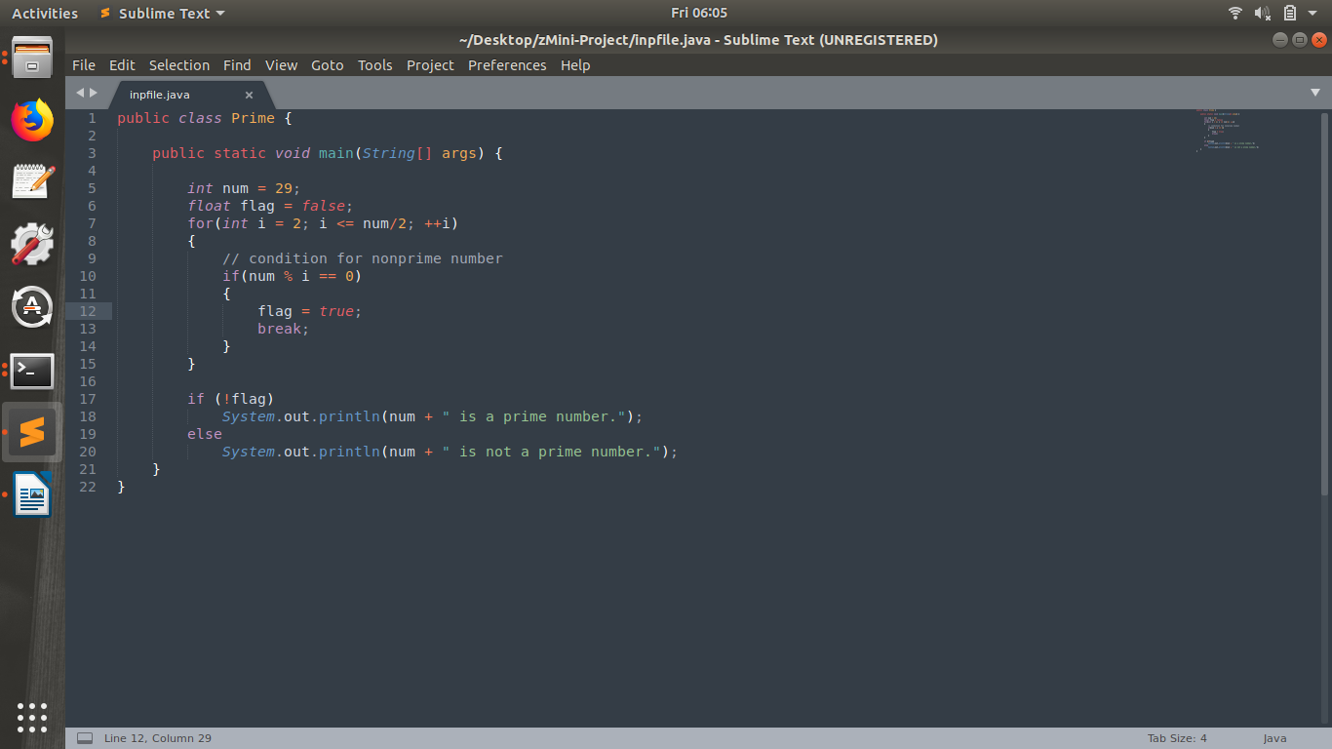 Input:

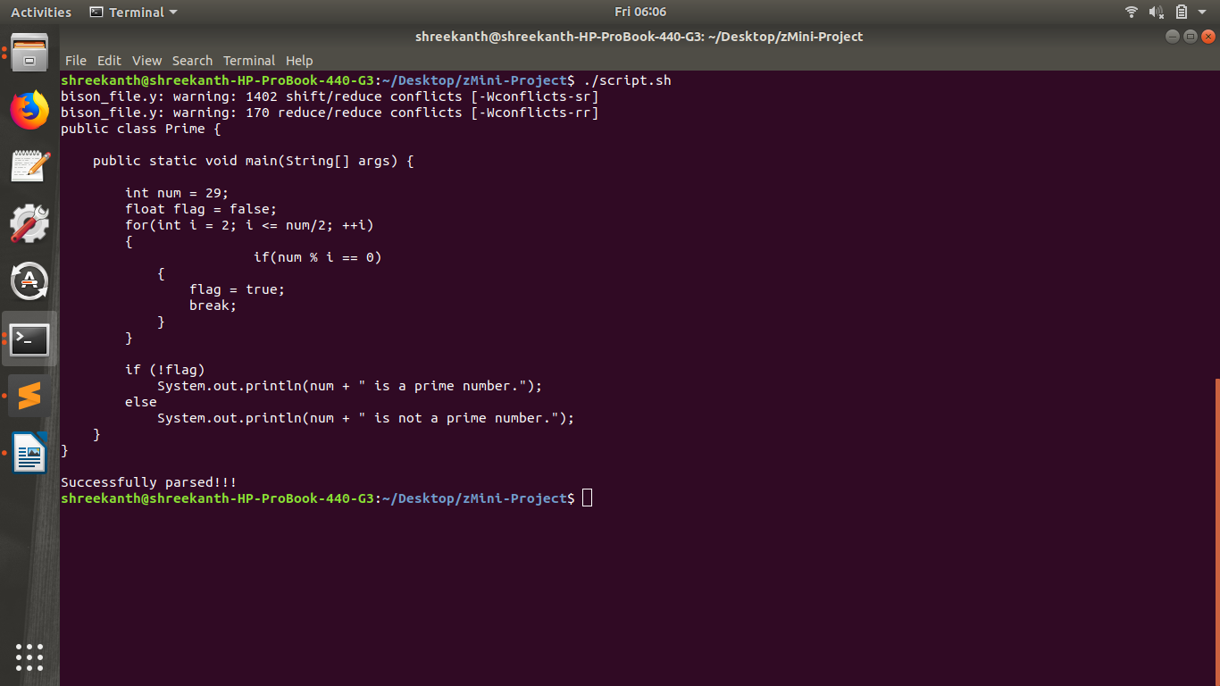 Terminal Output:

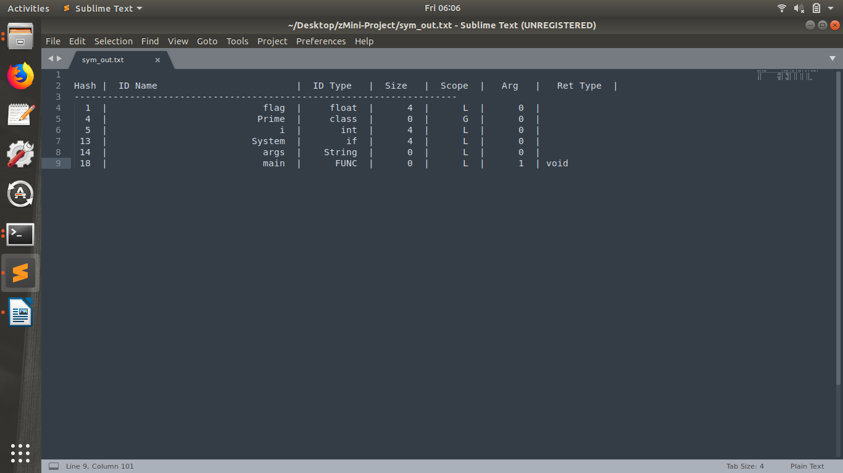Test File Output

Error Induced Input:

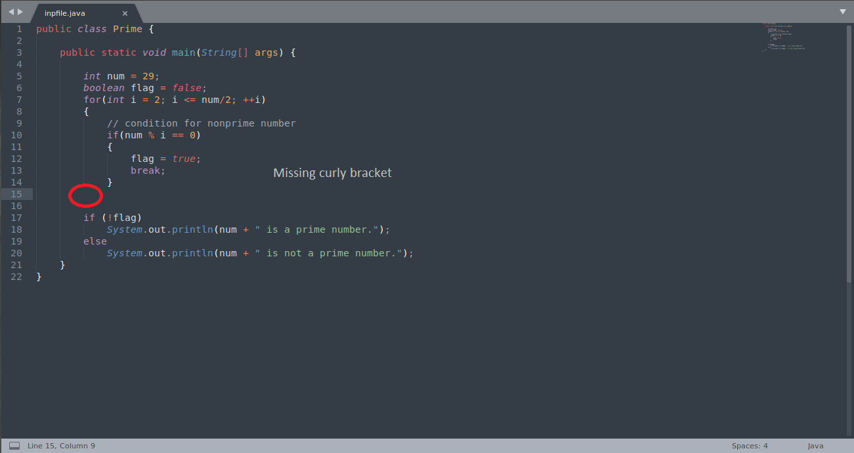

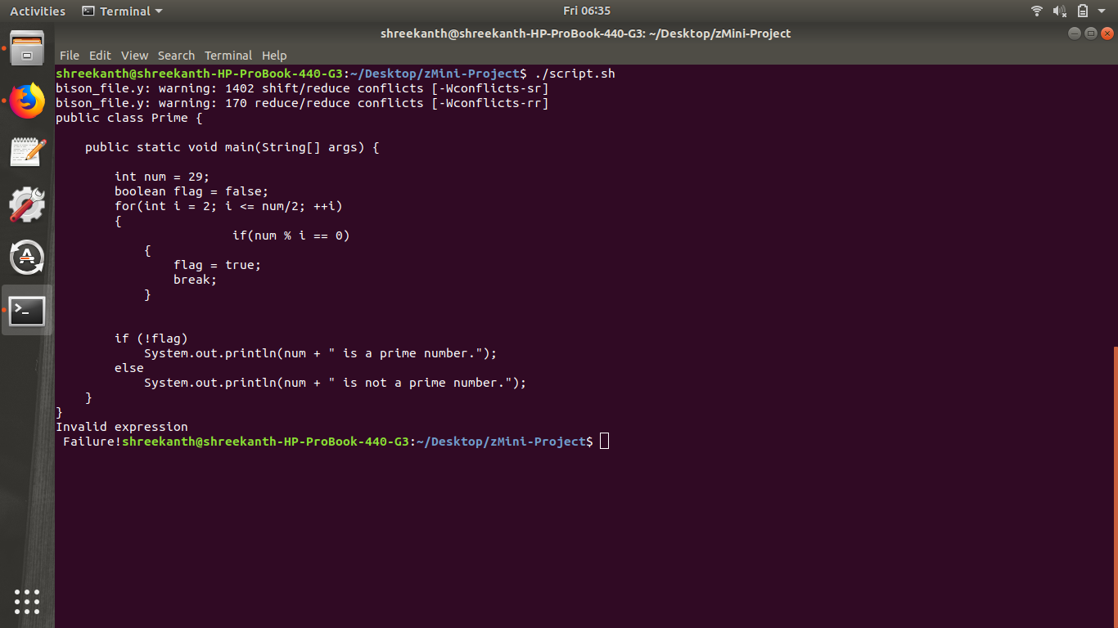Terminal Output:

**//TEST CASE 2**

Input:

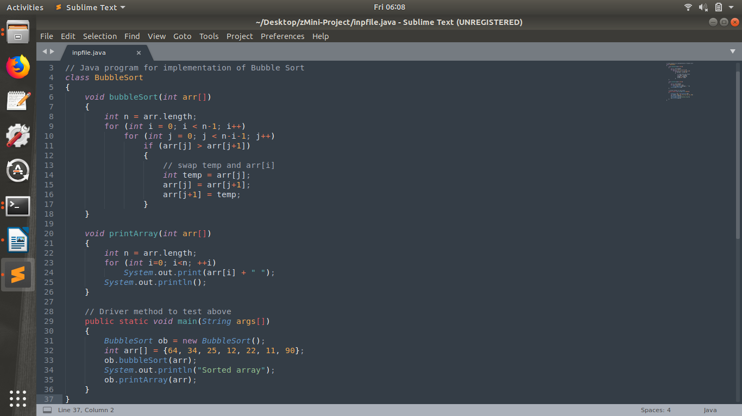

Terminal output:

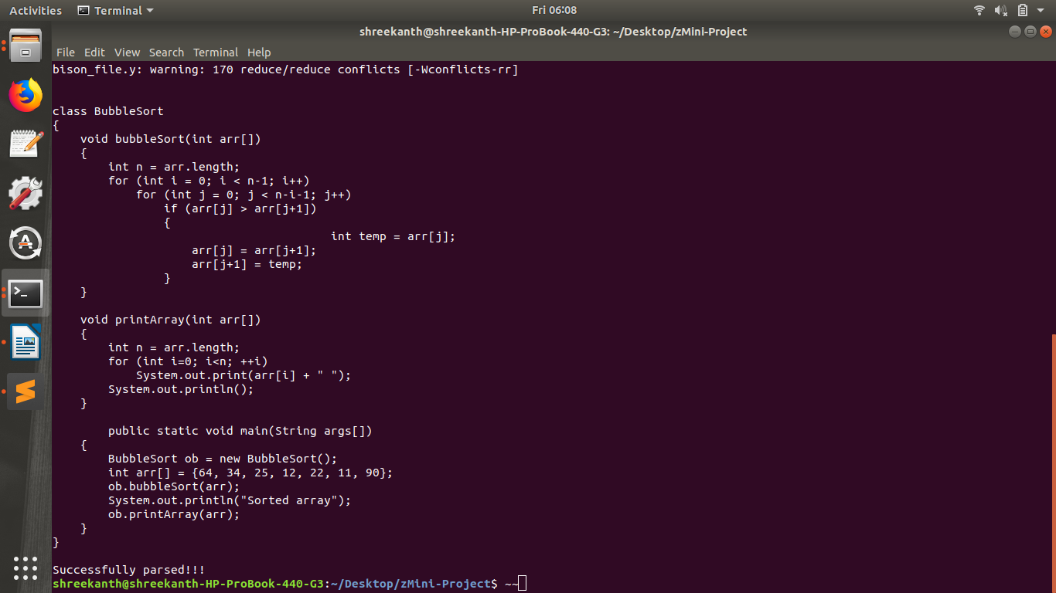`

Text File Output

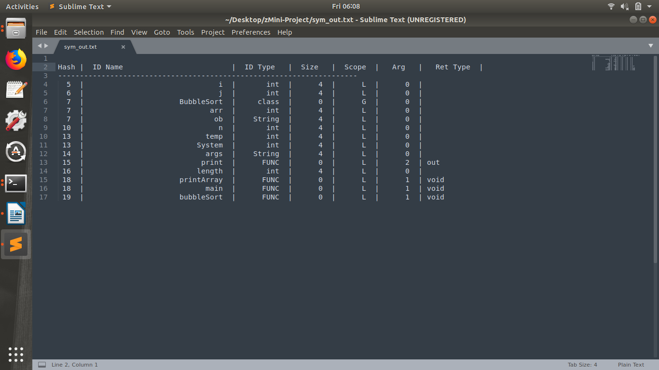

Error Induced Input

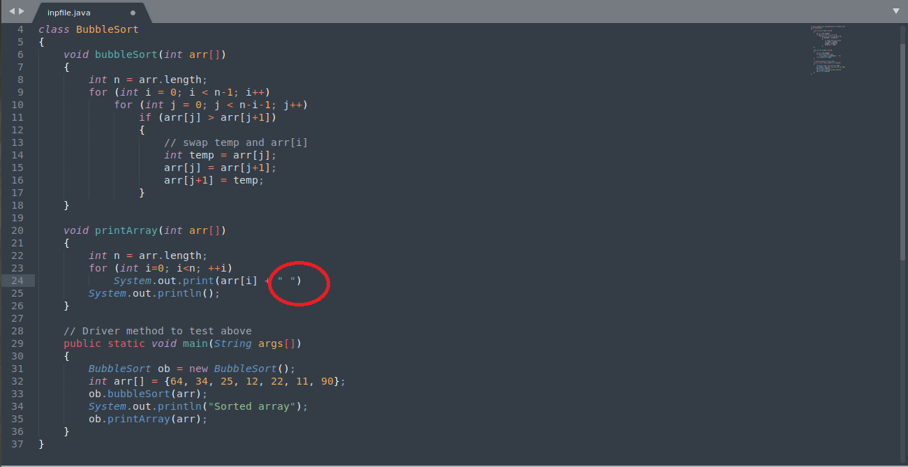

Terminal Output:

