Introduction

Bookstore gives you an online shopping cart and point-of-sale system for your school's bookstore. Online shoppers can browse and purchase items via the shopping interface or via Buy Now links for individual items embedded on other sites. In-person sales can be handled using Point of Sale, which works with USB barcode scanners and credit card readers. Students who want to pay later can charge their Bookstore orders to their accounts. On the back end, you can manage inventory, process online orders, and run sales reports. Additionally, all Bookstore transactions are automatically fed into your General Ledger.

Goals

Goal is to make books available at each corner through online medium and website is created in a way that showcases all the books of all authors in a single platform which make buying books easier.

Admin can update/Delete/Add books in website through logging securely.

Basic Requirements

* Microsoft SQL Server: It is Microsoft-owned relational database management system. The database server will allow storage and retrieval of data for the pizza store web application.
* AngularJS: A JavaScript MVW Framework that allows extending of HTML vocabulary to produce a more dynamic, expressive, and easy to develop web applications
* Summernote: A JavaScript library that will be used as the editor for this iteration of the project. It features a WYSIWYG (What You See Is What You Get) design while allowing customizations fit to the requirements which makes it a decent alternative to for this project.
* Bootstrap: A CSS Design library available for free. It boasts modern templates and a mobilefirst design.

Admin Access:

Only authorized person who admin username and password has access to add and delete the data that will be shown on the website

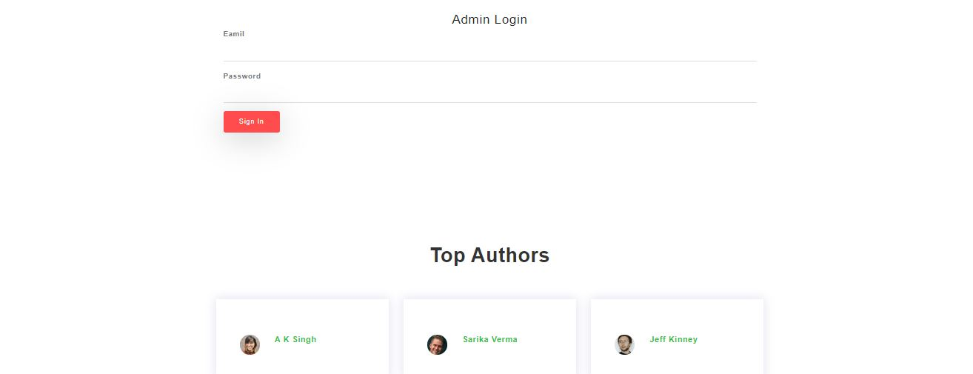

Username : kuldeep@admin.com

Password : admin

With this admin login person can add the Book for the website

Page will redirect to all the entries that has been entered to the database

By clicking on the delete button entry will be deleted and by clicking on the create new link new page will redirected to the adding the new record :

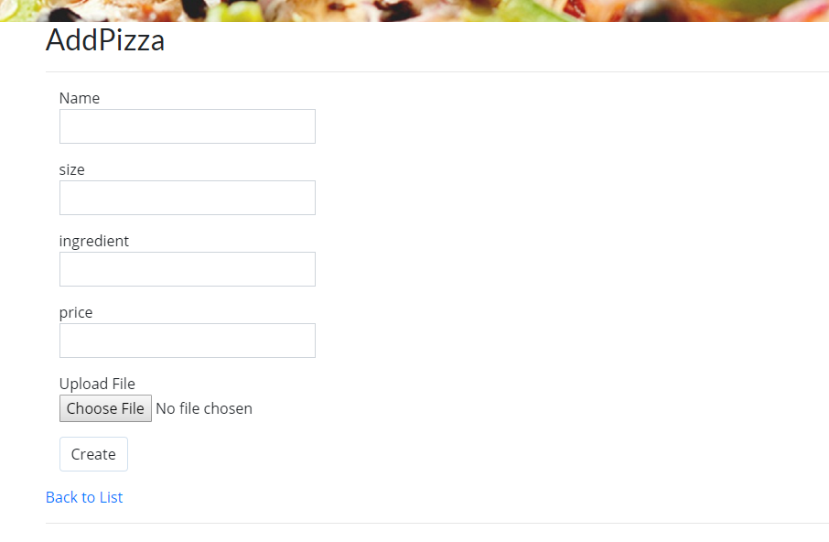

Homepage :

Index page is welcoming the book readers in a very attractive way with slider containing all books and after that all the books are there. 

About :

All the information about the company is given in the about page and many more interesting facts are also given t=in the website about the authors.

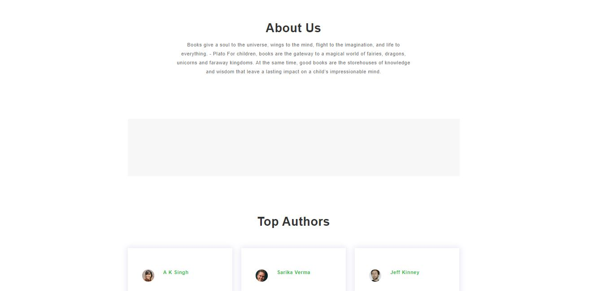

Contact

Contact page is general query handling page that if any customer who want to contact us regarding any query or other information about us can directly contact through the contact page

