Queires with Joins;

**Figure 1**

Retrieve information about movies and their directors first name and last name.

**Figure 2**

List of cities and their countries

**Figure 3**

Find video games and their developers:

**Figure 4**

Show the music titles and their artists.

Figure 5

Retrieve information about roles in movies, including actors and genres:

Queries with Subqueries:

**Figure 6**

Find countries with a population greater than the average population of all countries:

**Figure 7**

Find movies released in the same year as a specific movie, and list their titles:

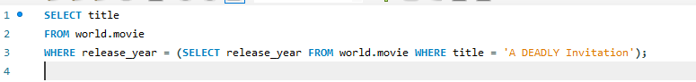

**Figure 8**

Show company who have released more than one video game:

**Figure 9**

Show the most common genres in music:

**Figure 10**

Show the name and population for France, Germany, Italy

**Figure 11**

Find the country that has all the vowels and no spaces in its name.

**Figure 12**

List videogame, genre and with the language is “Japanese”

**Figure 13**

retrieve the names of countries that have released movie

**Figure 14**

**Figure 15**

retrieve the names of video games along with the first and last names of their publishers

**Figure 16**

Retrieves the names and independence years of countries where the independence year is not NULL, ordered by the independence year in descending order.

**Figure 17**

Find countries where more than one language is official

**Figure 18**

Find the most spoken language (highest percentage) for each country:

**Figure 19**

Calculate the average percentage of language usage globally

**Figure 20**

Retrieve countries where English is an official language and its percentage is above a certain threshold:

