盐城师范学院信息工程学院
实验报告

课程名称 数据结构与算法
班级 | 178 | 学号 | 17263826 | 姓名 | 徐大瑞
实验地点 | 平西 | 实验日期 | 2018-4-27 | 实验学时 | 4
实验名称 | 实验五 串
实验类型 | √ 验证性  综合性  设计性
实验目的与要求：
1. 熟悉串类型的实现方法，了解简单文字处理的设计方法。
2. 熟悉C语言的字符和把字符串处理的原理和方法。
实验环境：(包括软件平台和硬件平台)
操作系统：Windows 7
Dev
实验内容及要求 (含源程序)：
实验内容：
#include <cstdlib>
#include <iostream>
#include <queue>
//#include <string>

using namespace std;

class String
{
public:
struct String1
{
char String[1000] = {'\0'};
} unit;
int length()
{
int i = 0;
for (; unit.String[i] != 0; i++)
;
return i;
}
};
class str
{
private:
int match(String MainStr, String SubStr, int pos)
{
int i = pos - 1, j = 0;
int ml = MainStr.length(), sl = SubStr.length();
while (i < ml && j < sl)
{
if (MainStr.unit.String[i] == SubStr.unit.String[j])
{
i++;
j++;
}
else
{
i = i + 1;
j = 0;
}
}
if (j == sl)
return (i - sl + 1);
else
return -1;
}

public:
void replace(String *MainStr, String StrToBeReplaced, String StrToReplace)
{
int ml = MainStr->length(), sl = StrToBeReplaced.length(), sl2 = StrToReplace.length();
int reco, mark = 0;
if (sl >= sl2)
{
for (int i = 1; i <= ml - sl;)
{
int flag = 0, rip = 0;
while (1)
{
mark = match(*MainStr, StrToBeReplaced, i);
if (mark == -1)
return;
for (int count = 0; count < sl2; count++)
(*MainStr).unit.String[mark + count - 1] = StrToReplace.unit.String[count];
for (int count = 0; count < ml - mark - sl + 2; count++)
(*MainStr).unit.String[mark + count + sl2 - 1] = (*MainStr).unit.String[mark + count + sl - 1];
i = i + sl2 + 1;
}
}
}
else
{
for (int i = 1; i <= ml - sl;)
{

int flag = 0, rip = 0;
while (1)
{
ml = MainStr->length();
mark = match(*MainStr, StrToBeReplaced, i) - 1;
if (mark == -2)
return;
for (int count = 0; count < ml - mark + sl2 - (sl * 2) - 1; count++)
(*MainStr).unit.String[ml - count + sl2 - sl - 1] = (*MainStr).unit.String[ml - count - 1];
for (int co = 0; co < sl2; co++)
(*MainStr).unit.String[mark + co] = StrToReplace.unit.String[co];
i = i + sl;
}
}
}
}
String Takeout(String MainStr, int pos, int num)
{
String SubStr;
for (int i = 0; i < num; i++)
SubStr.unit.String[i] = MainStr.unit.String[pos + i];
return SubStr;
}
void insert(String *MainStr, String StrToBeInserted, int pos)
{
int len = (*MainStr).length();
int ml = MainStr->length();
int sl = StrToBeInserted.length();
for (int i = 0; i < len - pos; i++)
(*MainStr).unit.String[ml + sl - 1 - i] = (*MainStr).unit.String[ml - i - 1];
for (int i = 0; i < sl; i++)
(*MainStr).unit.String[pos + i] = StrToBeInserted.unit.String[i];
cout << "Successful insert.";
system("pause");
return;
}
};

int main()
{
int op = -1;
while (op != 0)
{
system("cls");
cout << "1-Replace." << endl;
cout << "2-Insert." << endl;
cout << "3-Get SubString." << endl;
cout << "0-exit." << endl;
cin >> op;
switch (op)
{
case 0:
return -1;
case 1:
{
String a;
String b;
String c;
str s;
system("cls");
cout << "Type in the main string:";
cin >> a.unit.String;
cout << "\nType in the string you want to be replaced:";
cin >> b.unit.String;
cout << "\nType in the string to replace it:";
cin >> c.unit.String;
s.replace(&a, b, c);
cout << "\nReplace success!\nThe main string now is:";
cout << a.unit.String;
break;
}
case 2:
{
String a;
String b;
String c;
str s;
system("cls");
cout << "Type in the main string:";
cin >> a.unit.String;
int pos;
cout << "\nType in the position you want to insert:";
cin >> pos;
cout << "\nType in the string to insert:";
cin >> b.unit.String;
s.insert(&a, b, pos);
cout << "\nReplace success!\nThe main string now is:";
cout << a.unit.String;
break;
}
case 3:
{
String a;
str s;
system("cls");
cout << "Type in the main string:";
cin >> a.unit.String;
int pos;
cout << "\nType in the position of string you want to takeout:";
cin >> pos;
int num;
cout << "\nType in how many types you want to takeout:";
cin >> num;
String b = s.Takeout(a, pos - 1, num);
cout << "\nTakeout success!\nThe substring now is:";
cout << b.unit.String;
system("pause");
break;
}
default:
cout << "Wrong option.";
}
}
}
实验结果及分析：
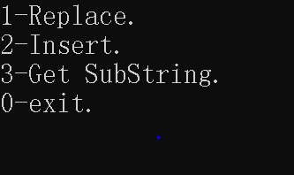

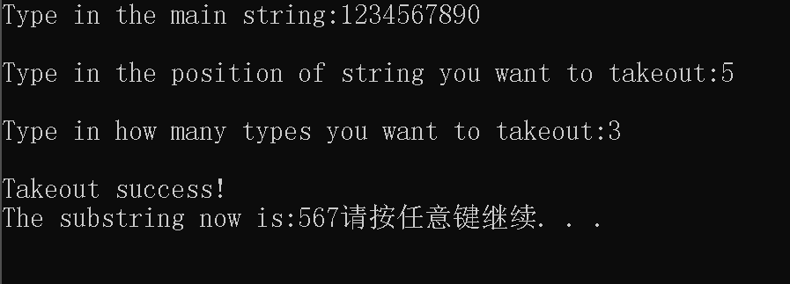

成绩 教师签名 周向华 日期

