1. https://server1.prod.lionfree.net:2083/

帳號: u1735752

密碼: jntweb2016

2.點擊file manager

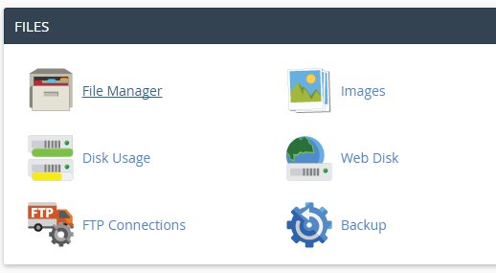

3.點擊public html

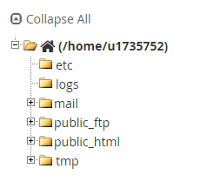

4.選擇要更改的頁面，按HTML Editor

