電通二乙微處理器實驗 實驗結報

實驗名稱 | 跑馬燈
組別 | 30 | 組員 | 許榮盛

- 實驗目的


- 實驗步驟
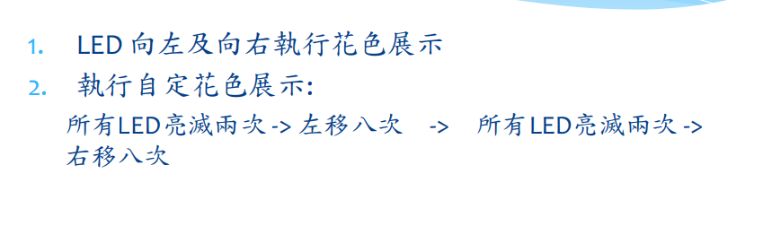

- 程式碼
Check point 1

const byte NUM=8;
const byte
led[]={4,5,8,9,10,11,12,13};
const int delaytime=50;
int ii;
void setup()
{
for (ii=0;ii<NUM;ii++)
{ pinMode(led[ii],OUTPUT);
digitalWrite(led[ii],LOW);
}
}

void loop()
/*左移*/
{
for(ii=0;ii<NUM;ii++)

{ digitalWrite(led[ii],HIGH);
delay(delaytime);
digitalWrite(led[ii],LOW);
}
for (ii=0;ii<NUM;ii++)
{
digitalWrite(led[ii],LOW);
}
delay(delaytime);

/*右移*/
for(ii=NUM-1;ii>=0;ii--)

{ digitalWrite(led[ii],HIGH);
delay(delaytime);
digitalWrite(led[ii],LOW);
}
for (ii=0;ii<NUM;ii++)
{
digitalWrite(led[ii],LOW);
}
delay(delaytime);
}

Check point 2
const byte total=8;
const byte
led[]={4,5,8,9,10,11,12,13};
int i;
void setup() {
for (i=0;i<total;i++)
{ pinMode(led[i],OUTPUT);

}
}

void loop()

{
for(byte j=0;j<=1;j++)
{digitalWrite(led[0],HIGH);
digitalWrite(led[1],HIGH);
digitalWrite(led[2],HIGH);
digitalWrite(led[3],HIGH);
digitalWrite(led[4],HIGH);
digitalWrite(led[5],HIGH);
digitalWrite(led[6],HIGH);
digitalWrite(led[7],HIGH);
delay(500);
digitalWrite(led[0],LOW);
digitalWrite(led[1],LOW);
digitalWrite(led[2],LOW);
digitalWrite(led[3],LOW);
digitalWrite(led[4],LOW);
digitalWrite(led[5],LOW);
digitalWrite(led[6],LOW);
digitalWrite(led[7],LOW);
delay(500);
}
for(i=0;i<total;i++)

{ digitalWrite(led[i],HIGH);
delay(100);
digitalWrite(led[i],LOW);
}
for (i=0;i<total;i++)
{
digitalWrite(led[i],LOW);
}
delay(100);

for(byte j=0;j<=1;j++)
{ digitalWrite(led[0],HIGH);
digitalWrite(led[1],HIGH);
digitalWrite(led[2],HIGH);
digitalWrite(led[3],HIGH);
digitalWrite(led[4],HIGH);
digitalWrite(led[5],HIGH);
digitalWrite(led[6],HIGH);
digitalWrite(led[7],HIGH);
delay(500);
digitalWrite(led[0],LOW);
digitalWrite(led[1],LOW);
digitalWrite(led[2],LOW);
digitalWrite(led[3],LOW);
digitalWrite(led[4],LOW);
digitalWrite(led[5],LOW);
digitalWrite(led[6],LOW);
digitalWrite(led[7],LOW);
delay(500);
}

for(i=total-1;i>=0;i--)

{ digitalWrite(led[i],HIGH);
delay(100);
digitalWrite(led[i],LOW);
}
for (i=0;i<total;i++)
{
digitalWrite(led[i],LOW);
}
delay(100);
}

- 實驗結果及分析
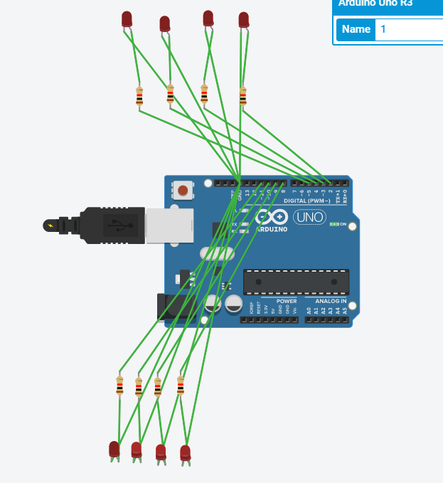

- 心得討論
這次的跑馬燈程式碼比較麻煩，最後還是花了很多時間完成，才發現有單芯線壞掉….希望下次能做順點

