**Game Playing, using Minimax Search**

**Indra Kumar Malav B15CS020 Mentor : Dr. Gaurav Harit**

**Ankit Kumar B15CS008**

**29 MARCH 2018**

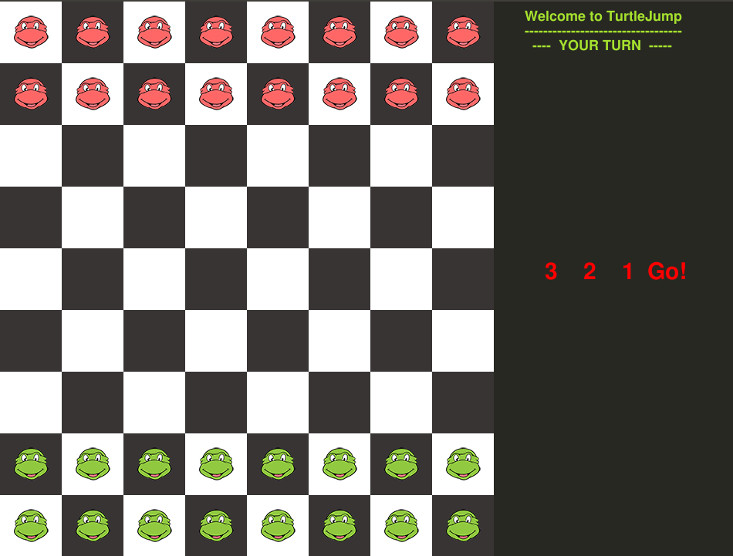

**GAMEPLAY**

To play the game one needs to run the python code “**TurtleJump.py**” along with the assisting files. The game can be played between a **human** and a **AI Bot** created by us.

Also there are certain difficulty levels “Easy , Moderate ,Hard”. The player can select using buttons(F1,F2,F3). The computer’s play will be based on techniques of artificial intelligence (**Minimax Algorithm and alpha-beta pruning**) making it difficult for the human play to win.

To make a move one needs to click on one of his turtle and then click on some valid position shown in the chekboard where it can move.If he selects a wrong tile then turtle won’t move and possible moves will be shown again for the previously selected turtle.

The pawn can move ‘left’,’right’,’up’,’down’ and he can move diagonally also provided the target location is empty.

Also if in any of the positions if the neighbour place is occupied by the pawn of opposite team and also the next neighbour in the same direction is empty, then occupy the next neighbour. In this case the neighbour pawn of opposite team changes its identity and joins the other team.

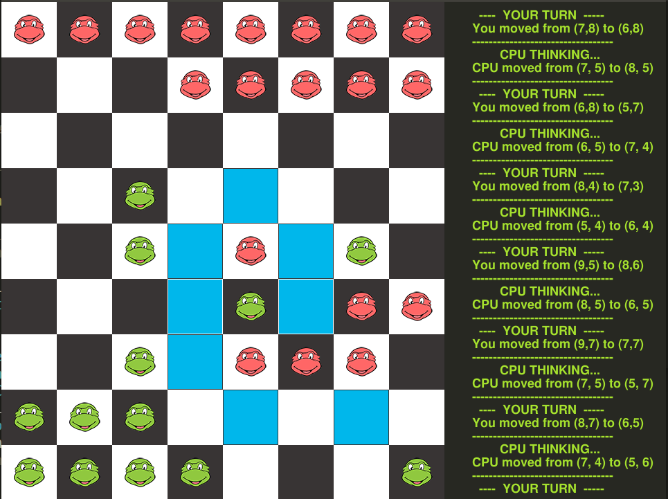

**HEURISTIC CHOICE**

For Easy Level : The computer searches for all the possible moves on its turn. However since the depth of this search can be huge, we need to cut stop this search at a certain depth D and estimate the advantage of the particular path followed on the search. In other words we need to evaluate a heuristic function at the state at which the search cut stops.

The heuristic function we have used is to simply calculate the total number of alive pawns and assign 1 point to each alive pawn.

For Moderate and Difficult Level :

Following will contribute to heuristic :

* Number of Pieces of our Team(One value for each piece) Game is won when all the pieces belong to the player, so more pieces means he is close to win state. Also, if he has more pieces the probability is less that he will be left with no moves. Furthermore, more pieces increase the player's ability to capture other player's pieces.
* For each piece of other player, A value is contributed to the heuristic. If the piece is captured by one piece then it will contribute 0.60 in heuristic, if it is captured from two or more sides then it will contribute 0.80 to the heuristic as there will be very less probability of escape.

**ALGORITHMS USED**

The computer uses minimax algorithm while searching for a suitable move.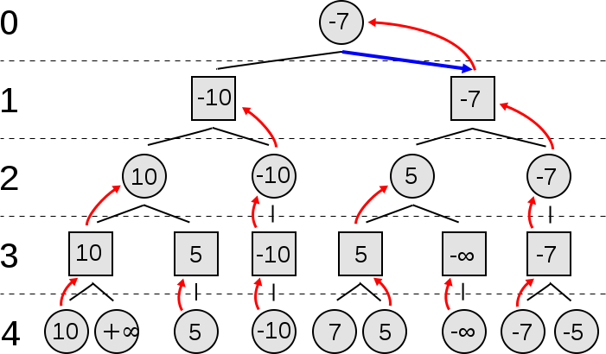

MINIMAX ALGORITHM DIAGRAM

Since the search being done is extensive, we can cut some of the branches which would anyways not make an effect on the final solution. Thus the computer uses alpha beta pruning to achieve this.

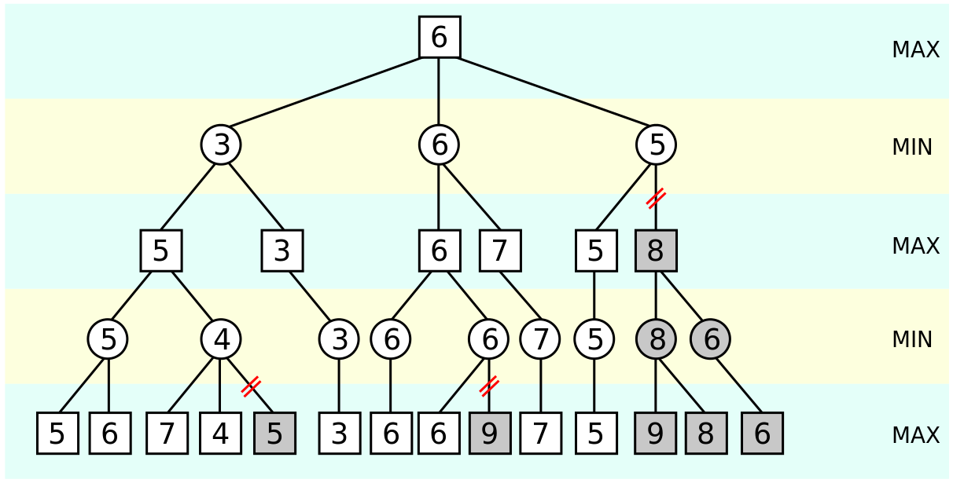

ALPHA-BETA PRUNING

**WIN AND LOSS STATISTICS**

After a total of 10 games of human vs Computer FOR EASY level it was recorded that 4 out of 10 games were won by the computer bot.

And for Moderate level 8 out of 10 games were won/draw by the computer bot.

And for Difficult 10 out of 10 game were won/draw by computer bot.

The extensive search done by the bot using the depth makes it difficult for the human to overcome the moves of bot .

The only strategy that worked out was to somehow move the entire regiment of pawns towards the bot players.