Strayer University

**Lab Assignment 3**

Week 3

for the

Course of

Web Design and Development

07/23/18

By

Kennedy Kabaso.

Professor: Rahat Zafar Ali

**Lab Assignment 3**

1. Create a storyboard for a four (4) page Website (one (1) home page and three (3) sub pages) and one (1) Cascading Style Sheet (.css). Using Microsoft Word, Microsoft Visio, or Dia, create a diagram of the layout and navigation structure.

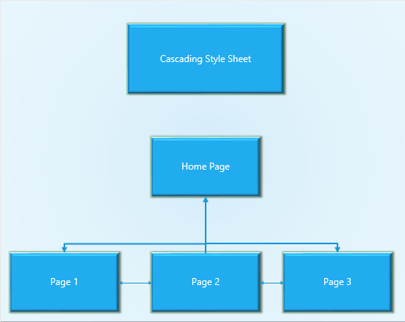

1. Explain the effects that the Cascading Style Sheet (.css) will have on the Web page. There must be a minimum of two (2) changes. Be sure to include detail. (Example: The Cascading Style Sheet (.css) will make the background color grey and change all H1 font to blue.)

CSS is a language for specifying how documents are presented to users, how they are styled and laid out. A document is usually a text file structured using a markup language. To presenting a document to a user means converting it into a usable form for your audience.

Web browsers apply CSS rules to a document to affect how they are displayed. A CSS rule is formed from a set of [properties](https://developer.mozilla.org/en-US/docs/Glossary/property/CSS), which have values set to update how the HTML content is displayed, for example I want my element's width to be 50% of its parent element, and its background to be red.

In addition, a [selector](https://developer.mozilla.org/en-US/docs/Glossary/CSS_Selector), which selects the element(s) you want to apply the updated property values to is used in this example, If I want to apply my CSS rule to all the paragraphs in my HTML document. A set of CSS rules contained within a stylesheet determines how a webpage should look is shown below.

h1 { color: blue; background-color: yellow; border: 1px solid black;} p {color: red;} The h1 selector will apply its property values to the [<h1>](https://developer.mozilla.org/en-US/docs/Web/HTML/Element/h1) element. Which contains three properties and their values. The first one sets the text color to blue. The second sets the background color to yellow and finally the last one puts a border around the header that is 1 pixel wide, solid and colored black.

1. Describe what the home page will look like. (Will it have text? Will it have headings? Will it have an image? Etc.)

The home page will have some navigation menu which will link to other pages. It will have a heading which is very important to the visitor about the site It will also have some images and some texts about the website.

1. Describe what the first, second, and third pages will look like. (Will they have text? Will they have headings? Will they have images? Etc.)

The second pages will have the text about the specific of the site. It will have text and an image of the person who is the founder of the organization. The layout will be the same of all the pages with the navigation menu, the header and the foot us.

The third page will have some addition information which the full information of the page of the link on the first page are. It will give the visitor more information which was not viewed in the first page.

The fourth page will have the same interface but different content which will be mostly the contact information. And a form to capture the information of the visitor which will be stored somewhere in the file on the saver.