Strayer University

**DATABASE AND PROGRAMMING DESIGN**

Week 6

**Database and Programming Design**

for the

Course of

Information Technology Capstone

11/12/18

By

Kennedy Kabaso.

Professor: Barrett Christopher

**Project**

page design document in

**Deliverable 3: Database and Programming Design**

**Section 1: Design Document**

**a. Create a database schema that supports the company’s business and processes.**

As the continue of the online ecommerce book, it is going to have a relational database which is suitable for the business environment. The data from the database is going to be transferred in to the information which is needed for the business. The database schema is going to have the Customers, Products, Suppliers, Shippers, Payment, Order, Employee, and Skills tables. The scheme is going to define all the attributes of the table and the relation which make them related to one another.

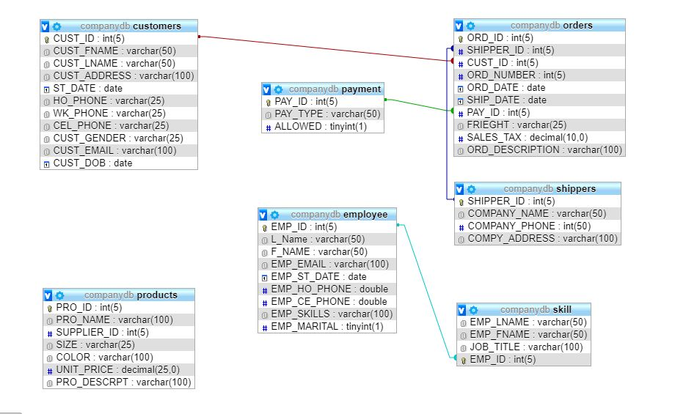

**b. Explain and support the database schema with relevant arguments that support the rationale for the structure.**

**Note:** The minimum requirement for the schema should entail the tables, fields, relationships, views, and indexes.

The schema for our company is going to have the Customers table which holds customer information like address, shipping address, billing address, Products table which holds product information like product name, description, size, color, unit price, we are selling, Our Suppliers information, Our Shippers , Payment ,Order table which holds information on when an order was placed including Customer ID, date of order, order shipping date, Employee which holds information of all our employees., Employee Skill which holds information of all our skilled employees and Skills tables which holds information of all the skilled in the company. In all these tables, they will be a unique identification field which is the primary key and will be linked by a foreign key which is the primary in one table. The Employee tables will have the following field, ID, company, last name, first name, email, job title, business, home, and mobile phone numbers, and address. The Inventory tables will have the following field, ID, item, and description, locations, supplier, manufacturer, model, reorder level, and stock level. The Inventory transactions will have the following field, the transaction item, employee, transaction type, quantity, date, purchase order, and comments. The Suppliers table will have the following field, the company, las name, first name, email, title, contact information, address information, website, and lastly, the Transaction types will include ID, description, and add/remove.

**c. Create database tables with appropriate field-naming conventions**.

The whole project will be well created with the best databases which is visually drown and is well represented. The following is the tables with appropriate field-naming conventions. They are uniquely identified by the primary keys which is the ID on each table identify primary keys and foreign keys which I have mentioned above. The integrity will be achieved by.

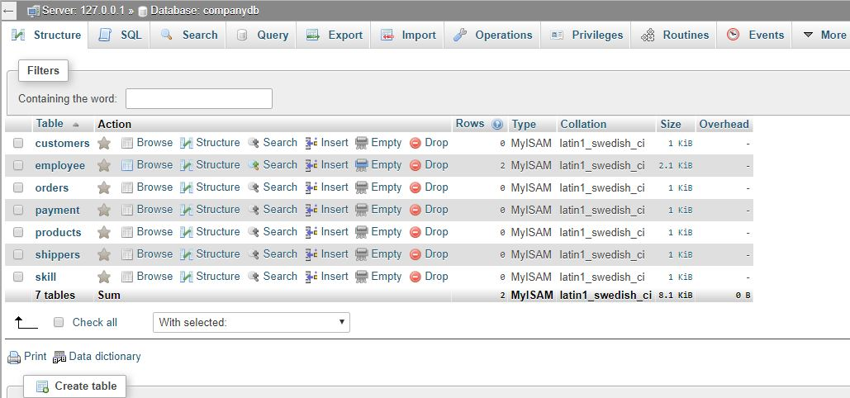

**d. Normalize the database tables to third normal form (3NF)**.

What is Normalization? It is the process of bringing or returning something to a normal condition. In a database system, it is the process of reorganizing data in a database so that it meets two basic requirements which are no data redundancy and logical data dependence. No data redundancy means there would be no data which is going to be stored in more than one place. While data dependencies are logical can mean all data with related items are stored together. It can be done by organizing the attributes and relations of a relational database so that the integrity of data is achieved. Normalization can also simplify the process of designing the database which achieves the optimal structure composition of an atomic elements.

The process can be in three forms which are the first, second and third form. The First normal form has the following criteria, eliminate repeating groups in individual tables, create a separate table for each set of related data and Identify each set of related data with a primary key. The above-mentioned criteria make the table to be in the first form (1NF). The next form is the second form which is characterized by a table which is in first form and it does not have partial dependencies. And the last one which is a third form is which is characterized by a table that is in second normal form and it doesn’t have transitive dependencies. And this form is the one which is the normal form. It is used to normalize a database design which result in the reduction of the duplicate of data and ensure referential integrity

Moreover, the third normal form has an improvement in the database processing which result in a saving of storage costs.

**e. Create an Entity-Relationship (E-R) Diagram** through the use of graphical tools in Microsoft Visio or an open source alternative such as Dia. **Note:** The graphically depicted solution is not included in the required page length but must be included in the design document appendix.

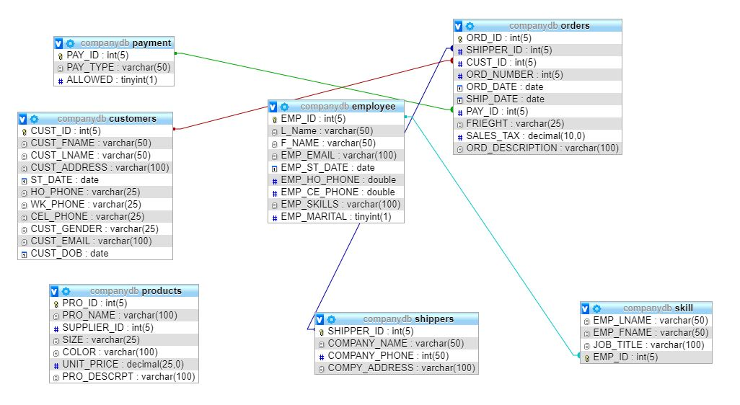

**f. Explain your rationale behind the design of your E-R Diagram**.

Before explanting everything in a diagram, I would like to define what an E-R diagram is. It is a type of flowchart which shows how “entities” such as people, objects or concepts relate to each other within a system. There are used to design or debug relational databases in the fields of software engineering, business information systems, education and research. In our company database, some entitles such as the Customer ID, employee ID and other are found in two tables. This make them to have a relationship as you can see in the above diagram. One primary key from one table, which is the unique identify for that table if found in the other table because the foreign key in the other table. These can be shown by the relation line which link them which is shown above.

**g. Create a Data Flow Diagram (DFD)**

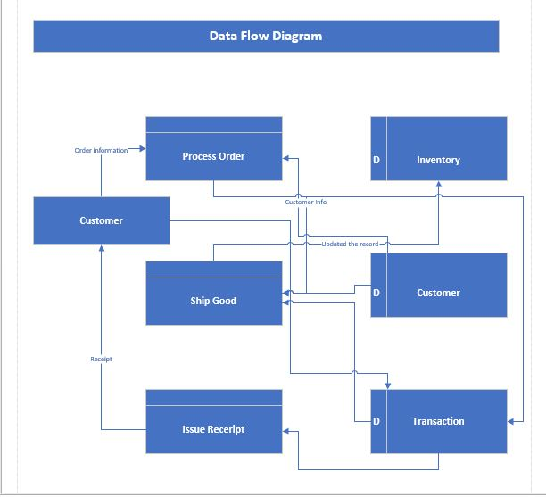

**h. Explain your rationale behind the design of your DFD.**

The following is the Data Flow Diagram for our company project which make it easy to see how data flow in an organization. It shows how the process of ordering the book on our company site work. It simplifies everything from ordering the book online which is ordered by selecting the books, the inventory will be reduced from the system from the item purchased by processing that order. Then the transaction will happen by, then the shipping process will be placed after the receipt is printed out. All the new record will be recorded of the above-mentioned transaction.

**i. Create at least two (2) sample queries that will support the organizational reporting needs.**

The following are the result obtained from the company database and the

records were obtained from the employee table.

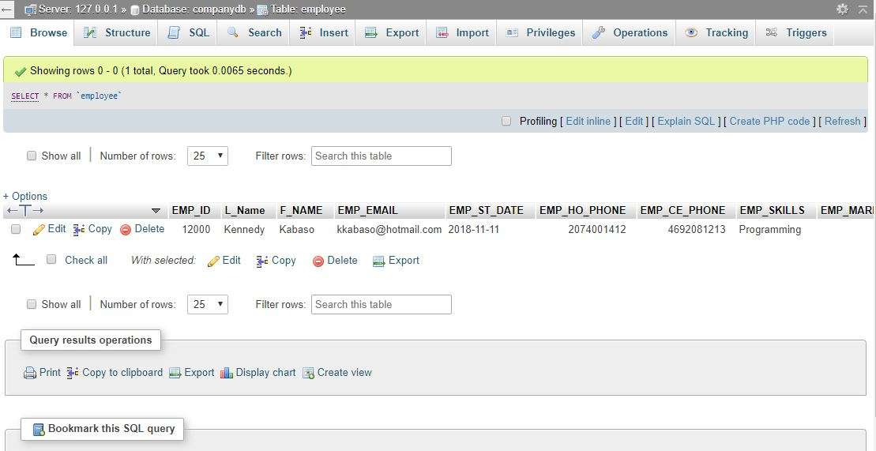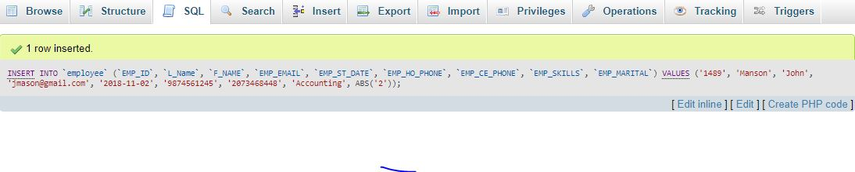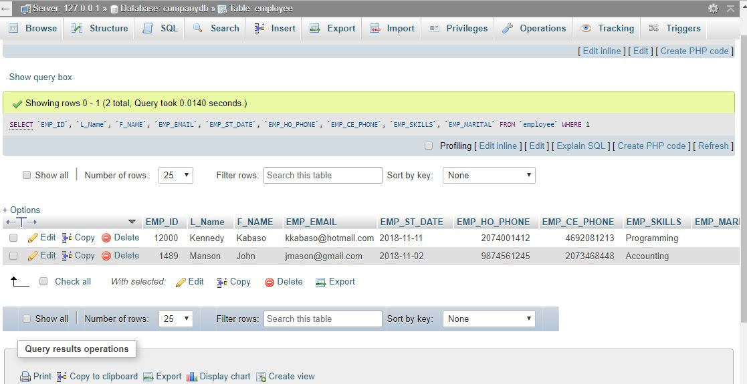

**j. Create at least two (2) screen layouts that illustrate the interface that organizational users will utilize.**

The following figure is a graphical user interface of a customer going through the

process of buying the product on our website. He browses our website, select his

products, checkout after doing the purchase and he print his receipt.

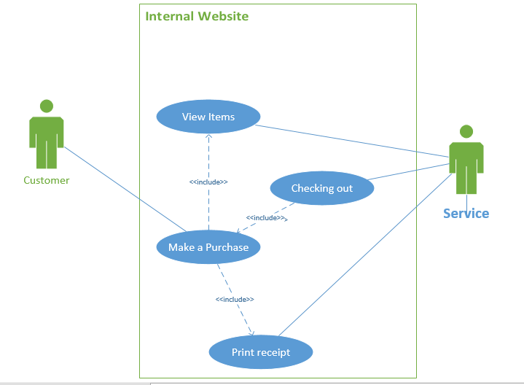

**User Interface one**

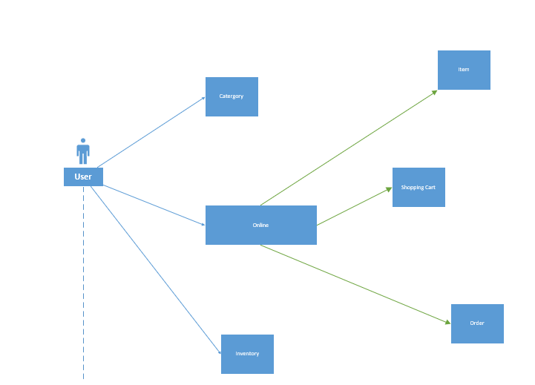

**User Interface Two**

**Bibliography.**

1. (Kerzner i) Kerzner, Harold R. *Project Management - Best Practices: Achieving Global Excellence, 3rd Edition*. John Wiley & Sons P&T, 01/2014.
2. Roberts, D. (2013). *Unleashing the power of IT*. (2nd ed.). Hoboken, NJ: John Wiley & Sons, Inc.
3. http://www.ambysoft.com/unifiedprocess/aup11/html/inception.html<http://support.sas.com/resources/papers/proceedings17/SAS0436-2017.pdf>
4. <https://econsultancy.com/reports/building-an-ecommerce-team/>
5. <https://en.wikipedia.org/wiki/Database_normalization>
6. <https://www.tutorialcup.com/dbms/normalization.htm>
7. https://strayer.vitalsource.com/#/books/9781305886841/cfi/226!/4/4@0.00:0.00
8. They vary in terms of specific project requirements, but these tools are the essentials of cloud project management software, which is widely understood as a necessity for boosting the following performance factors for many companies, like yours:
9. Saving time and money during project planning and execution is akin to eating when you are hungry; it’s something you plainly need to do to grow and survive. If you are unfamiliar with how project controls are vital concerning the use of cloud-based project management software (PM software), fear not: we are here to help you wrap your head around it. According to the omniscient Project Management Body of Knowledge (PMBOK), project controls are defined as the following:
10. “Project controls are the data gathering, management and analytical processes used to predict, understand and constructively influence the time and cost outcomes of a project or program; through the communication of information in formats that assist effective management and decision making.”
11. But, what does that mean in simple terms beyond the vagueness of words like “management” and “analytical processes”? Thanks, PMBOK, we appreciate everything you do for us, but we need a little bit more clarification and maybe a couple examples…
12. To begin with a simple explanation (we will get into the details soon), project controls are the tools that help you save time and [stay on schedule during your project planning and execution](https://www.easyprojects.net/resource-planning-software/), cutting costs. They vary in terms of specific project requirements, but these tools are the essentials of cloud project management software, which is widely understood as a necessity for boosting the following performance factors for many companies, like yours: