Strayer University

**INFRASTRUCTURE AND SECURITY**

Week 8

**Infrastructure and Security**

for the

Course of

Information Technology Capstone

11/26/18

By

Kennedy Kabaso.

Professor: Barrett Christopher.

**Deliverable 4: Infrastructure and Security.**

**Section 1: Infrastructure Document**.

1. **Design a logical and physical topographical layout of the planned network**

through the use of graphical tools in Microsoft Word or Visio, or an open source alternative such as Dia. **Note:** The graphically depicted solution is not included in the required page length.

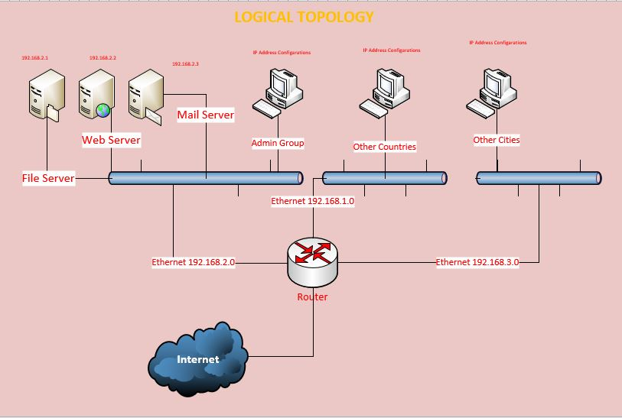

***A logical topographical figure 1***

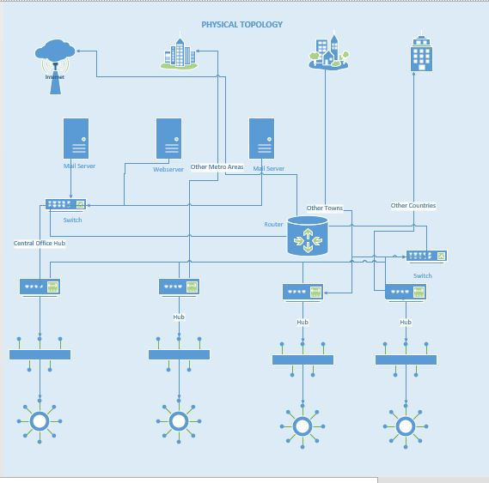

***A physical topographical figure 2***

1. **Illustrate the possible placement of servers including access paths to the Internet and firewalls**. **Note:** Facility limitations, workstations, printers, routers, switches, bridges and access points should be considered in the illustration.

The servers which are in this design are the Web Server which will host websites and delivers web content from the company websites over the internet. It will follow a network protocol known as hypertext transfer protocol (HTTP**)** which will handle web traffic, the Mail Server which is an application in a network whose purpose is to act as a post office. This server stores incoming mail for distribution to local employees and sends out outgoing messages. In addition, the server will handle the mails from our customers and employees all over the world. It will use a simple mail transfer protocol (SMTP), and finally, the File Server will be responsible for the central storage and management of data files so that other computers on our company network can access the files. It will allow employees to share information over a network of our company without having to physically transfer files by some other external storage devices. All these would be connected to the switch and a single cable would connect to the Router which will link to the internet. Moreover, a firewall be configured with strong restriction to order to handle the security of the network before connected these servers to the internet. This would make it difficult for some hankers to break into the network.

1. **Explain the rationale for the logical and physical topographical layout of the planned network.**

.

The logical topology is the term in networking that defines the architecture of the communication mechanism for all nodes in a network. It can be made by using network devices like routers and switches. It can be dynamically maintained and reconfigured to handle all device in a network.

In the planned network of our company, it is going to be almost the same or less depending on the size of the network. I have shown three serves which are important for the whole project which would be connected to one ethernet, then to a switch, then routed to the internet as shown. Other cities and countries have been simplified by the grouping of them into a single place as shown for demonstration purposes. The would be more devices and a lot of wiring on the actual network like switches which would reduce traffics on the network by filtering and more hub which would depend on the size of the network. Hubs would connect all network Local Area Network together which will be connected to the switches, then to the Routers as shown in the diagram.

To simplified what the Physical topology is, it is the interconnected structure of a local area network. The method employed to connect the physical devices on the network with the cables, and the type of cabling used, all makes the physical topology. The above diagram simplified the whole things of connection by showing the basic of the whole network. This topology will expand as more areas in other places and countries are built. It would be easy to expand from this physical topology as more room would be made available without using more resources.

All three servers are connected to a single switch which then is connected to the router. The router is configured with security measures to ensure all the data in our company are protected.

**d. Create a comprehensive security policy for the company that will:**

**i. Protect the company infrastructure and assets by applying the principals** of CIA. **Note:** CIA is a widely used benchmark for evaluation of information systems security, focusing on the three core goals of confidentiality, integrity and availability of information

In order to protect the company’s infrastructure and assets, the principals of CIA must be applied to our company. These are confidentiality, integrity and availability of information.

Data needs to be kept safe by protect the confidentiality, by preserve the integrity and by promote the availability of it for authorized use.

Confidentiality of it keep data private from any unauthorized user. Those authorized users should be given only enough privilege to perform their duties, and no more. Some other synonyms for confidentiality are privacy*,*secrecy*,* anddiscretion. Moreover, the Confidentiality of the data are intended to ensure that no unauthorized access to information is permitted and that accidental disclosure of sensitive information is not possible. The only way to get to those data is by using login user IDs and passwords.

Integrity of it keep data pure and trustworthy by protecting system data from intentional or accidental changes. This can be done by prevent unauthorized users from making modifications to data, prevent authorized users from making unauthorized modifications and maintain internal and external consistency of data.

Availability keep data and resources available for authorized use, especially during emergencies.

All the above mentioned can be achieved by granting access only to authorized personnel. In addition, applying encryption to information that will be sent over the Internet is going to be taken seriously because of the type of the business we are involved in.

To put the company on a continually pace, a software defensive method and a disaster recovery plan must be built to ensure that the business can continue to exist in the event of a disaster.

**ii. Address ethical aspects related to employee behavior, contractors, password usage, and access to networked resources and information**.

Using a computer is an important role in our company as we are an ecommerce company. Our IT employees must be trained to become aware of the impacts that computers, and the department in general, have on society. This includes maintaining proper ethical conduct, understanding legal issues, enforcing IT-related policies, maintaining data integrity and security, and identifying risks to data and employees.

Before I go any further, I would like to define what Ethics are. There are codes of moral conducts or sets of principles that govern behaviors. Therefore, it is an ethical for employees to use other people’s computer resources without authorization or proper compensation. Moreover, the company should respect the privacy of their customers and a consideration should be taken such as under what circumstances should a company use the data accumulated about its customers. Also, the employee should not use a computer to harm other people, not interfere with other people’s computer work, not snoop around in other people’s computer files, not use a computer to steal and finally, not to use it to bear false witness.

To keep the security culture within our company, security policies of our employee should be put in place. This can start by enforcing password usage, and access to networked resources and information by all our employees and contractors. Therefore, every employee ‘s password should be changed every three months, the same password can not be used for more than three time in a period of two years and remote connection should be assigned to the appropriate authorized users.

The network resources should be only assigned to the employee of our company and their security should be protected with network policy which would drop some package which do not match the company’s settings. To deal with the integrity of the data, the person who make any changes must leave a detailed report what was change and at what time. This will make it easy to keep every alteration of report documented, so it can be easy to resort the original data in case of accidentally alter of the record.

**Bibliography.**

1. (Kerzner i) Kerzner, Harold R. *Project Management - Best Practices: Achieving Global Excellence, 3rd Edition*. John Wiley & Sons P&T, 01/2014.
2. Roberts, D. (2013). *Unleashing the power of IT*. (2nd ed.). Hoboken, NJ: John Wiley & Sons, Inc.
3. http://www.ambysoft.com/unifiedprocess/aup11/html/inception.html<http://support.sas.com/resources/papers/proceedings17/SAS0436-2017.pdf>
4. <https://econsultancy.com/reports/building-an-ecommerce-team/>
5. https://searchnetworking.techtarget.com/answer/Why-is-it-useful-to-use-both-a-physical-and-a-logical-network-design