=== FINAL RESULTS ===
Best Fitness: 1604.964700
Best Solution: [-51.5995115995116, -11.746031746031747, 42.759462759462764, 1.3431013431013383, -6.422466422466428, -28.986568986568983, -14.578754578754584, -48.47374847374848, -8.034188034188034, 39.145299145299134, -62.637362637362635, 42.46642246642247, -68.05860805860806, -11.111111111111114, -99.46275946275946, -68.74236874236874, 23.12576312576313, -45.05494505494505, -51.5995115995116, -39.48717948717949]
Total Time: 21.95s

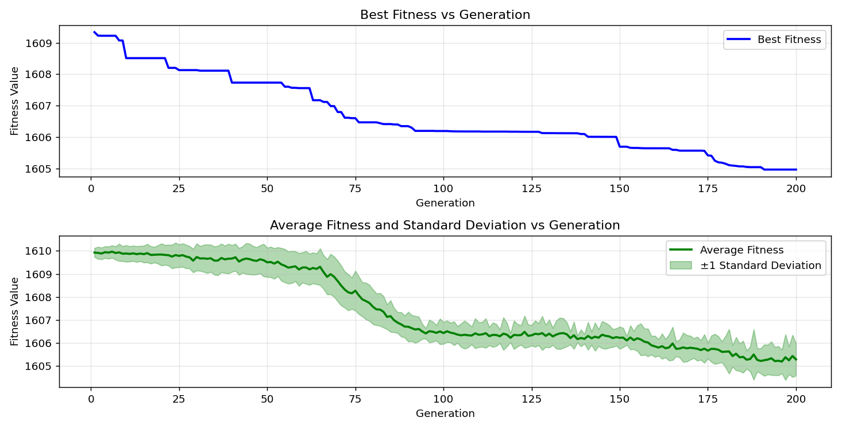
=== FINAL RESULTS ===
Best Fitness: 1606.069299
Best Solution: [-50.085470085470085, -7.789987789987791, 12.576312576312574, -9.694749694749689, 44.66422466422466, 18.1929181929182, -31.379731379731382, -70.35409035409035, 85.88522588522588, 29.81684981684981, 8.376068376068375, 48.913308913308924, -49.5970695970696, 90.96459096459097, 91.45299145299145, 10.671550671550676, 87.44810744810744, -92.86935286935287, -59.804639804639805, 27.13064713064712]
Total Time: 21.98s

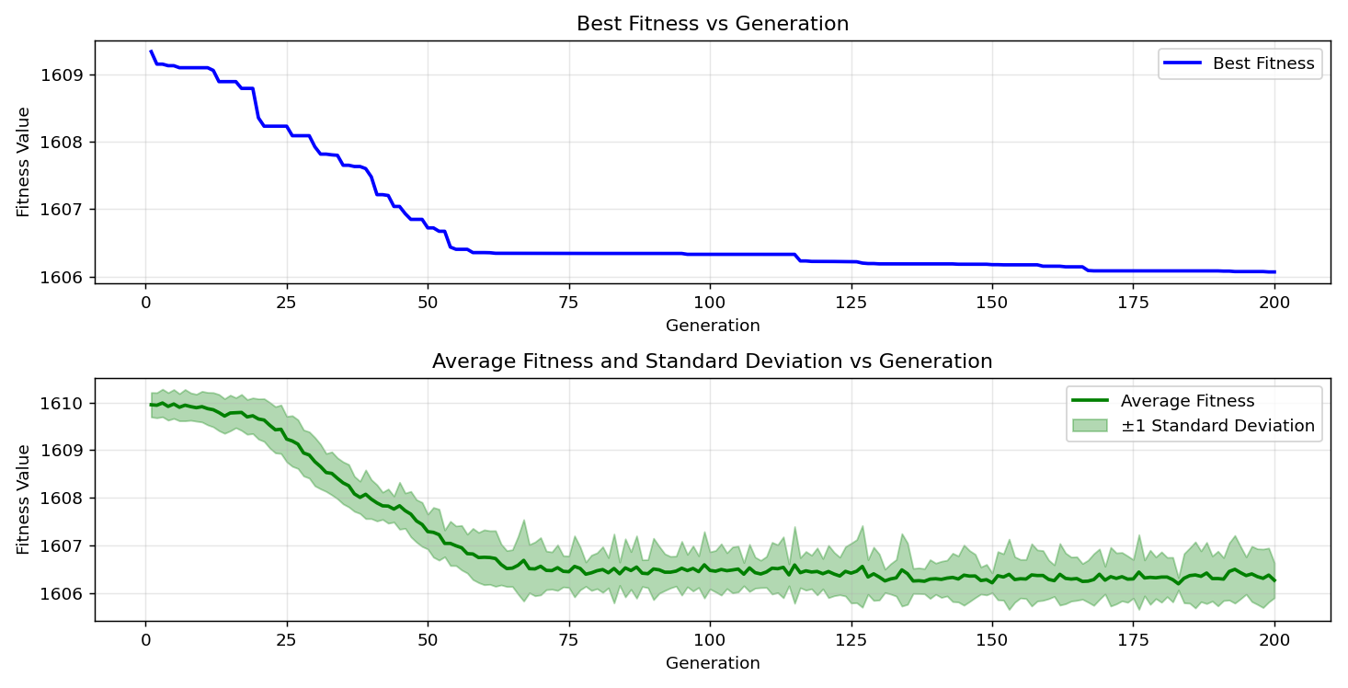
=== FINAL RESULTS ===
Best Fitness: 1605.968546
Best Solution: [-66.05616605616606, 4.126984126984141, -93.74847374847374, -9.059829059829056, 64.49328449328448, -94.77411477411478, -8.717948717948715, -89.01098901098901, -92.33211233211233, 33.9194139194139, 93.94383394383394, 51.501831501831504, -65.95848595848597, -100.0, -72.35653235653236, -34.358974358974365, 69.91452991452991, -37.24053724053724, -65.66544566544567, 47.59462759462761]
Total Time: 22.02s

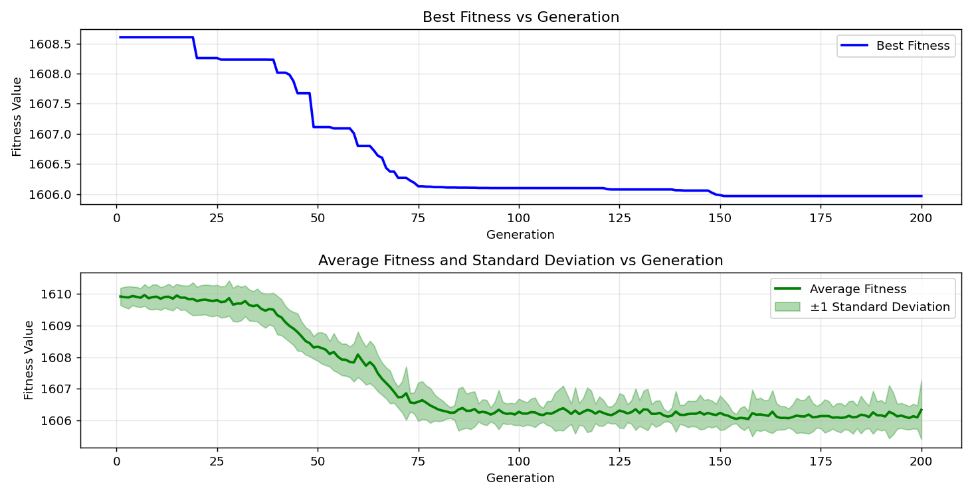

=== FINAL RESULTS ===
Best Fitness: 1605.902783
Best Solution: [-57.55799755799756, 50.62271062271063, -99.16971916971917, 16.923076923076934, -24.981684981684978, -84.02930402930403, -15.702075702075703, -66.00732600732601, -66.98412698412699, 24.639804639804638, -99.12087912087912, 24.981684981684978, -75.72649572649573, -43.443223443223445, -82.71062271062272, -50.03663003663004, -40.12210012210012, -6.373626373626379, -56.82539682539682, -46.227106227106226]
Total Time: 22.20s

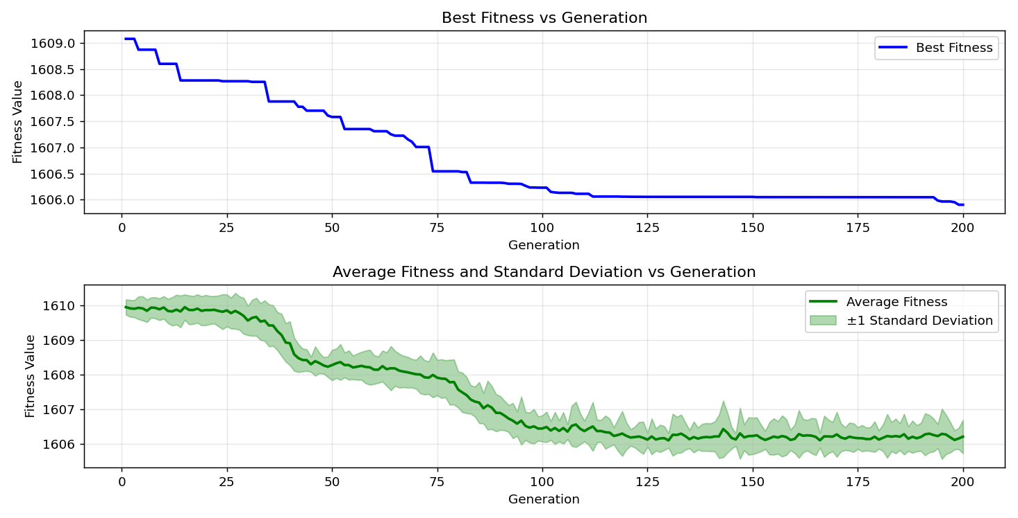
=== FINAL RESULTS ===
Best Fitness: 1604.809914
Best Solution: [-71.86813186813187, 53.35775335775338, -86.12942612942612, -5.25030525030526, -15.018315018315022, -0.024420024420024333, -17.606837606837615, -63.27228327228327, 18.339438339438345, 24.395604395604394, -28.00976800976801, 51.062271062271066, -65.66544566544567, -67.47252747252747, -82.07570207570208, -42.95482295482296, -93.6019536019536, -21.46520146520146, -67.66788766788767, 3.5897435897436054]
Total Time: 22.21s

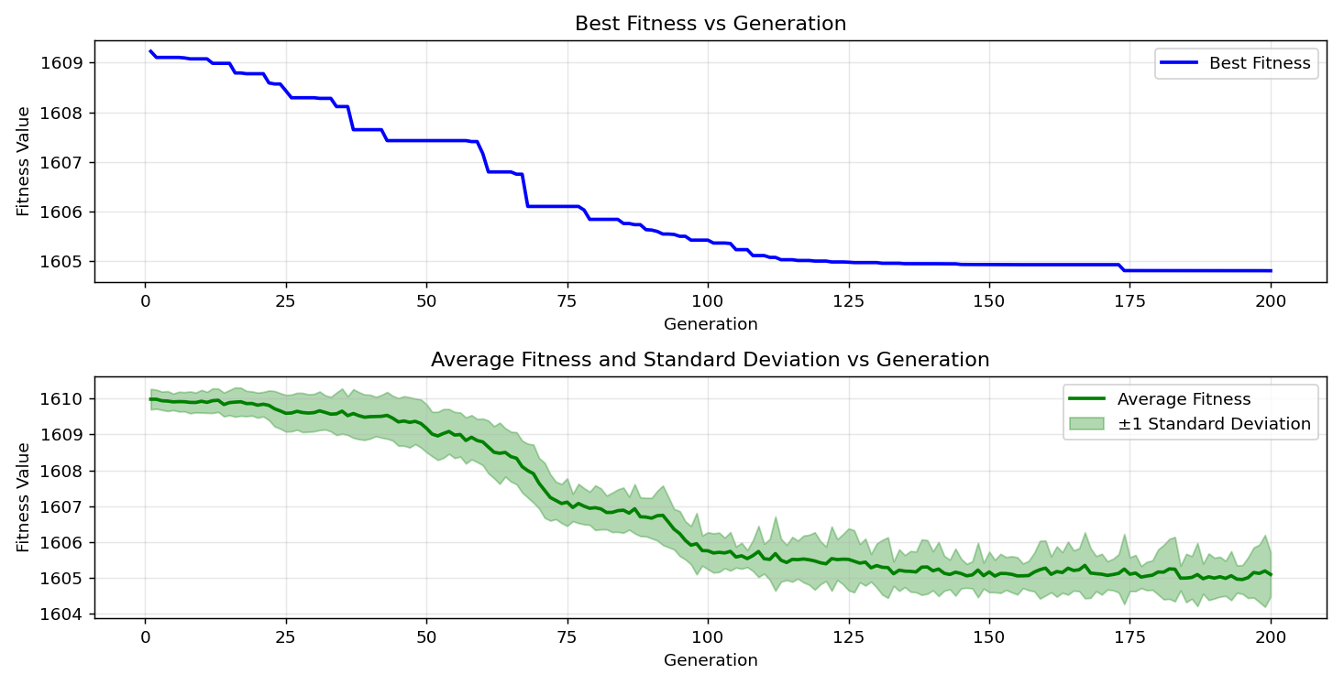
=== FINAL RESULTS ===
Best Fitness: 1605.627626
Best Solution: [-48.424908424908416, -25.372405372405368, -85.34798534798534, -14.432234432234438, 8.864468864468861, 28.69352869352869, 4.713064713064725, -69.86568986568986, -53.894993894993895, 34.065934065934044, -49.45054945054945, 34.94505494505495, -56.63003663003663, -71.72161172161172, -87.15506715506716, -50.18315018315018, 97.94871794871796, -33.235653235653245, -77.63125763125763, 30.59829059829059]
Total Time: 21.66s

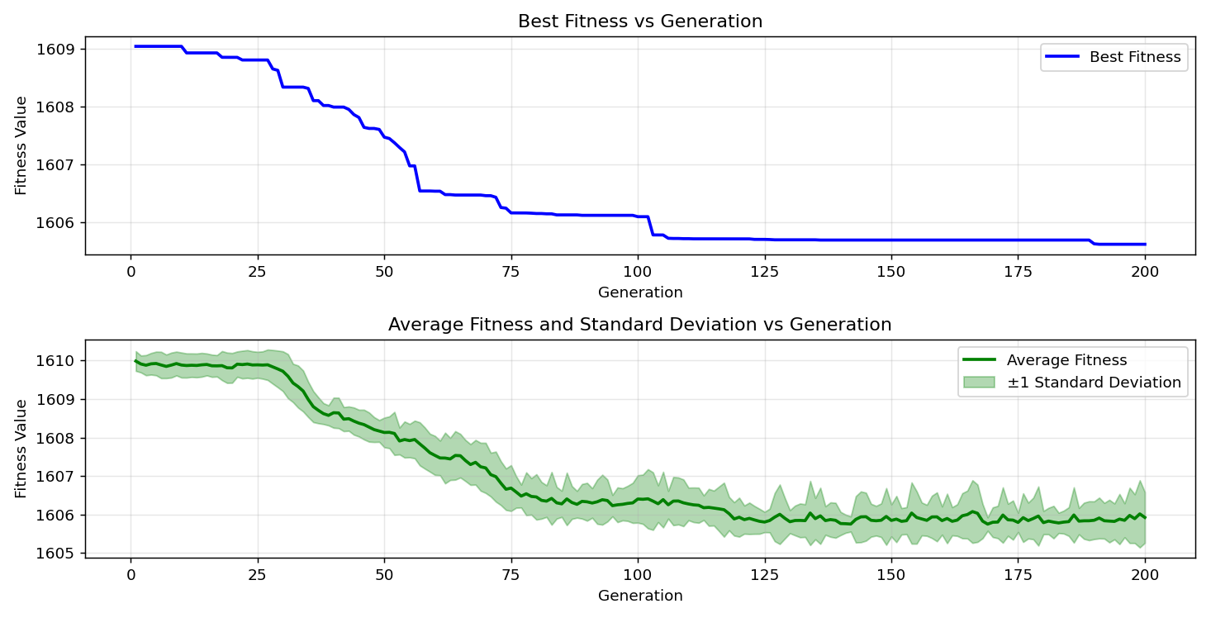

=== FINAL RESULTS ===
Best Fitness: 1605.720049
Best Solution: [-70.84249084249083, -28.156288156288156, 49.645909645909654, -13.45543345543345, -10.964590964590968, 3.9804639804639947, -14.920634920634924, -66.64224664224665, 32.64957264957263, 51.74603174603175, -23.516483516483518, 51.64835164835165, -69.96336996336996, 27.032967032967022, -76.65445665445665, -45.299145299145295, 92.57631257631257, -17.80219780219781, -74.60317460317461, -1.9291819291819365]
Total Time: 21.74s

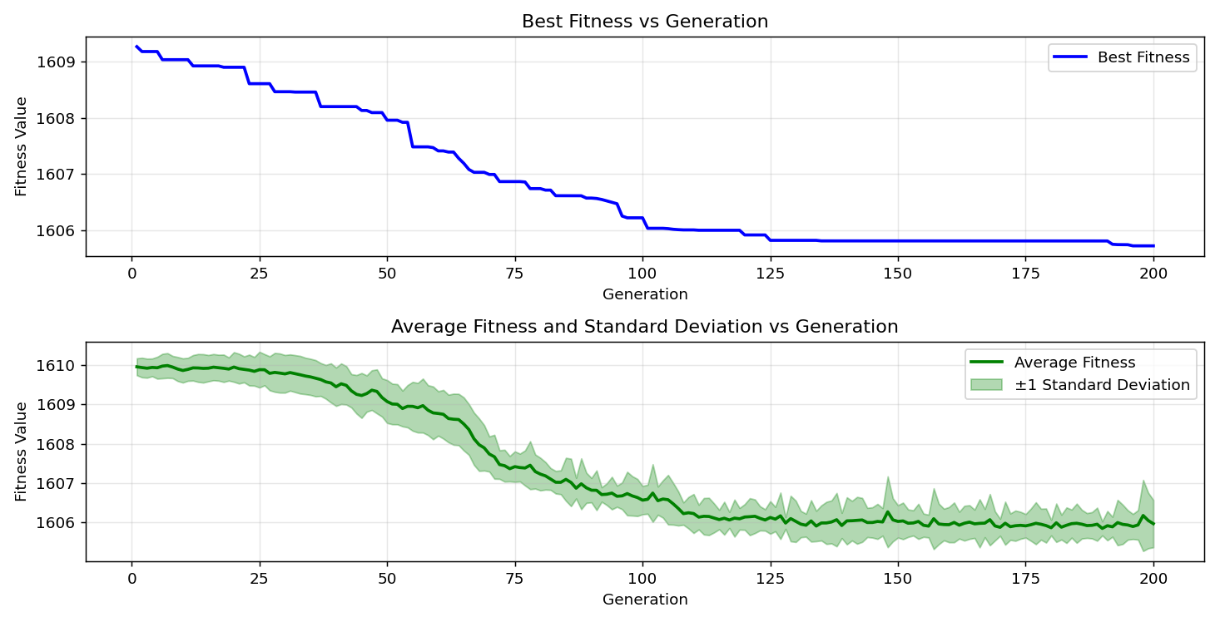

=== FINAL RESULTS ===
Best Fitness: 1605.608215
Best Solution: [-28.35164835164835, -14.578754578754584, -68.84004884004884, 1.098901098901095, -20.634920634920633, -0.805860805860803, -9.401709401709397, -62.588522588522586, 35.824175824175825, 31.477411477411465, -46.666666666666664, 43.63858363858364, -81.001221001221, 26.984126984126974, -82.85714285714286, -29.328449328449324, -64.73748473748473, 8.91330891330891, -47.008547008547005, -83.63858363858364]
Total Time: 21.44s

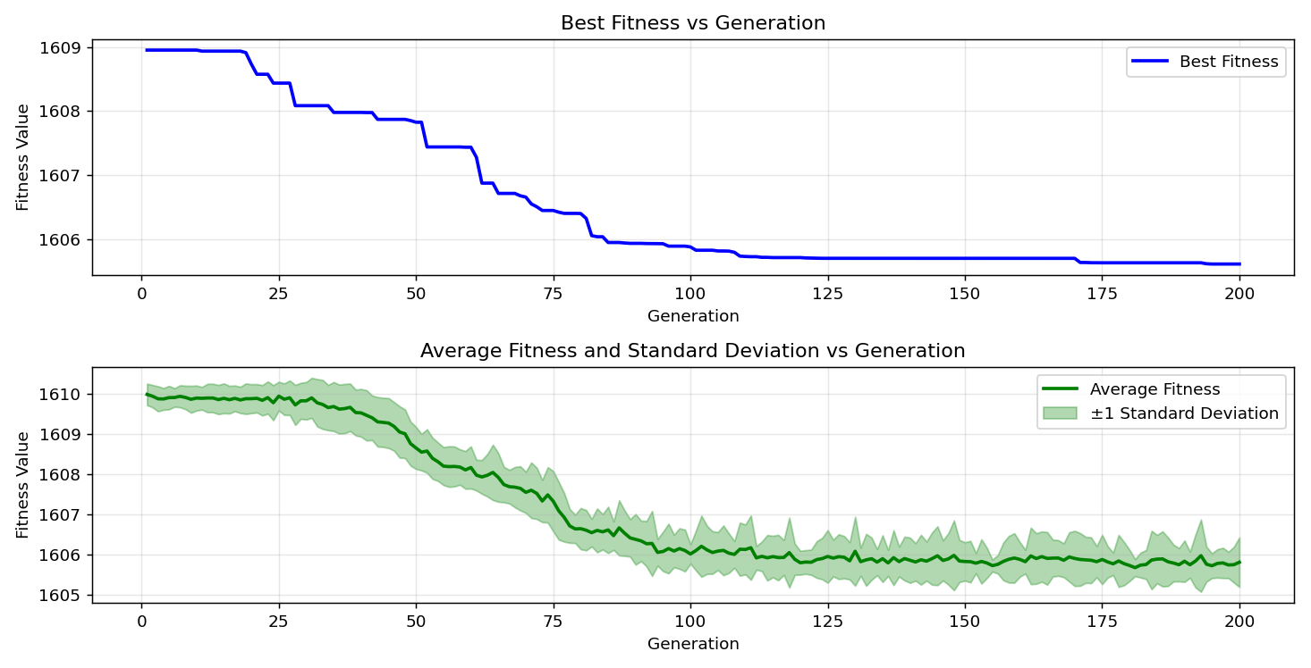
=== FINAL RESULTS ===
Best Fitness: 1605.362613
Best Solution: [-46.86202686202686, -33.72405372405373, -2.0757020757020825, 6.227106227106233, -63.956043956043956, 48.22954822954824, -22.14896214896214, -72.7960927960928, 0.512820512820511, 37.48473748473748, 3.2967032967033134, 39.92673992673991, -66.05616605616606, 2.9059829059828957, -71.86813186813187, -31.282051282051285, 23.565323565323567, 63.90720390720389, -56.63003663003663, 44.66422466422466]
Total Time: 21.76s

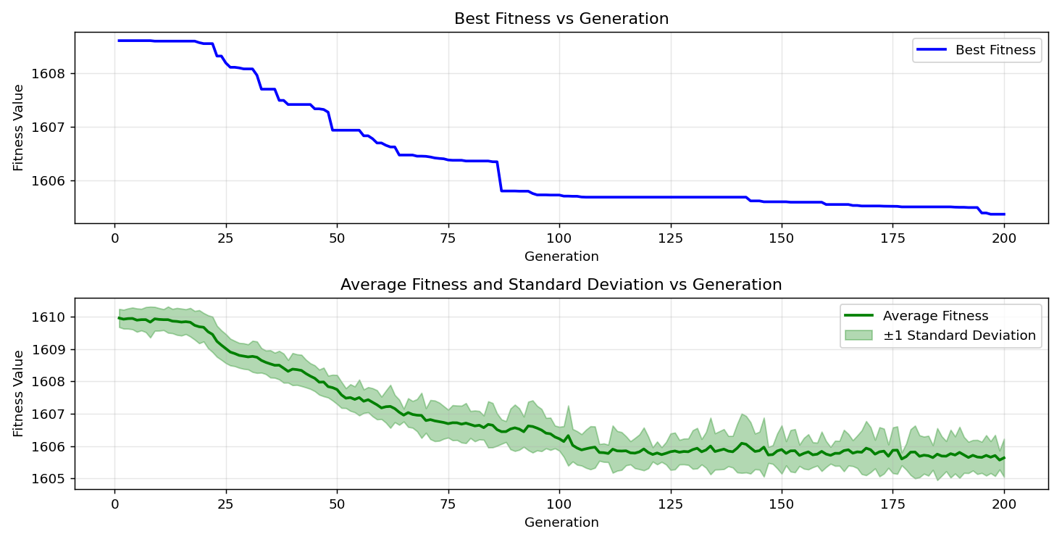

=== FINAL RESULTS ===
Best Fitness: 1605.514009
Best Solution: [-57.8021978021978, -42.85714285714286, -43.052503052503056, 33.57753357753356, 28.205128205128204, -78.5103785103785, 0.805860805860803, -46.86202686202686, -5.25030525030526, 18.1929181929182, -35.33577533577534, 45.73870573870573, -68.15628815628816, -1.4896214896214843, -81.29426129426129, -60.146520146520146, -76.55677655677655, -64.34676434676435, -49.4993894993895, 73.77289377289378]
Total Time: 21.56s

