=== FINAL RESULTS ===
Best Fitness: 1612.215464
Best Solution: [35.67765567765568, -53.6996336996337, -69.52380952380952, -5.689865689865698, -24.49328449328449, -6.227106227106233, -8.717948717948715, 85.59218559218559, -36.21489621489622, 54.62759462759465, 0.073260073260073, -1.0500610500610463, 52.67399267399267, -49.20634920634921, -70.2075702075702, -7.008547008547012, 2.9059829059828957, 3.492063492063508, -81.29426129426129, -97.8021978021978, 56.2881562881563, -57.411477411477414, 49.35286935286936, -33.968253968253975, -93.74847374847374, 93.3089133089133, -28.937728937728934, 44.61538461538461, 94.48107448107447, 10.769230769230774]
Total Time: 28.65s
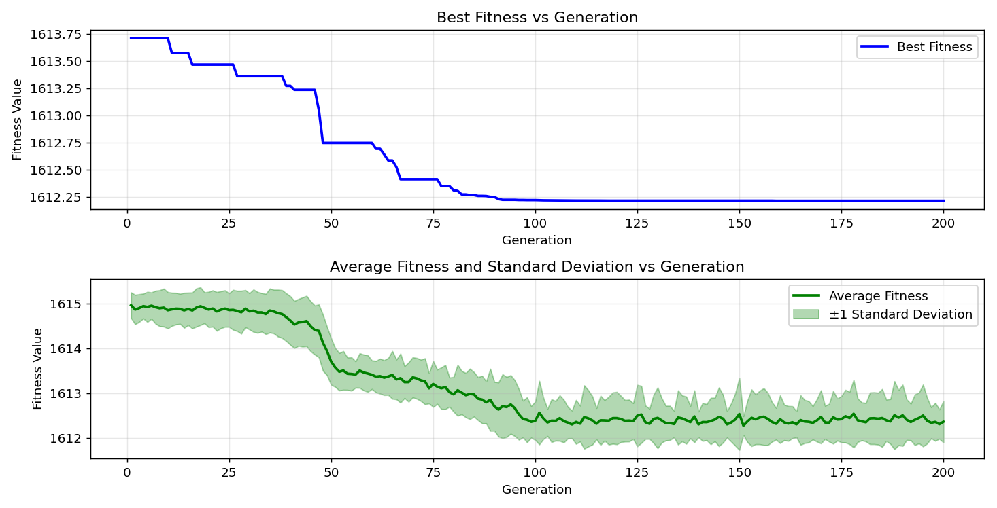
=== FINAL RESULTS ===
Best Fitness: 1611.450364
Best Solution: [15.506715506715494, 51.99023199023199, 61.46520146520146, -38.9010989010989, -40.07326007326007, -46.71550671550671, -46.17826617826618, -8.376068376068375, 0.31746031746031633, -22.686202686202677, 2.7594627594627497, -81.24542124542124, -76.45909645909646, -15.164835164835168, -20.39072039072039, 60.537240537240535, 5.98290598290599, -41.001221001221, -50.76923076923077, 95.99511599511598, -93.16239316239316, 71.72161172161171, 87.98534798534797, 2.564102564102555, -99.36507936507937, 33.8217338217338, -50.134310134310134, -52.57631257631258, 47.399267399267416, -11.111111111111114]
Total Time: 28.31s

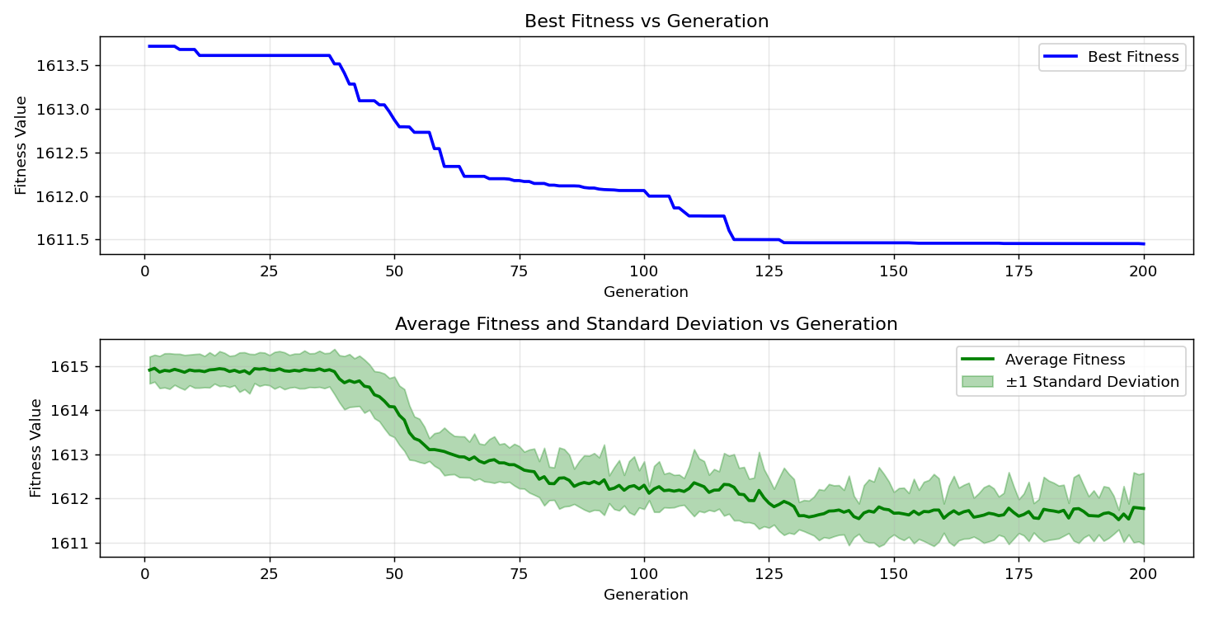

=== FINAL RESULTS ===
Best Fitness: 1611.617980
Best Solution: [-85.006105006105, -92.42979242979243, -62.53968253968254, 45.006105006105, 72.11233211233213, 61.17216117216117, 19.365079365079367, 4.761904761904773, -99.26739926739927, 4.273504273504287, -15.750915750915752, -43.052503052503056, -31.379731379731382, 61.9047619047619, 12.234432234432234, 61.12332112332112, -49.4993894993895, -95.26251526251527, -81.19658119658119, -0.805860805860803, 92.03907203907204, -53.11355311355312, -3.296703296703299, -52.57631257631258, -57.65567765567766, -8.424908424908423, -73.43101343101343, 81.09890109890111, 68.74236874236874, 83.93162393162393]
Total Time: 28.03s

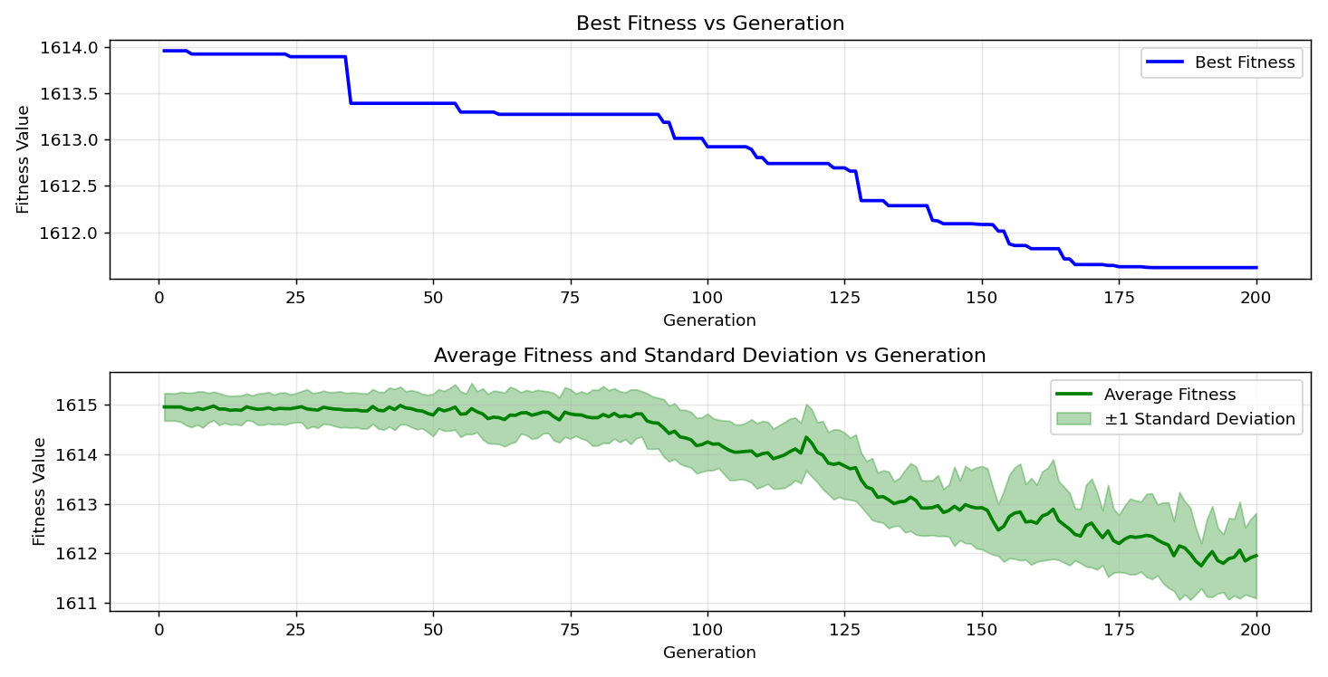

=== FINAL RESULTS ===
Best Fitness: 1612.498806
Best Solution: [72.25885225885227, 100.0, -20.34188034188034, 9.352869352869348, -58.82783882783883, 17.948717948717956, 63.076923076923066, -83.1990231990232, -98.58363858363859, -5.543345543345552, -63.80952380952381, -21.611721611721606, -15.84859584859585, -70.25641025641025, -78.21733821733821, -81.0989010989011, 99.95115995115995, -59.95115995115995, -79.78021978021978, 5.836385836385844, -100.0, 13.211233211233207, 6.324786324786331, -76.36141636141636, -7.692307692307693, -99.12087912087912, -29.08424908424908, -26.88644688644689, -7.643467643467645, 51.5995115995116]
Total Time: 28.40s

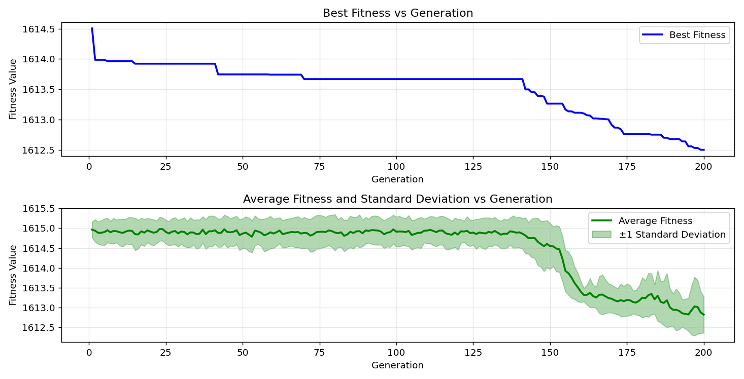

=== FINAL RESULTS ===
Best Fitness: 1612.126343
Best Solution: [-79.73137973137973, -27.521367521367523, -16.97191697191697, 53.601953601953625, 73.47985347985349, -8.083028083028083, -73.38217338217338, -74.60317460317461, -18.1929181929182, -72.94261294261294, -62.83272283272283, 28.937728937728934, -75.92185592185592, 27.326007326007314, -81.39194139194139, 62.97924297924297, 7.496947496947499, 39.19413919413918, 59.60927960927961, 18.339438339438345, -24.15140415140415, 5.885225885225893, 28.107448107448107, -81.14774114774114, 36.898656898656895, 6.959706959706963, -13.162393162393158, 81.44078144078145, -9.64590964590964, 51.30647130647131]
Total Time: 28.36s

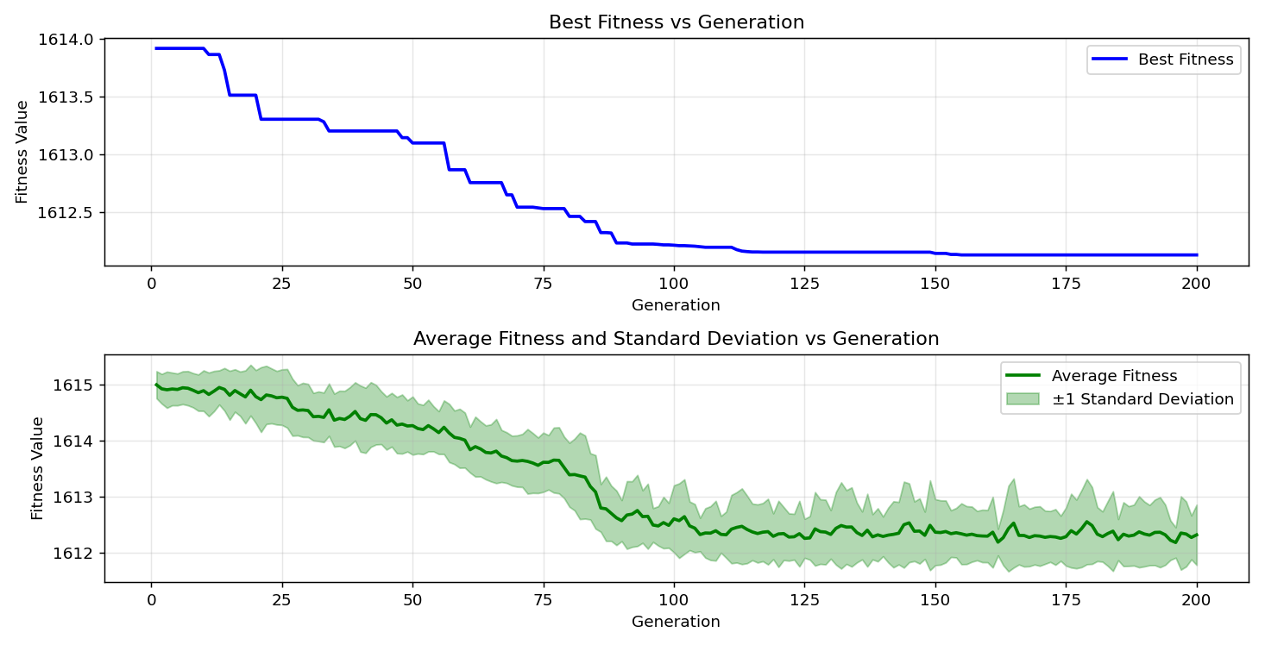
=== FINAL RESULTS ===
Best Fitness: 1611.540640
Best Solution: [-93.6996336996337, -48.37606837606837, 35.18925518925519, -56.87423687423687, 55.89743589743591, 85.2014652014652, -23.125763125763115, -100.0, 8.962148962148959, 100.0, -50.476190476190474, -81.24542124542124, -87.05738705738706, 81.3919413919414, -80.31746031746032, -79.68253968253968, 45.250305250305246, 40.219780219780205, 81.73382173382174, -4.664224664224662, -97.46031746031746, -16.483516483516482, 48.32722832722834, -13.45543345543345, 6.129426129426136, 17.313797313797323, 77.24053724053724, -16.434676434676433, 8.766788766788764, 30.98901098901098]
Total Time: 28.41s

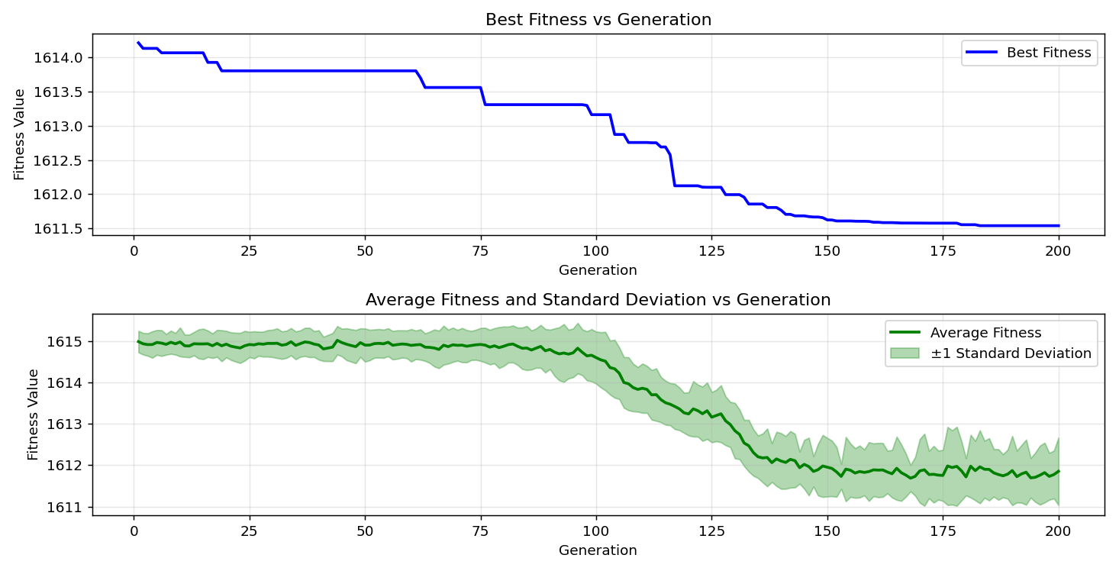

=== FINAL RESULTS ===
Best Fitness: 1611.602487
Best Solution: [-100.0, -88.81562881562881, -12.429792429792428, 20.439560439560438, 64.39560439560438, -97.85103785103784, 72.01465201465203, -96.67887667887668, -87.78998778998779, 32.84493284493283, -50.23199023199023, -1.4407814407814357, -24.053724053724054, -73.91941391941391, 76.8986568986569, 69.67032967032966, 36.75213675213675, 89.74358974358972, -26.88644688644689, -3.882783882783883, -90.62271062271063, -22.58852258852258, -1.538461538461533, 14.041514041514034, 98.77899877899878, 13.260073260073256, -96.82539682539682, -44.76190476190476, -60.73260073260073, -50.18315018315018]
Total Time: 28.21s

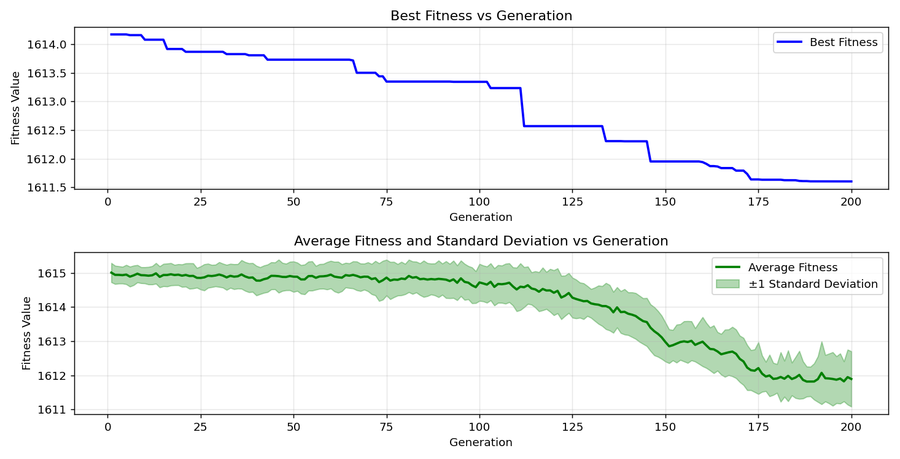

=== FINAL RESULTS ===
Best Fitness: 1612.327476
Best Solution: [-1.2942612942612897, 50.96459096459097, 59.95115995115995, -92.67399267399267, 29.963369963369956, 1.391941391941387, -3.1013431013431045, 28.05860805860806, 52.136752136752136, 89.10866910866909, -62.002442002442, -0.5616605616605597, 26.593406593406584, -1.6849816849816932, 34.26129426129424, 33.96825396825395, 74.993894993895, -56.97191697191697, -99.9023199023199, 86.7155067155067, -68.3028083028083, -0.26862026862026767, -64.34676434676435, 58.77899877899878, 60.537240537240535, 18.095238095238102, -6.275946275946282, 19.072039072039075, 35.92185592185592, 10.91575091575092]
Total Time: 28.24s

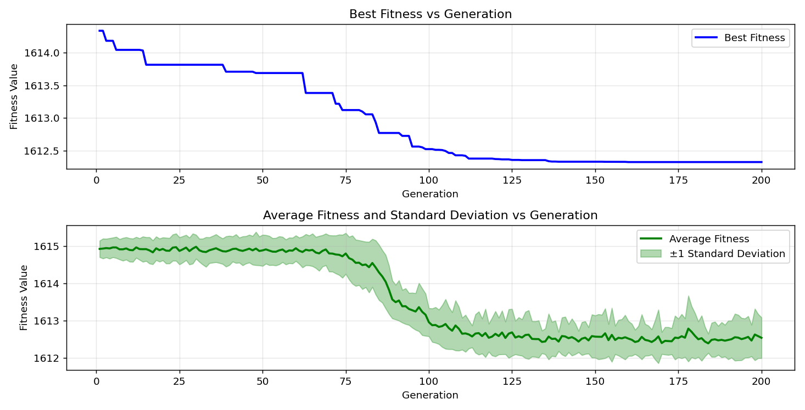

=== FINAL RESULTS ===
Best Fitness: 1612.368111
Best Solution: [-98.0952380952381, 100.0, -21.221001221001217, 74.65201465201466, -100.0, 13.308913308913304, 77.14285714285714, -88.66910866910867, -68.5958485958486, -10.72039072039071, 0.219780219780219, -24.49328449328449, -7.594627594627596, 57.16727716727718, -64.3956043956044, -87.3992673992674, -40.17094017094017, -44.81074481074481, -10.329670329670321, -52.67399267399268, 86.32478632478632, -81.05006105006105, -23.76068376068376, 64.83516483516482, -88.22954822954823, 100.0, 50.62271062271063, -100.0, 56.532356532356545, 20.195360195360195]
Total Time: 28.42s

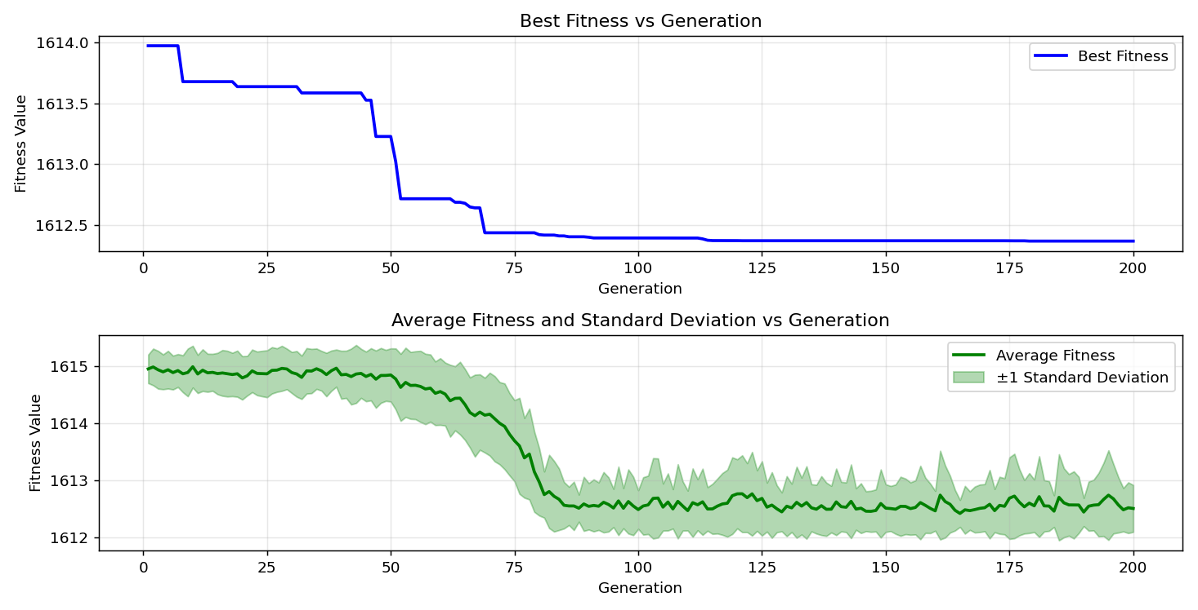

=== FINAL RESULTS ===
Best Fitness: 1611.879274
Best Solution: [21.611721611721606, -15.018315018315022, 20.04884004884005, 60.39072039072039, -56.14163614163614, -64.49328449328449, -99.46275946275946, 77.82661782661782, -84.17582417582418, 34.993894993895, -48.131868131868124, -56.28815628815629, -7.789987789987791, -99.41391941391942, -22.442002442002433, -2.710622710622715, -62.1978021978022, 49.84126984126985, 89.30402930402929, 70.25641025641025, 41.978021978021985, 71.47741147741147, -72.25885225885226, -45.44566544566545, 65.37240537240535, -48.57142857142858, 47.49694749694751, -65.66544566544567, -90.67155067155068, 29.914529914529908]
Total Time: 28.23s

