=== FINAL RESULTS ===
Best Fitness: -1.801296
Best Solution: [2.2025652967032965, 1.5711785885225884]
Total Time: 4.79s

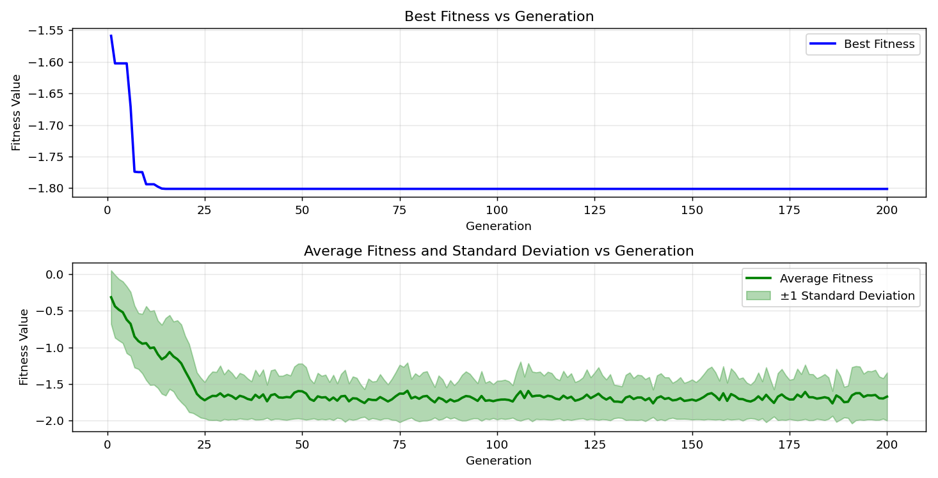
=== FINAL RESULTS ===
Best Fitness: -1.801296
Best Solution: [2.2025652967032965, 1.5711785885225884]
Total Time: 4.72s

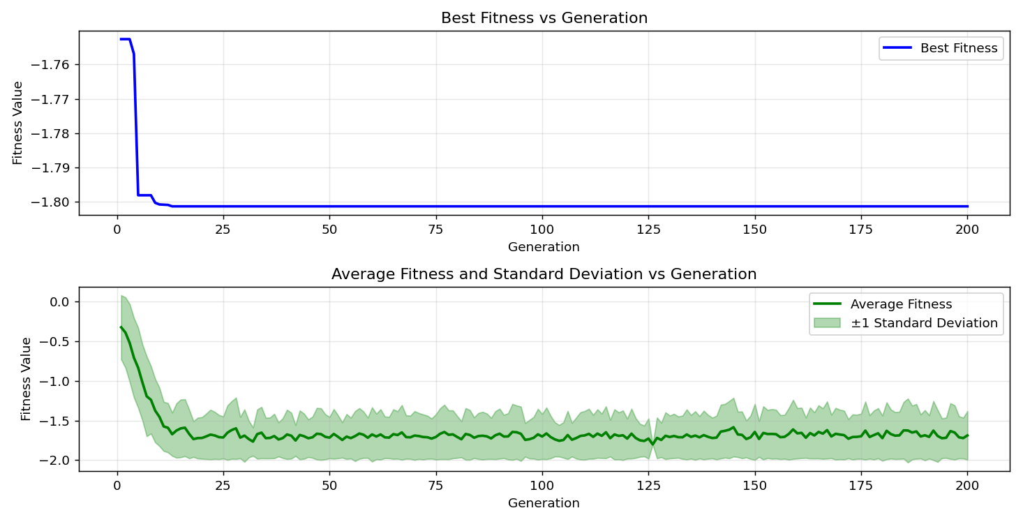

=== FINAL RESULTS ===
Best Fitness: -1.801295
Best Solution: [2.2033324737484734, 1.5711785885225884]
Total Time: 4.83s

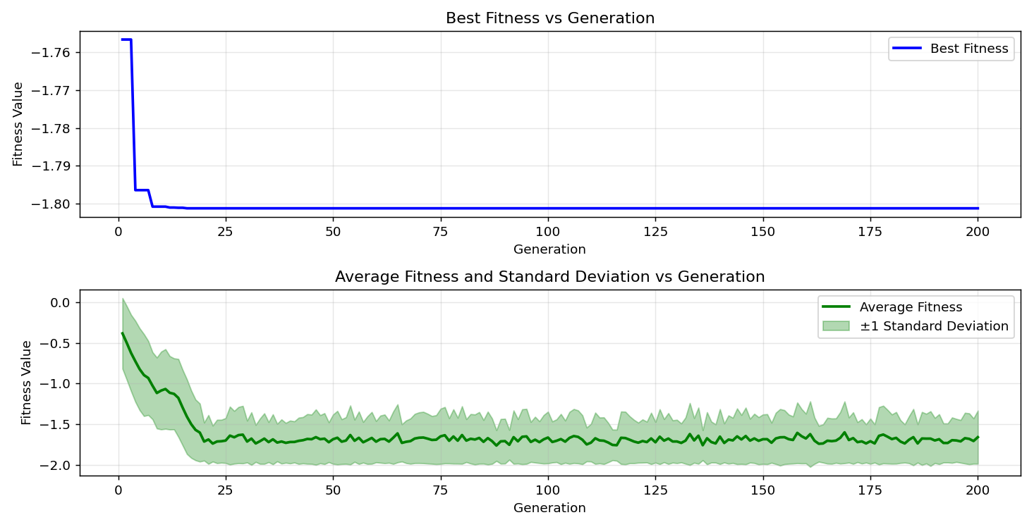
=== FINAL RESULTS ===
Best Fitness: -1.801296
Best Solution: [2.2025652967032965, 1.5711785885225884]
Total Time: 4.71s

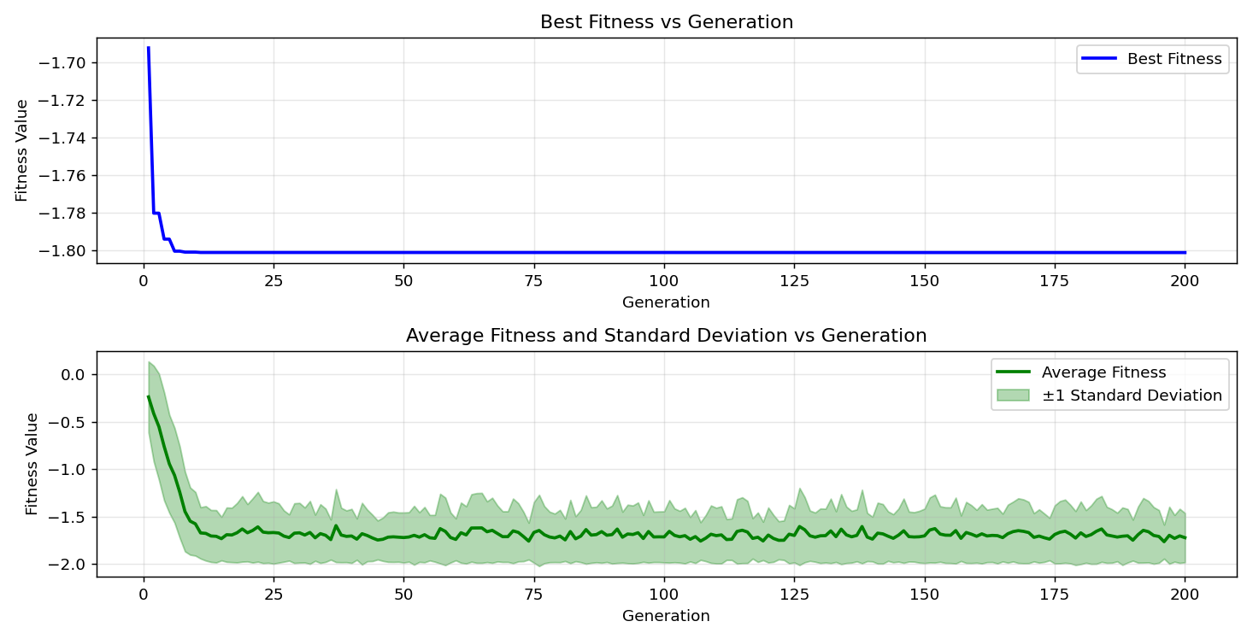

=== FINAL RESULTS ===
Best Fitness: -1.801296
Best Solution: [2.2025652967032965, 1.5711785885225884]
Total Time: 4.73s

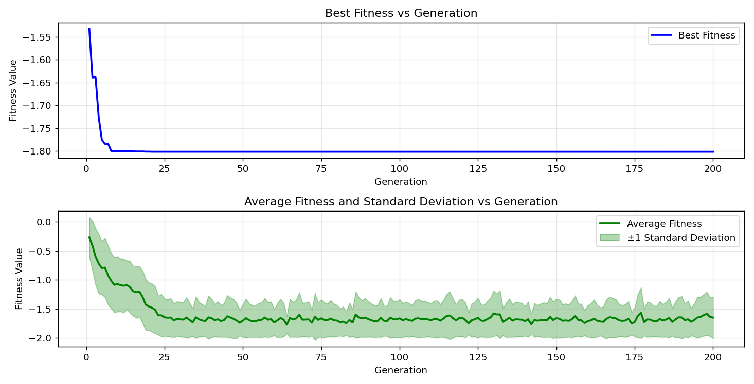
=== FINAL RESULTS ===
Best Fitness: -1.801295
Best Solution: [2.2033324737484734, 1.5711785885225884]
Total Time: 4.81s

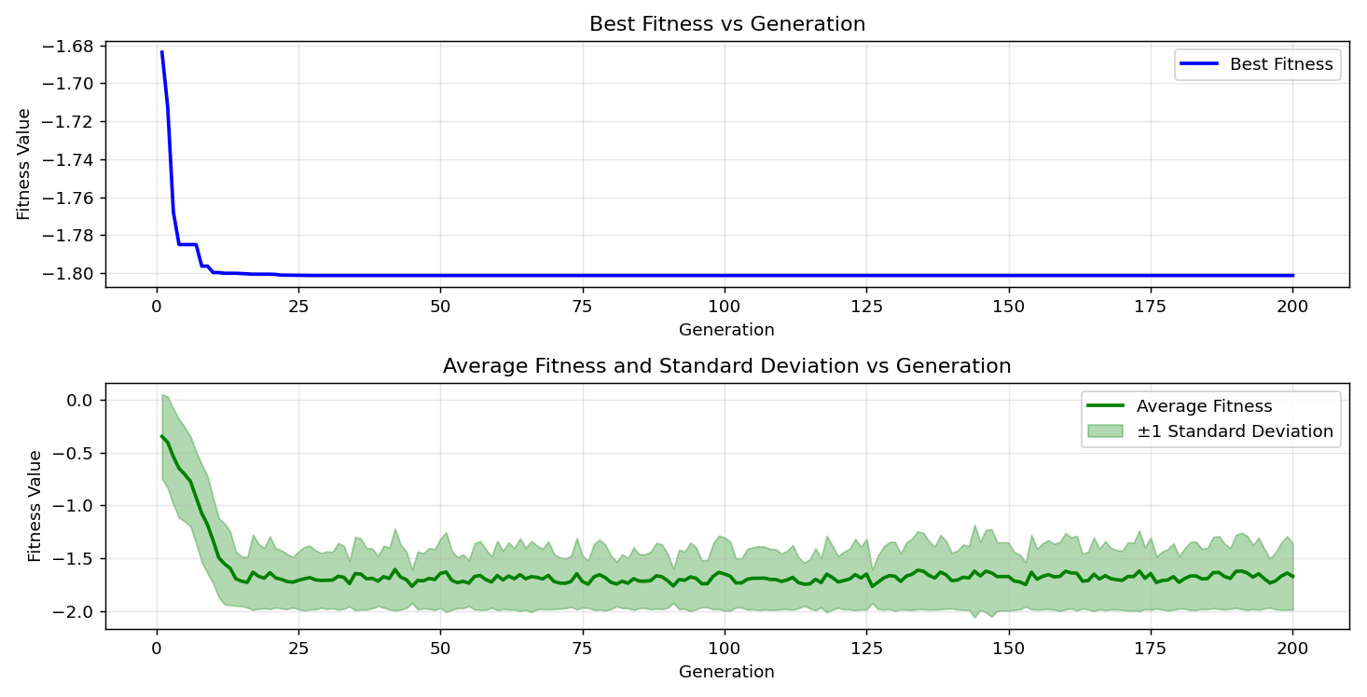

=== FINAL RESULTS ===
Best Fitness: -1.801296
Best Solution: [2.2025652967032965, 1.5704114114774115]
Total Time: 4.76s

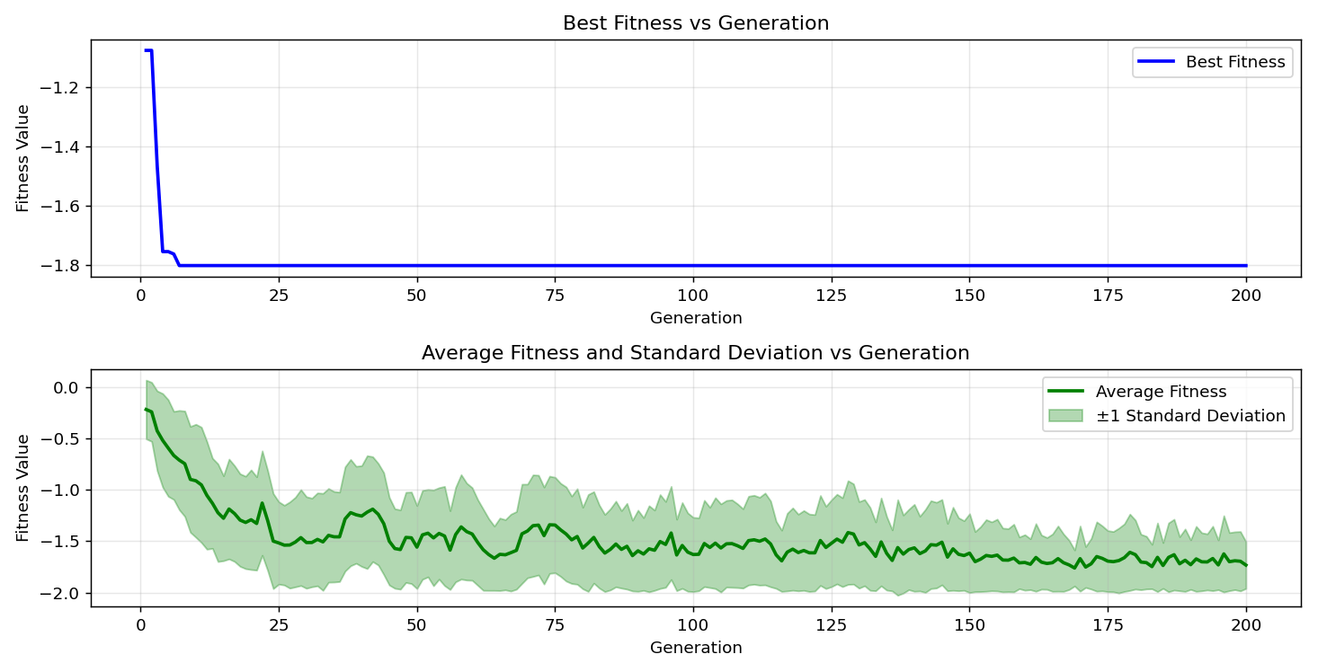
=== FINAL RESULTS ===
Best Fitness: -1.801296
Best Solution: [2.2025652967032965, 1.5711785885225884]
Total Time: 4.61s

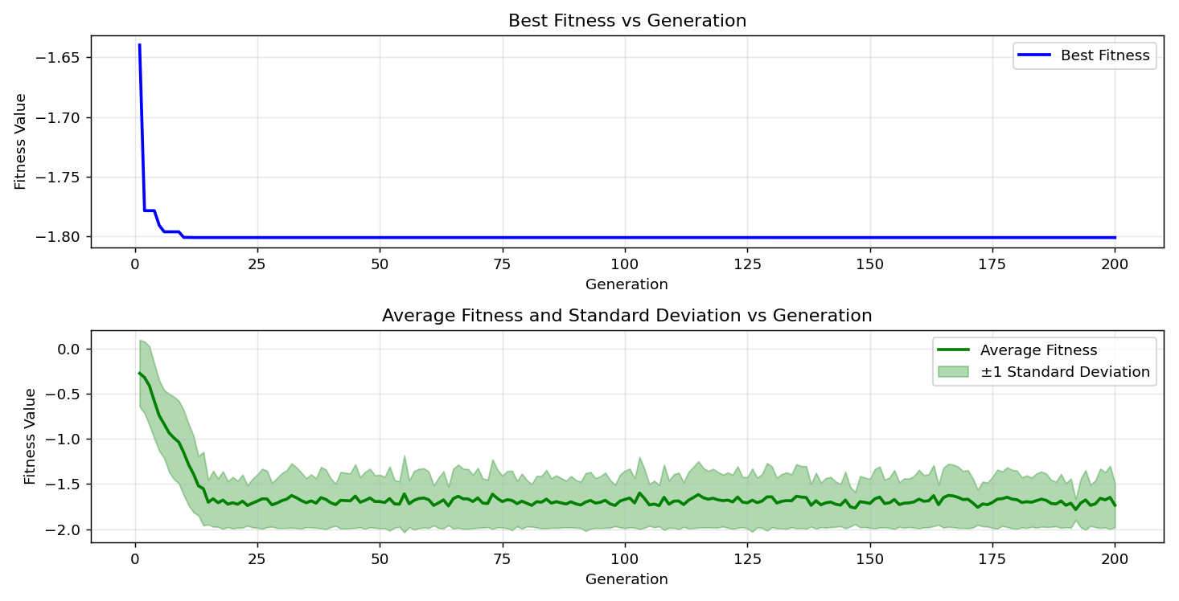

=== FINAL RESULTS ===
Best Fitness: -1.801296
Best Solution: [2.2025652967032965, 1.5704114114774115]
Total Time: 4.68s

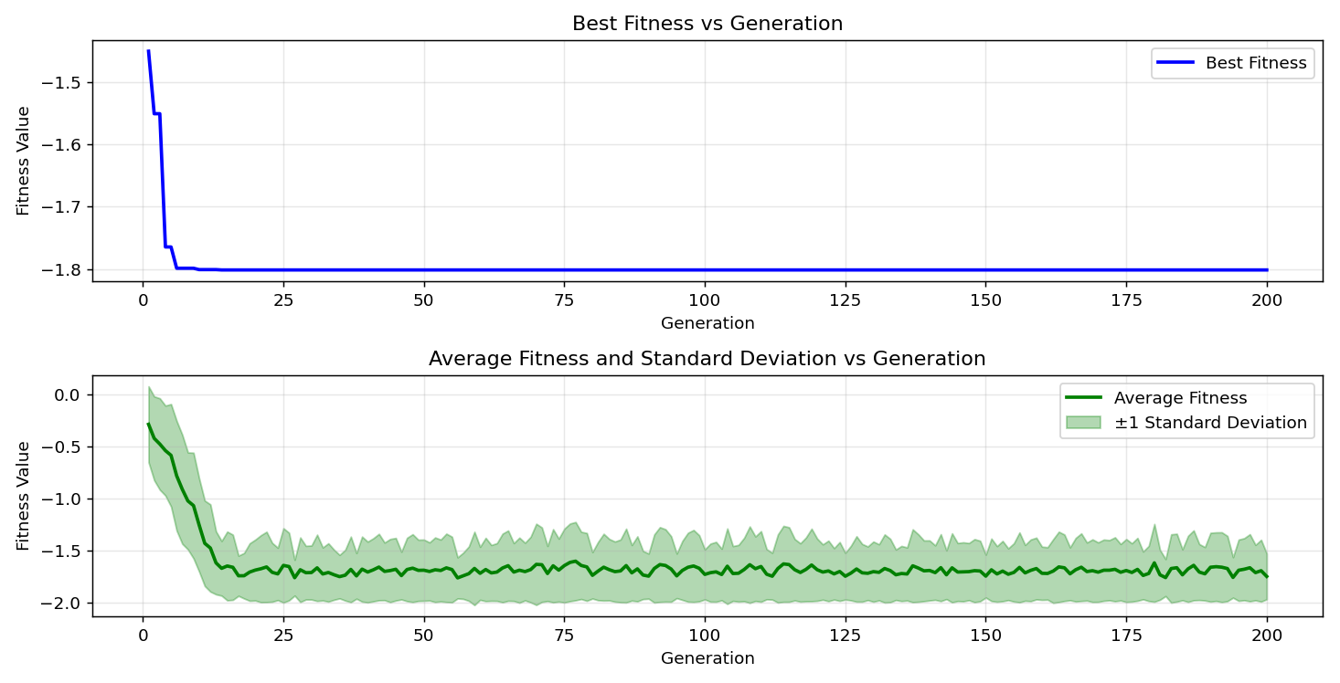
=== FINAL RESULTS ===
Best Fitness: -1.801294
Best Solution: [2.2033324737484734, 1.5704114114774115]
Total Time: 4.76s

