=== FINAL RESULTS ===
Best Fitness: 1606.537906
Best Solution: [-54.57875457875458, -86.42246642246643, -79.48717948717949, -19.755799755799757, -72.6007326007326, -65.17704517704519, 0.17094017094017033, -63.71184371184371, 38.754578754578745, 86.8131868131868, -40.708180708180706, 58.388278388278394, -59.02319902319903, 79.7802197802198, -13.260073260073256, -41.880341880341874, -58.29059829059829, -68.4981684981685, -7.838827838827839, 12.673992673992672]
Total Time: 20.13s
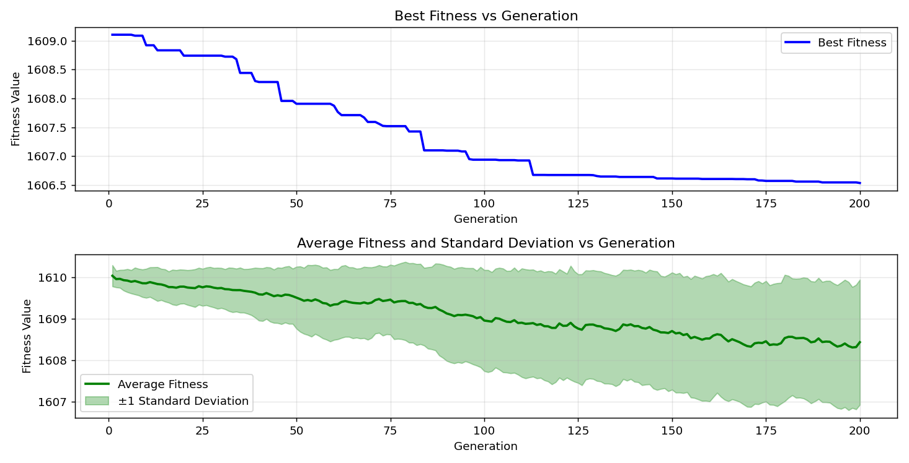
=== FINAL RESULTS ===
Best Fitness: 1606.735716
Best Solution: [-59.65811965811966, -22.58852258852258, -18.53479853479854, 6.666666666666671, 65.4212454212454, 34.7985347985348, 26.837606837606828, -49.05982905982906, 62.68620268620268, 19.95115995115995, 17.948717948717956, 41.83150183150184, -76.75213675213675, -18.730158730158735, -94.13919413919415, -39.242979242979246, 80.26862026862028, -67.22832722832723, -81.88034188034189, -39.1941391941392]
Total Time: 20.06s

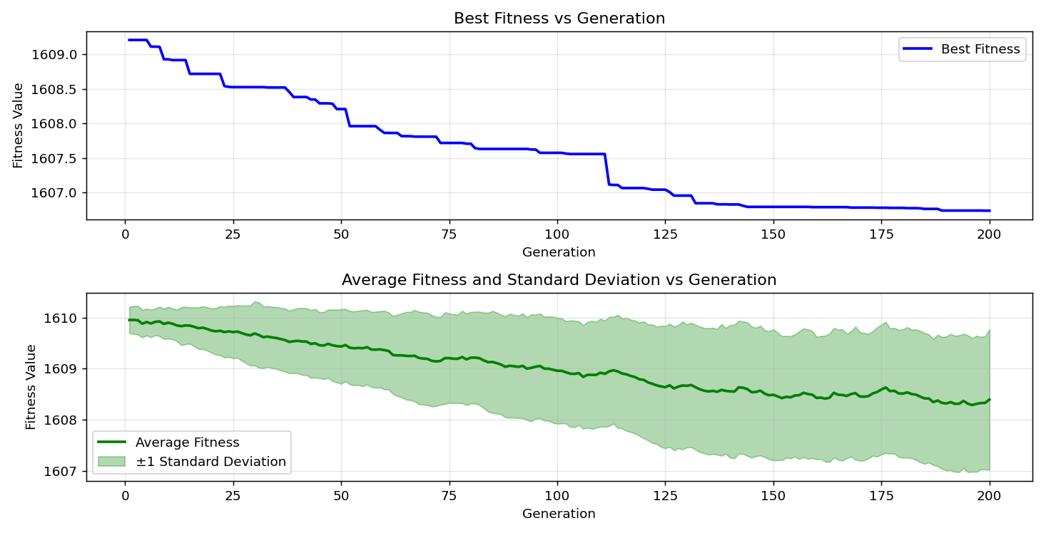
=== FINAL RESULTS ===
Best Fitness: 1605.377339
Best Solution: [-57.46031746031746, -63.85836385836386, 20.78144078144078, -13.357753357753353, -34.993894993895, -37.875457875457876, 12.576312576312574, -61.953601953601954, 54.676434676434695, 32.84493284493283, 59.804639804639805, -1.9780219780219852, 67.03296703296704, 38.21733821733821, -83.1013431013431, -53.45543345543346, -76.31257631257631, -51.452991452991455, -51.74603174603175, -34.40781440781441]
Total Time: 20.31s

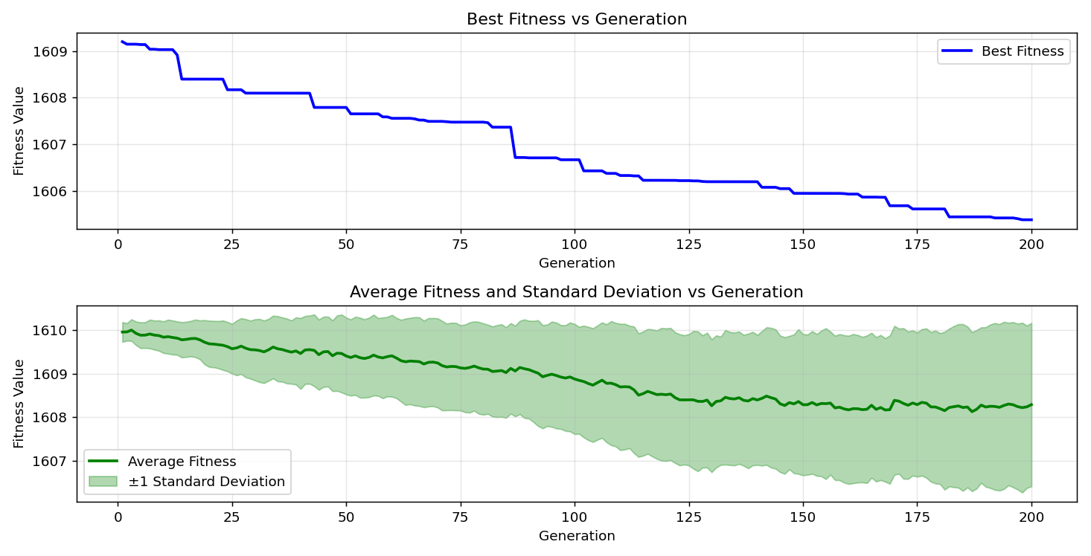

=== FINAL RESULTS ===
Best Fitness: 1606.200141
Best Solution: [-96.19047619047619, 69.42612942612942, -16.53235653235653, 5.885225885225893, 8.083028083028083, 93.5042735042735, -25.030525030525027, -51.89255189255189, -20.097680097680097, 29.963369963369956, -72.55189255189255, 33.23565323565322, -50.23199023199023, 12.771672771672769, -87.93650793650794, -40.8058608058608, -63.27228327228327, 48.22954822954824, 53.45543345543348, 94.92063492063491]
Total Time: 19.98s

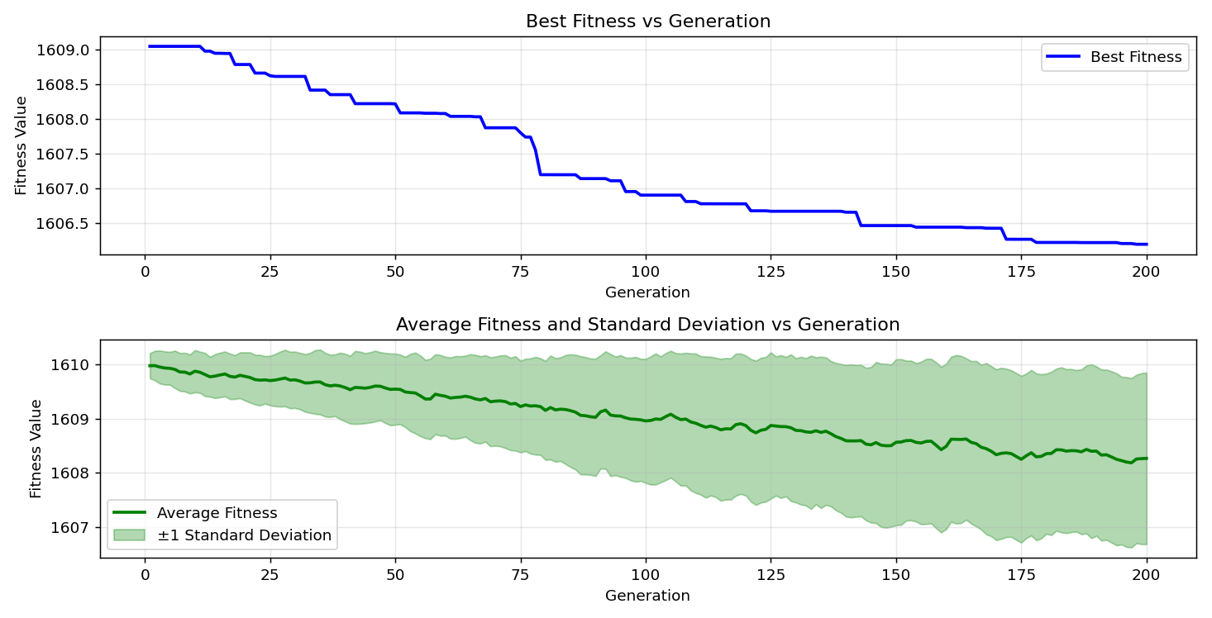

=== FINAL RESULTS ===
Best Fitness: 1605.490393
Best Solution: [-48.669108669108674, -65.66544566544567, -90.03663003663004, 15.018315018315008, 20.830280830280827, 29.963369963369956, -21.318681318681314, -62.979242979242976, 61.7094017094017, 35.97069597069597, -28.3028083028083, 48.62026862026863, -69.23076923076923, 55.11599511599513, -74.45665445665446, -56.43467643467643, -89.84126984126985, 77.09401709401709, -53.65079365079365, -83.3943833943834]
Total Time: 19.98s

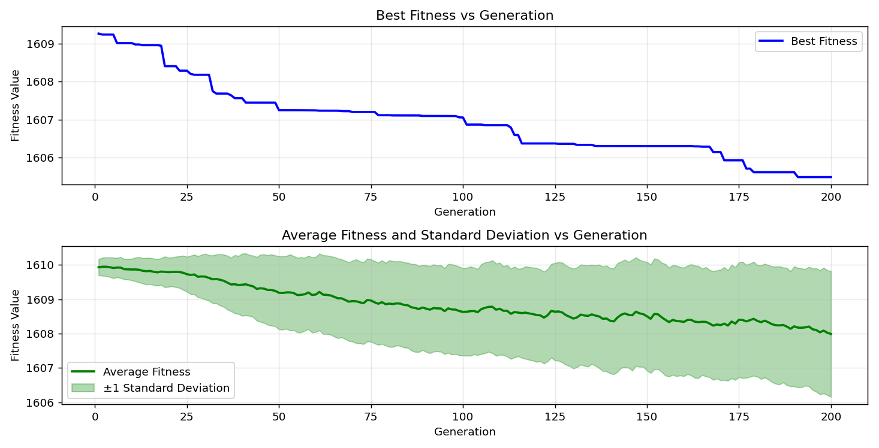
=== FINAL RESULTS ===
Best Fitness: 1607.129960
Best Solution: [32.84493284493283, 66.3003663003663, 44.02930402930403, 8.57142857142857, 12.38095238095238, 67.13064713064713, 98.14407814407815, -59.60927960927961, 0.805860805860803, 21.51404151404151, 43.785103785103786, 47.59462759462761, -62.1978021978022, 12.576312576312574, -74.2124542124542, -41.147741147741144, -50.96459096459097, 33.38217338217336, -93.6996336996337, 87.74114774114773]
Total Time: 20.14s

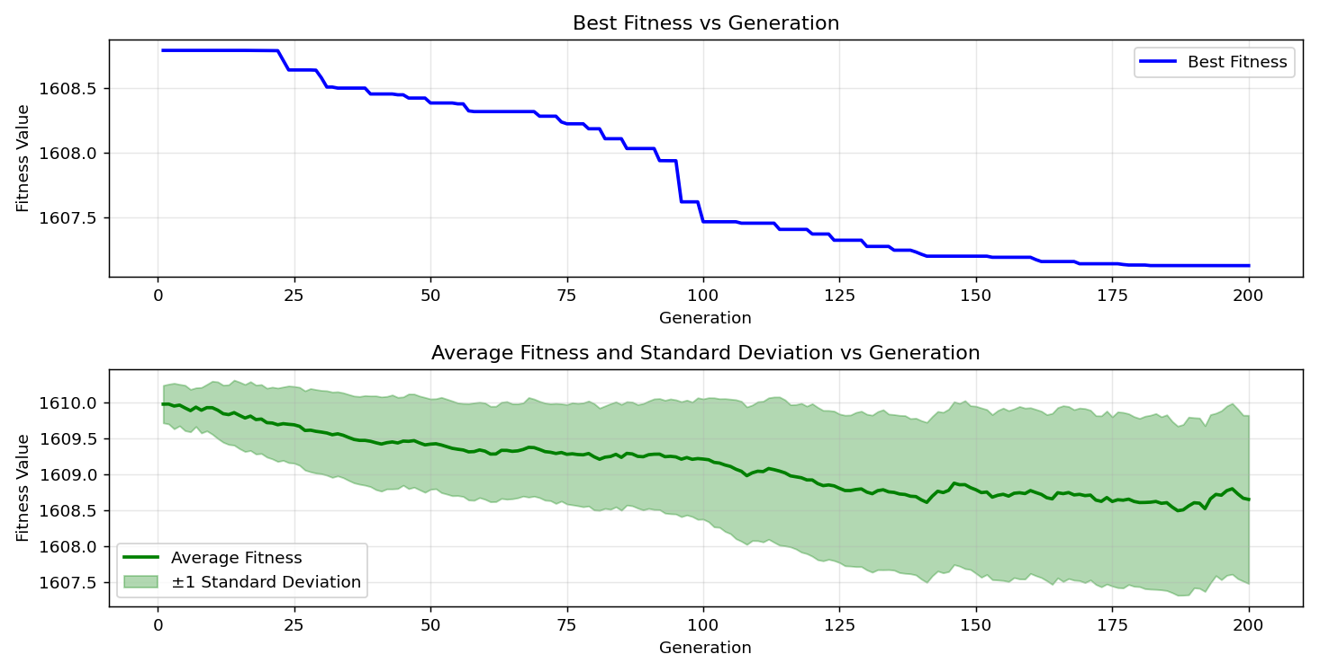

=== FINAL RESULTS ===
Best Fitness: 1605.943627
Best Solution: [-53.162393162393165, -69.03540903540903, -60.586080586080584, 6.910866910866915, -57.46031746031746, -56.14163614163614, -8.229548229548229, -69.52380952380952, 53.79731379731382, 93.11355311355311, -41.782661782661776, 30.54945054945054, -71.57509157509158, 31.33089133089132, -76.11721611721612, -53.6996336996337, -85.25030525030525, -59.413919413919416, -47.692307692307686, 10.866910866910871]
Total Time: 20.59s

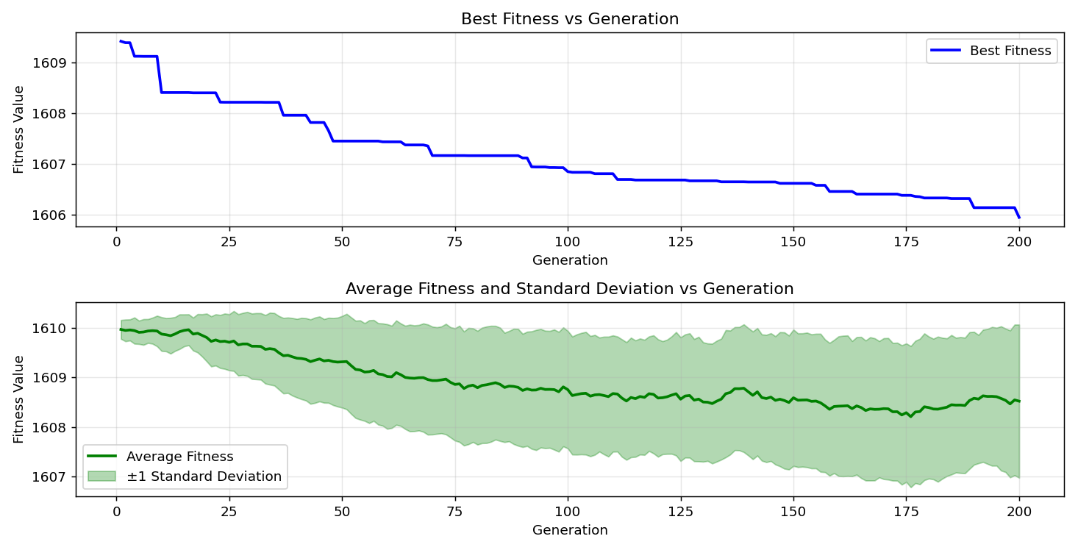

=== FINAL RESULTS ===
Best Fitness: 1606.241209
Best Solution: [-45.34798534798535, -52.08791208791209, -35.482295482295484, 1.4896214896214843, -95.6043956043956, -61.80708180708181, -18.095238095238102, 48.62026862026863, 41.09890109890111, 33.77289377289375, 18.827838827838832, 38.11965811965811, 98.24175824175825, 25.470085470085465, -86.08058608058607, -30.40293040293041, 21.46520146520146, -3.003663003663007, -57.21611721611722, -84.56654456654456]
Total Time: 20.60s

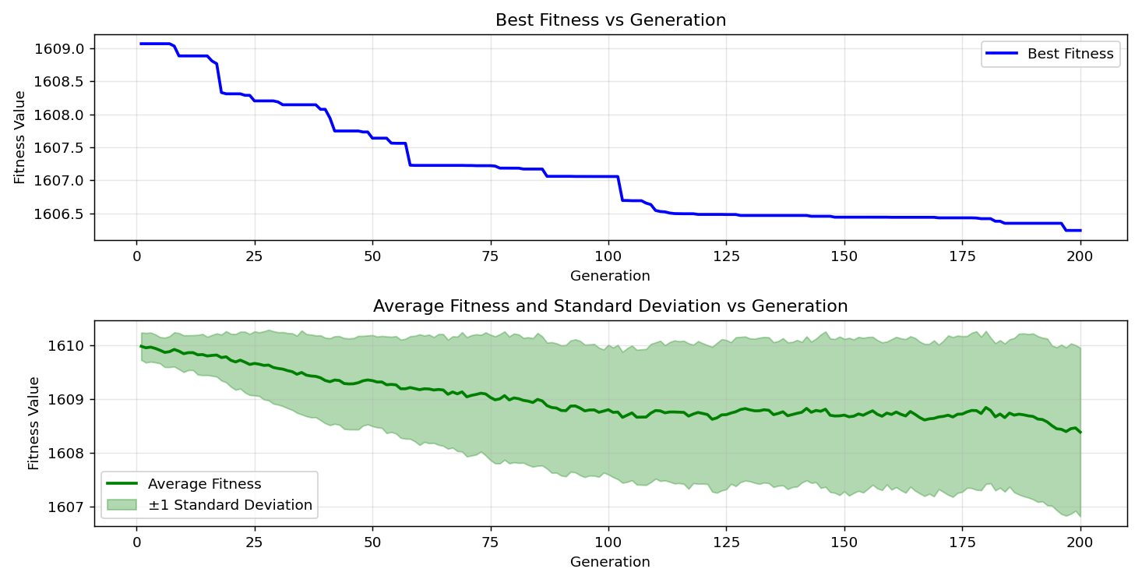

=== FINAL RESULTS ===
Best Fitness: 1607.347461
Best Solution: [-54.38339438339438, -72.94261294261294, -66.4957264957265, -16.385836385836384, -68.25396825396825, -20.293040293040292, -15.311355311355314, -1.245421245421241, -40.024420024420024, 31.379731379731368, 79.19413919413921, 33.13797313797312, 90.57387057387055, -72.25885225885226, 70.98901098901098, -80.31746031746032, 94.48107448107447, -5.641025641025649, -53.162393162393165, -42.56410256410257]
Total Time: 19.84s

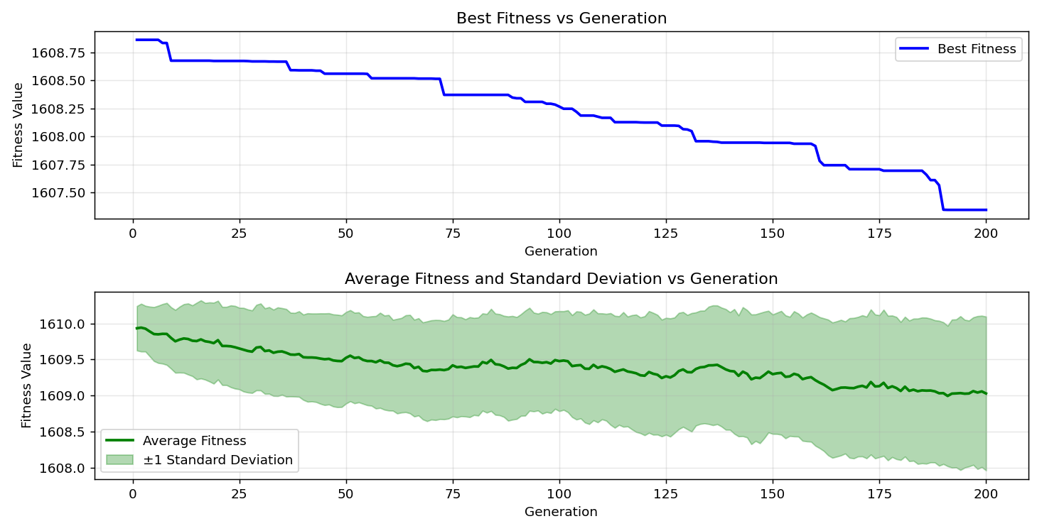

=== FINAL RESULTS ===
Best Fitness: 1607.237154
Best Solution: [-62.637362637362635, -17.069597069597066, -81.63614163614163, 6.080586080586087, -40.9035409035409, 59.853479853479854, 8.18070818070818, -52.33211233211233, -17.167277167277163, 11.25763125763126, -95.36019536019536, -79.0964590964591, -73.33333333333333, -28.986568986568983, -73.91941391941391, -47.54578754578754, -18.827838827838832, -87.54578754578755, -2.857142857142861, -95.55555555555556]
Total Time: 19.96s

