=== FINAL RESULTS ===
Best Fitness: 1612.423637
Best Solution: [99.31623931623932, -57.411477411477414, -49.89010989010989, 22.442002442002448, -22.97924297924297, -91.30647130647131, -94.0903540903541, 91.06227106227107, 82.61294261294262, -16.385836385836384, -56.776556776556774, 3.199023199023216, -80.36630036630036, -3.63858363858364, -4.859584859584871, -21.953601953601947, -72.55189255189255, 37.43589743589743, 97.41147741147742, -64.54212454212454, 31.379731379731368, 74.16361416361417, 19.169719169719173, -21.953601953601947, 84.42002442002442, -46.324786324786324, 16.67887667887669, -66.25152625152626, 91.25763125763126, -51.25763125763126]
Total Time: 26.44s

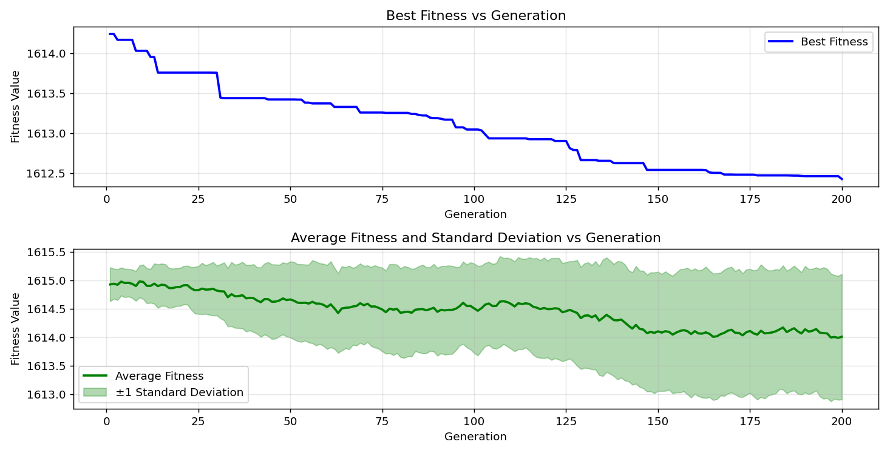

=== FINAL RESULTS ===
Best Fitness: 1612.054468
Best Solution: [-66.4957264957265, -42.22222222222223, -29.96336996336997, 20.39072039072039, -25.763125763125757, -74.55433455433456, -24.444444444444443, 5.494505494505503, -74.40781440781441, -60.927960927960925, -14.72527472527473, 17.948717948717956, 25.030525030525027, -16.630036630036628, 60.73260073260073, 6.813186813186817, -97.31379731379731, -13.504273504273499, 40.561660561660545, 23.516483516483518, -31.184371184371187, -14.38339438339439, 28.3028083028083, 55.31135531135533, 74.26129426129427, -82.61294261294262, 3.2478632478632647, 25.763125763125757, -71.86813186813187, 19.462759462759465]
Total Time: 25.92s

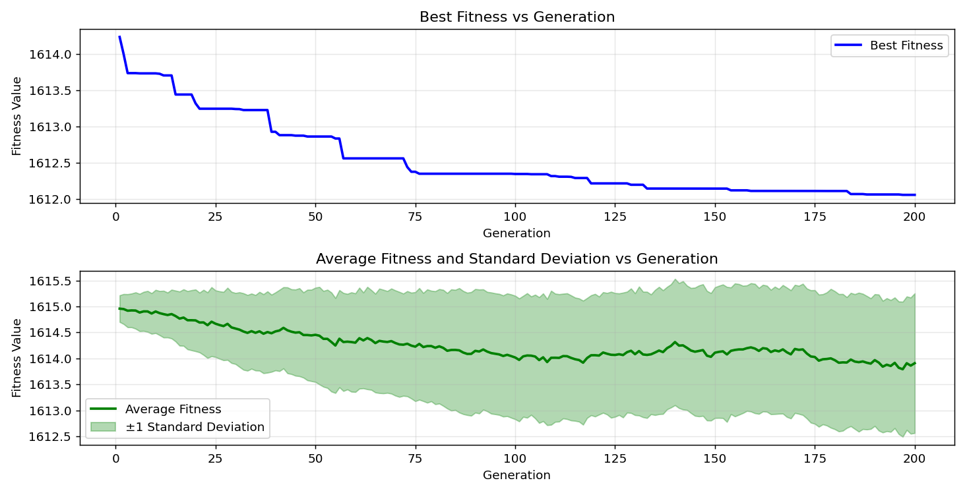
=== FINAL RESULTS ===
Best Fitness: 1612.719564
Best Solution: [-40.65934065934066, 97.997557997558, -87.44810744810745, -26.788766788766793, -62.93040293040293, -41.001221001221, 99.46275946275946, 85.88522588522588, -14.090354090354097, 5.494505494505503, -81.63614163614163, -54.72527472527472, -73.57753357753357, 73.04029304029305, 80.65934065934067, -34.358974358974365, -16.678876678876676, 20.68376068376068, 94.33455433455433, 91.8925518925519, -81.53846153846153, 69.76800976800976, 96.04395604395603, -10.280830280830273, 41.34310134310135, -34.16361416361417, 26.495726495726487, -61.17216117216117, 50.720390720390725, 34.45665445665446]
Total Time: 26.56s

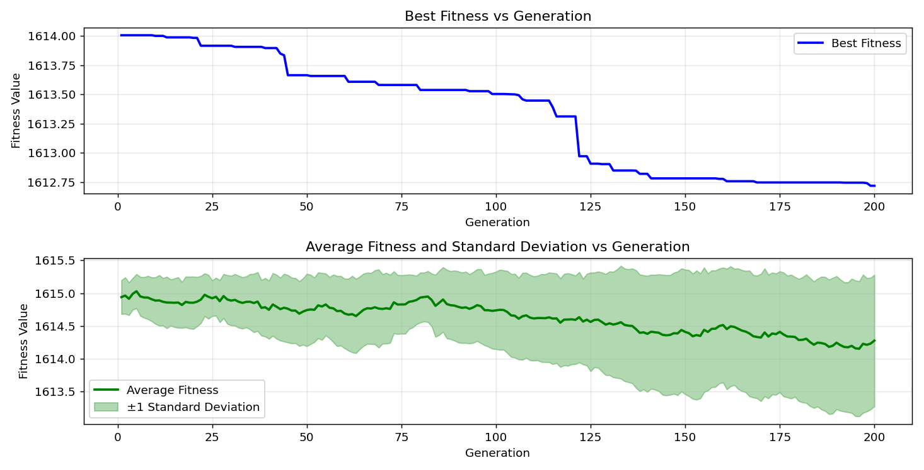

=== FINAL RESULTS ===
Best Fitness: 1612.584753
Best Solution: [-14.481074481074486, -99.8046398046398, -95.45787545787546, 4.273504273504287, 53.65079365079367, 38.363858363858355, -55.50671550671551, 86.76434676434675, 99.31623931623932, 60.78144078144078, -47.692307692307686, 97.21611721611723, 61.75824175824175, -56.385836385836384, -74.65201465201466, 38.55921855921855, -69.96336996336996, -32.747252747252745, 77.24053724053724, 26.886446886446876, 82.85714285714286, -32.893772893772905, -61.56288156288156, -40.366300366300365, 83.3943833943834, -5.543345543345552, -14.822954822954827, 74.65201465201466, 44.517704517704516, -22.295482295482287]
Total Time: 26.35s

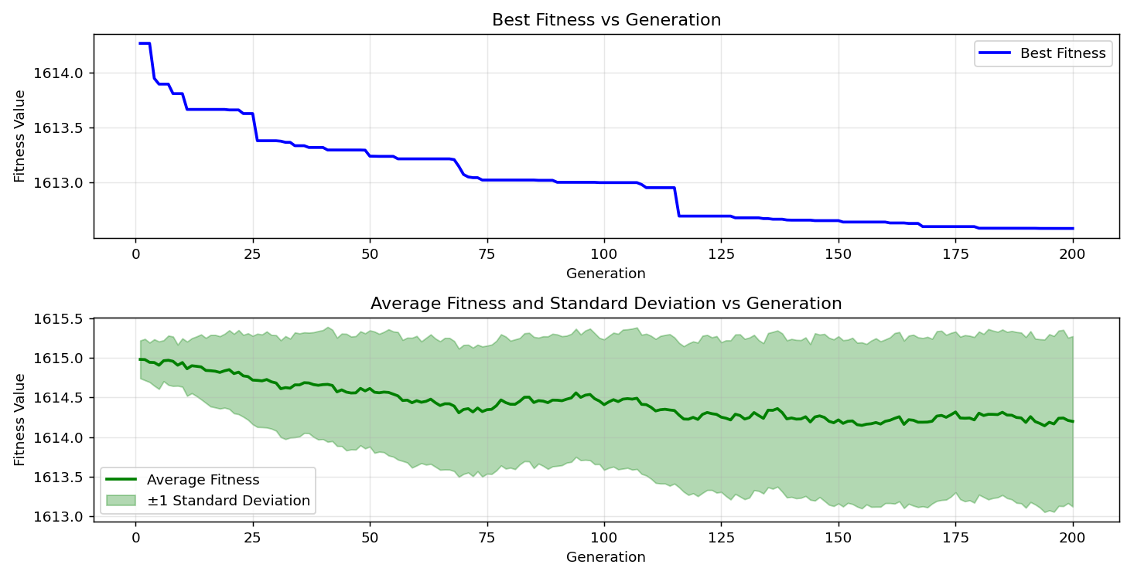
=== FINAL RESULTS ===
Best Fitness: 1612.262223
Best Solution: [69.57264957264957, 57.16727716727718, -27.130647130647134, -5.787545787545795, -0.17094017094017033, 38.94993894993894, -32.698412698412696, -61.904761904761905, 74.26129426129427, 27.912087912087898, -83.2967032967033, 41.53846153846155, -47.59462759462759, 12.136752136752136, 64.39560439560438, 67.96092796092796, -97.75335775335775, -22.53968253968253, -1.8315018315018392, -31.623931623931625, -54.969474969474966, -30.451770451770457, 35.62881562881563, -51.404151404151406, -4.4200244200244185, -39.1941391941392, -14.139194139194146, 73.67521367521368, 17.216117216117226, -41.58730158730158]
Total Time: 26.27s

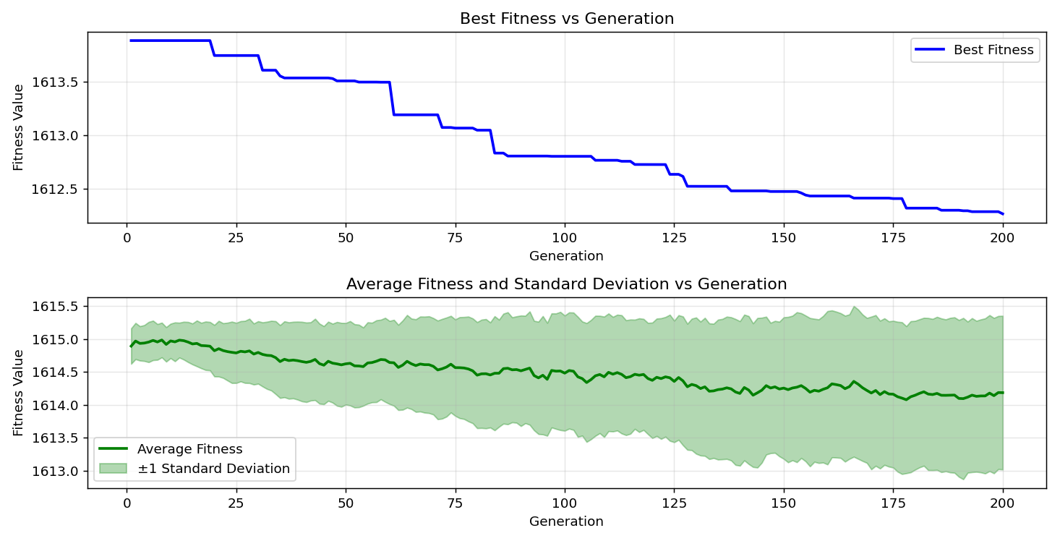
=== FINAL RESULTS ===
Best Fitness: 1612.338955
Best Solution: [-77.72893772893772, -36.31257631257632, 9.157509157509153, 47.54578754578756, -17.80219780219781, 60.83028083028083, -20.34188034188034, 1.7826617826617763, -96.87423687423687, -12.625152625152623, -45.34798534798535, -36.996336996337, -99.70695970695971, -63.17460317460317, 58.77899877899878, -77.48473748473748, 43.492063492063494, -60.0, 76.36141636141636, 14.139194139194132, -97.8021978021978, -61.80708180708181, -33.284493284493294, -69.18192918192918, 75.43345543345544, 60.927960927960925, -14.432234432234438, -74.06593406593406, 23.07692307692308, -92.77167277167277]
Total Time: 26.02s

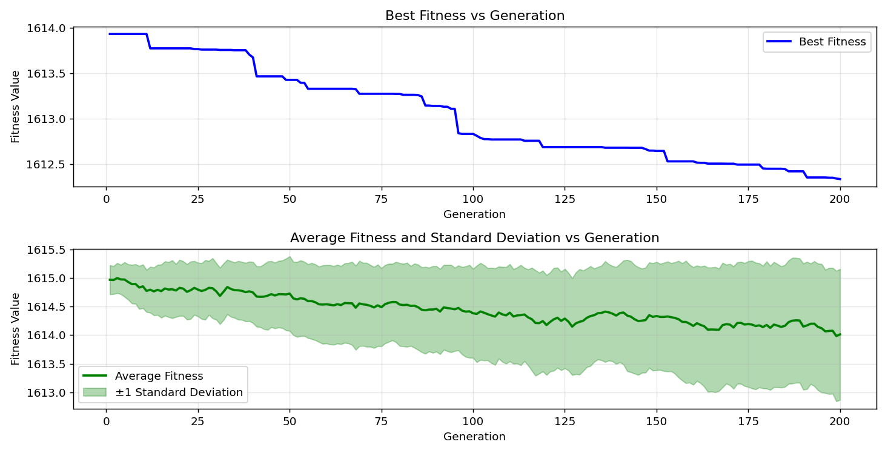

=== FINAL RESULTS ===
Best Fitness: 1612.744093
Best Solution: [-8.669108669108667, 24.297924297924297, -56.776556776556774, 78.51037851037853, -36.31257631257632, -88.37606837606837, -61.22100122100122, -97.85103785103784, 75.57997557997558, -39.584859584859586, -93.79731379731379, 36.41025641025641, 28.3028083028083, -44.07814407814408, -18.14407814407815, -5.445665445665455, 34.60317460317461, -43.15018315018315, -64.3956043956044, -64.8840048840049, -5.885225885225893, 27.86324786324785, 46.031746031746025, 31.67277167277166, 45.39682539682539, 7.789987789987791, 14.57875457875457, 19.853479853479854, -95.65323565323565, -40.46398046398046]
Total Time: 25.87s

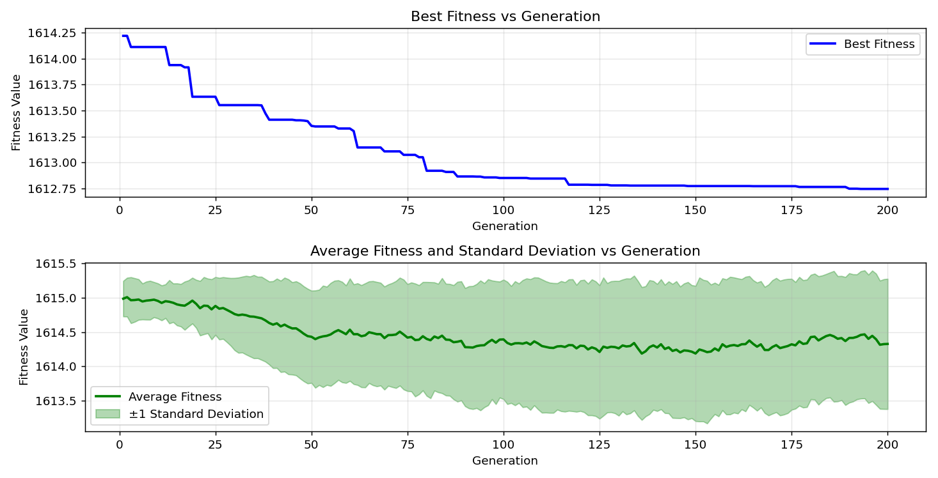

=== FINAL RESULTS ===
Best Fitness: 1612.623862
Best Solution: [62.49084249084248, -76.5079365079365, -58.24175824175824, 56.23931623931625, -29.377289377289372, -11.013431013431017, -39.0964590964591, -53.65079365079365, -24.786324786324784, 31.67277167277166, 83.34554334554335, -20.68376068376068, 6.275946275946282, -47.88766788766788, -16.092796092796092, 25.66544566544566, -75.23809523809524, 11.941391941391942, 20.097680097680097, -23.907203907203908, -81.48962148962148, -36.800976800976805, -74.84737484737485, 76.36141636141636, 97.75335775335776, -30.256410256410263, 48.522588522588535, 0.46398046398046233, 59.31623931623932, 24.444444444444443]
Total Time: 26.41s

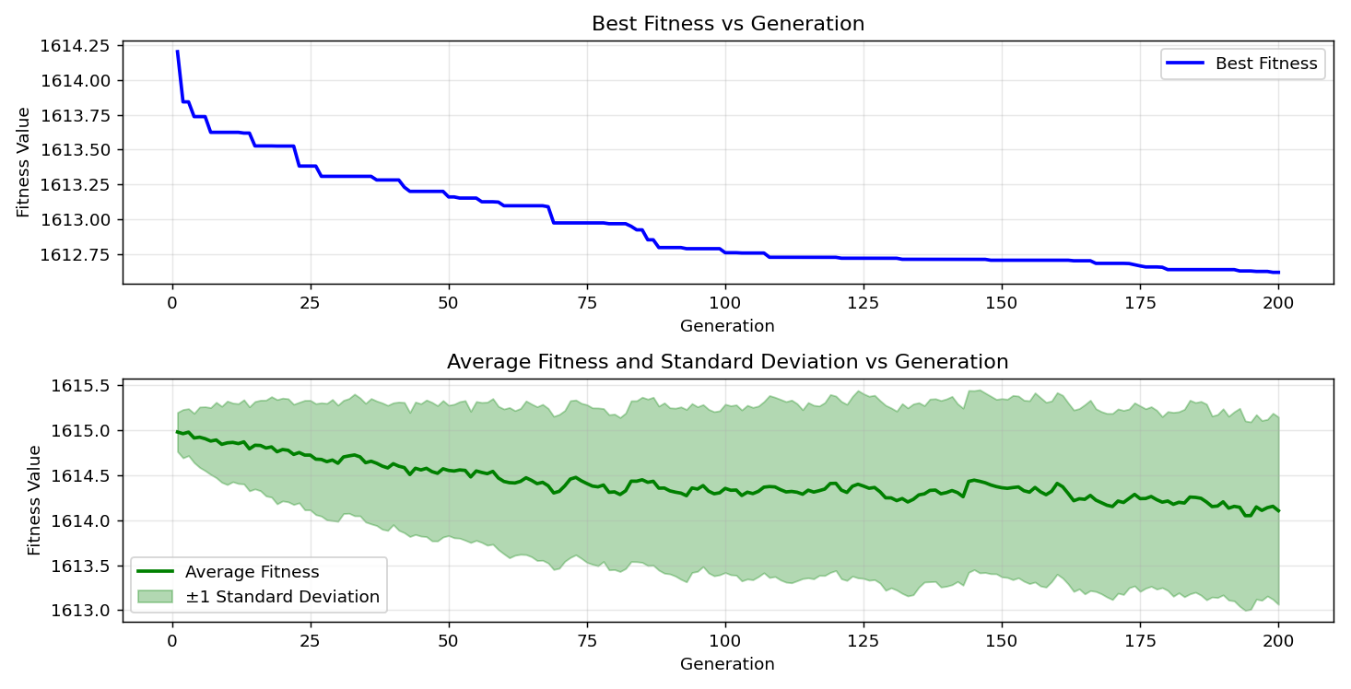
=== FINAL RESULTS ===
Best Fitness: 1612.721766
Best Solution: [-8.52258852258852, 68.5958485958486, -38.315018315018314, 68.98656898656898, -41.050061050061046, -70.69597069597069, -24.88400488400488, 19.65811965811966, -90.86691086691087, -5.738705738705747, 56.483516483516496, -0.659340659340657, 3.345543345543362, -68.93772893772893, 66.5934065934066, -18.87667887667888, -81.05006105006105, 15.506715506715494, -48.03418803418803, -73.04029304029304, -36.65445665445666, -21.904761904761898, -82.80830280830281, 37.43589743589743, 90.08547008547006, -88.32722832722833, -57.94871794871795, -15.262515262515265, 93.45543345543345, -30.061050061050068]
Total Time: 26.68s

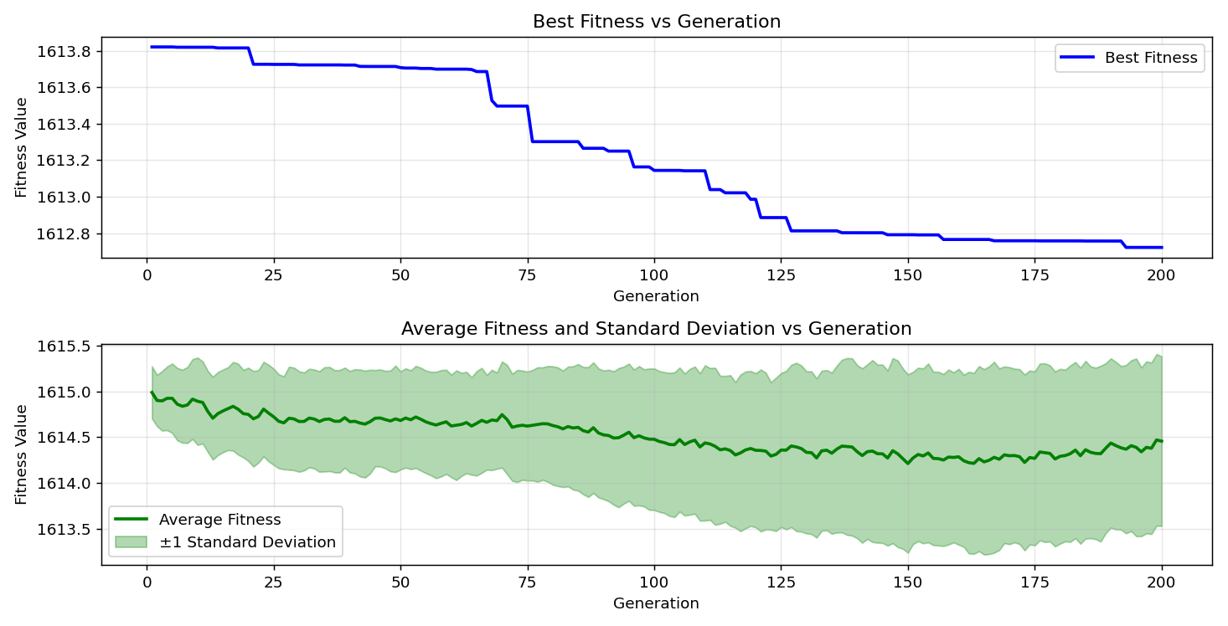

=== FINAL RESULTS ===
Best Fitness: 1612.067768
Best Solution: [34.11477411477409, -70.3052503052503, 4.908424908424919, 2.271062271062263, 63.90720390720389, -38.75457875457875, 43.73626373626374, 61.17216117216117, -58.485958485958484, -11.013431013431017, 32.991452991452974, -26.739926739926744, -5.445665445665455, 15.067155067155056, 21.12332112332112, -29.03540903540903, -72.06349206349206, 24.297924297924297, -14.676434676434681, 39.38949938949938, 74.8962148962149, -15.7997557997558, 46.91086691086693, 64.44444444444443, -93.06471306471306, -10.622710622710613, 68.64468864468864, -65.66544566544567, 73.23565323565325, -47.15506715506715]
Total Time: 25.53s

