=== FINAL RESULTS ===
Best Fitness: -9.221164
Best Solution: [2.1649736214896214, 1.5681098803418803, 1.2827200195360196, 1.1231471941391942, 1.7138735189255188, 1.5665755262515262, 2.2087027130647128, 1.3533003076923078, 1.6578695946275945, 1.5734801196581196]
Total Time: 6.22s

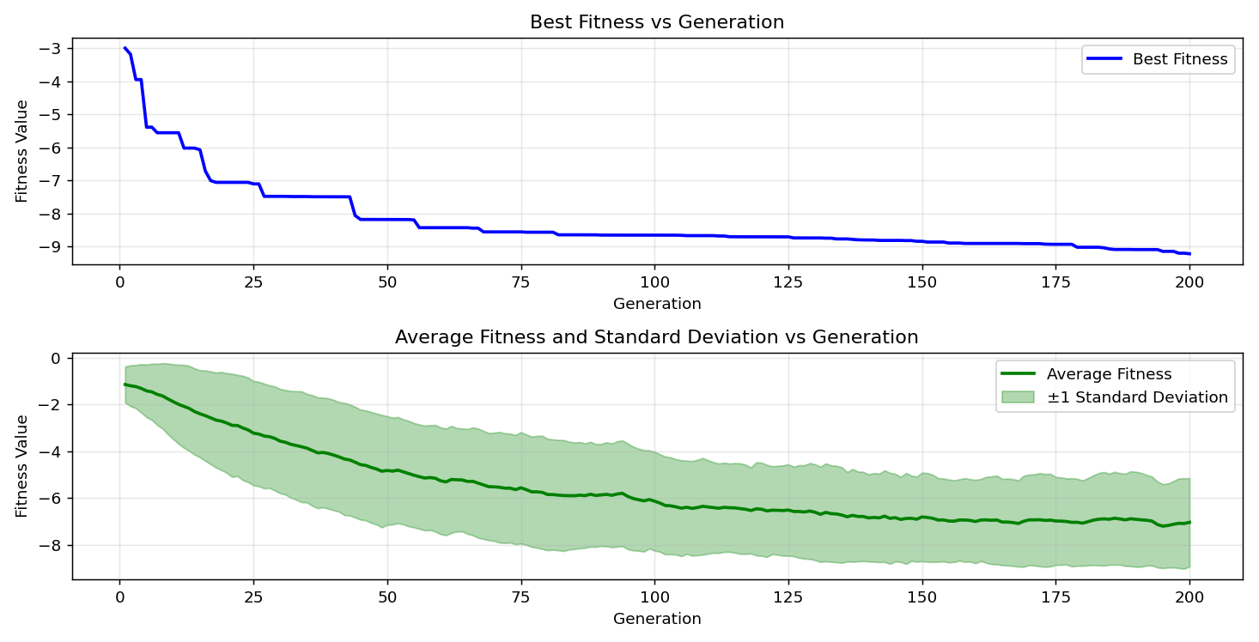
=== FINAL RESULTS ===
Best Fitness: -9.543215
Best Solution: [2.20946989010989, 1.5727129426129425, 1.2888574358974358, 1.1101051843711844, 1.7177094041514038, 1.5719457655677656, 1.4553348547008547, 1.358670547008547, 1.2758154261294261, 1.5704114114774115]
Total Time: 6.37s

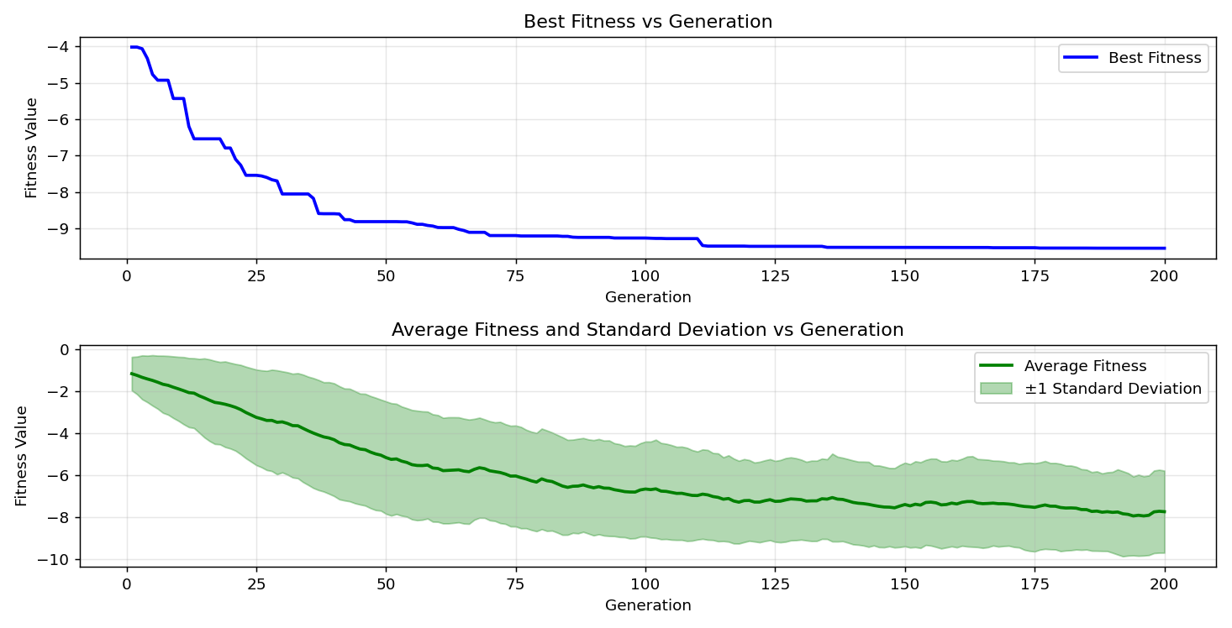

=== FINAL RESULTS ===
Best Fitness: -9.070341
Best Solution: [2.20946989010989, 1.5757816507936506, 1.2696780097680098, 1.120078485958486, 1.7177094041514038, 1.5773160048840047, 0.8408260415140415, 1.7568354334554335, 2.2217447228327227, 1.2182771477411478]
Total Time: 6.10s
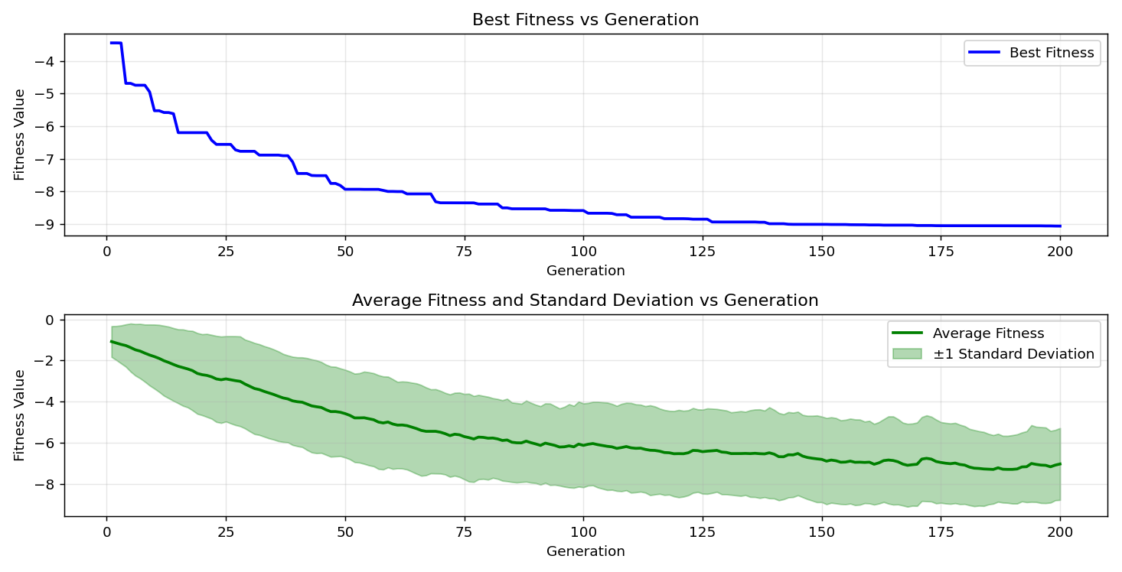
=== FINAL RESULTS ===
Best Fitness: -9.284592
Best Solution: [2.2040996507936503, 1.563506818070818, 1.2865559047619046, 1.9233128522588523, 0.9934942735042734, 1.5704114114774115, 1.447663084249084, 1.3609720781440782, 1.6693772503052502, 1.8596371575091575]
Total Time: 6.23s

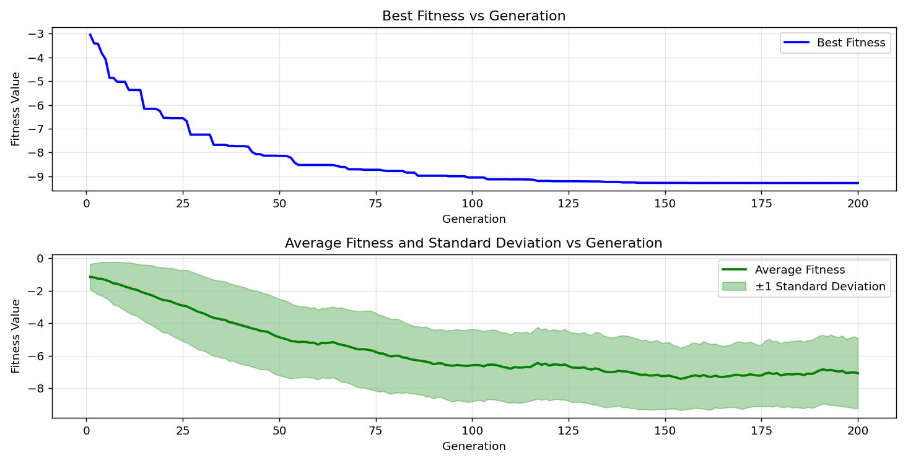

=== FINAL RESULTS ===
Best Fitness: -9.246376
Best Solution: [2.2025652967032965, 1.5704114114774115, 1.2758154261294261, 1.9248472063492064, 1.0065362832722833, 2.022278691086691, 1.8765150525030523, 1.374014087912088, 1.6578695946275945, 1.5696442344322343]
Total Time: 6.32s

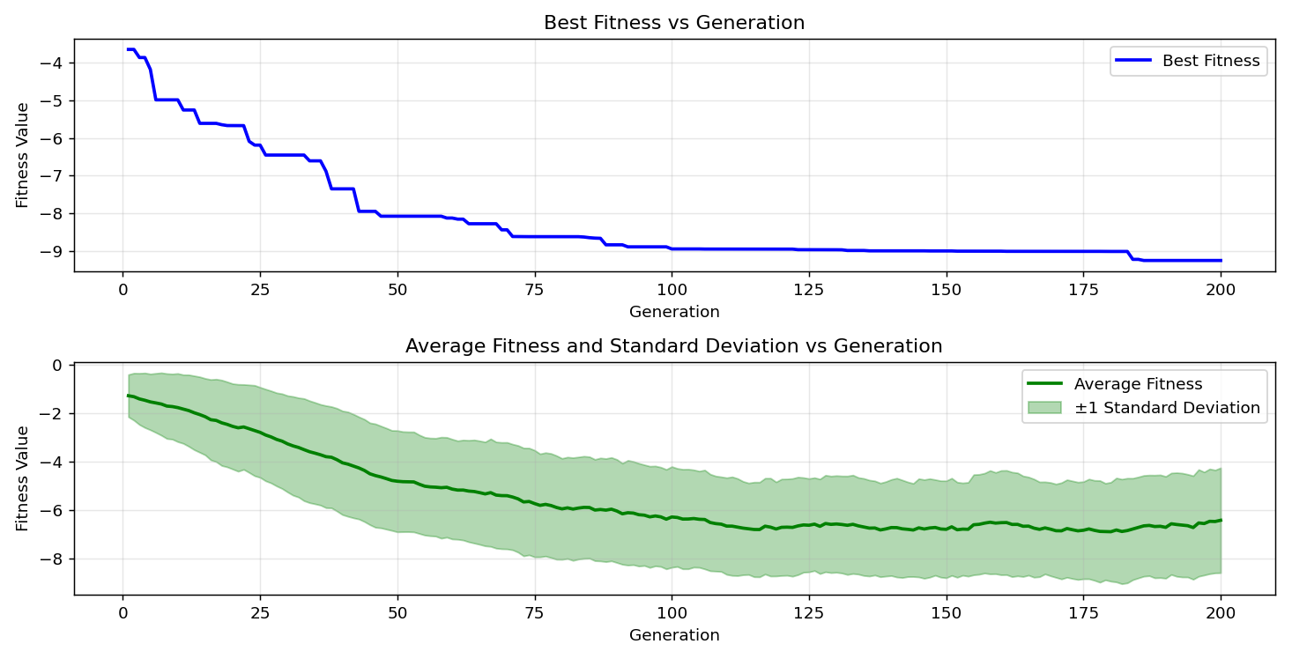

=== FINAL RESULTS ===
Best Fitness: -9.365667
Best Solution: [2.1887561098901096, 1.5650411721611721, 2.2087027130647128, 1.9164082588522589, 1.7223124664224665, 1.5658083492063493, 1.4691440415140415, 1.7545339023199022, 1.6571024175824176, 1.5704114114774115]
Total Time: 6.36s

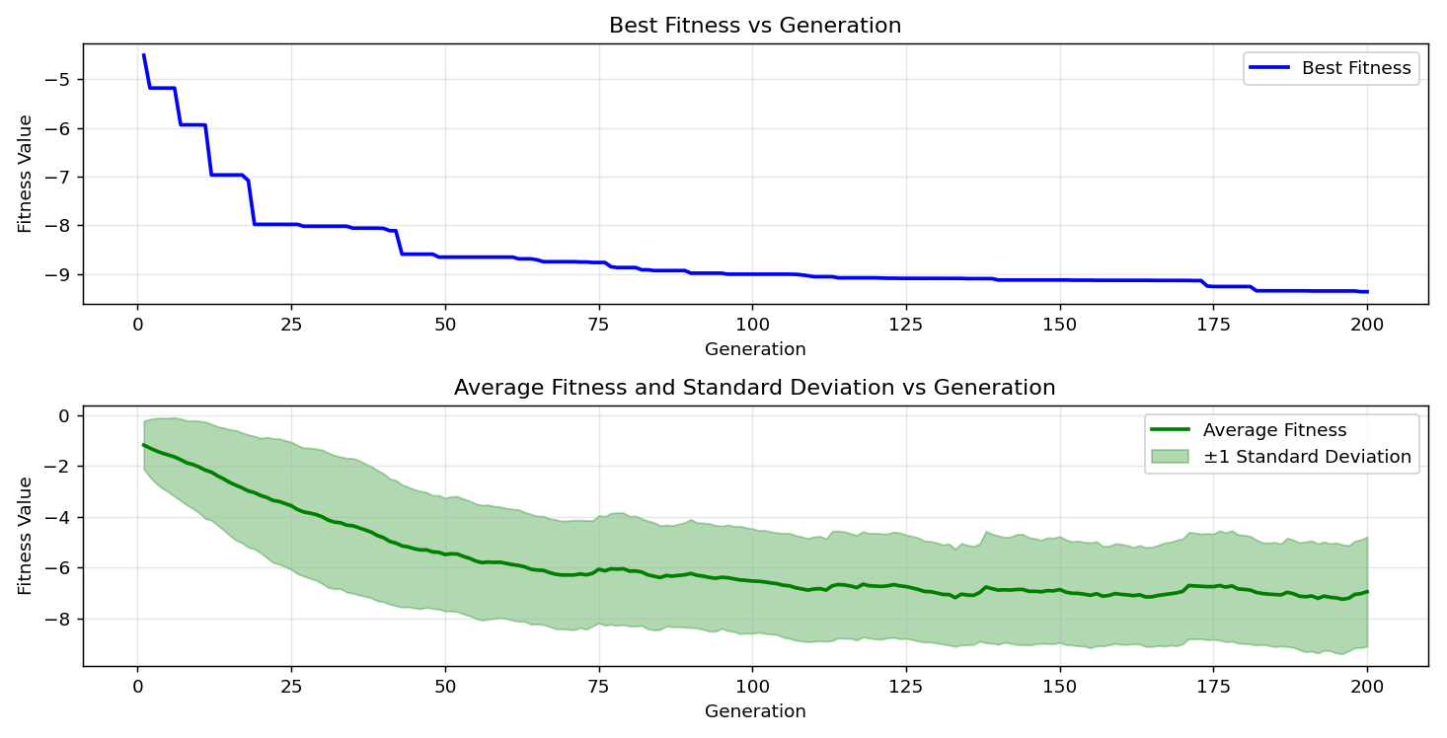

=== FINAL RESULTS ===
Best Fitness: -9.491596
Best Solution: [2.2033324737484734, 1.5727129426129425, 1.291926144078144, 1.1055021221001222, 1.716942227106227, 1.5773160048840047, 1.4491974383394384, 1.3632736092796092, 1.2811856654456655, 1.8581028034188034]
Total Time: 6.62s

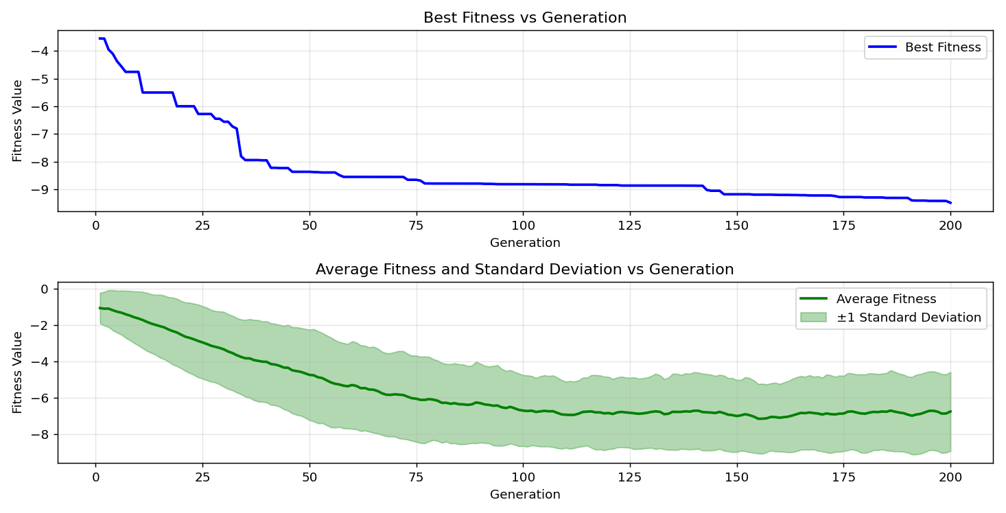
=== FINAL RESULTS ===
Best Fitness: -9.338173
Best Solution: [2.158836205128205, 1.5750144737484737, 1.2758154261294261, 1.9110380195360193, 1.7177094041514038, 1.5727129426129425, 0.8408260415140415, 1.7545339023199022, 1.6563352405372405, 1.5711785885225884]
Total Time: 6.24s

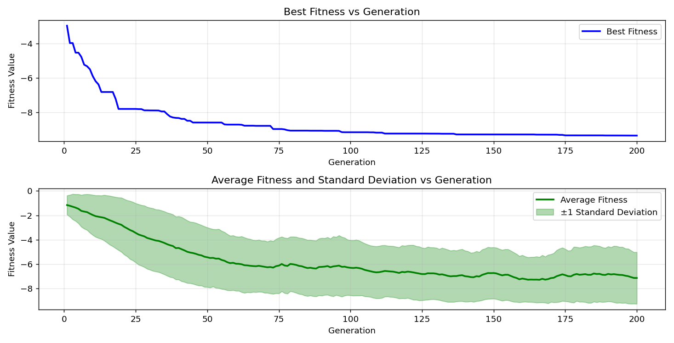
=== FINAL RESULTS ===
Best Fitness: -9.094503
Best Solution: [2.210237067155067, 1.5757816507936506, 2.207935536019536, 1.1032005909645908, 1.716942227106227, 1.5727129426129425, 1.4499646153846155, 1.3609720781440782, 1.2827200195360196, 2.3283823321123323]
Total Time: 6.38s

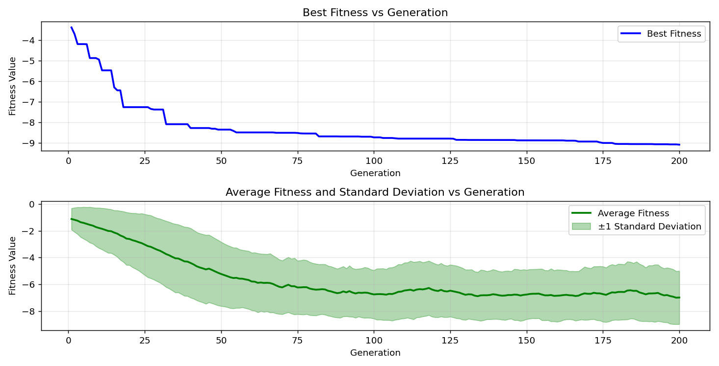
=== FINAL RESULTS ===
Best Fitness: -9.143900
Best Solution: [2.1994965885225883, 1.5757816507936506, 1.2857887277167277, 1.9225456752136754, 1.0065362832722833, 1.5704114114774115, 1.4530333235653237, 1.35790336996337, 1.2758154261294261, 2.3322182173382173]
Total Time: 6.17s

