=== FINAL RESULTS ===
Best Fitness: -4.517762
Best Solution: [2.2033324737484734, 1.5704114114774115, 1.2857887277167277, 1.9233128522588523, 0.9812194407814407]
Total Time: 5.18s

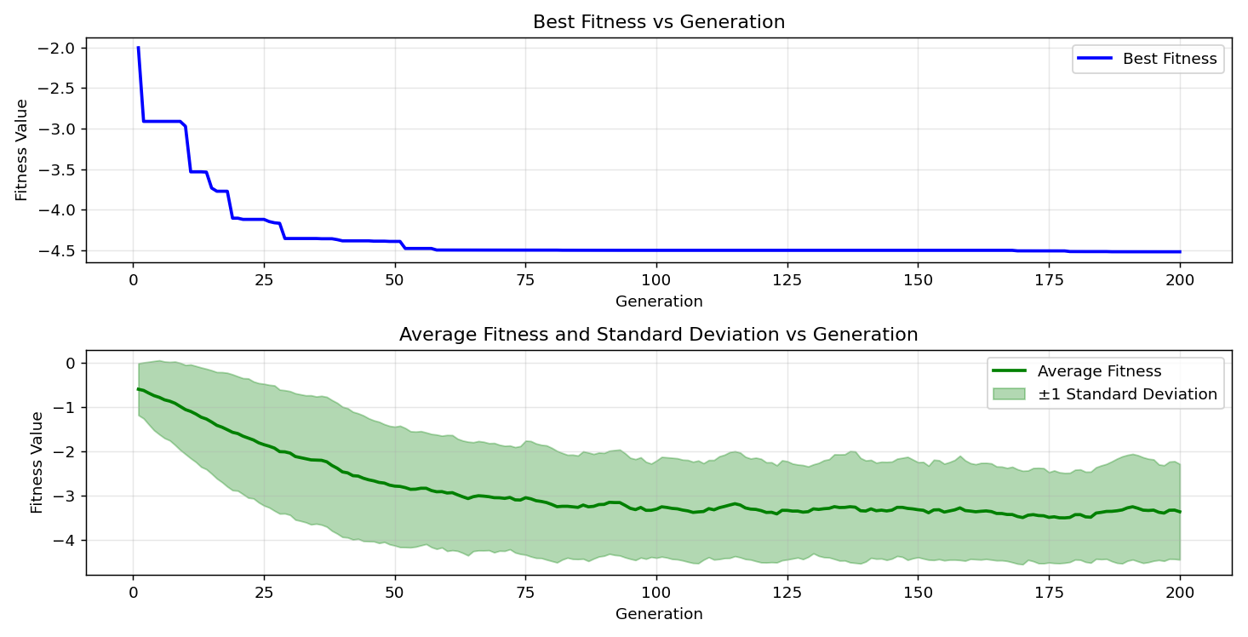

=== FINAL RESULTS ===
Best Fitness: -4.686211
Best Solution: [2.20946989010989, 1.5673427032967033, 1.2850215506715505, 1.9240800293040294, 1.7207781123321124]
Total Time: 5.12s

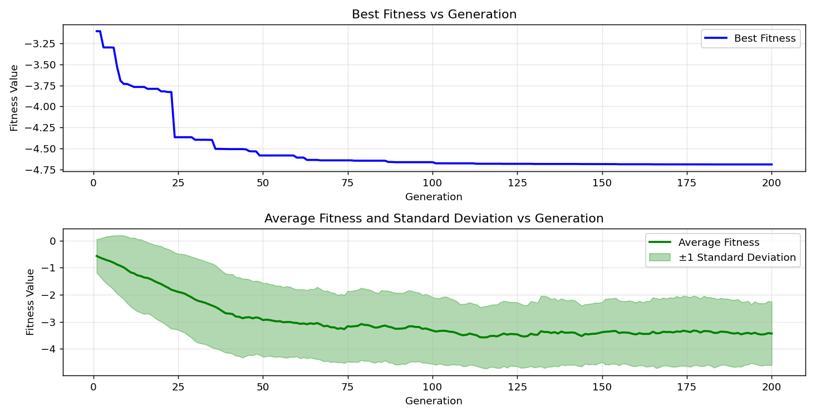
=== FINAL RESULTS ===
Best Fitness: -4.669799
Best Solution: [2.2033324737484734, 1.5704114114774115, 1.2850215506715505, 1.9141067277167274, 1.7207781123321124]
Total Time: 5.16s

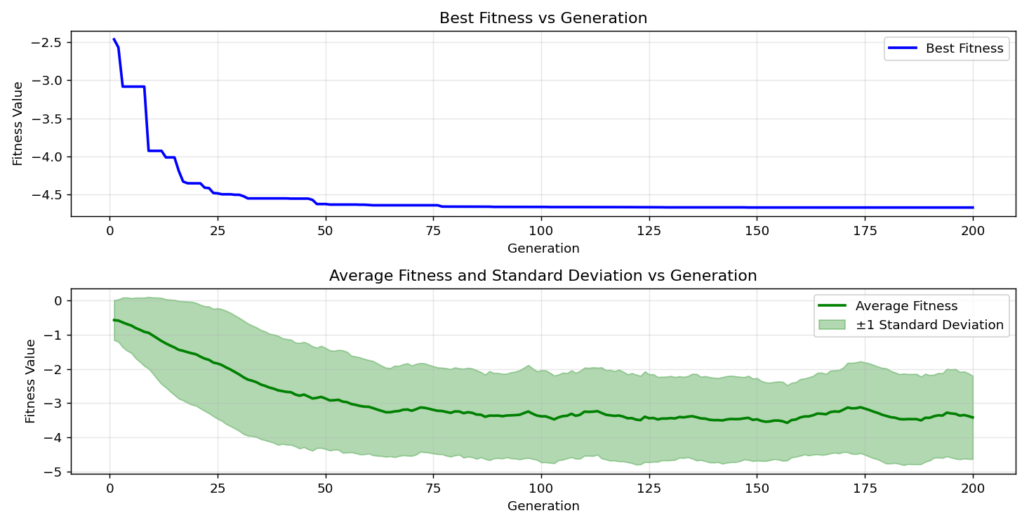

=== FINAL RESULTS ===
Best Fitness: -4.687386
Best Solution: [2.2033324737484734, 1.5704114114774115, 1.2850215506715505, 1.9240800293040294, 1.7207781123321124]
Total Time: 5.08s

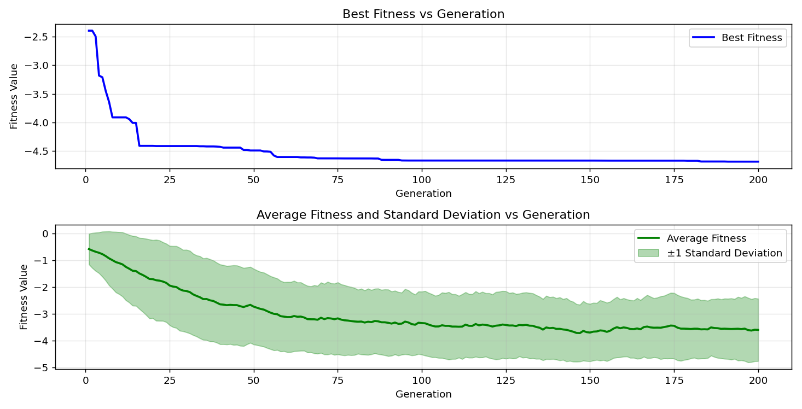

=== FINAL RESULTS ===
Best Fitness: -4.684504
Best Solution: [2.2025652967032965, 1.5711785885225884, 1.2888574358974358, 1.9233128522588523, 1.7177094041514038]
Total Time: 5.16s

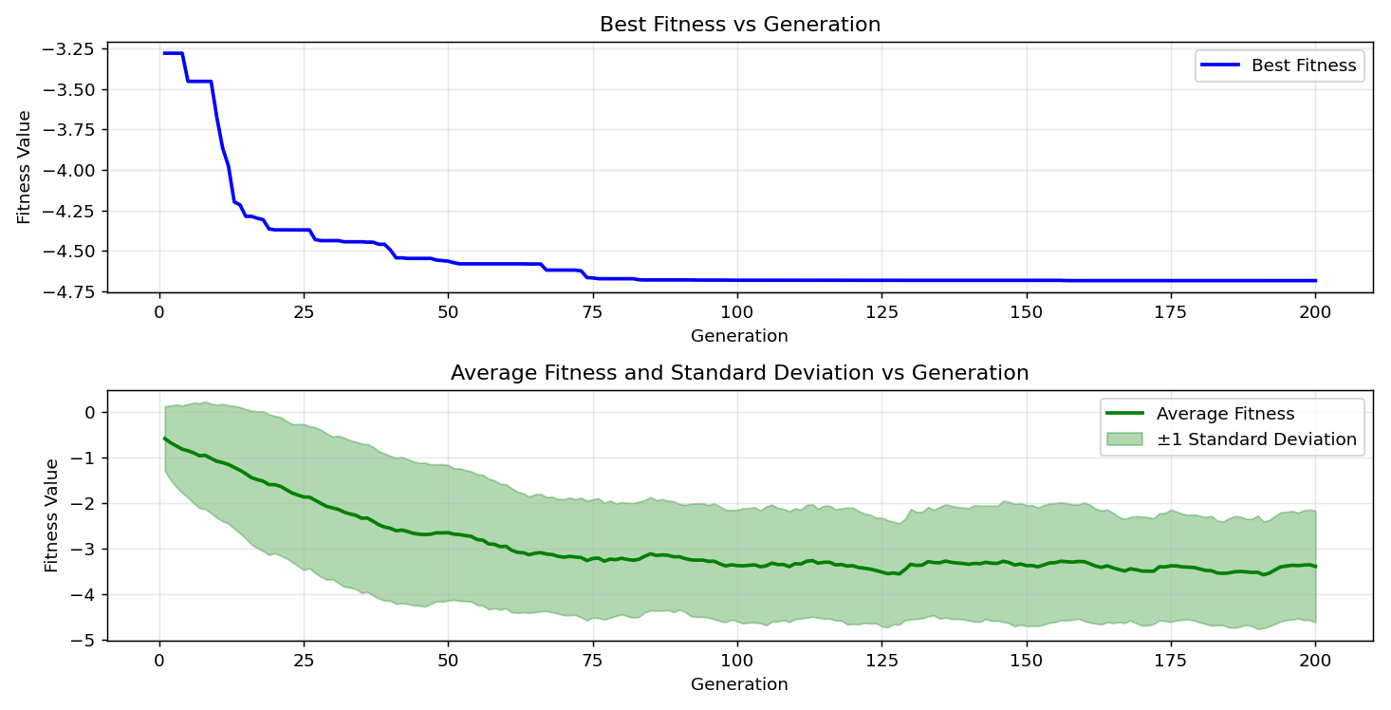

=== FINAL RESULTS ===
Best Fitness: -4.681887
Best Solution: [2.2125385982905983, 1.5696442344322343, 1.2888574358974358, 1.9194769670329672, 1.7192437582417583]
Total Time: 5.03s

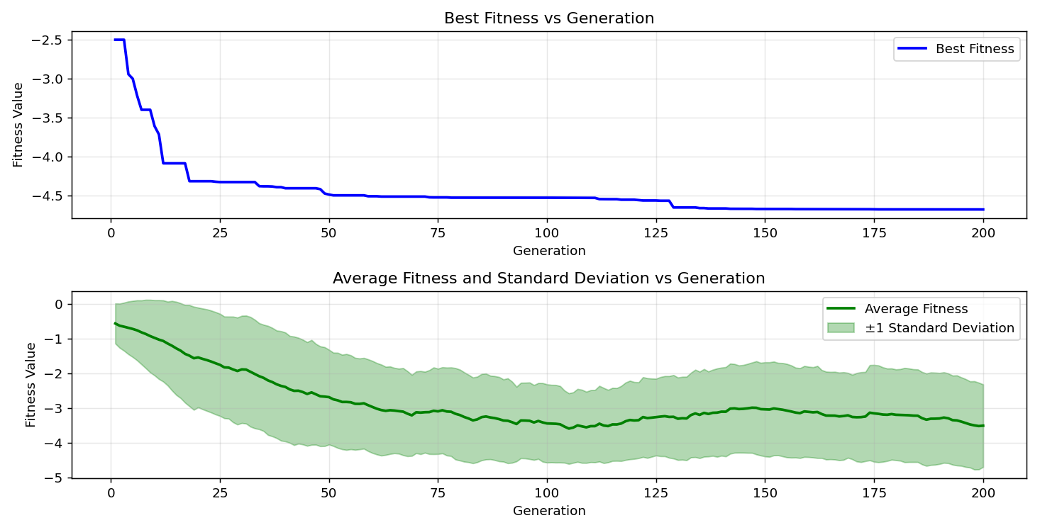

=== FINAL RESULTS ===
Best Fitness: -4.686649
Best Solution: [2.20946989010989, 1.5711785885225884, 1.2857887277167277, 1.9240800293040294, 1.7207781123321124]
Total Time: 5.24s

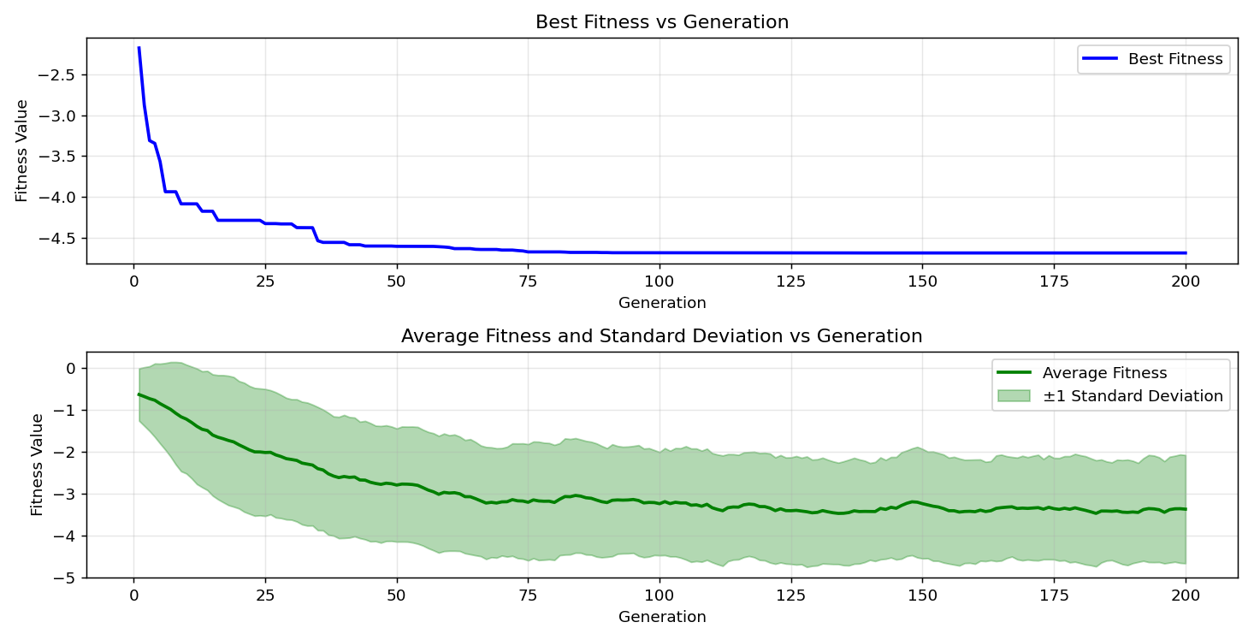

=== FINAL RESULTS ===
Best Fitness: -4.664929
Best Solution: [2.2033324737484734, 1.5704114114774115, 1.2758154261294261, 1.9141067277167274, 1.7207781123321124]
Total Time: 5.03s

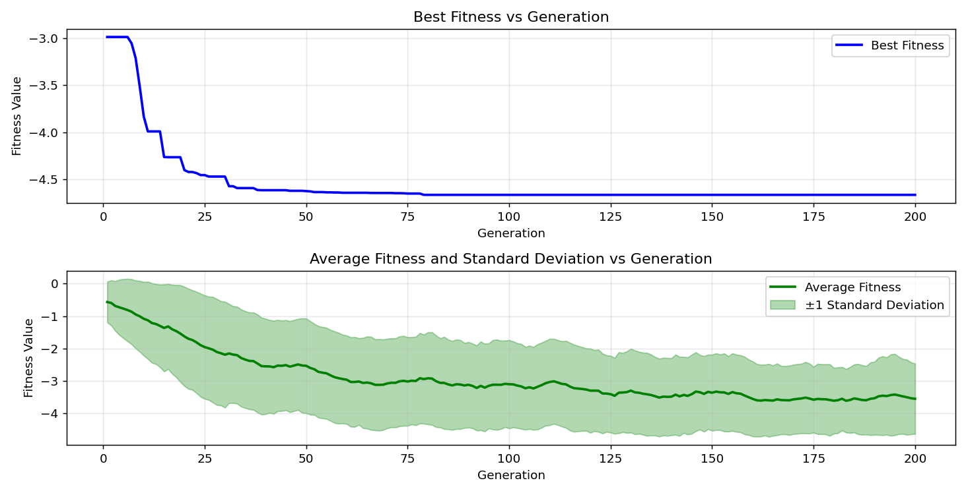

=== FINAL RESULTS ===
Best Fitness: -4.687160
Best Solution: [2.2025652967032965, 1.5711785885225884, 1.2834871965811965, 1.9233128522588523, 1.7215452893772896]
Total Time: 5.01s

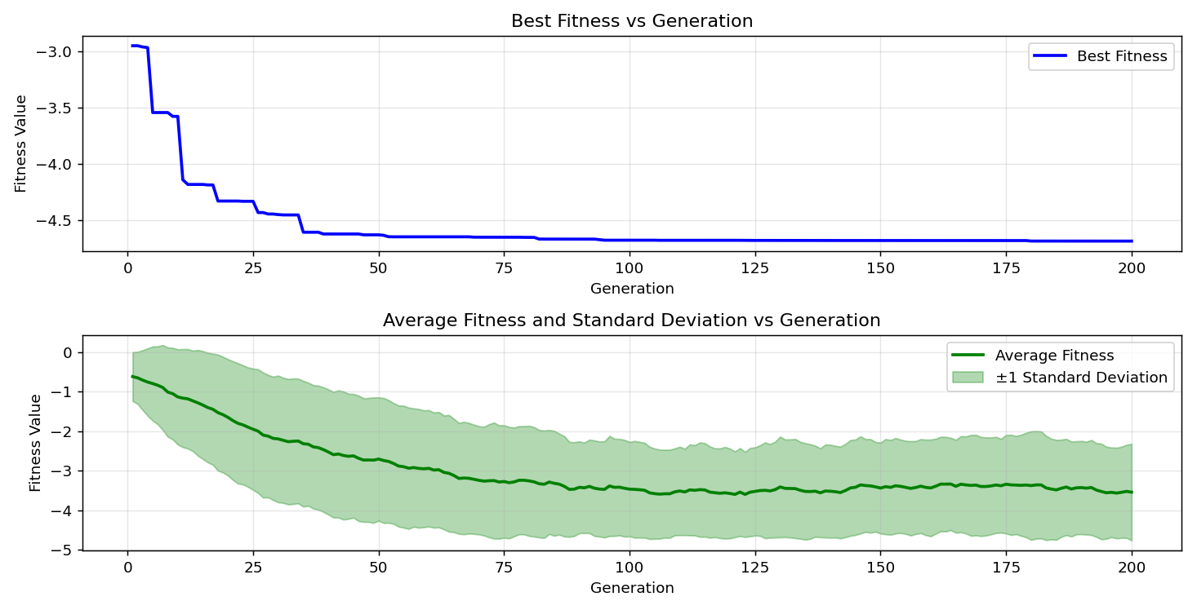

=== FINAL RESULTS ===
Best Fitness: -4.683849
Best Solution: [2.2025652967032965, 1.5711785885225884, 1.2850215506715505, 1.9271487374847376, 1.7207781123321124]
Total Time: 5.02s

