=== FINAL RESULTS ===
Best Fitness: 1602.384866
Best Solution: [-18.339438339438345, -46.275946275946275, -49.98778998778999, 16.825396825396837, -24.737484737484735, -26.105006105006098, 5.054945054945065, -53.26007326007326, 24.346764346764346, 80.56166056166057]
Total Time: 15.34s

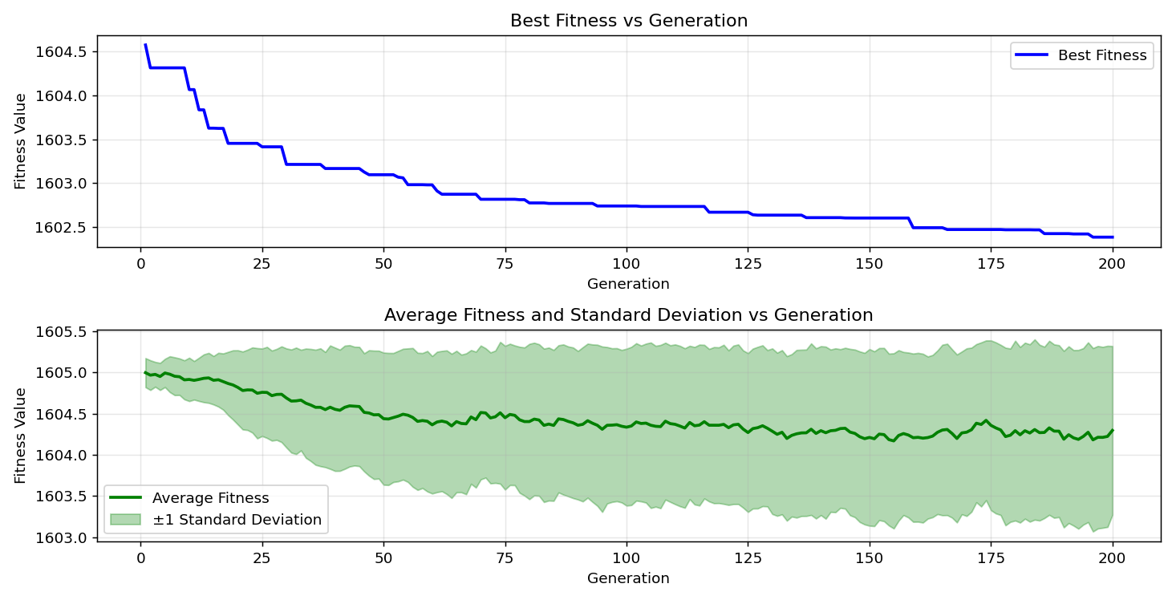

=== FINAL RESULTS ===
Best Fitness: 1603.676325
Best Solution: [-28.107448107448107, 99.9023199023199, -9.401709401709397, -45.73870573870574, -0.073260073260073, -62.1978021978022, -84.51770451770452, -26.300366300366292, 76.6056166056166, 11.062271062271066]
Total Time: 15.29s

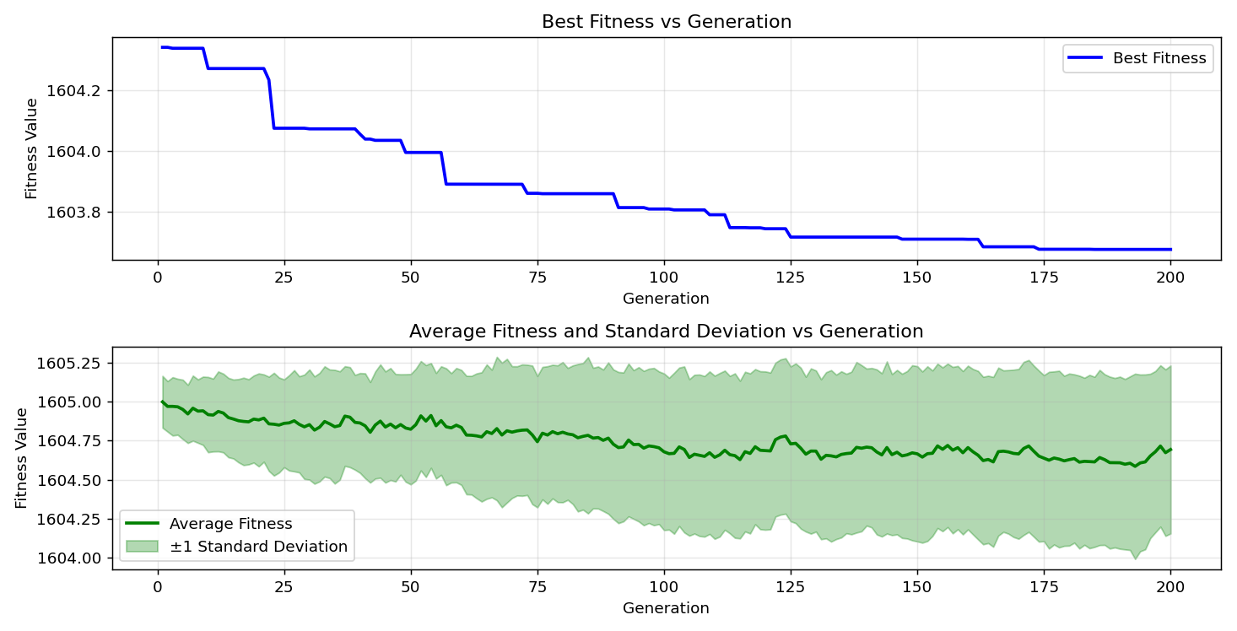
=== FINAL RESULTS ===
Best Fitness: 1603.487561
Best Solution: [-10.476190476190467, -31.86813186813187, 10.134310134310141, -54.38339438339438, -8.620268620268618, 23.02808302808303, -27.374847374847377, 87.78998778998778, -18.339438339438345, 8.669108669108667]
Total Time: 15.31s

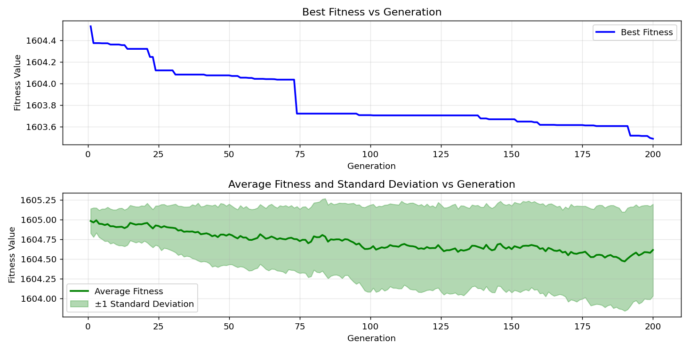
=== FINAL RESULTS ===
Best Fitness: 1603.010980
Best Solution: [-76.8009768009768, -34.26129426129427, 25.079365079365076, 91.45299145299145, 24.688644688644686, -42.46642246642247, 72.16117216117217, -59.413919413919416, -14.627594627594632, 97.36263736263737]
Total Time: 15.61s

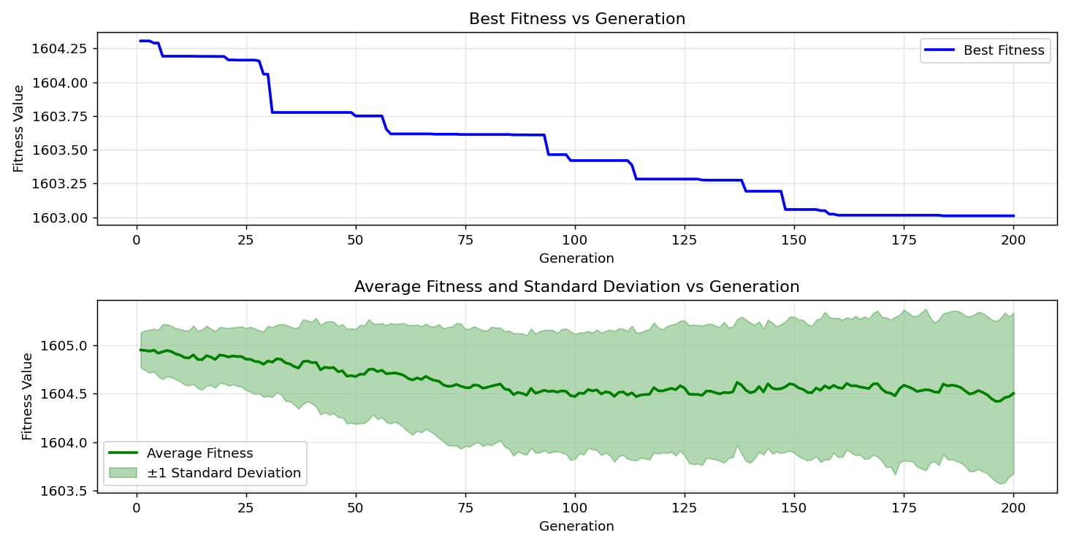

=== FINAL RESULTS ===
Best Fitness: 1603.318074
Best Solution: [-76.6056166056166, -50.427350427350426, -89.74358974358975, -67.66788766788767, -61.7094017094017, -61.7094017094017, -39.047619047619044, -53.211233211233214, 36.75213675213675, -25.714285714285708]
Total Time: 15.40s

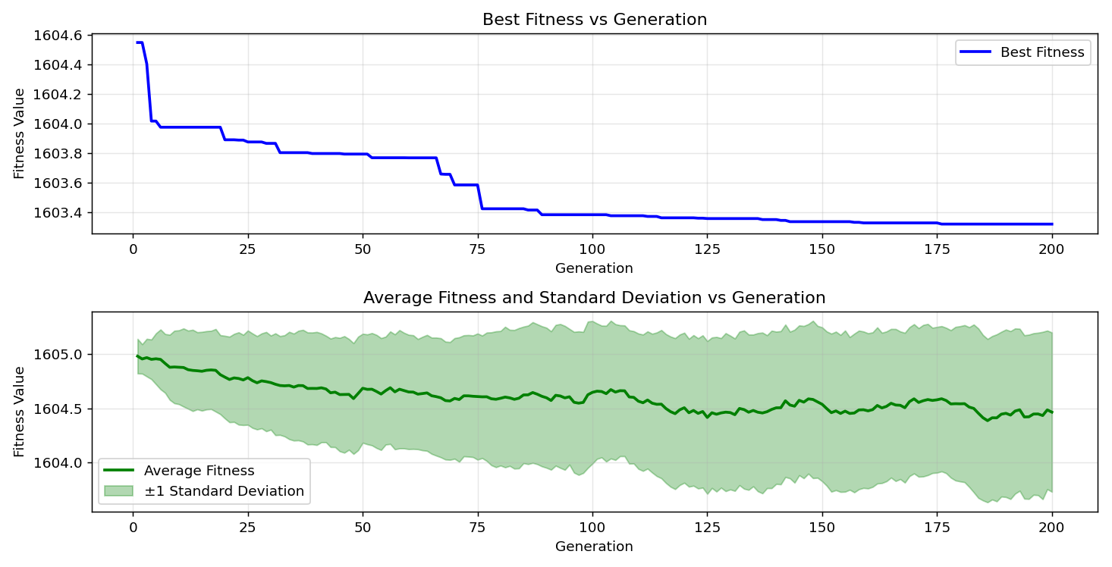
=== FINAL RESULTS ===
Best Fitness: 1603.660619
Best Solution: [42.56410256410257, 27.179487179487168, 31.28205128205127, 17.557997557997567, -19.853479853479854, -52.820512820512825, -48.131868131868124, 29.670329670329664, 35.67765567765568, -99.85347985347985]
Total Time: 15.45s

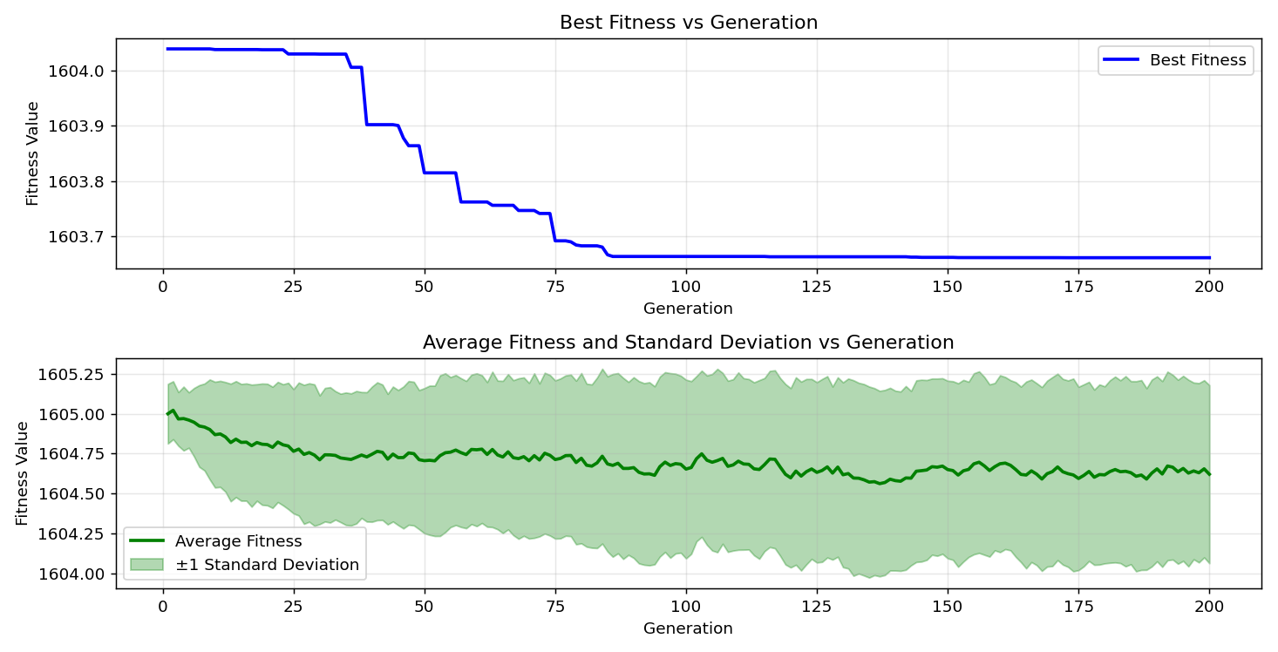

=== FINAL RESULTS ===
Best Fitness: 1603.239791
Best Solution: [-20.78144078144078, -37.48473748473749, -59.75579975579976, 11.794871794871796, -23.614163614163616, -15.995115995115995, -39.82905982905983, 9.7924297924298, 96.92307692307693, -17.264957264957275]
Total Time: 15.42s

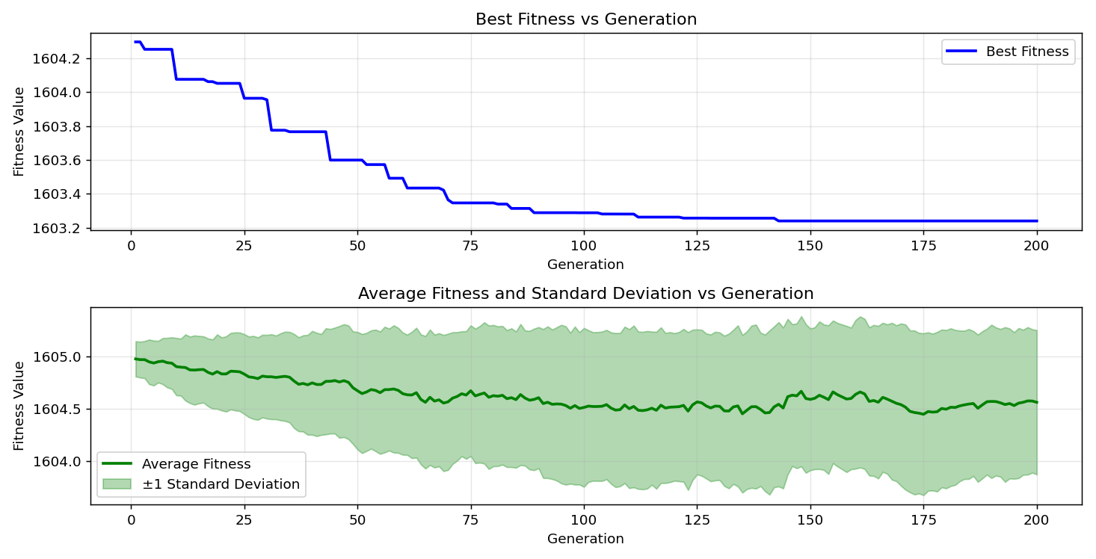
=== FINAL RESULTS ===
Best Fitness: 1603.342749
Best Solution: [-65.27472527472528, -62.979242979242976, -91.64835164835165, -28.107448107448107, -46.275946275946275, -31.42857142857143, 42.368742368742375, 34.017094017093996, -17.216117216117226, 41.44078144078145]
Total Time: 15.35s

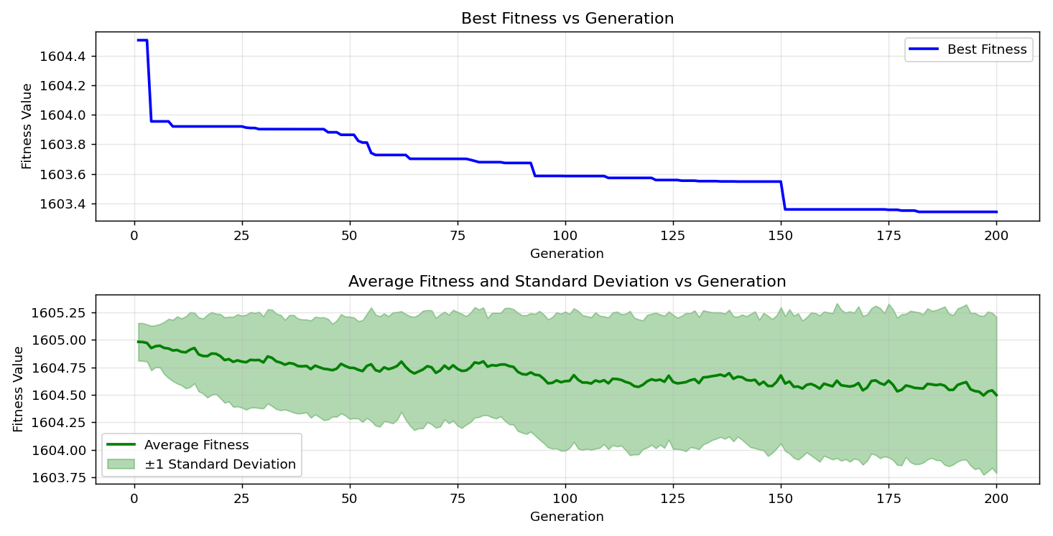

=== FINAL RESULTS ===
Best Fitness: 1602.892226
Best Solution: [0.17094017094017033, -37.24053724053724, 38.754578754578745, -90.42735042735043, -22.490842490842482, -37.28937728937729, -69.03540903540903, -66.83760683760684, -26.007326007326, 16.190476190476204]
Total Time: 15.35s

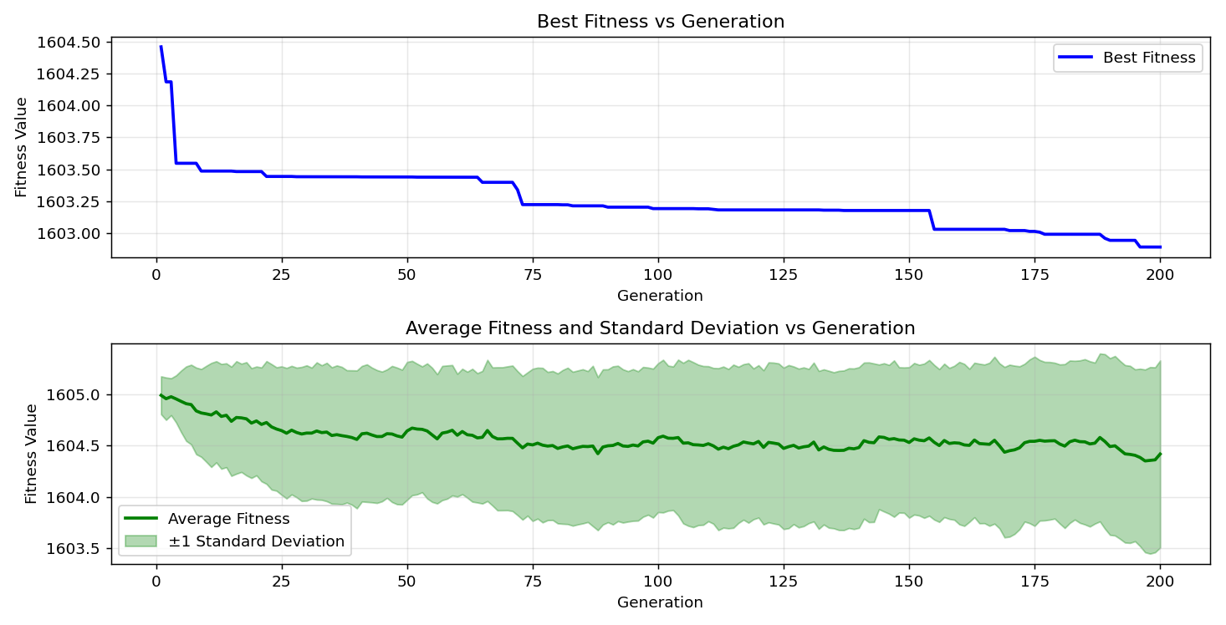
=== FINAL RESULTS ===
Best Fitness: 1602.971603
Best Solution: [6.471306471306477, -10.915750915750905, -77.68009768009767, 95.75091575091574, -8.229548229548229, -41.34310134310134, -52.33211233211233, -4.664224664224662, 3.1013431013430903, -91.20879120879121]
Total Time: 15.44s

