=== FINAL RESULTS ===
Best Fitness: -1.801296
Best Solution: [2.2025652967032965, 1.5704114114774115]
Total Time: 4.44s
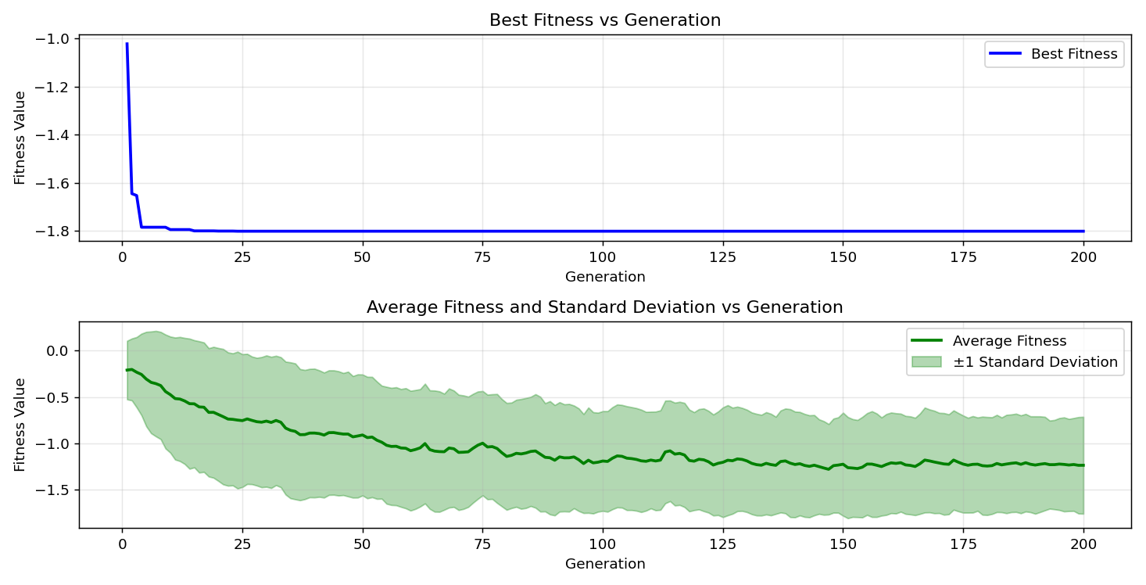

=== FINAL RESULTS ===
Best Fitness: -1.801296
Best Solution: [2.2025652967032965, 1.5711785885225884]
Total Time: 4.44s
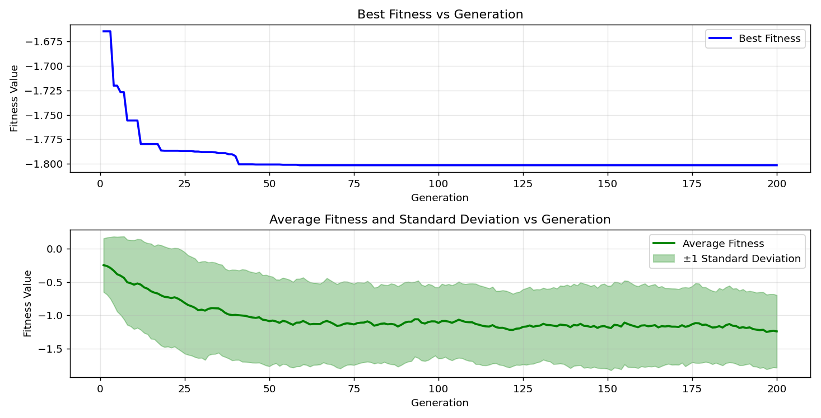

=== FINAL RESULTS ===
Best Fitness: -1.801296
Best Solution: [2.2025652967032965, 1.5711785885225884]
Total Time: 4.30s

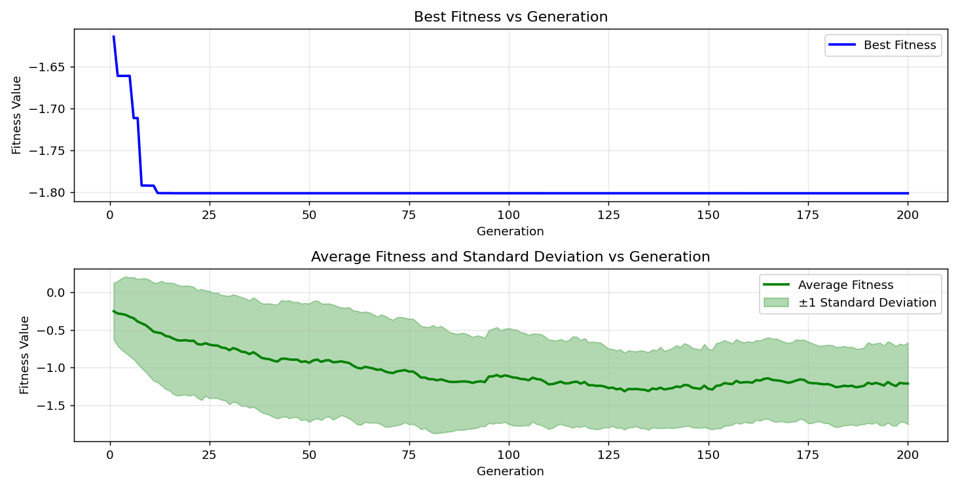

=== FINAL RESULTS ===
Best Fitness: -1.801296
Best Solution: [2.2025652967032965, 1.5704114114774115]
Total Time: 4.31s

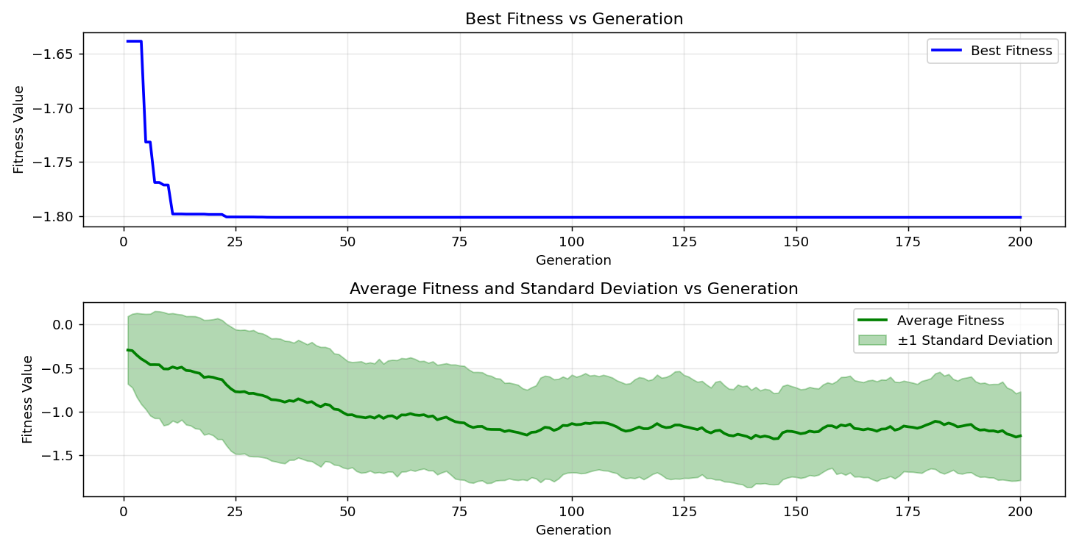

=== FINAL RESULTS ===
Best Fitness: -1.801296
Best Solution: [2.2025652967032965, 1.5704114114774115]
Total Time: 4.53s

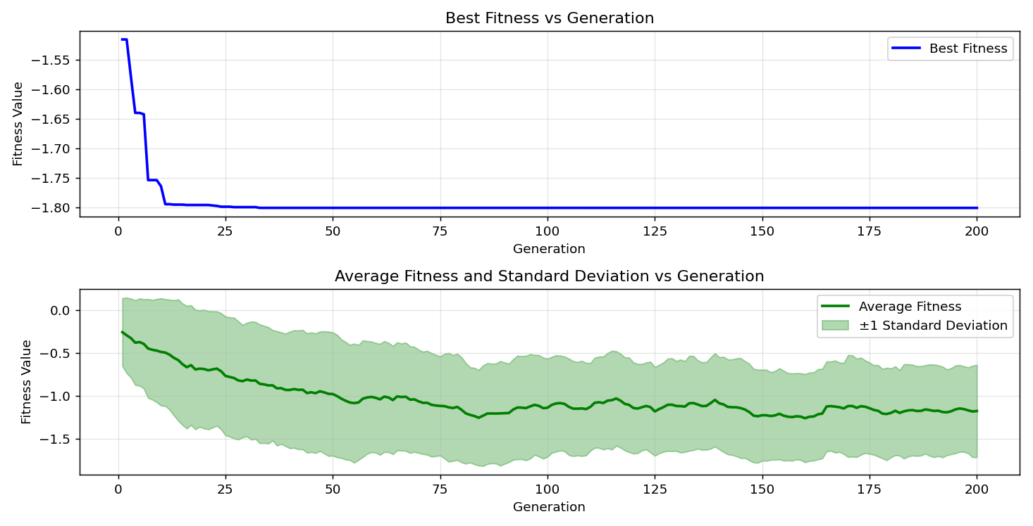

=== FINAL RESULTS ===
Best Fitness: -1.801295
Best Solution: [2.2033324737484734, 1.5711785885225884]
Total Time: 4.56s

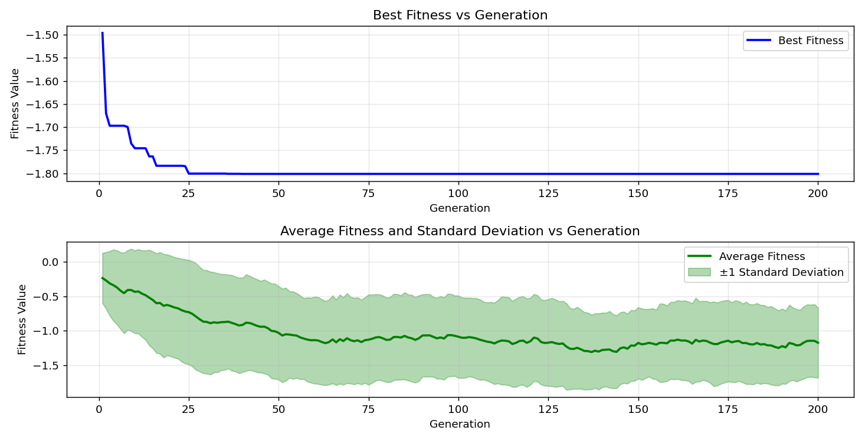

=== FINAL RESULTS ===
Best Fitness: -1.801296
Best Solution: [2.2025652967032965, 1.5711785885225884]
Total Time: 4.45s

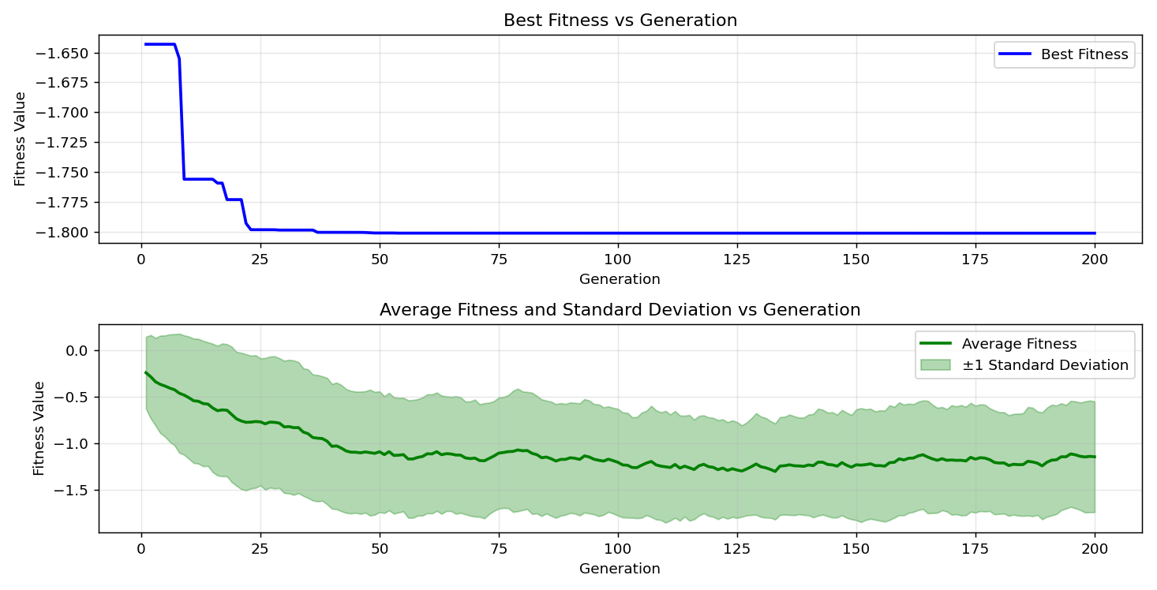

=== FINAL RESULTS ===
Best Fitness: -1.801296
Best Solution: [2.2025652967032965, 1.5711785885225884]
Total Time: 4.53s

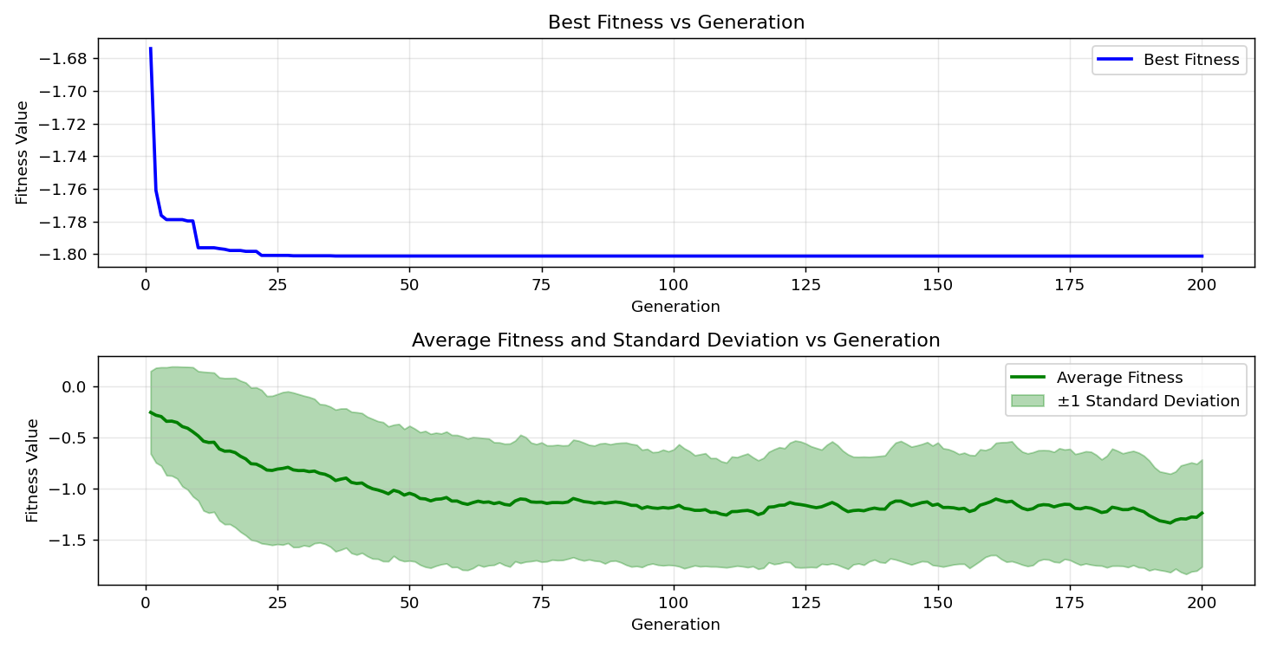

=== FINAL RESULTS ===
Best Fitness: -1.801296
Best Solution: [2.2025652967032965, 1.5711785885225884]
Total Time: 4.41s

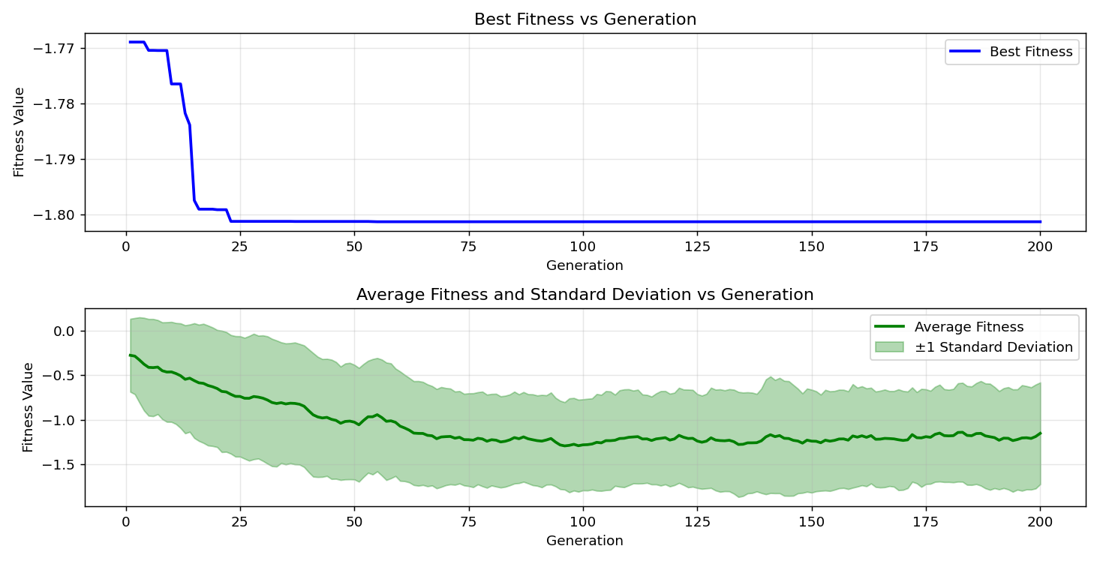

=== FINAL RESULTS ===
Best Fitness: -1.801296
Best Solution: [2.2025652967032965, 1.5711785885225884]
Total Time: 4.50s

