=== FINAL RESULTS ===
Best Fitness: 1612.022454
Best Solution: [29.914529914529908, 93.79731379731379, 17.167277167277177, -92.62515262515262, -61.46520146520146, 54.13919413919416, -70.69597069597069, -68.4004884004884, -28.253968253968253, -16.434676434676433, -17.216117216117226, 93.01587301587301, 52.42979242979243, 44.566544566544565, -46.91086691086691, -85.68986568986568, 1.1965811965811923, 70.25641025641025, -11.25763125763126, 7.789987789987791, -61.7094017094017, 69.18192918192918, -37.48473748473749, 37.87545787545787, 31.086691086691076, -25.372405372405368, 75.38461538461539, 91.06227106227107, 24.004884004884005, -28.35164835164835]
Total Time: 28.06s

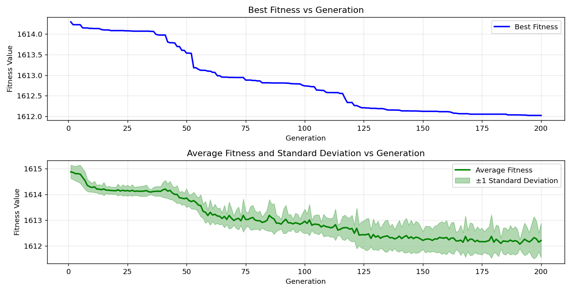
=== FINAL RESULTS ===
Best Fitness: 1611.907293
Best Solution: [-34.700854700854705, -82.75946275946276, -67.32600732600733, -47.98534798534798, -45.34798534798535, -2.026862026862034, -68.44932844932845, -81.24542124542124, -63.12576312576312, -64.05372405372405, -53.99267399267399, -49.401709401709404, 16.190476190476204, 79.82905982905984, -43.101343101343105, 83.58974358974359, -81.39194139194139, 67.96092796092796, -24.93284493284493, -70.45177045177044, 19.853479853479854, 43.54090354090354, 50.81807081807082, -47.350427350427346, 58.97435897435898, -52.38095238095239, -21.904761904761898, -24.444444444444443, -98.04639804639805, -52.33211233211233]
Total Time: 27.87s

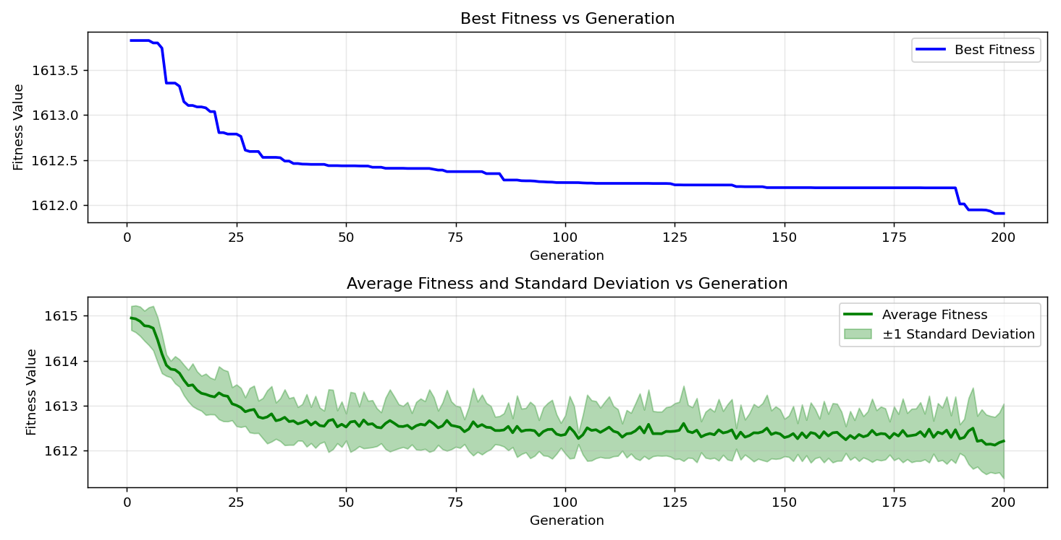
=== FINAL RESULTS ===
Best Fitness: 1612.178214
Best Solution: [10.280830280830287, 16.3858363858364, -12.967032967032964, -89.05982905982906, -60.586080586080584, -36.01953601953603, 1.684981684981679, 63.95604395604394, -49.25518925518926, 37.04517704517704, -35.775335775335776, 77.82661782661782, -14.529914529914535, -17.948717948717956, -54.38339438339438, -70.35409035409035, -14.285714285714292, -98.48595848595849, -35.72649572649573, -27.27716727716728, -66.34920634920636, -49.694749694749696, 71.03785103785103, -85.1037851037851, 46.47130647130646, -43.15018315018315, -79.1941391941392, 51.64835164835165, 11.25763125763126, -22.686202686202677]
Total Time: 27.79s

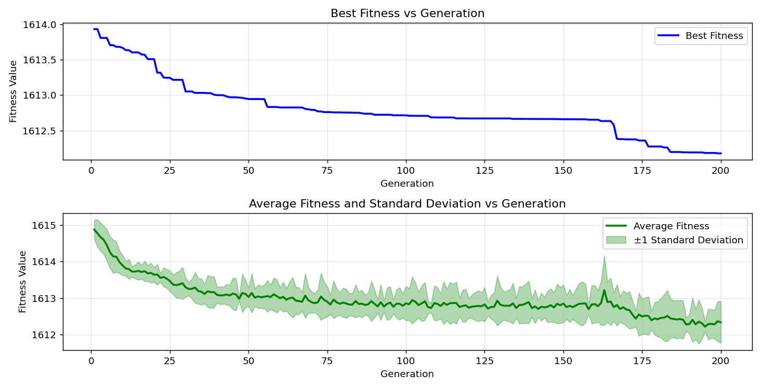

=== FINAL RESULTS ===
Best Fitness: 1612.742032
Best Solution: [62.393162393162385, -16.043956043956044, 48.81562881562883, -20.830280830280827, 24.688644688644686, 85.64102564102564, -80.51282051282051, -63.956043956043956, 37.19169719169719, 59.853479853479854, -6.71550671550672, 46.86202686202685, -10.525030525030516, 91.30647130647131, -1.5873015873015959, -51.74603174603175, -96.97191697191697, 82.31990231990233, 94.52991452991452, 76.8009768009768, -27.130647130647134, -50.81807081807082, -5.054945054945065, -45.34798534798535, 99.02319902319903, 20.634920634920633, 86.56898656898656, 59.02319902319903, -50.81807081807082, -84.81074481074481]
Total Time: 28.26s

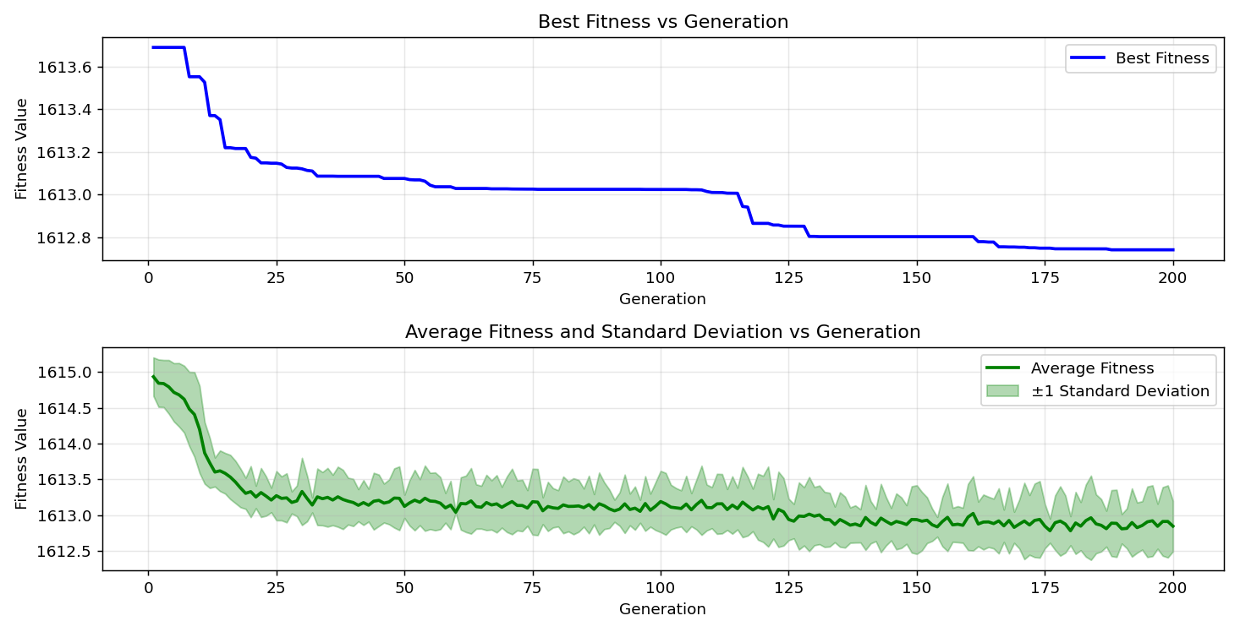
=== FINAL RESULTS ===
Best Fitness: 1611.799597
Best Solution: [-90.67155067155068, -97.31379731379731, -48.18070818070817, -57.8021978021978, 45.250305250305246, -57.60683760683761, -19.95115995115995, -15.750915750915752, 3.1501831501831674, 16.092796092796107, -58.095238095238095, 46.47130647130646, -92.38095238095238, 3.199023199023216, 15.653235653235669, -33.577533577533586, -75.28693528693529, 29.719169719169713, -22.19780219780219, 3.2967032967033134, -10.964590964590968, 34.94505494505495, 99.56043956043956, 61.75824175824175, 53.89499389499392, -20.830280830280827, 21.85592185592185, -34.40781440781441, -11.550671550671552, 11.306471306471309]
Total Time: 27.68s

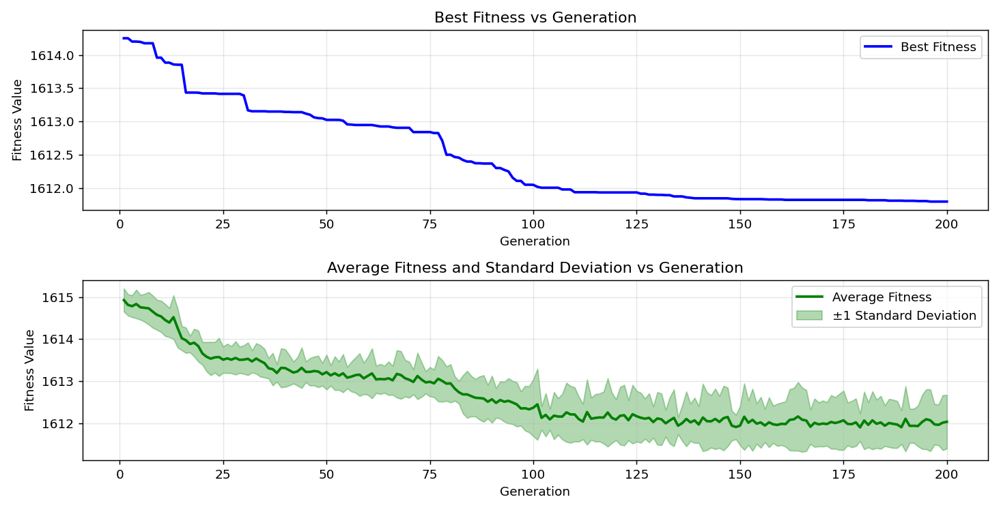
=== FINAL RESULTS ===
Best Fitness: 1612.250581
Best Solution: [73.52869352869354, 62.97924297924297, -81.0989010989011, -83.78510378510379, -74.94505494505495, -28.547008547008545, -11.550671550671552, -34.84737484737485, -13.406593406593402, -90.76923076923077, 37.48473748473748, -93.6019536019536, -51.452991452991455, -55.16483516483516, -77.97313797313797, 6.227106227106233, 88.13186813186812, -31.379731379731382, -2.564102564102569, -76.41025641025641, -38.46153846153846, 7.887667887667888, -34.358974358974365, -2.026862026862034, 35.14041514041514, -6.471306471306477, 22.539682539682545, 47.35042735042737, -51.062271062271066, 13.11355311355311]
Total Time: 27.91s

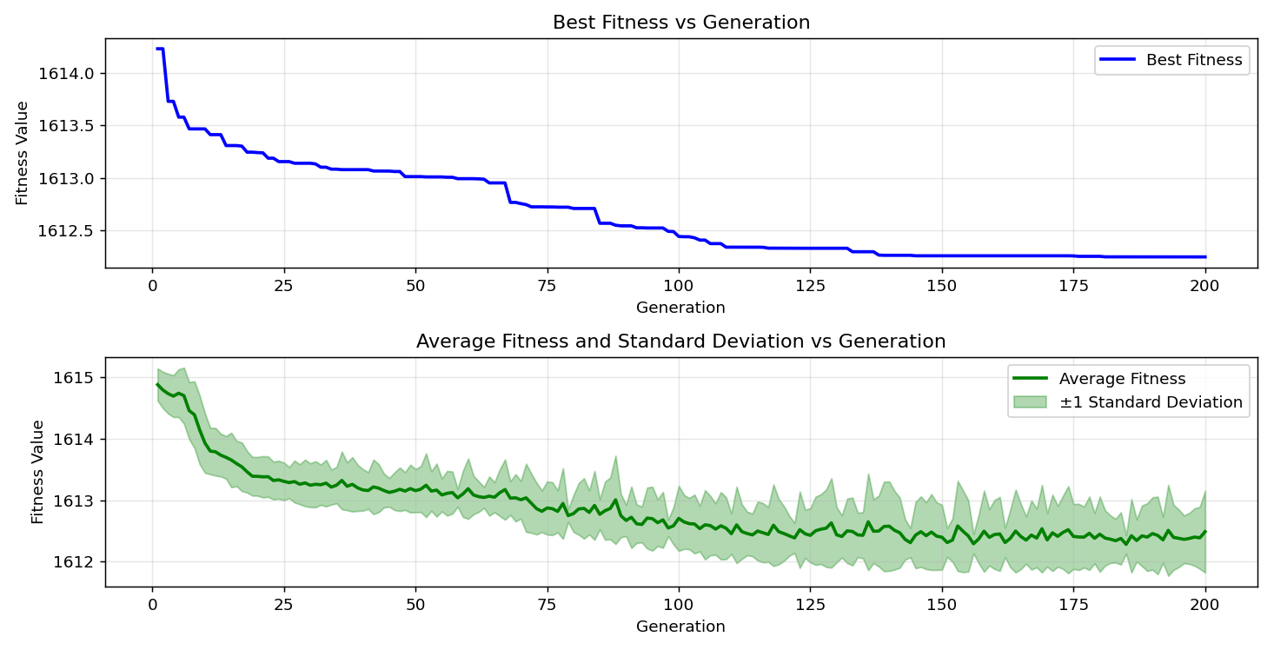

=== FINAL RESULTS ===
Best Fitness: 1611.032180
Best Solution: [-13.357753357753353, 50.720390720390725, 65.6166056166056, 1.7338217338217277, -32.991452991453, 4.51770451770453, -78.02197802197801, -85.2014652014652, -63.27228327228327, 54.334554334554355, -49.05982905982906, 39.487179487179475, -77.38705738705738, -98.04639804639805, -32.844932844932856, -61.22100122100122, -88.18070818070818, 24.981684981684978, -73.04029304029304, 43.2967032967033, 68.4004884004884, 93.74847374847374, -72.16117216117216, 15.115995115995105, 96.63003663003661, -49.5970695970696, -5.445665445665455, -46.71550671550671, 58.48595848595849, -11.013431013431017]
Total Time: 28.02s
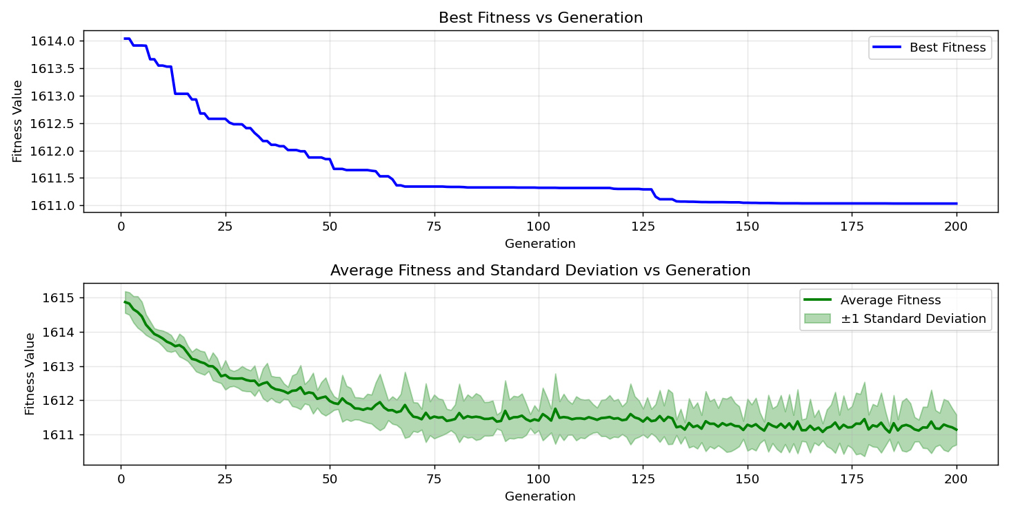

=== FINAL RESULTS ===
Best Fitness: 1612.838815
Best Solution: [76.11721611721612, 64.10256410256409, 78.55921855921858, -52.57631257631258, -40.61050061050061, 36.898656898656895, 45.982905982905976, -1.3431013431013383, -59.413919413919416, -7.741147741147742, 7.057387057387061, -83.2967032967033, 38.85225885225884, 10.52503052503053, 37.38705738705738, -12.234432234432234, 92.13675213675214, 92.96703296703296, 68.35164835164835, 28.05860805860806, 61.17216117216117, -86.22710622710622, -22.97924297924297, 88.5225885225885, -95.50671550671551, 3.931623931623946, 44.566544566544565, 82.31990231990233, 50.62271062271063, -55.7020757020757]
Total Time: 28.26s

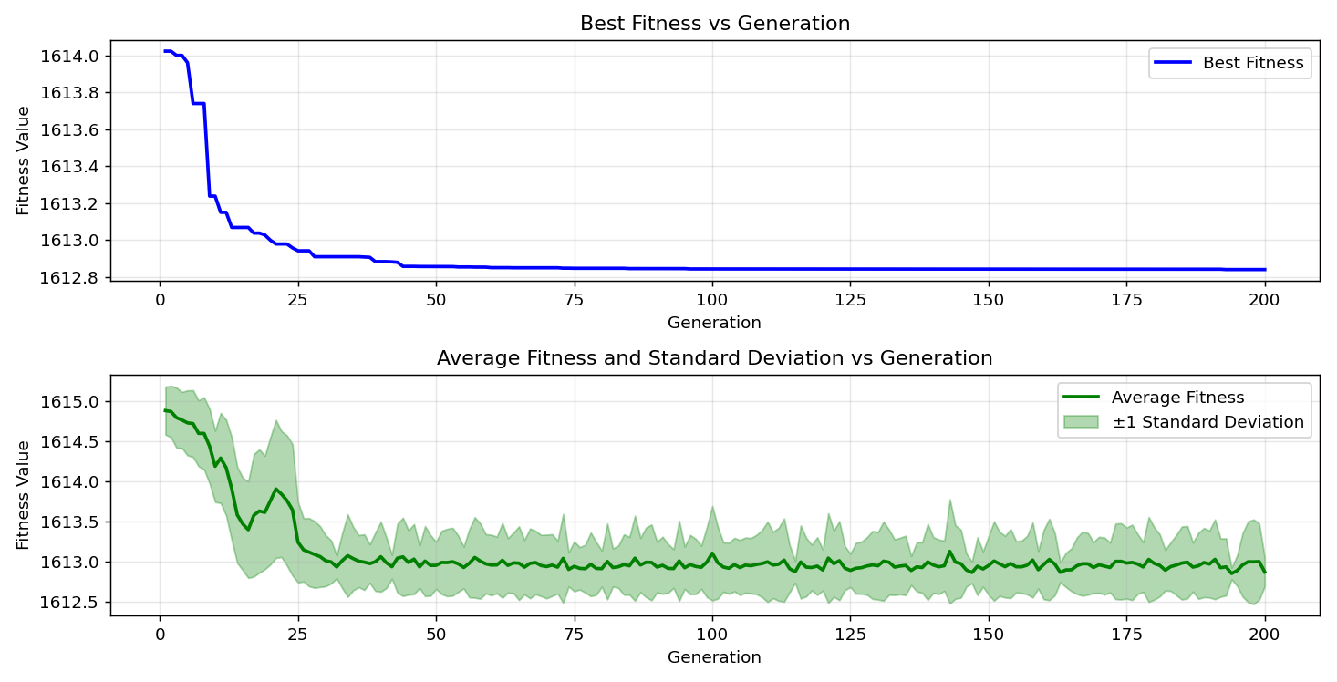
=== FINAL RESULTS ===
Best Fitness: 1611.772018
Best Solution: [2.5152625152625063, 32.991452991452974, -0.17094017094017033, 96.09279609279608, -7.594627594627596, 5.006105006105017, -98.2905982905983, 53.16239316239319, -99.70695970695971, 57.06959706959708, -6.910866910866915, 13.797313797313791, 31.28205128205127, 30.451770451770443, -5.689865689865698, -36.31257631257632, 11.746031746031747, -78.16849816849816, -57.85103785103785, 15.604395604395592, -10.183150183150175, -67.47252747252747, -24.688644688644686, -35.775335775335776, -99.46275946275946, -11.159951159951163, 85.49450549450549, -78.998778998779, 34.065934065934044, 39.096459096459085]
Total Time: 27.88s

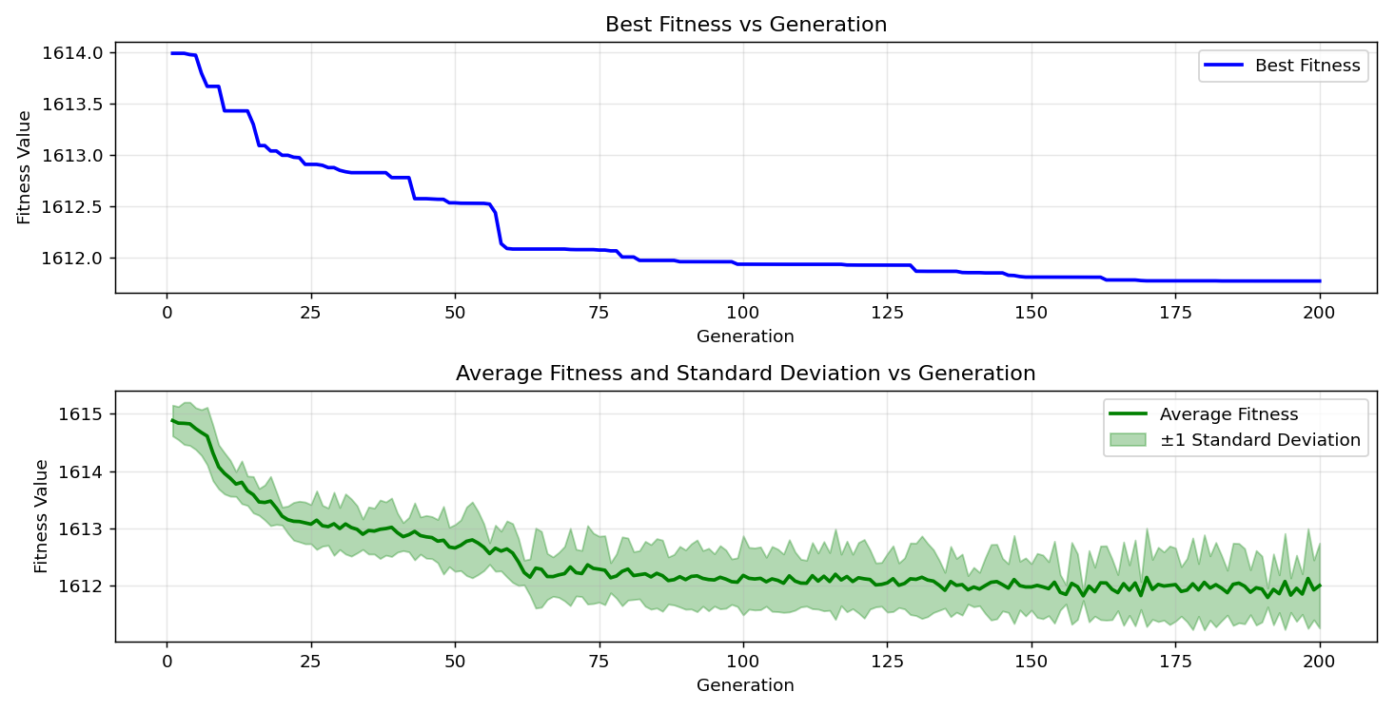

=== FINAL RESULTS ===
Best Fitness: 1612.037555
Best Solution: [-98.97435897435898, 72.84493284493286, 66.5934065934066, -47.741147741147735, -39.53601953601954, 87.008547008547, -15.409035409035411, 27.032967032967022, 90.6227106227106, -34.55433455433456, -29.816849816849825, 55.70207570207572, -71.81929181929182, 68.79120879120879, -41.440781440781436, 31.770451770451757, -62.1001221001221, 37.82661782661782, -70.3052503052503, -99.46275946275946, -25.763125763125757, -87.74114774114774, -9.841269841269835, 98.92551892551893, 25.567765567765562, -35.775335775335776, -47.789987789987784, 72.45421245421247, -37.582417582417584, 62.393162393162385]
Total Time: 27.83s

