=== FINAL RESULTS ===
Best Fitness: -9.242698
Best Solution: [2.2033324737484734, 1.5711785885225884, 1.2758154261294261, 1.9141067277167274, 1.7215452893772896, 1.5704114114774115, 1.8772822295482294, 0.7863564713064712, 1.2819528424908424, 1.8581028034188034]
Total Time: 6.99s
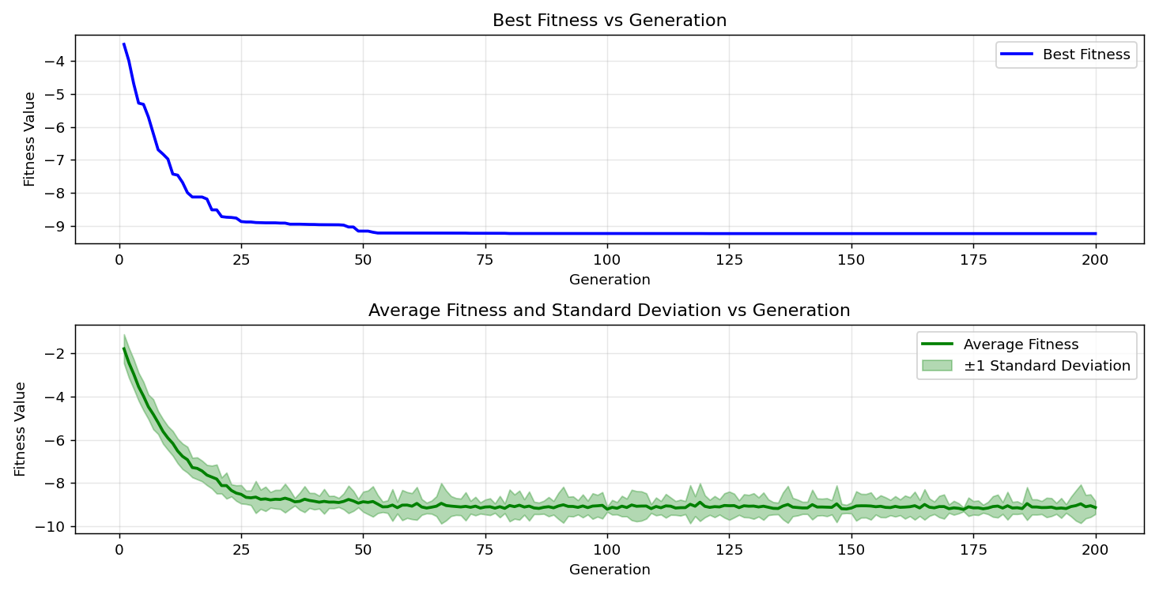
=== FINAL RESULTS ===
Best Fitness: -8.833304
Best Solution: [2.2025652967032965, 1.5711785885225884, 1.1776167643467643, 1.1131738925518926, 1.7207781123321124, 2.0276489304029304, 1.4538005006105006, 2.077515438339438, 1.6440604078144079, 1.5711785885225884]
Total Time: 6.87s

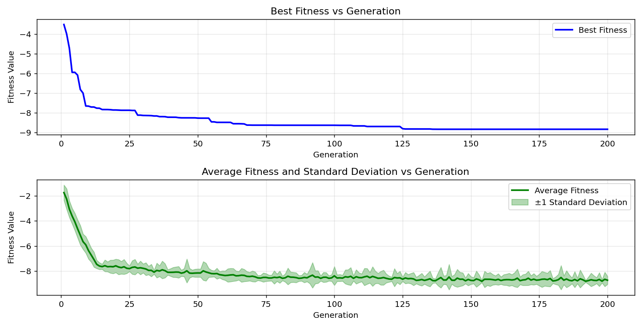

=== FINAL RESULTS ===
Best Fitness: -8.734745
Best Solution: [2.20946989010989, 2.7104365006105007, 1.2758154261294261, 1.9233128522588523, 1.7161750500610498, 1.5704114114774115, 1.8765150525030523, 1.7545339023199022, 1.6555680634920635, 2.3322182173382173]

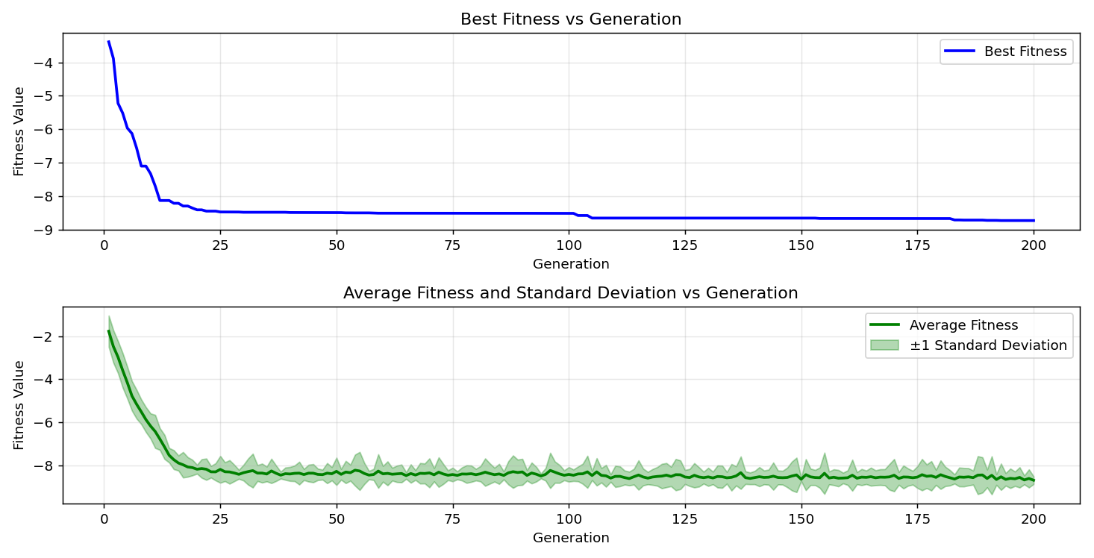
=== FINAL RESULTS ===
Best Fitness: -9.230319
Best Solution: [2.210237067155067, 1.5704114114774115, 1.2758154261294261, 1.1139410695970695, 0.9812194407814407, 2.0261145763125765, 1.4545676776556777, 2.077515438339438, 1.6555680634920635, 1.5711785885225884]

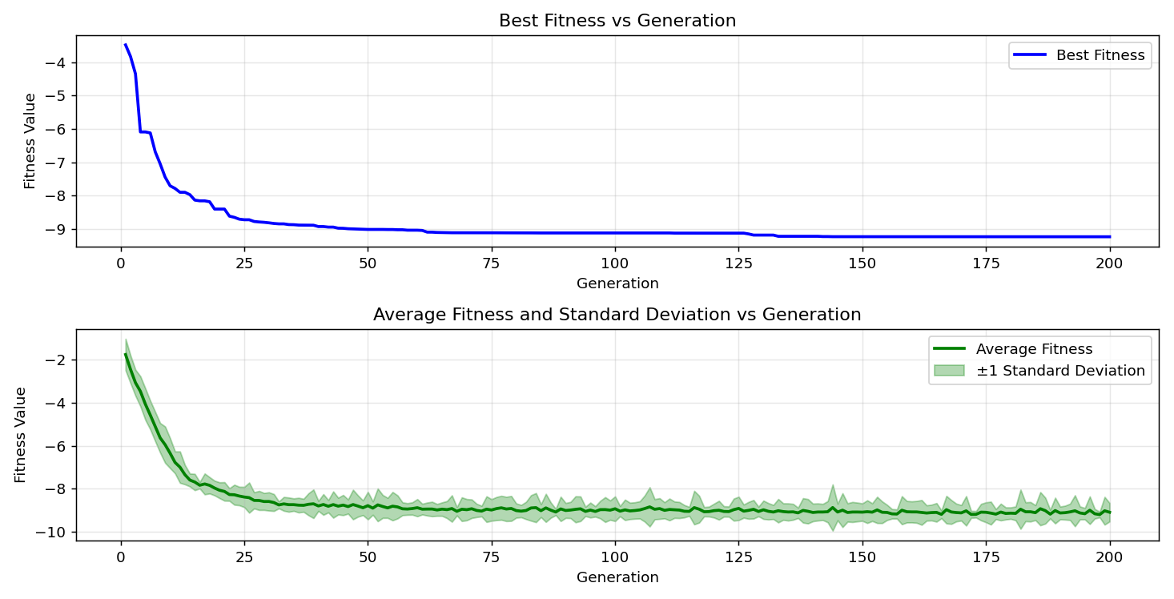

=== FINAL RESULTS ===
Best Fitness: -8.804336
Best Solution: [2.1987294114774114, 1.5688770573870574, 1.275048249084249, 1.1177769548229548, 0.9812194407814407, 1.5704114114774115, 2.2087027130647128, 1.3625064322344322, 1.2827200195360196, 2.3322182173382173]
Total Time: 7.03s

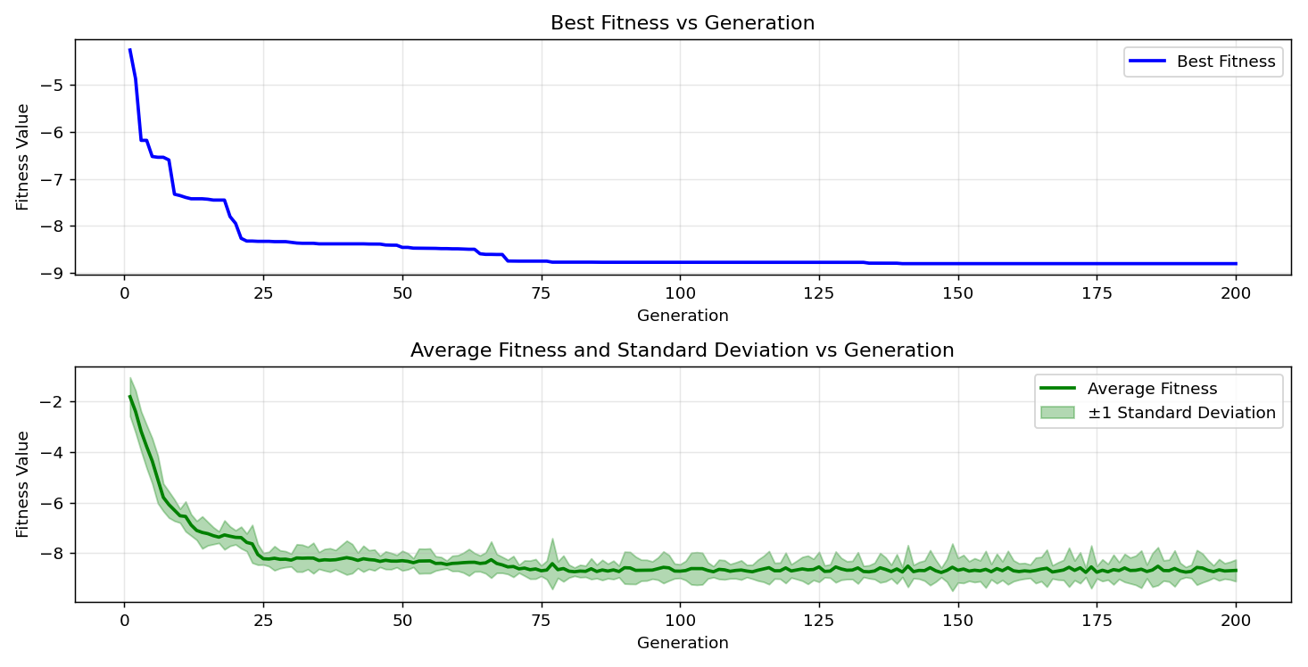

=== FINAL RESULTS ===
Best Fitness: -9.370377
Best Solution: [2.2025652967032965, 1.5704114114774115, 1.2842543736263736, 1.9233128522588523, 2.220977545787546, 1.5704114114774115, 1.4538005006105006, 1.3747812649572648, 1.6555680634920635, 1.5711785885225884]
Total Time: 6.89s

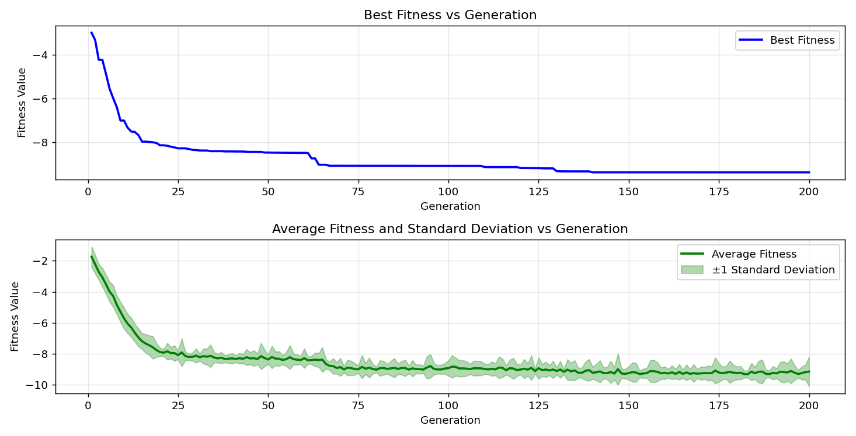
=== FINAL RESULTS ===
Best Fitness: -9.109588
Best Solution: [2.159603382173382, 1.5711785885225884, 1.2758154261294261, 1.0794181025641025, 0.9804522637362637, 2.0245802222222222, 1.8780494065934066, 1.7568354334554335, 1.9570686422466421, 1.5704114114774115]
Total Time: 7.22s

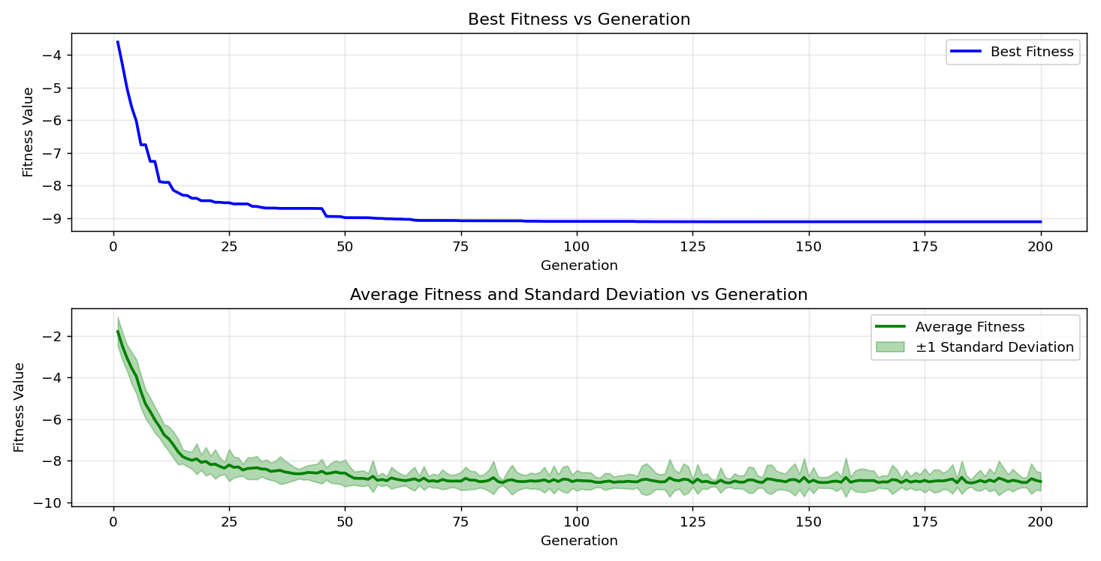

=== FINAL RESULTS ===
Best Fitness: -9.505056
Best Solution: [2.2033324737484734, 1.5704114114774115, 1.2758154261294261, 1.9233128522588523, 1.7207781123321124, 2.0284161074481073, 1.8780494065934066, 1.3625064322344322, 1.6555680634920635, 1.5704114114774115]
Total Time: 6.91s

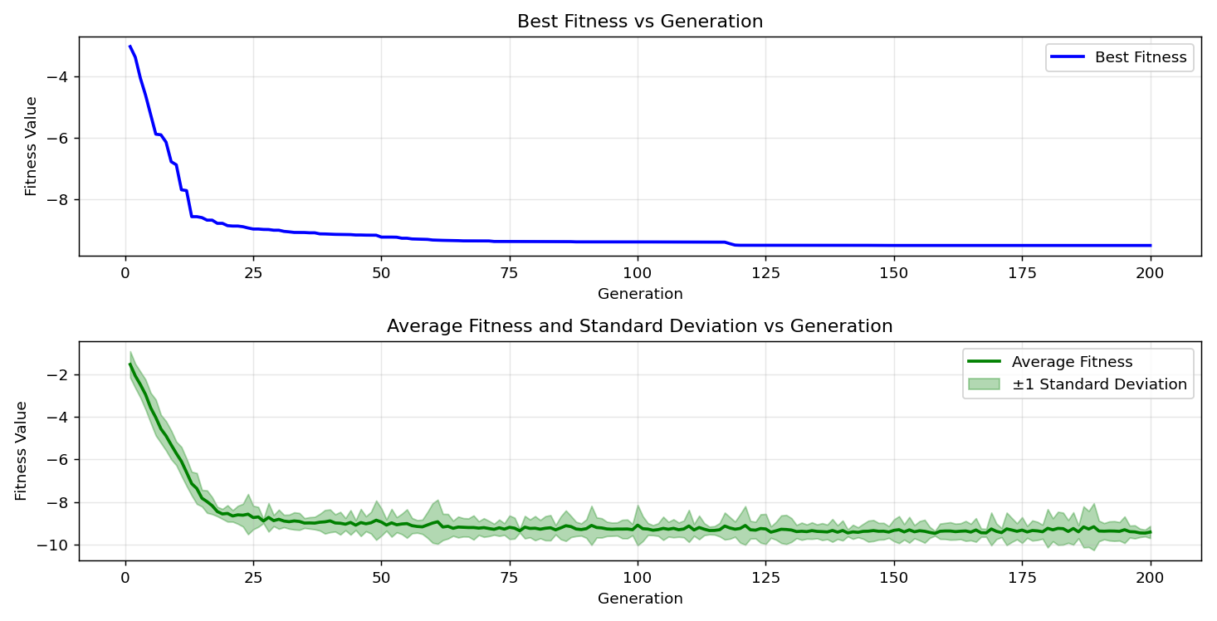
=== FINAL RESULTS ===
Best Fitness: -8.781481
Best Solution: [2.2033324737484734, 1.5719457655677656, 2.2087027130647128, 1.9240800293040294, 0.9973301587301586, 0.9075704444444443, 1.4545676776556777, 0.7894251794871795, 1.2758154261294261, 1.5704114114774115]
Total Time: 6.96s

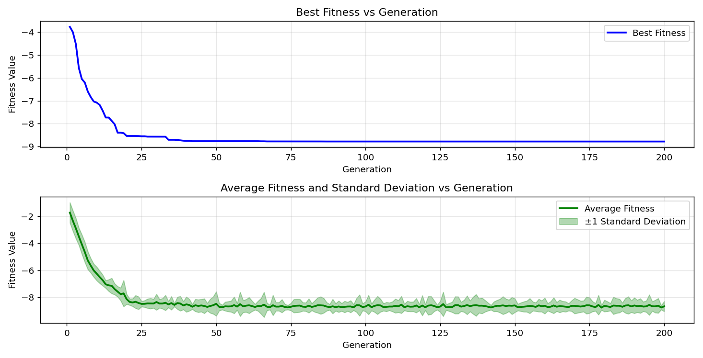
=== FINAL RESULTS ===
Best Fitness: -9.377782
Best Solution: [2.1994965885225883, 1.5711785885225884, 1.2758154261294261, 1.1101051843711844, 0.9812194407814407, 1.5711785885225884, 1.4545676776556777, 1.7545339023199022, 1.2758154261294261, 1.5711785885225884]
Total Time: 7.08s

