=== FINAL RESULTS ===
Best Fitness: -1.801294
Best Solution: [2.2033324737484734, 1.5704114114774115]
Total Time: 4.66s

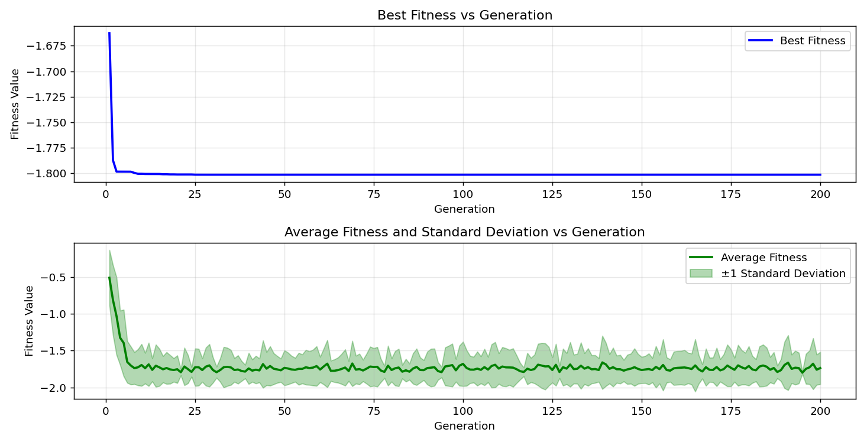

=== FINAL RESULTS ===
Best Fitness: -1.800595
Best Solution: [2.20946989010989, 1.5711785885225884]
Total Time: 4.78s

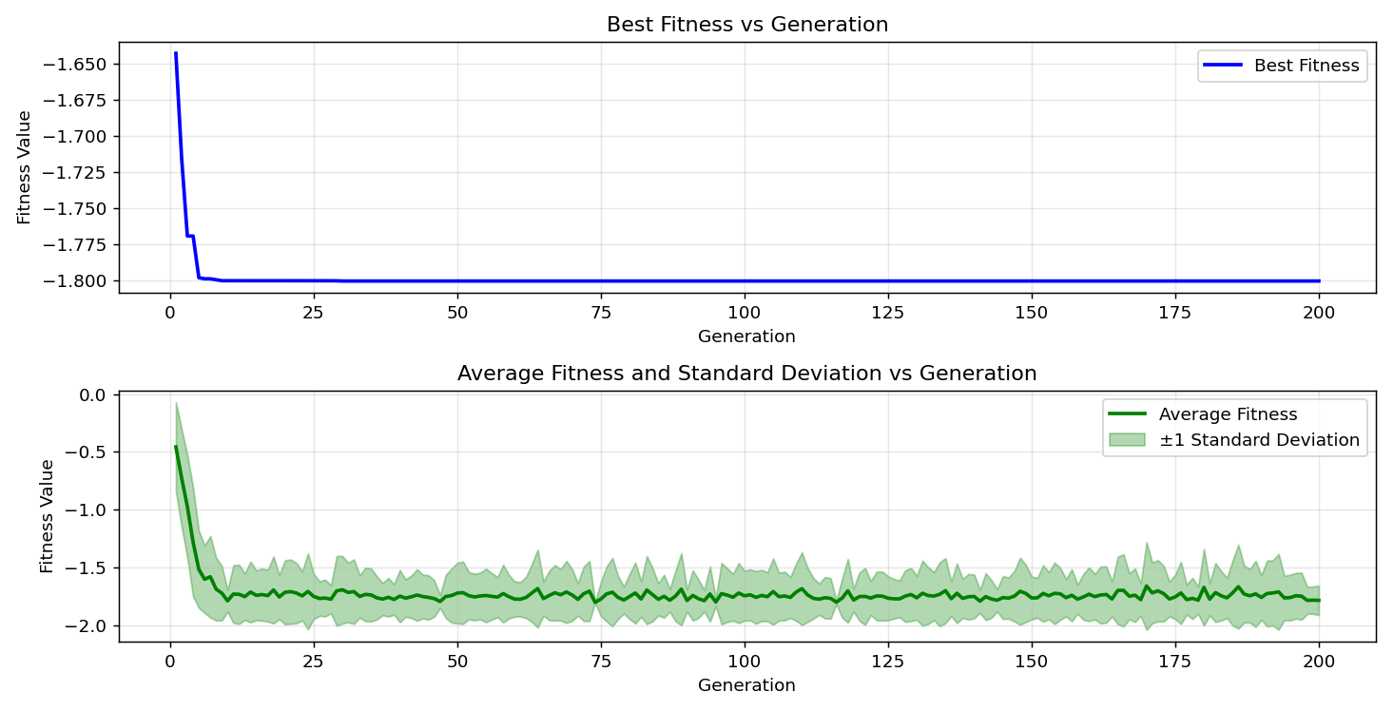

=== FINAL RESULTS ===
Best Fitness: -1.801296
Best Solution: [2.2025652967032965, 1.5711785885225884]
Total Time: 4.64s

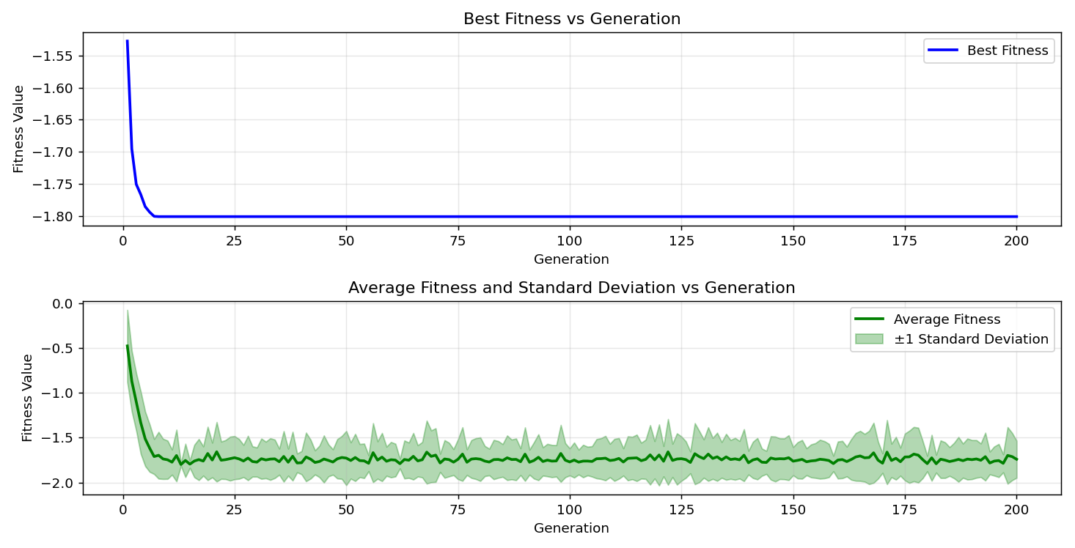

=== FINAL RESULTS ===
Best Fitness: -1.801294
Best Solution: [2.2033324737484734, 1.5704114114774115]
Total Time: 4.61s

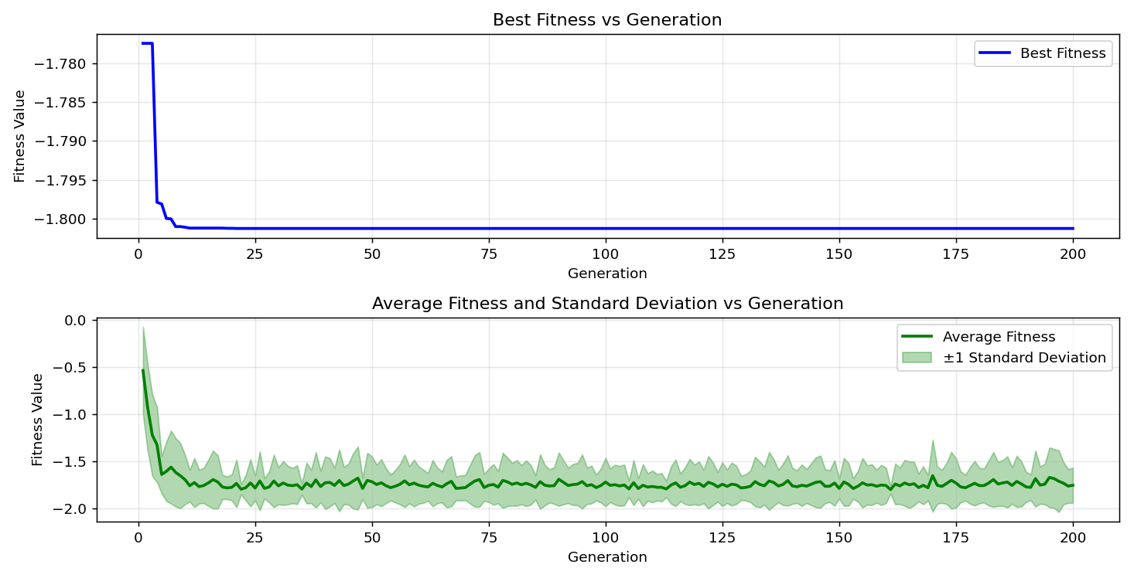

=== FINAL RESULTS ===
Best Fitness: -1.801296
Best Solution: [2.2025652967032965, 1.5704114114774115]
Total Time: 4.66s

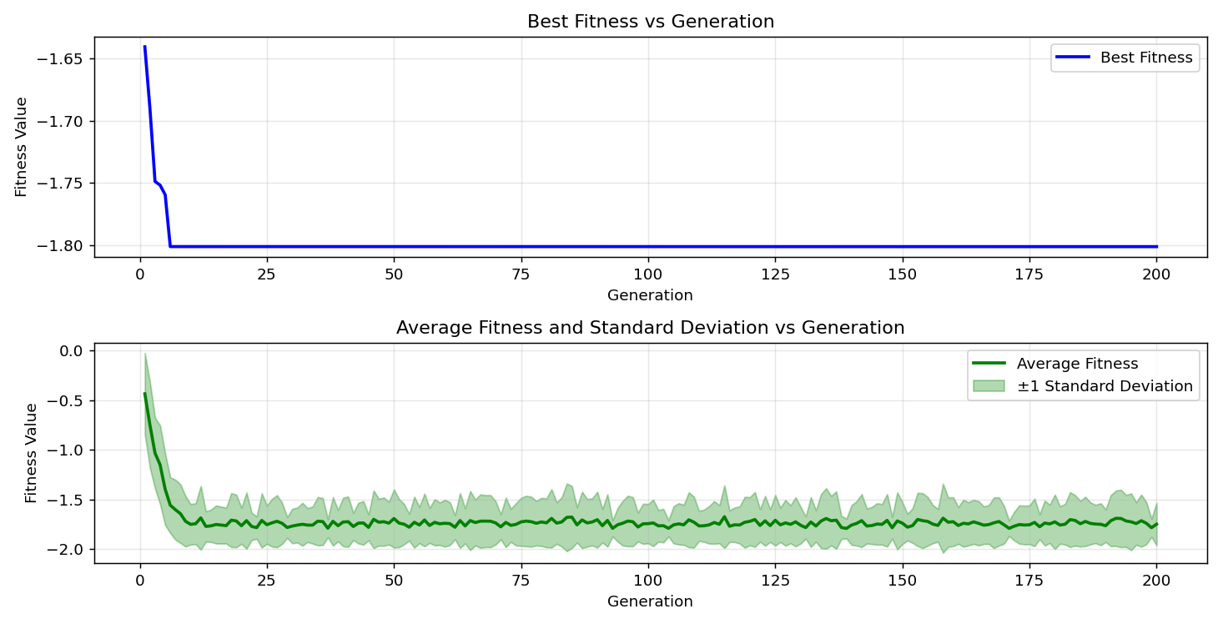

=== FINAL RESULTS ===
Best Fitness: -1.800595
Best Solution: [2.20946989010989, 1.5711785885225884]
Total Time: 4.53s

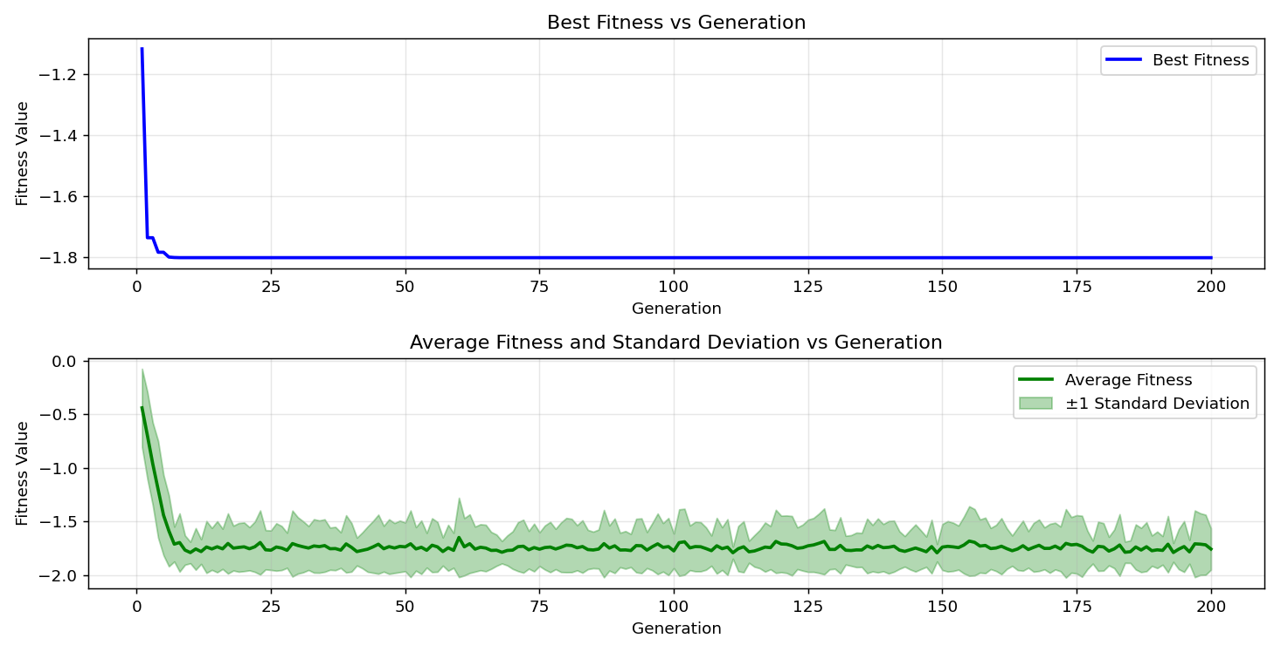

=== FINAL RESULTS ===
Best Fitness: -1.801296
Best Solution: [2.2025652967032965, 1.5704114114774115]
Total Time: 4.56s

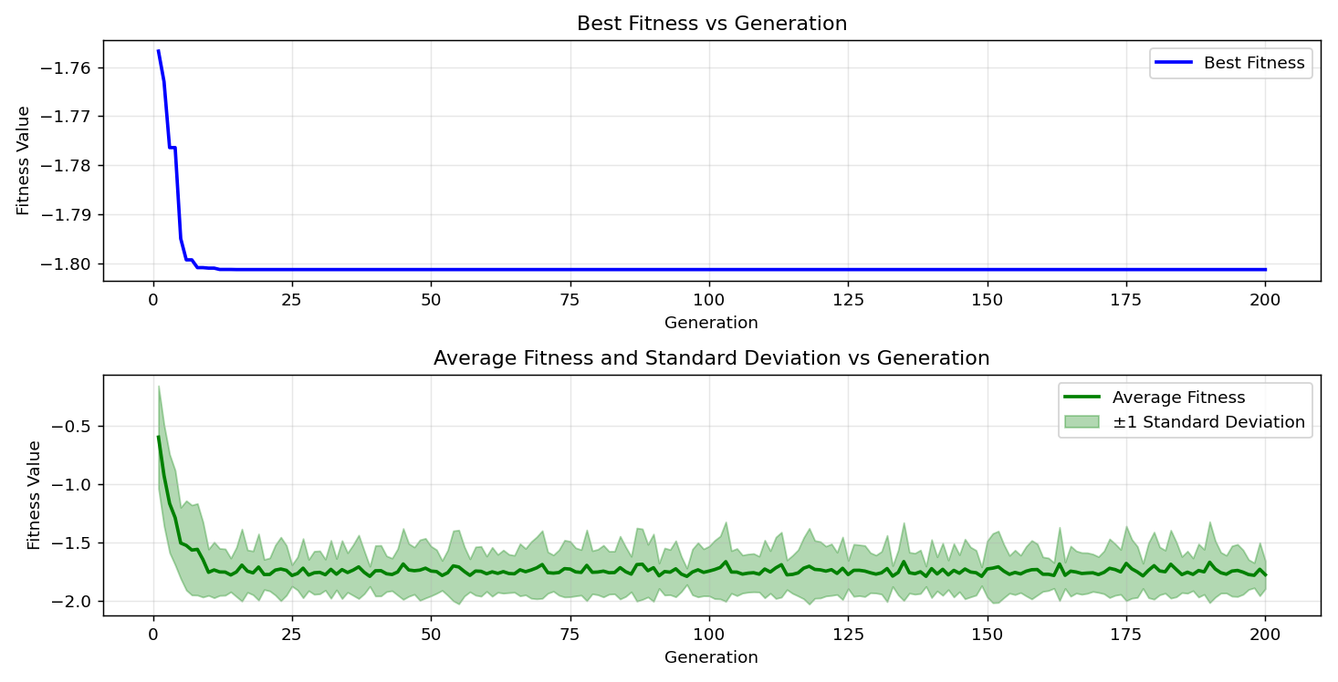
=== FINAL RESULTS ===
Best Fitness: -1.801294
Best Solution: [2.2033324737484734, 1.5704114114774115]
Total Time: 4.52s

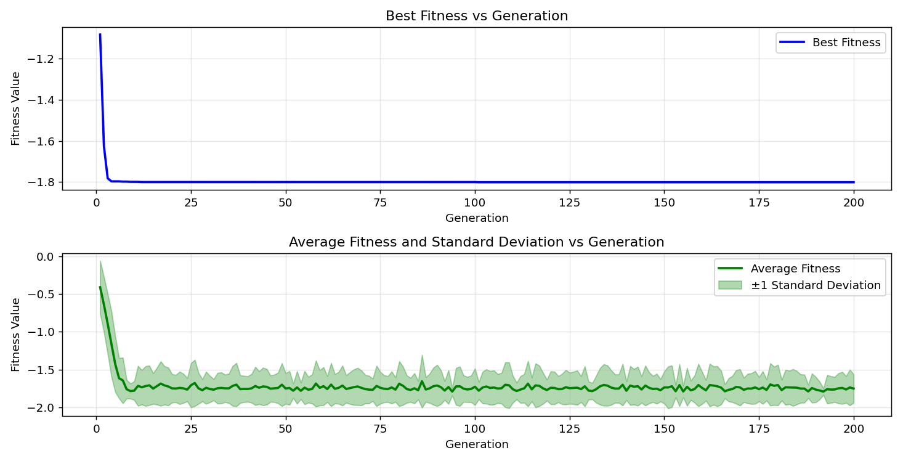

=== FINAL RESULTS ===
Best Fitness: -1.800595
Best Solution: [2.20946989010989, 1.5704114114774115]
Total Time: 4.58s

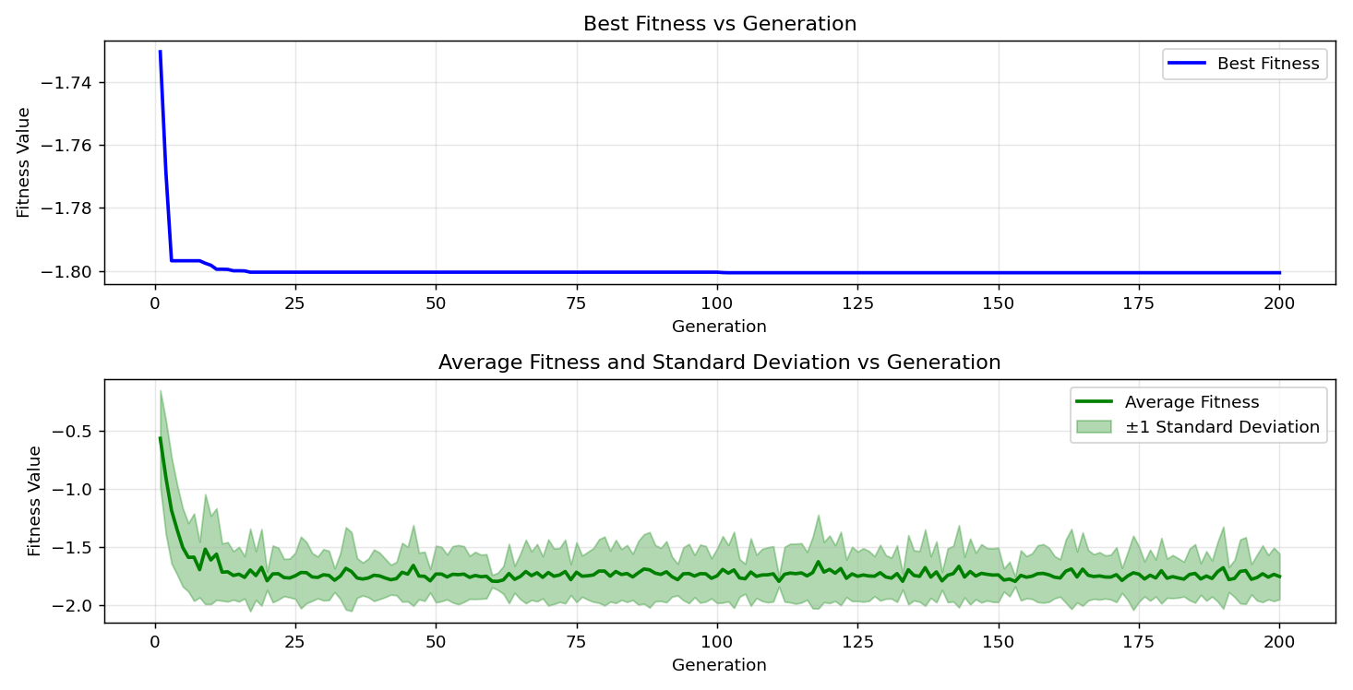
=== FINAL RESULTS ===
Best Fitness: -1.801296
Best Solution: [2.2025652967032965, 1.5704114114774115]
Total Time: 4.52s

