=== FINAL RESULTS ===
Best Fitness: -4.640287
Best Solution: [2.20946989010989, 1.5711785885225884, 1.2758154261294261, 1.1139410695970695, 1.7207781123321124]
Total Time: 5.45s
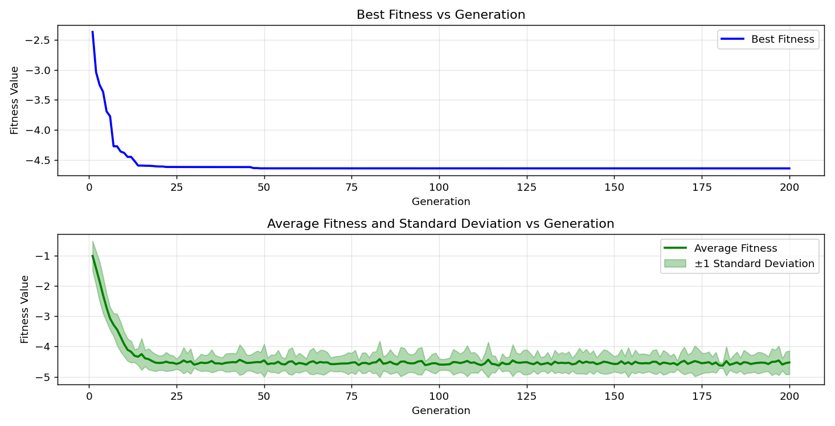

=== FINAL RESULTS ===
Best Fitness: -4.687607
Best Solution: [2.2025652967032965, 1.5704114114774115, 1.2850215506715505, 1.9233128522588523, 1.7207781123321124]
Total Time: 5.41s

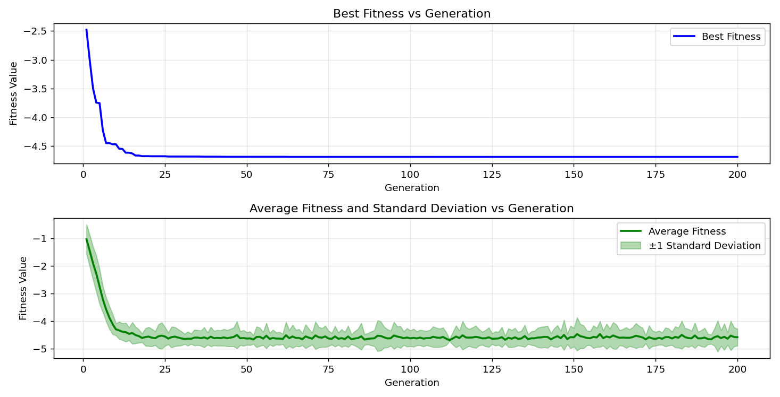

=== FINAL RESULTS ===
Best Fitness: -4.680920
Best Solution: [2.20946989010989, 1.5711785885225884, 1.2850215506715505, 1.9271487374847376, 1.7177094041514038]
Total Time: 5.45s

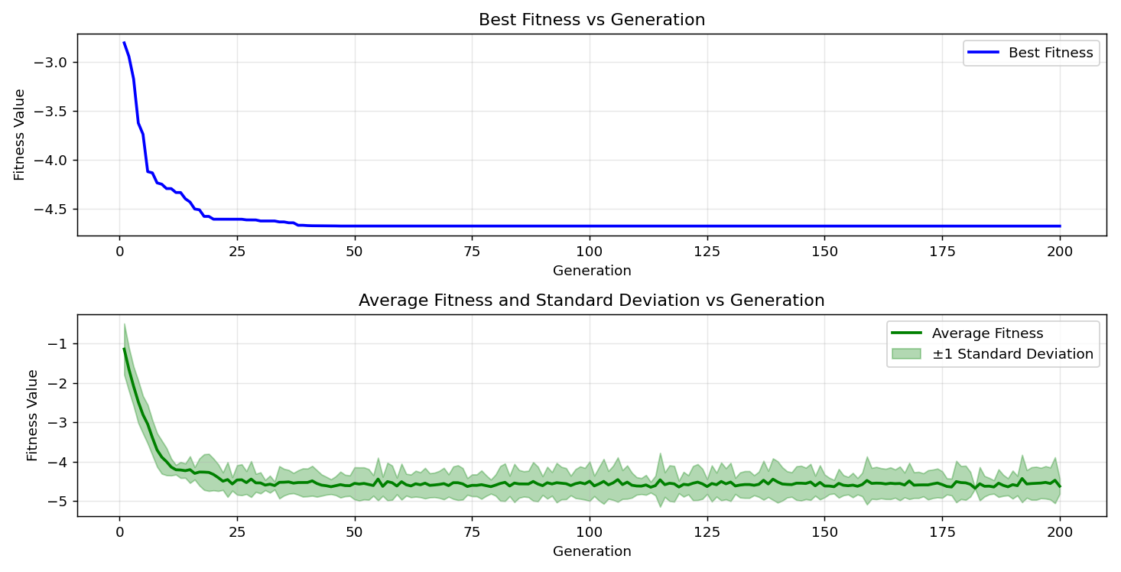

=== FINAL RESULTS ===
Best Fitness: -4.685379
Best Solution: [2.2025652967032965, 1.5704114114774115, 1.2850215506715505, 1.9233128522588523, 1.7177094041514038]
Total Time: 5.55s

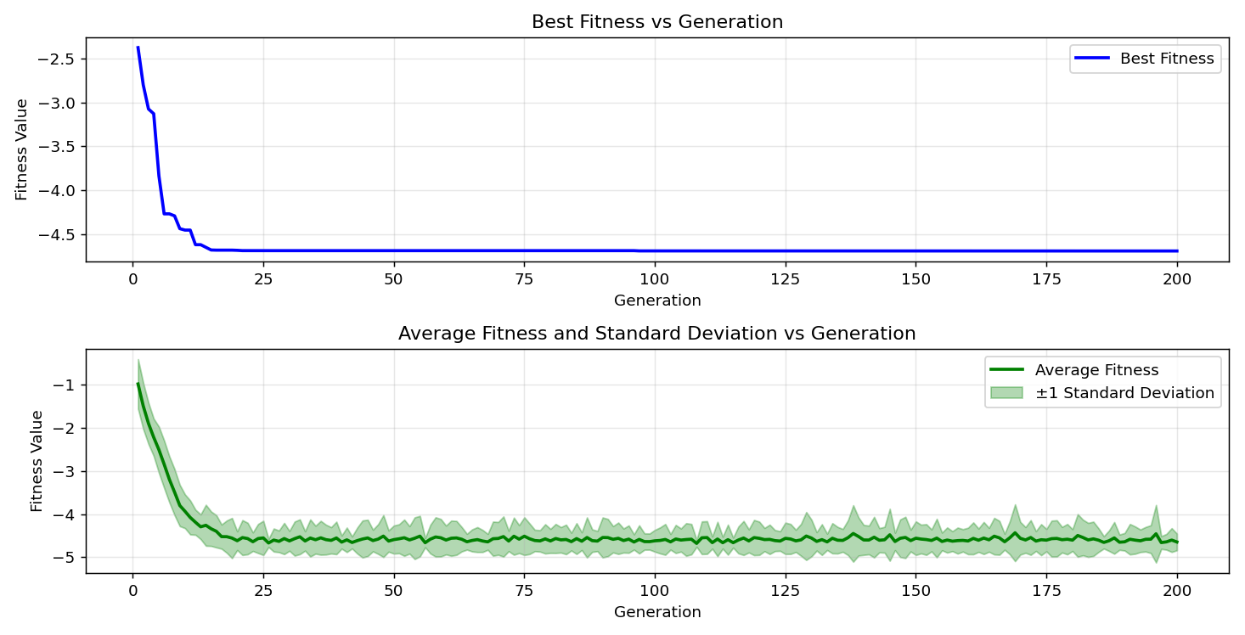

=== FINAL RESULTS ===
Best Fitness: -4.640987
Best Solution: [2.2025652967032965, 1.5704114114774115, 1.2758154261294261, 1.1139410695970695, 1.7207781123321124]
Total Time: 5.57s

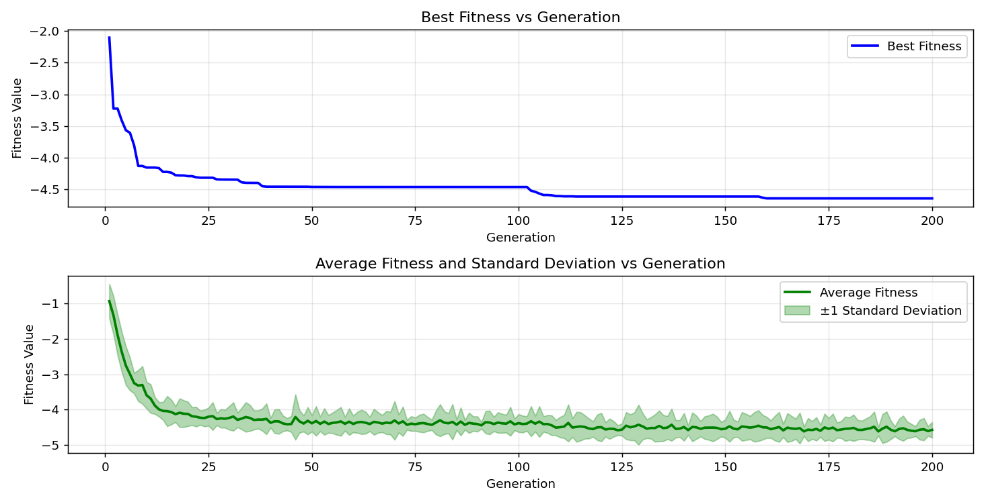
=== FINAL RESULTS ===
Best Fitness: -4.658158
Best Solution: [2.159603382173382, 1.5704114114774115, 1.2857887277167277, 1.9225456752136754, 1.7207781123321124]
Total Time: 5.47s

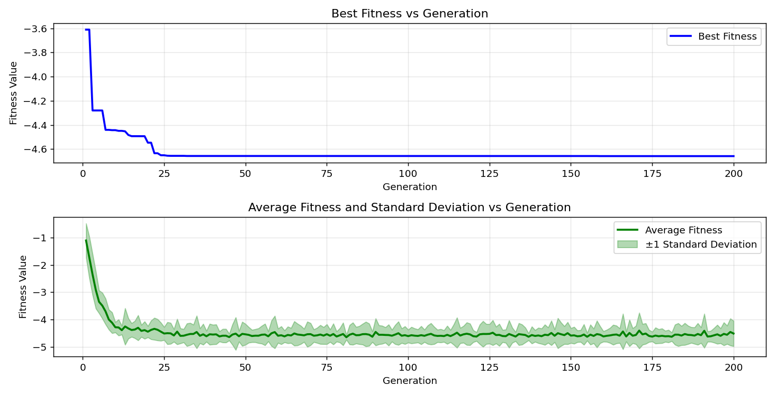

=== FINAL RESULTS ===
Best Fitness: -4.517100
Best Solution: [2.20946989010989, 1.5704114114774115, 1.2850215506715505, 1.9233128522588523, 0.9812194407814407]
Total Time: 5.54s

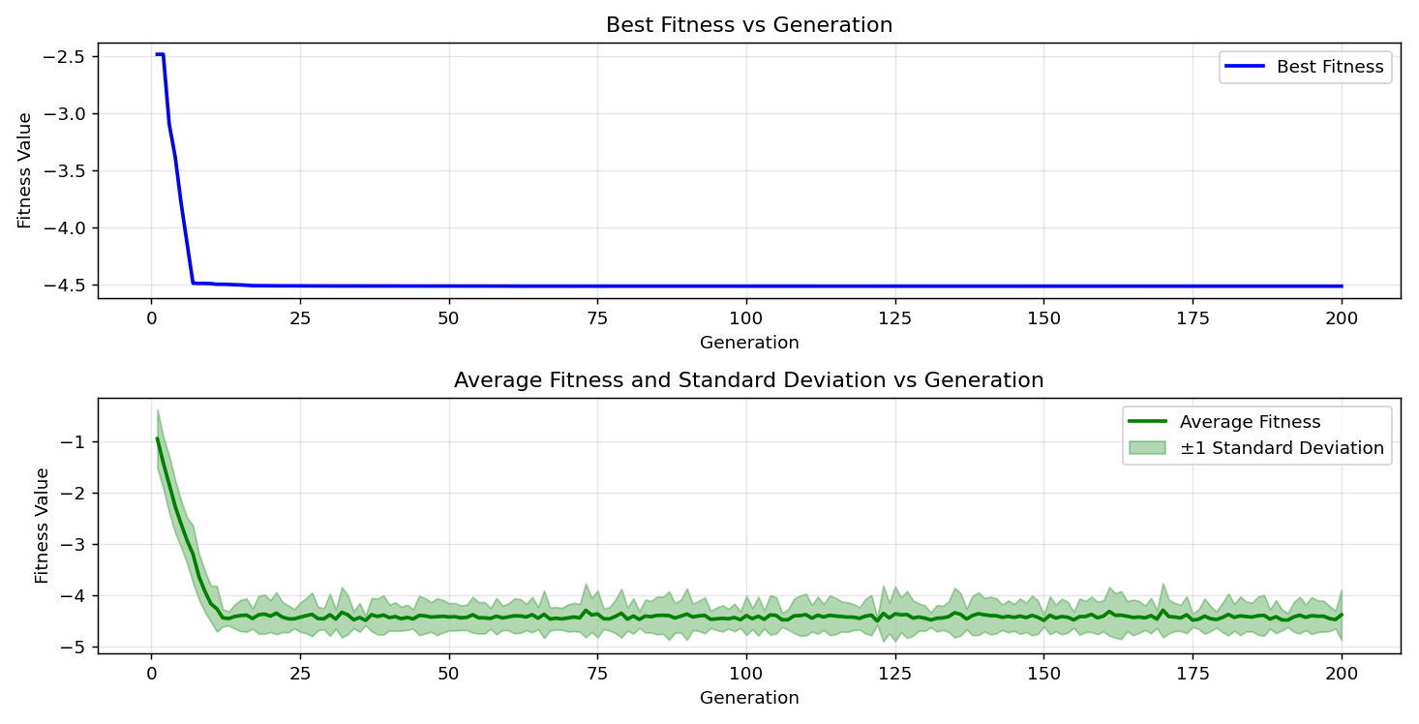

=== FINAL RESULTS ===
Best Fitness: -4.684647
Best Solution: [2.20946989010989, 1.5711785885225884, 1.2842543736263736, 1.9233128522588523, 1.7177094041514038]
Total Time: 5.62s

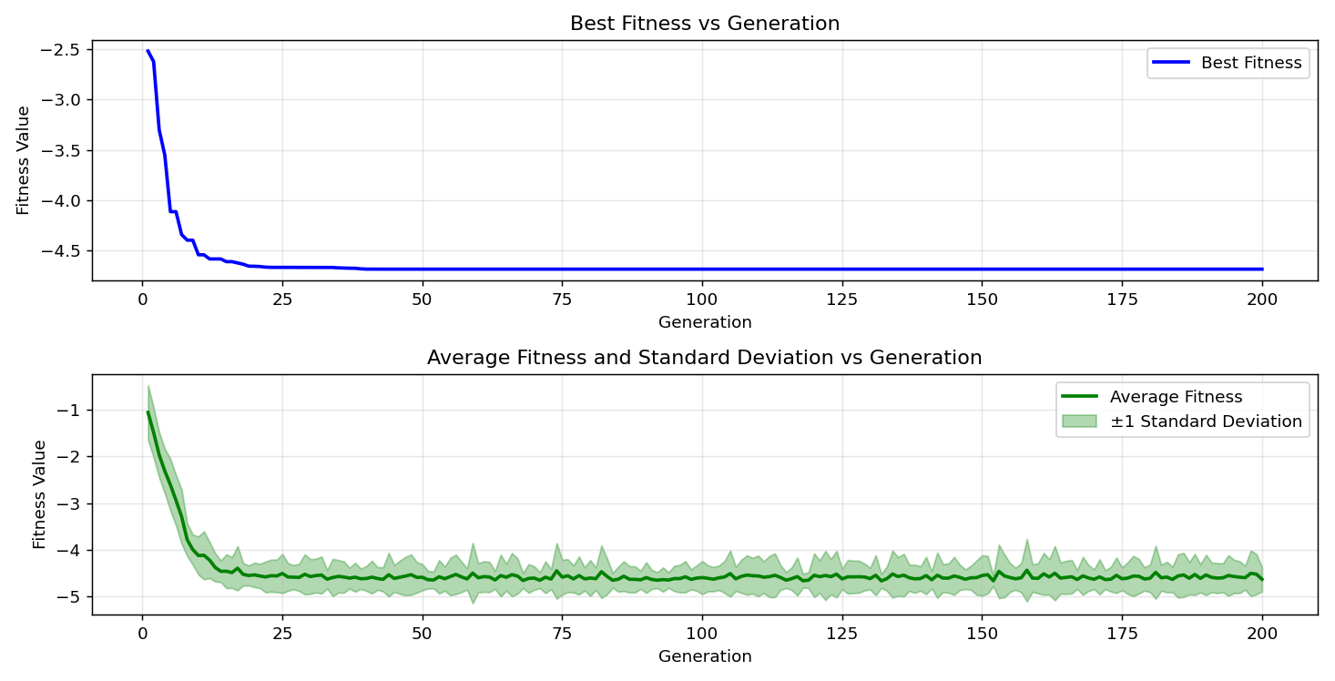

=== FINAL RESULTS ===
Best Fitness: -4.685342
Best Solution: [2.2025652967032965, 1.5711785885225884, 1.2857887277167277, 1.9233128522588523, 1.7177094041514038]
Total Time: 5.51s

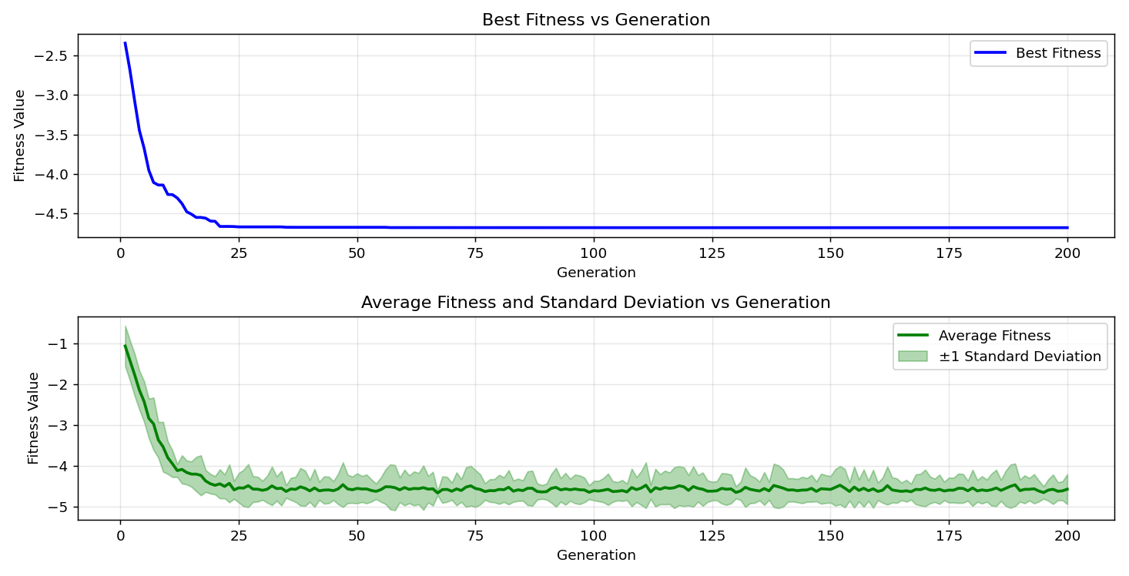

=== FINAL RESULTS ===
Best Fitness: -4.642848
Best Solution: [2.2040996507936503, 1.5711785885225884, 1.2850215506715505, 1.1170097777777779, 1.7177094041514038]
Total Time: 5.53s

